

CSA1560 - Cloud Computing and Big Data Analytics for Engineers

LAB Programs

Experiment-01

Presented by

VETRISELVAN K (192511290)

Guided by

Dr. K. Sampath Kumar

EXP NO 1: CREATE A SIMPLE CLOUD SOFTWARE APPLICATION AND PROVIDE IT AS A SERVICE USING ANY CLOUD SERVICE PROVIDER TODEMONSTRATE SOFTWARE AS A SERVICE (SAAS).
DATE:
AIM:
To create a simple cloud software application and provide it as a service using any cloud service provider to demonstrate software as a service (saas).

PROCEDURE:
STEP1: GOTO ZOHO.COM

STEP 2: LOGIN TO THE ZOHO.COM STEP 3: SELECT ONE APPLICATION STEP 4: ENTER APPLICATION NAME
STEP 5: CREATED NEW APPLICATION
STEP 6: SELECT ONE FORM
STEP 7: THE SOFTWARE HASE BEEN CREATED.
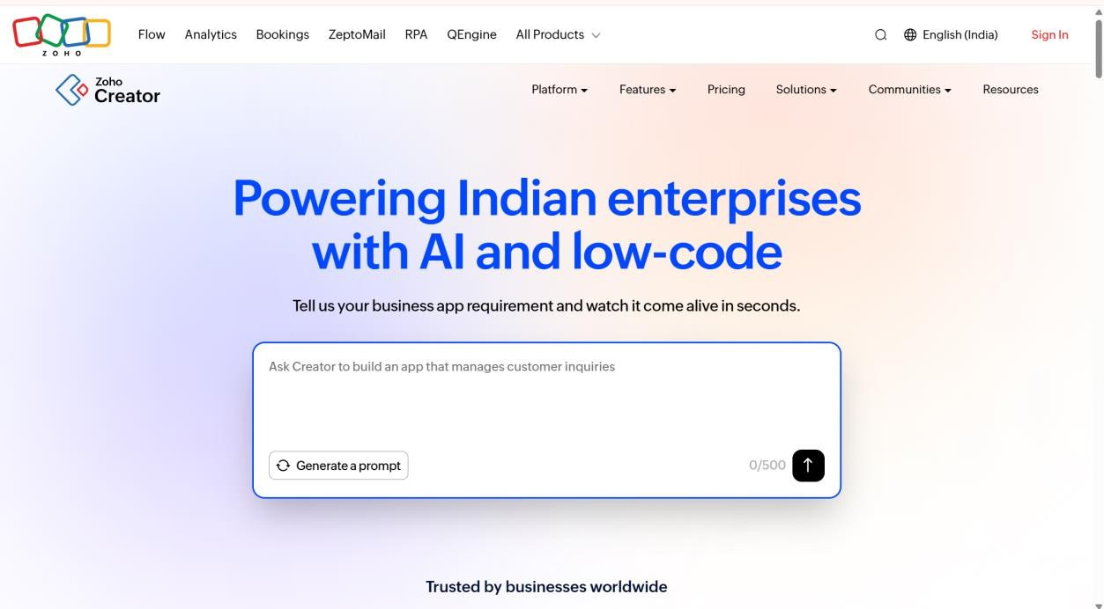

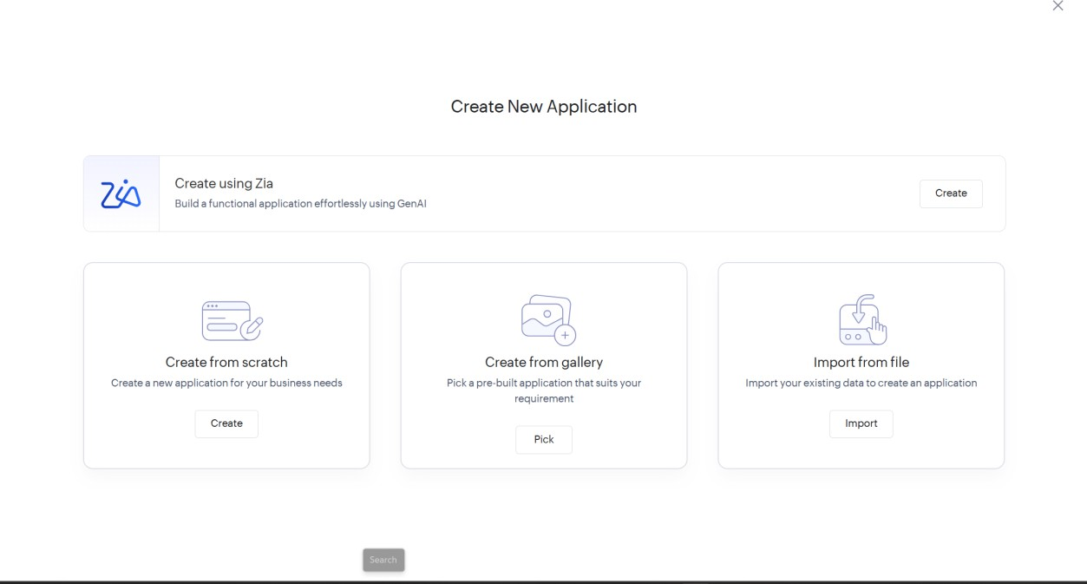
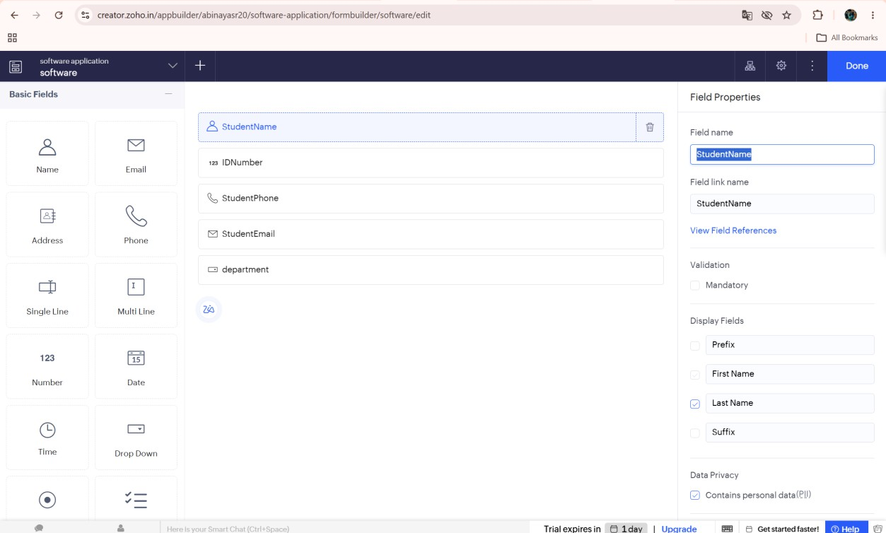

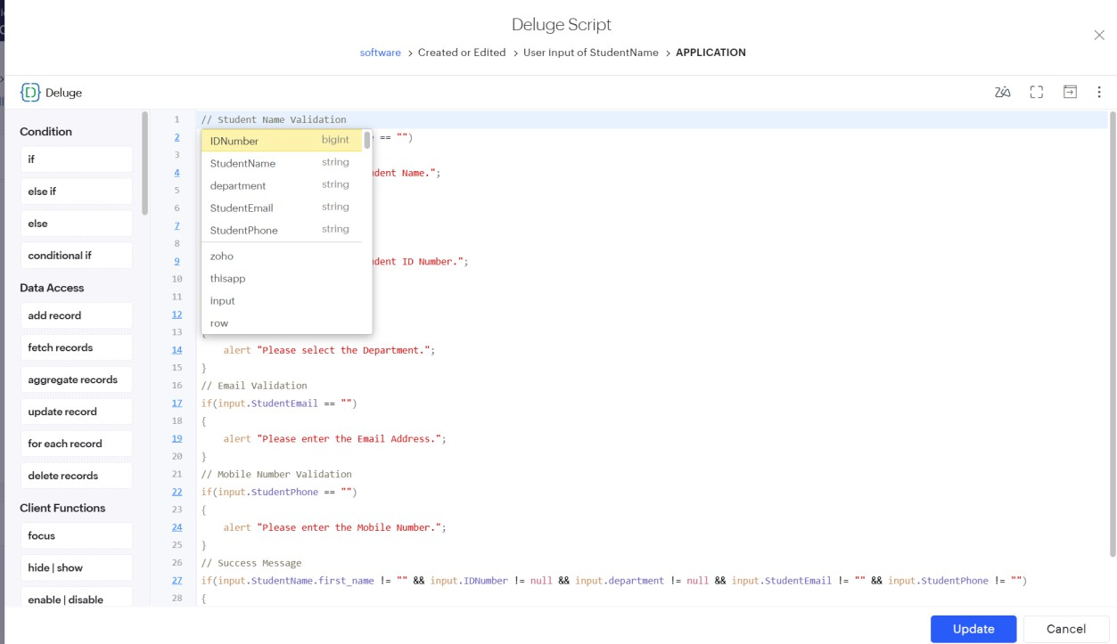
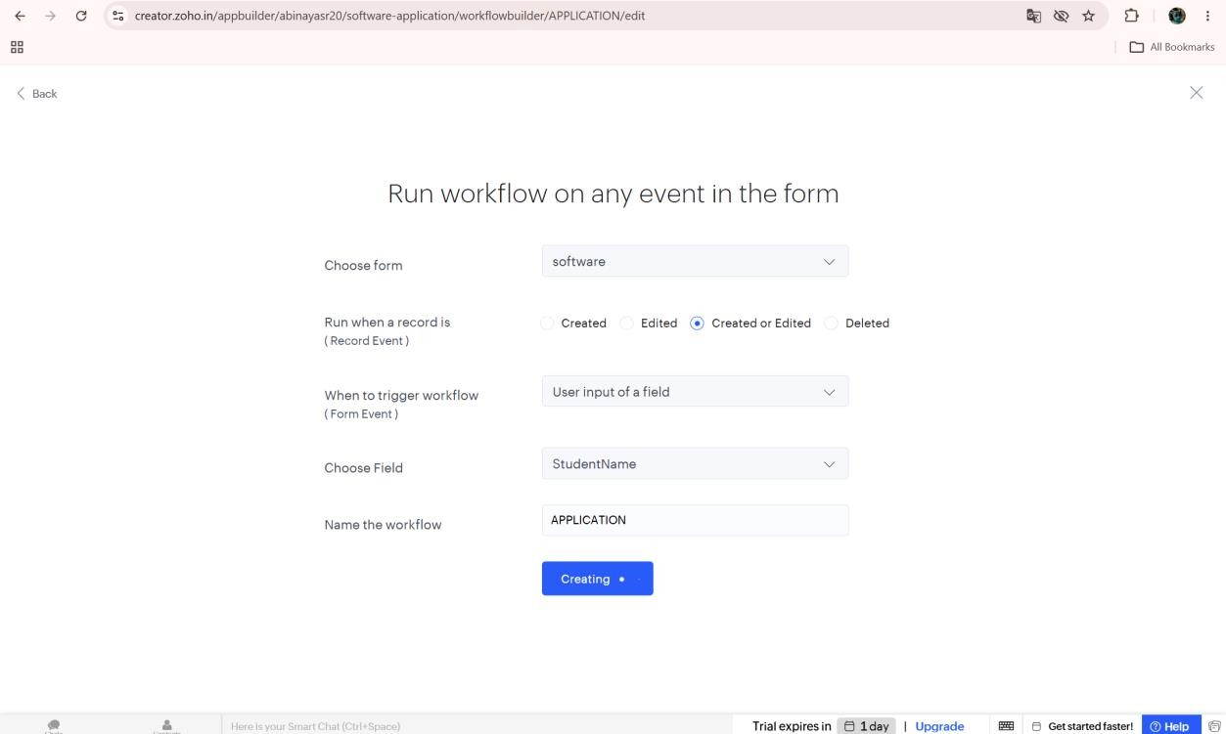

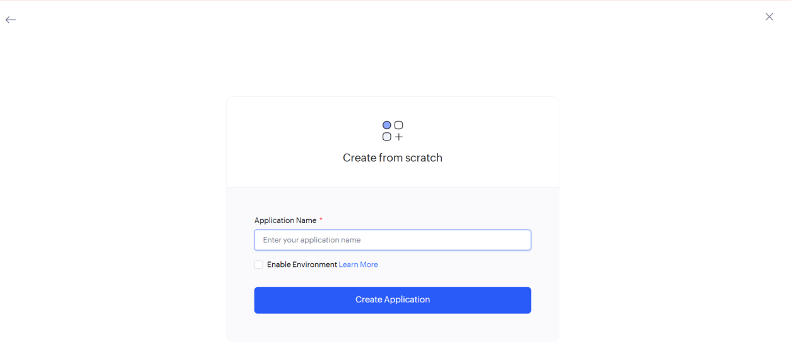

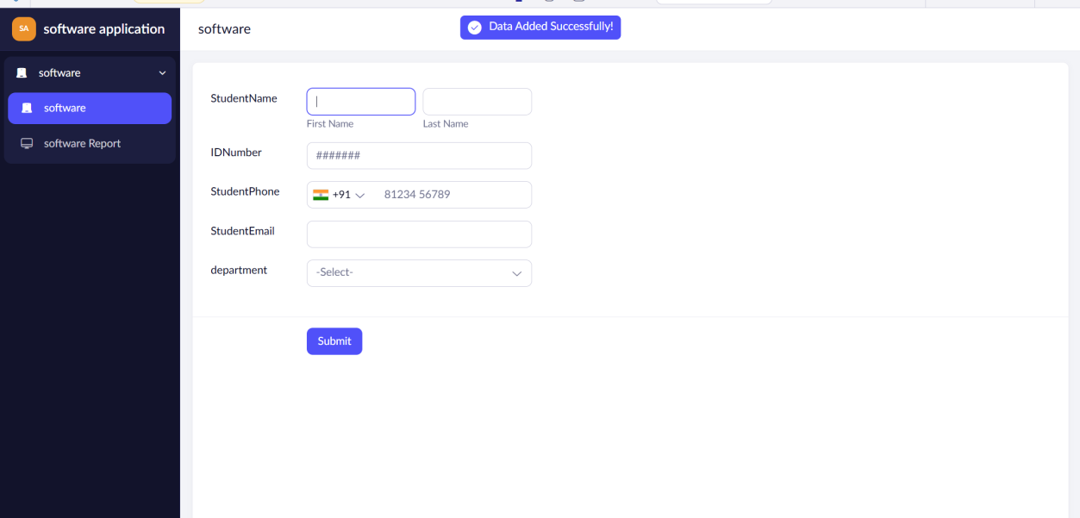

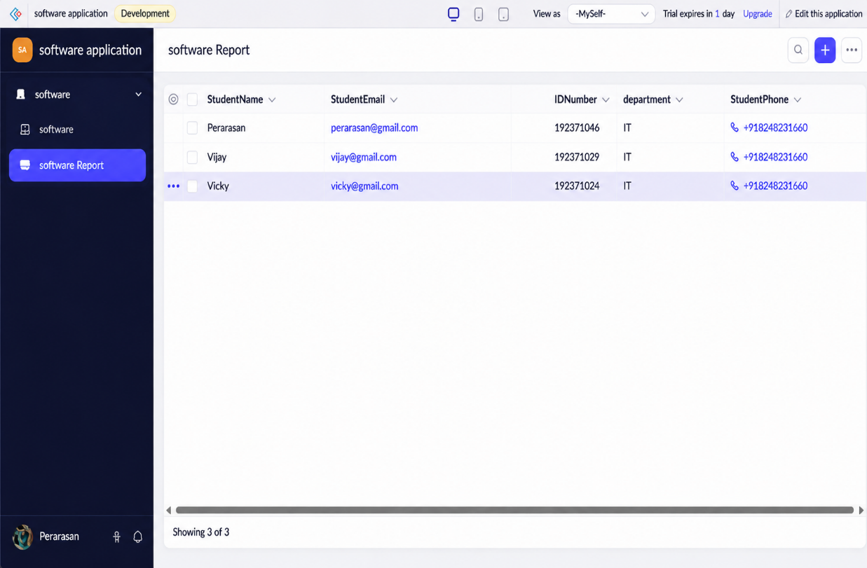

Implement:
// Check Student Name if(input.StudentName == "")
{
alert "Please enter the Student Name."; cancel submit;
}

// Check ID Number if(input.IDNumber == null)
{
alert "Please enter the Student ID."; cancel submit;
}

// Check Department if(input.department == "")
{
alert "Please select the Department.";

cancel submit;
}

// Check Email if(input.StudentEmail == "")
{
alert "Please enter the Email Address."; cancel submit;
}

// Check Phone Number if(input.StudentPhone == "")
{
alert "Please enter the Mobile Number."; cancel submit;
}

// Phone Number Validation if(input.StudentPhone.length() != 10)
{
alert "Mobile Number must contain 10 digits."; cancel submit;
}

// Success Message
info "Student Details Submitted Successfully.";
Result:
Thus, a simple cloud software application was successfully developed using Zoho Creator and provided as a Software as a Service (SaaS) application. The application is accessible through the cloud and demonstrates the SaaS model successfully.

