

CSA1560 - Cloud Computing and Big Data Analytics for Engineers

LAB Programs

Experiment-02

Presented by

VETRISELVAN K (192511290)

Guided by

Dr. K. Sampath Kumar

EXP NO 2: CREATE A SIMPLE CLOUD SOFTWARE APPLICATION FOR FLIGHT RESERVATION SYSTEM USING ANY CLOUD SERVICE PROVIDER TO DEMONSTRATE SAAS.
DATE: 10.08.2026 AIM:
To create a simple cloud software application for flight reservation system using any cloud service provider to demonstrate saas.
PROCEDURE:
step1: Go to zoho.com.
step 2: Log into the zoho.com. step 3: Select one application step.
step4: Enter application name as flight reservation system. step 5: Created new application flight reservation system. step 6: Select one form
step 7: The software has been created.
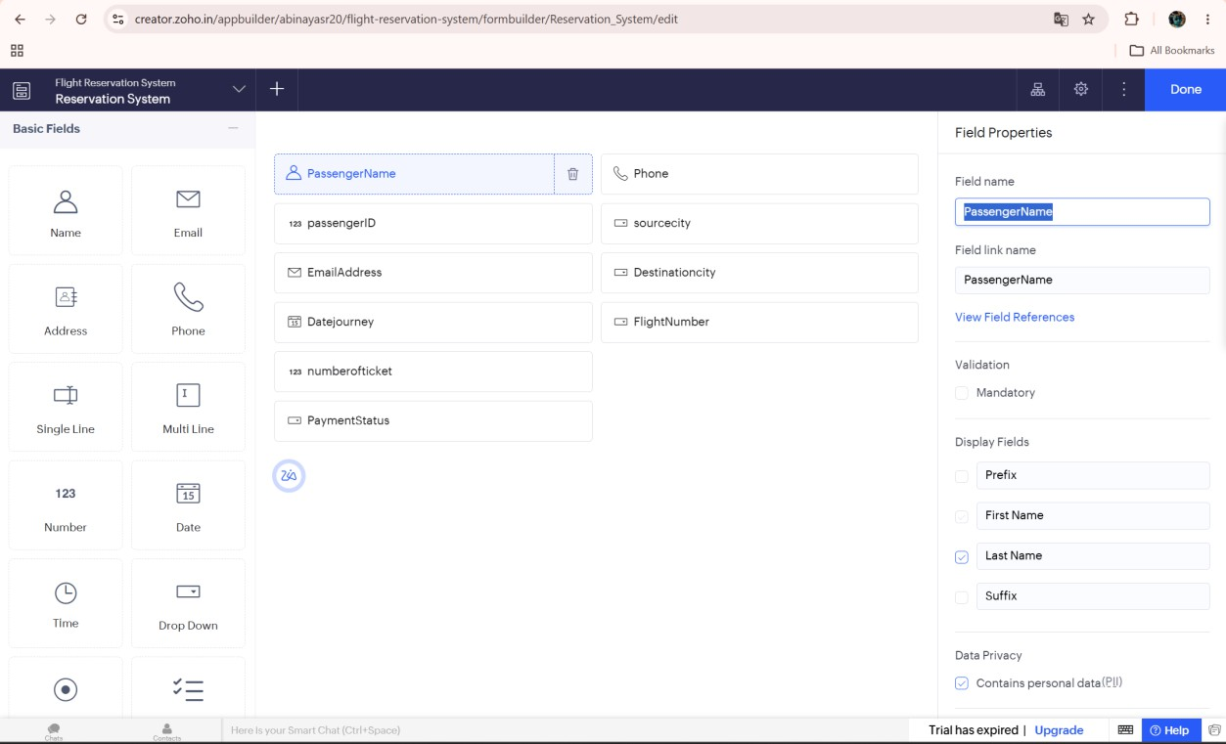

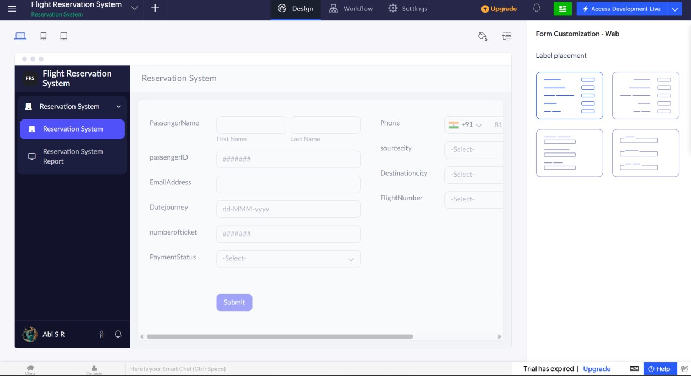
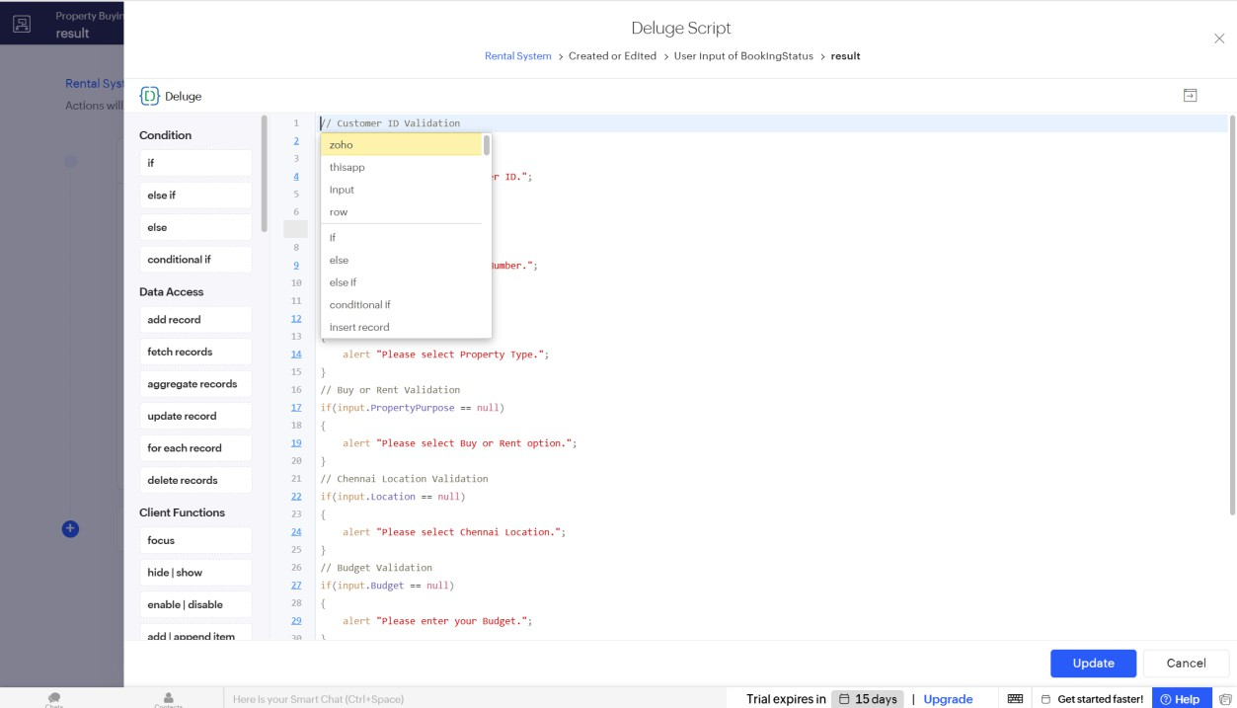

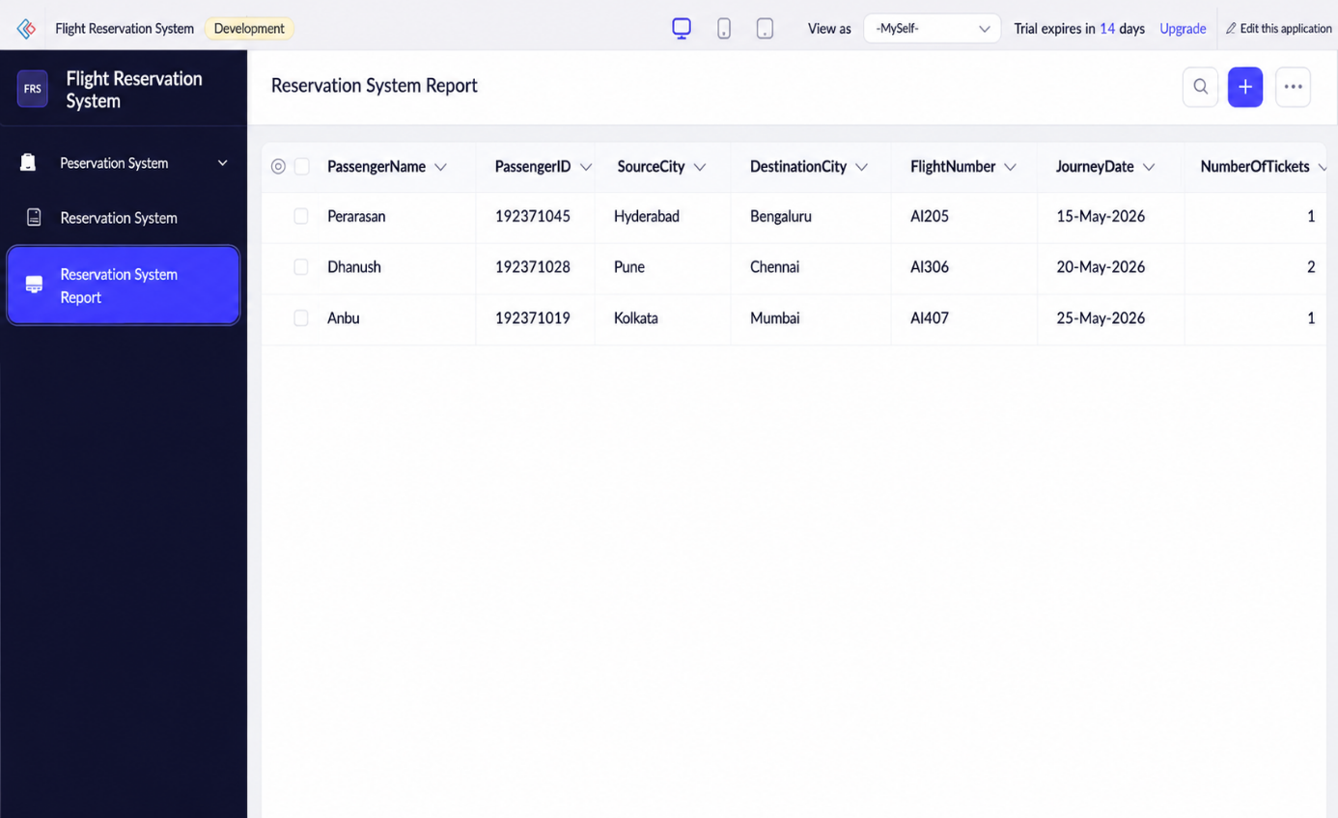
// Passenger Name Validation

if(input.PassengerName.first_name == "")
{
alert "Please enter Passenger Name."; cancel submit;
}

// Passenger ID Validation

if(input.PassengerID == null)
{
alert "Please enter Passenger ID."; cancel submit;
}

// Email Validation

if(input.PassengerEmail == "")
{
alert "Please enter Email Address."; cancel submit;
}

// Phone Number Validation

if(input.PassengerPhone == "")
{
alert "Please enter Mobile Number."; cancel submit;
}

// Source City Validation

if(input.SourceCity == null)
{
alert "Please select Source City."; cancel submit;
}

// Destination City Validation

if(input.DestinationCity == null)
{
alert "Please select Destination City."; cancel submit;
}

// Prevent Same Source and Destination

if(input.SourceCity == input.DestinationCity)
{
alert "Source and Destination cannot be the same."; cancel submit;
}

// Flight Number Validation

if(input.FlightNumber == null)
{
alert "Please select Flight Number."; cancel submit;
}

// Journey Date Validation

if(input.JourneyDate == null)
{
alert "Please select Journey Date."; cancel submit;
}

// Class Type Validation

if(input.ClassType == null)
{
alert "Please select Class Type.";

cancel submit;
}

// Number of Tickets Validation

if(input.NumberofTickets == null)
{
alert "Please enter Number of Tickets."; cancel submit;
}

// Payment Status Validation

if(input.PaymentStatus == null)
{
alert "Please select Payment Status."; cancel submit;
}

// Booking Confirmation Message

info "Flight Ticket Booked Successfully.";

Result:
Thus, a simple cloud-based Flight Reservation System was successfully developed using Zoho Creator. The application enables users to reserve flight tickets online, stores reservation details in the cloud, and demonstrates the Software as a Service (SaaS) model.

