

CSA1560 - Cloud Computing and Big Data Analytics for Engineers

LAB Programs

Experiment-03

Presented by

VETRISELVAN K (192511290)

Guided by

Dr. K. Sampath Kumar

EXP NO 3: CREATE A SIMPLE CLOUD SOFTWARE APPLICATION FOR PROPERTY BUYING & RENTAL PROCESS (IN CHENNAI CITY) USING ANY CLOUD SERVICE PROVIDER TO DEMONSTRATE SAAS.
DATE:30.07.2026 AIM:
To Create a simple cloud software application for Property Buying & Rental process (In Chennai city) using any Cloud Service Provider to demonstrate SaaS.
PROCEDURE:
step1: Go to zoho.com.
step 2: Log into the zoho.com. step 3: Select one application step.
step4: Enter application name as property buying & rental. step 5: Created new application as property buying & rental. step 6: Select one form
step 7: The software has been created.
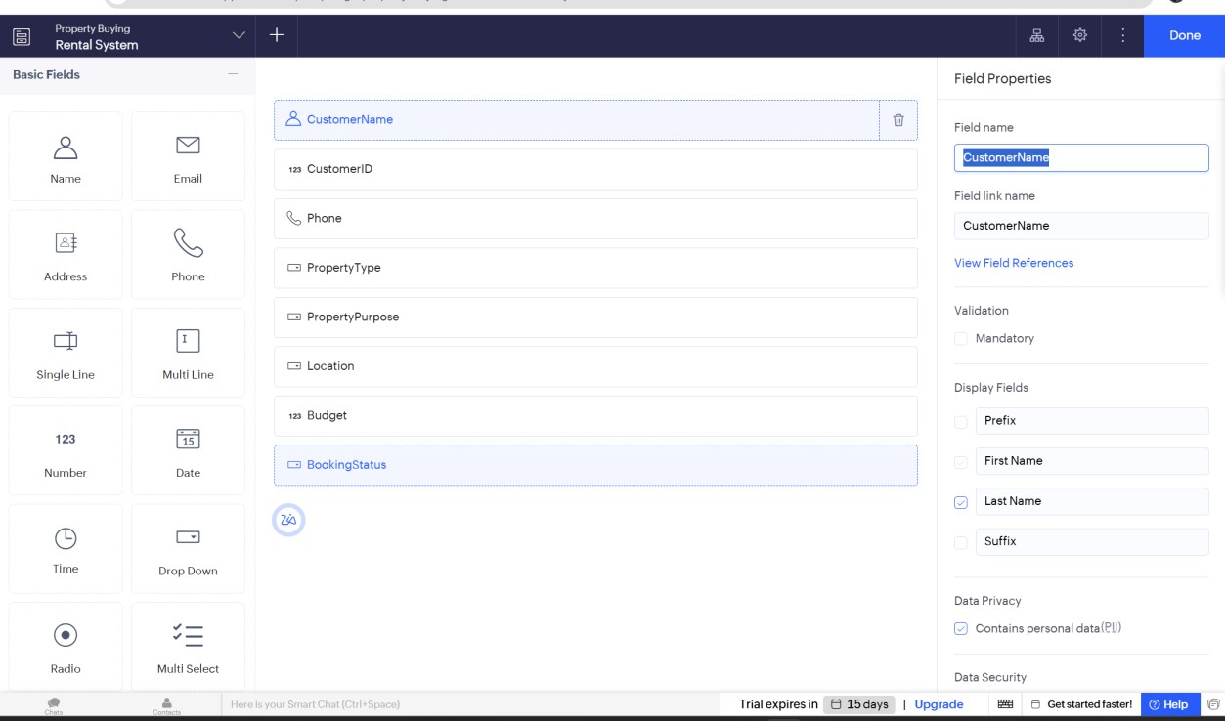

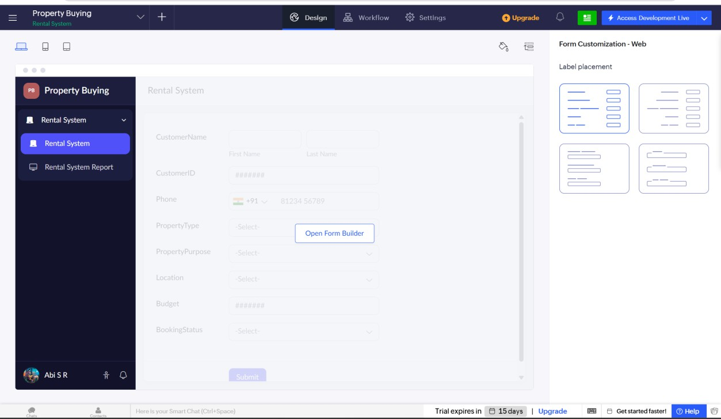
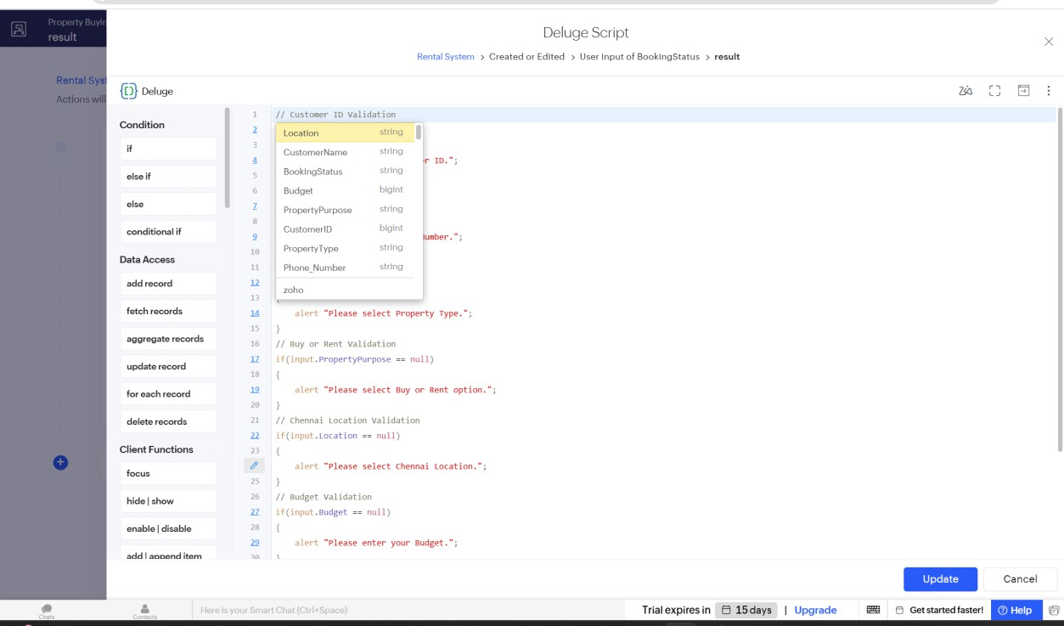

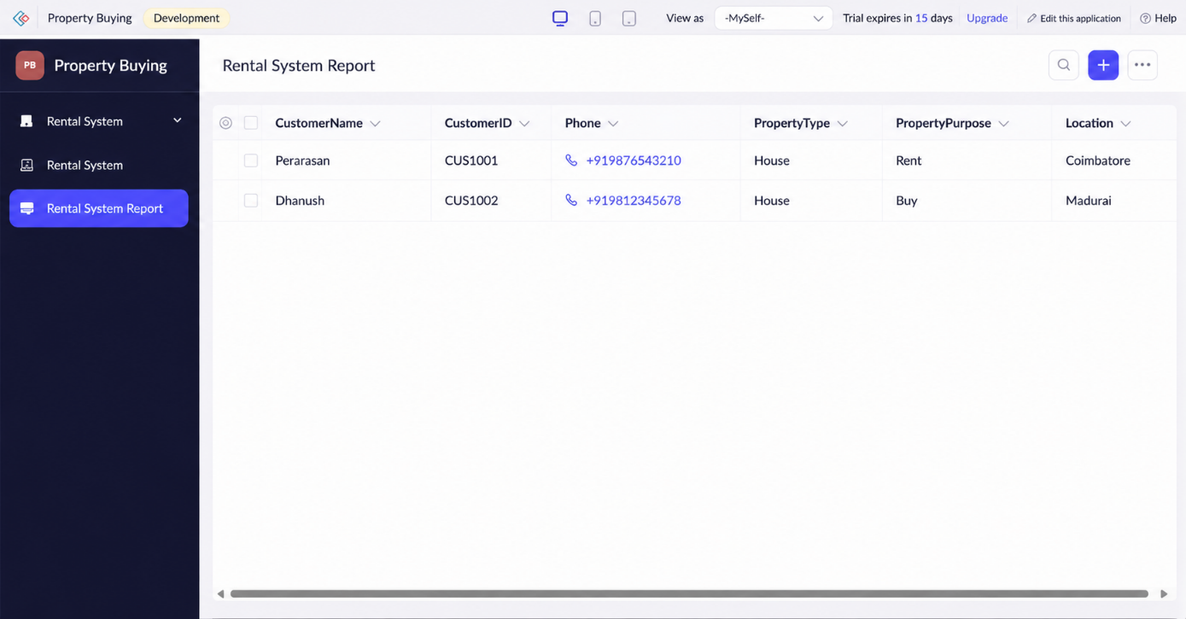
// Customer ID Validation

if(input.CustomerID == null)
{
alert "Please enter Customer ID.";
}

// Phone Number Validation

if(input.Phone == null)
{
alert "Please enter Phone Number.";
}

// Email Validation

if(input.EmailAddress == "")
{
alert "Please enter Email Address.";
}

// Property Type Validation

if(input.PropertyType == null)
{
alert "Please select Property Type.";
}

// Property Purpose Validation

if(input.PropertyPurpose == null)
{
alert "Please select Buying or Rental Option.";
}

// Chennai Location Validation

if(input.AreaLocation == null)
{
alert "Please select Chennai Location.";
}

// Budget Validation

if(input.Budget == null)
{
alert "Please enter Property Budget.";
}

// Bedrooms Validation

if(input.NumberofBedrooms == null)
{
alert "Please select Number of Bedrooms.";
}

// Payment Mode Validation

if(input.PaymentMode == null)
{
alert "Please select Payment Mode.";
}

// Visit Date Validation

if(input.VisitDate == null)
{
alert "Please select Visit Date.";
}

// Booking Status Validation

if(input.BookingStatus == null)
{
alert "Please select Booking Status.";
}

// Success Message

info "Property Booking Submitted Successfully.";

info "Thank You For Choosing Chennai Property Services.";

Result:
Thus, a simple cloud-based Property Buying & Rental System for Chennai city was successfully developed using Zoho Creator. The application allows users to search, buy, or rent properties online and demonstrates the Software as a Service (SaaS) model.

