

CSA1560 - Cloud Computing and Big Data Analytics for Engineers

LAB Programs

Experiment-04

Presented by

VETRISELVAN K (192511290)

Guided by

Dr. K. Sampath Kumar

EXP NO 4: CREATE A SIMPLE CLOUD SOFTWARE APPLICATION FOR CAR BOOKING RESERVATION SYSTEM USING ANY CLOUD SERVICE PROVIDER TO DEMONSTRATE SAAS.
DATE:10.08.2026 AIM:
To Create a simple cloud software application for Car Booking Reservation System using any Cloud Service Provider to demonstrate SaaS.
PROCEDURE:
step1: Go to zoho.com.
step 2: Log into the zoho.com. step 3: Select one application step.
step4: Enter application name as Car Booking Reservation System. step 5: Created new application as Car Booking Reservation System. step 6: Select one form
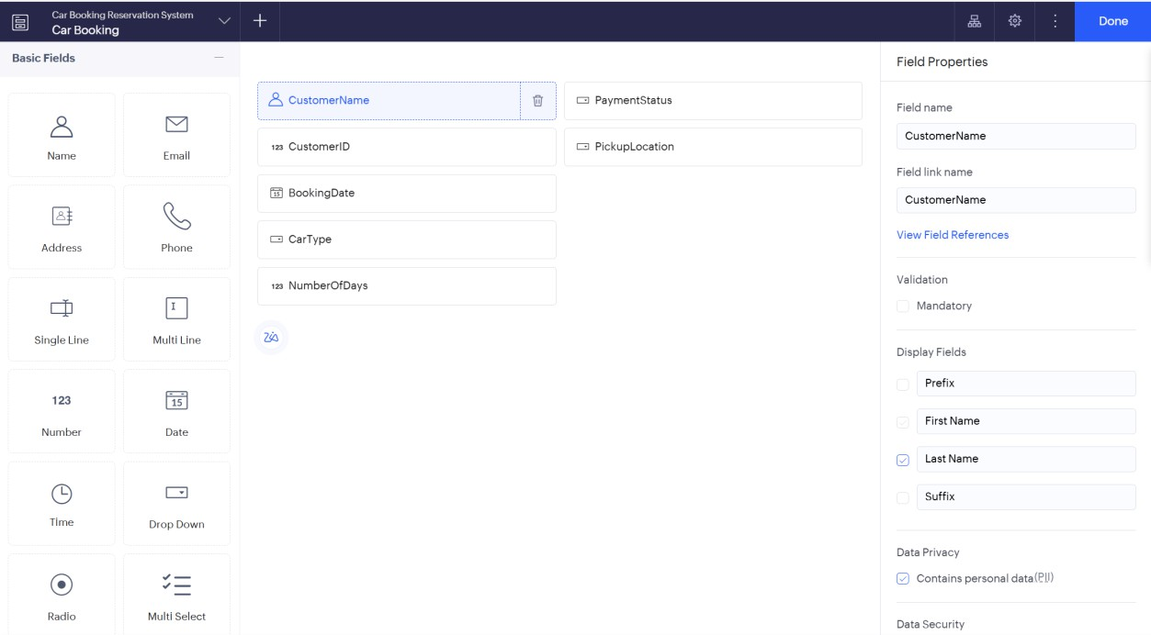
step 7: The software has been created. IMPLEMENTATION:

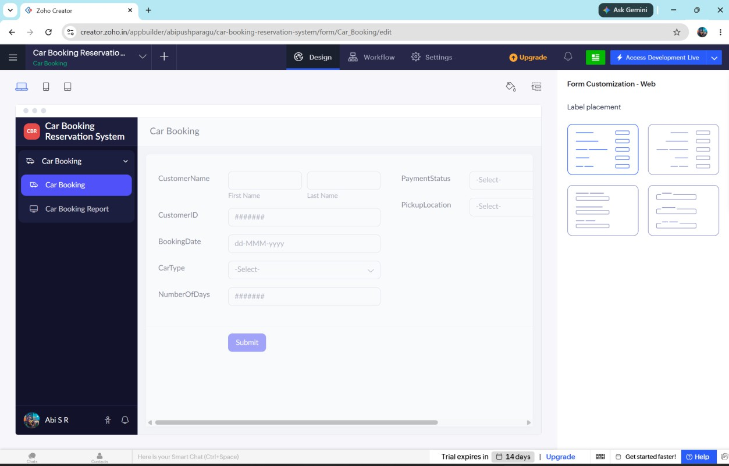
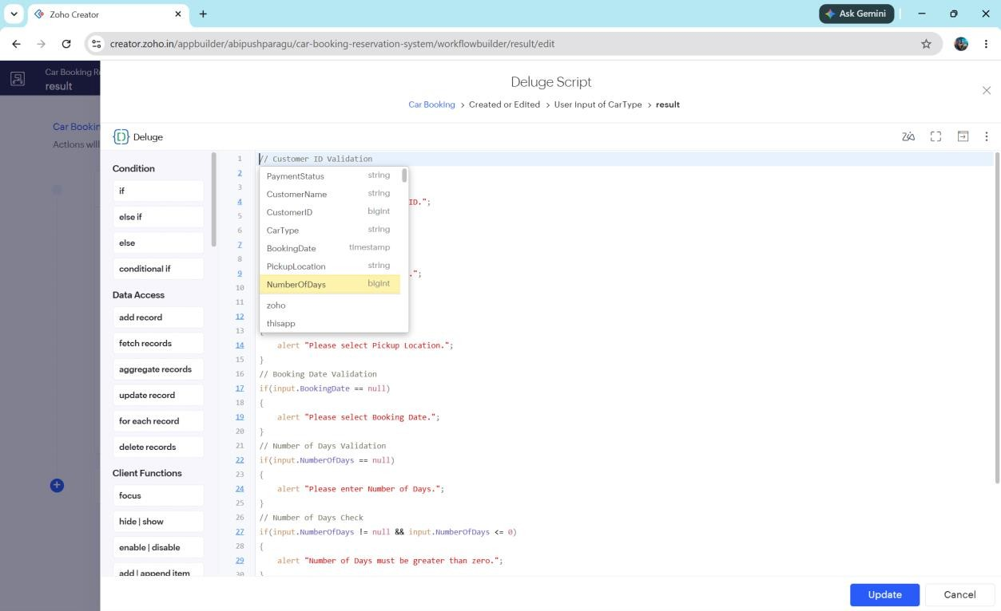

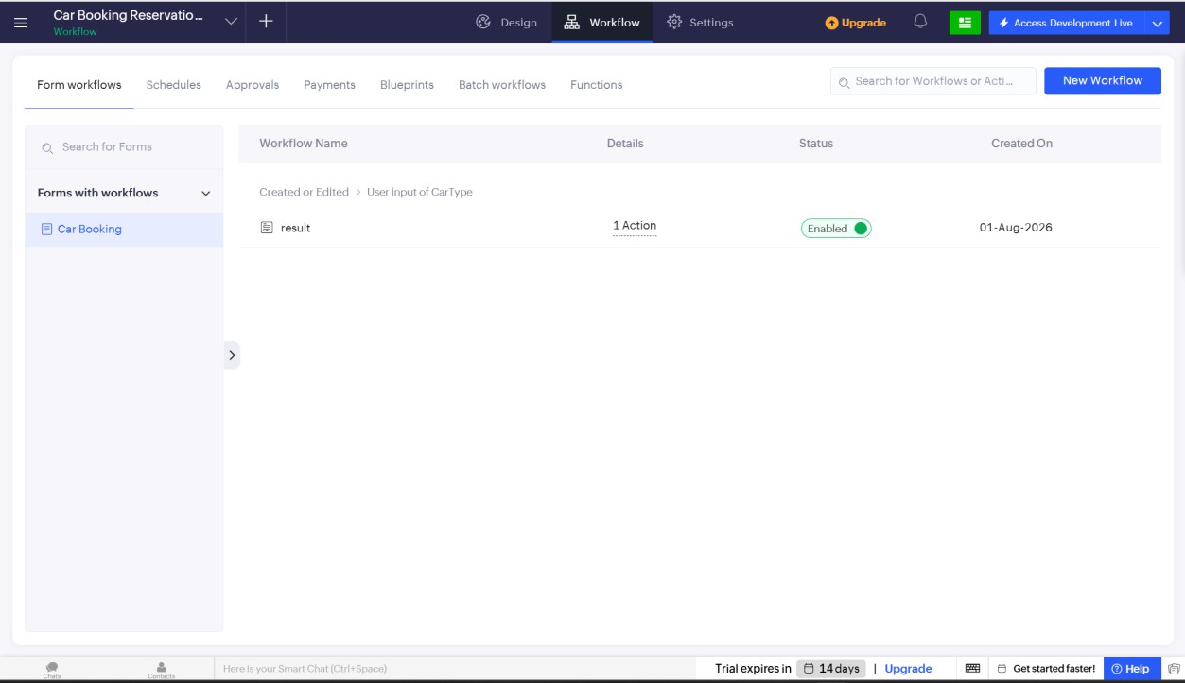

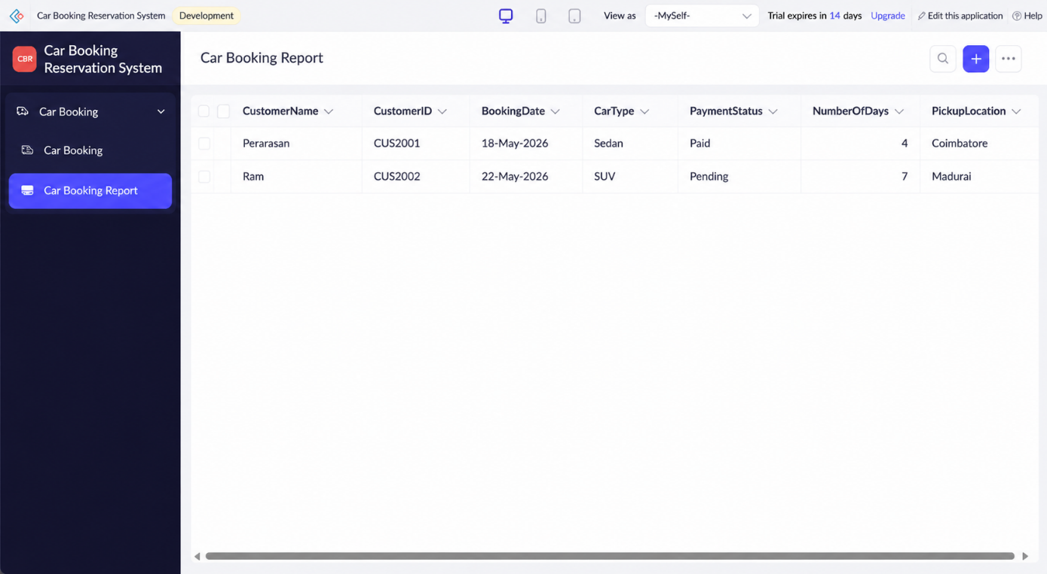// Customer ID Validation

if(input.CustomerID == null)
{
alert "Please enter Customer ID.";
}

// Car Type Validation

if(input.CarType == null)
{
alert "Please select Car Type.";
}

// Pickup Location Validation

if(input.PickupLocation == null)
{
alert "Please select Pickup Location.";
}

// Booking Date Validation

if(input.BookingDate == null)
{
alert "Please select Booking Date.";
}

// Number of Days Validation

if(input.NumberOfDays == null)
{
alert "Please enter Number of Days.";
}

// Number of Days Check

if(input.NumberOfDays != null && input.NumberOfDays <= 0)
{
alert "Number of Days must be greater than zero.";
}

// Payment Status Validation

if(input.PaymentStatus == null)
{
alert "Please select Payment Status.";
}

// Success Message

info "Car Booking Reservation Submitted Successfully.";

Result:
Thus, a simple cloud-based Car Booking Reservation System was successfully developed using Zoho Creator. The application enables users to reserve cars online, securely stores booking information in the cloud, and demonstrates the Software as a Service (SaaS) model.

