

CSA1560 - Cloud Computing and Big Data Analytics for Engineers

LAB Programs

Experiment-05

Presented by

VETRISELVAN K (192511290)

Guided by

Dr. K. Sampath Kumar

EXP NO 5: CREATE A SIMPLE CLOUD SOFTWARE APPLICATION FOR LIBRARY BOOK RESERVATION SYSTEM FOR SIMATS LIBRARY USING ANY CLOUD SERVICE PROVIDER TO DEMONSTRATE SAAS
DATE: 10.08.2026 AIM:
To Create a simple cloud software application for Library book reservation system for SIMATS library using any Cloud Service Provider to demonstrate SaaS
PROCEDURE:
step1: Go to zoho.com.
step 2: Log into the zoho.com. step 3: Select one application step.
step4: Enter application name as library book reservation system. step 5: Created new application as library book reservation system. step 6: Select one form
step 7: The software has been created. IMPLEMENTATION:
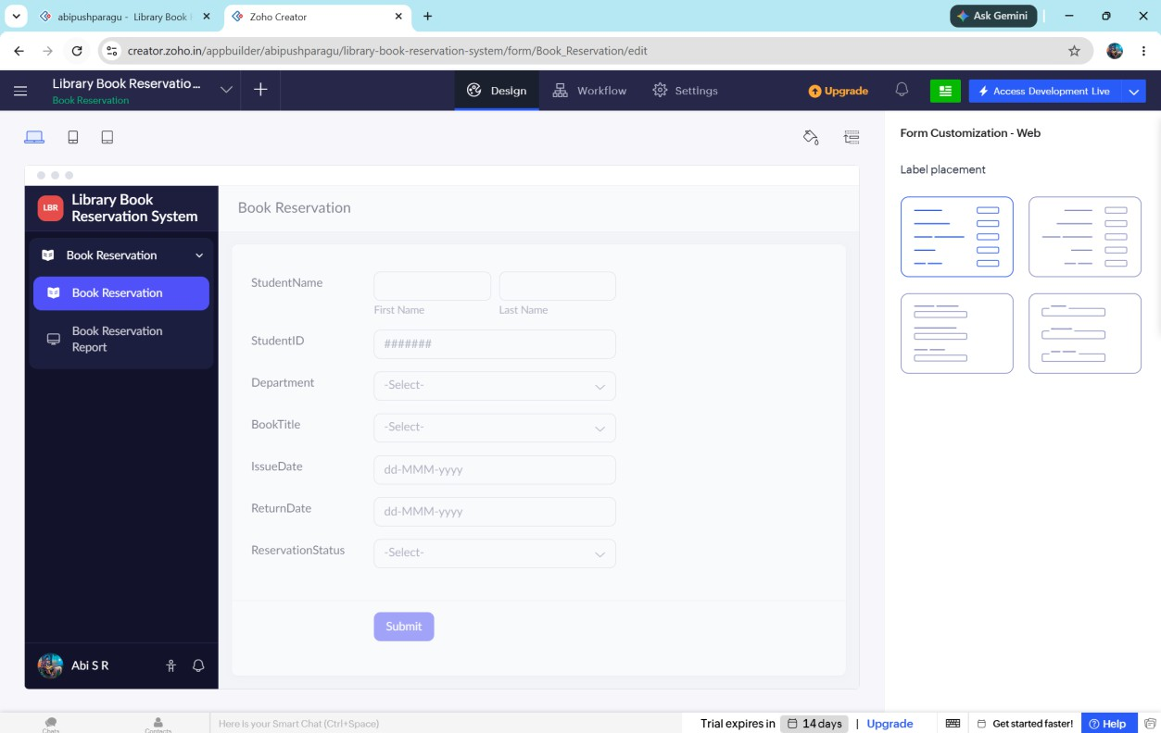

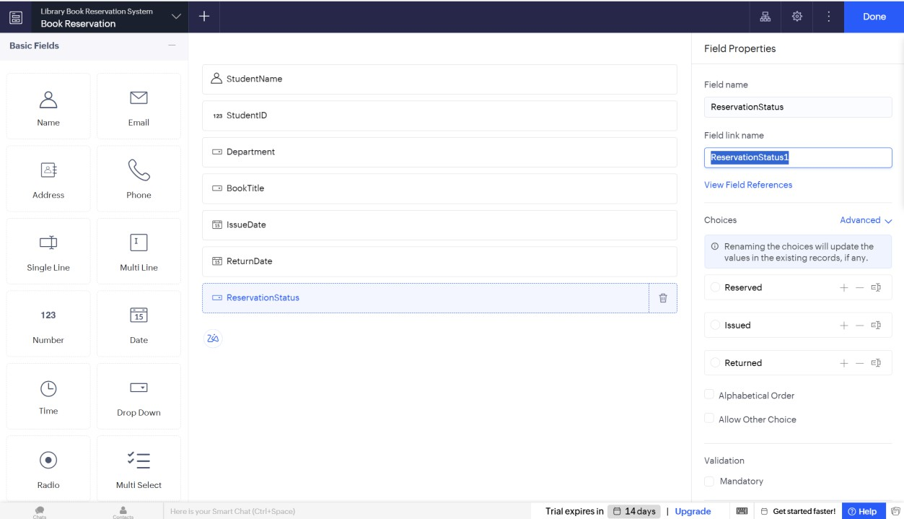
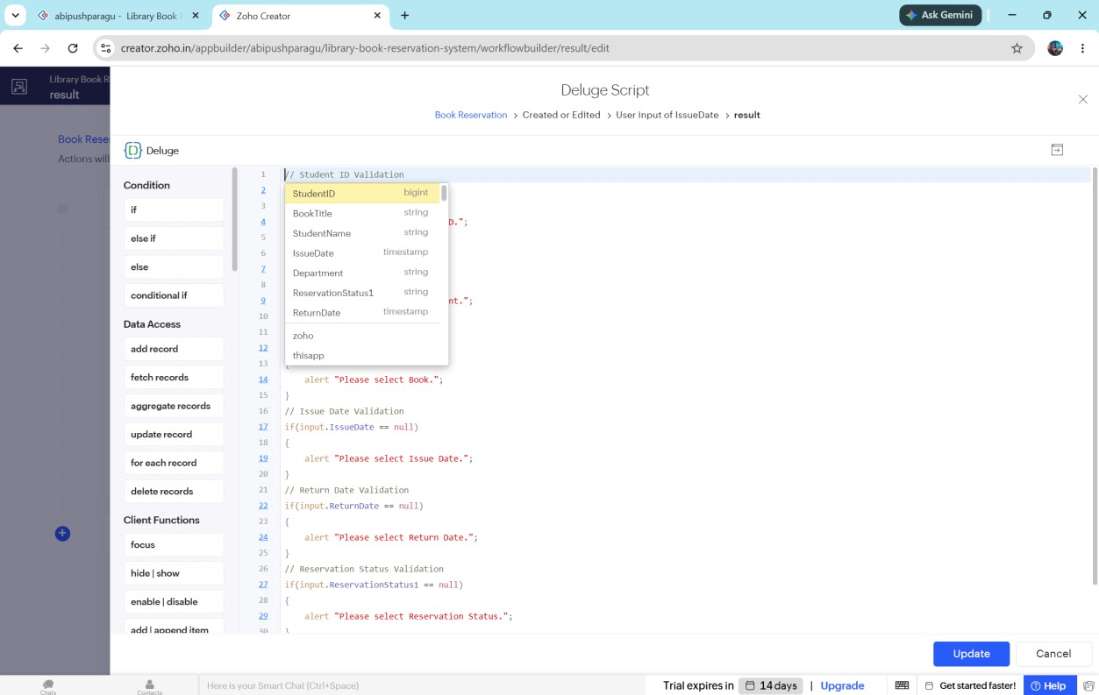

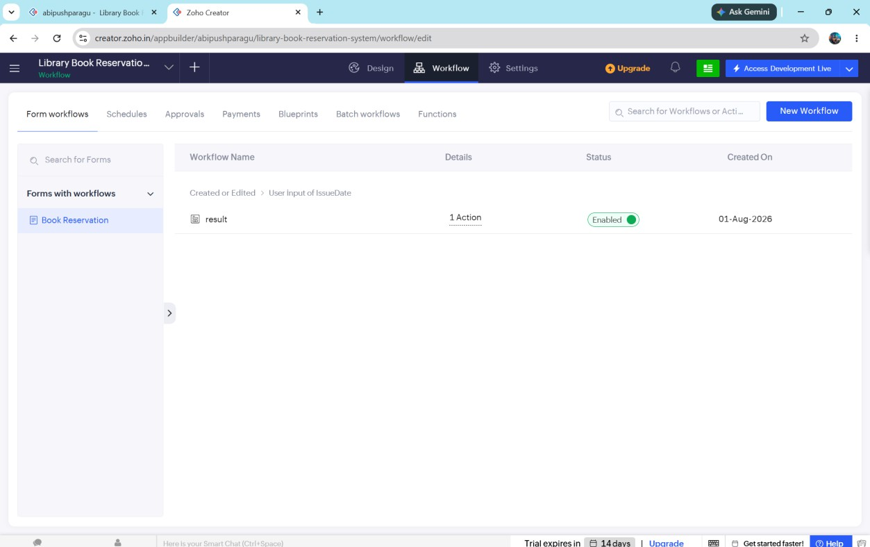
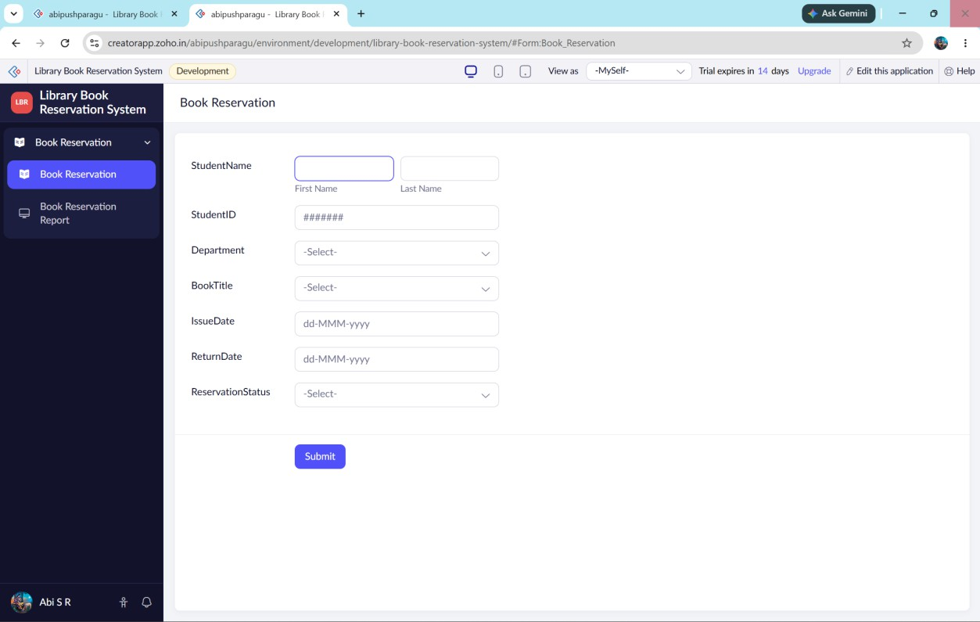

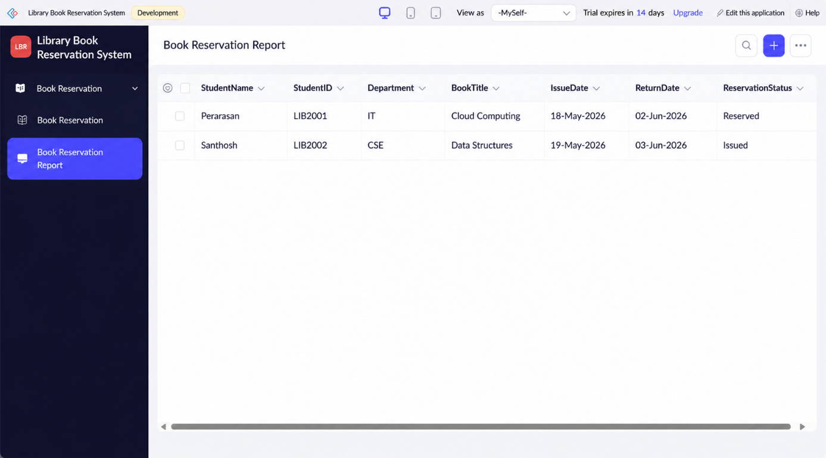

// Student ID if(input.StudentID == null)
{
alert "Please enter Student ID.";
}
// Department Validation if(input.Department == null)
{
alert "Please select Department.";
}

// Book Validation

if(input.BookTitle == null)
{
alert "Please select Book.";
}

// Issue Date Validation if(input.IssueDate == null)
{
alert "Please select Issue Date.";
}
// Return Date Validation if(input.ReturnDate == null)
{
alert "Please select Return Date.";
}

// Reservation Status Validation

if(input.ReservationStatus == null)
{
alert "Please select Reservation Status.";
}

// Success Message

info "Book Reserved Successfully.";

Result:
Thus, a simple cloud-based Library Book Reservation System for SIMATS Library was successfully developed using Zoho Creator. The application allows students to reserve library books online, stores reservation details securely in the cloud, and demonstrates the Software as a Service (SaaS) model.

