

CSA1560 - Cloud Computing and Big Data Analytics for Engineers

LAB Programs

Experiment-06

Presented by

VETRISELVAN K

(192511290)

Guided by

Dr. K. Sampath Kumar

EXP NO 6: CREATE A SIMPLE CLOUD SOFTWARE APPLICATION FOR PRODUCT SELLING USING ANY CLOUD SERVICE PROVIDER TO DEMONSTRATE SAAS.
DATE: 10.08.2026 AIM:
To create a simple cloud software application for product selling using any cloud service provider to demonstrate saas.
PROCEDURE:
step1: Go to zoho.com.
step 2: Log into the zoho.com. step 3: Select one application step.
step4: Enter application name as product selling. step 5: Created new application as product selling. step 6: Select one form
step 7: The software has been created. IMPLEMENTATION:
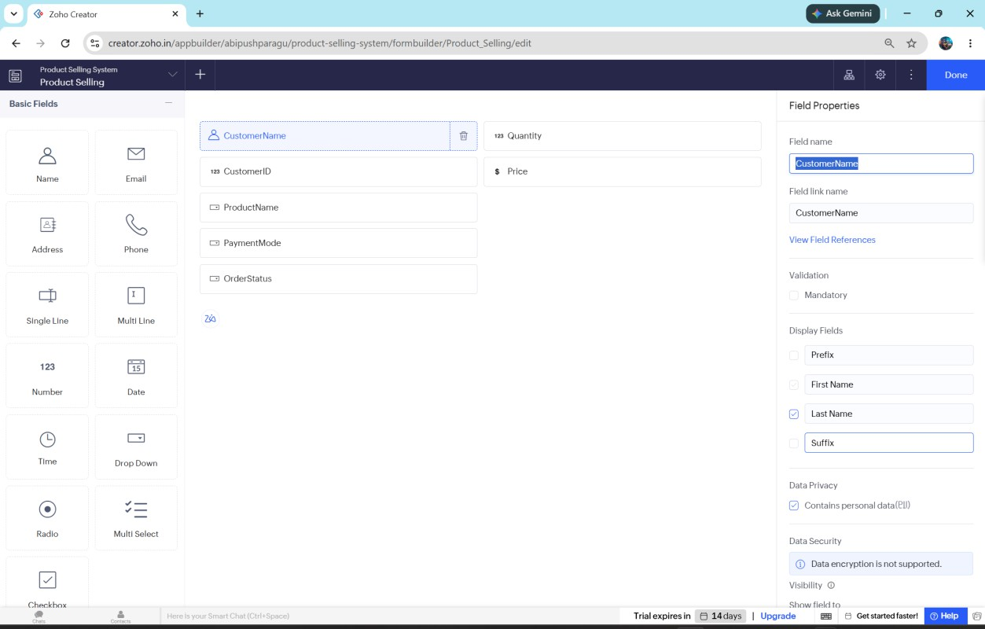

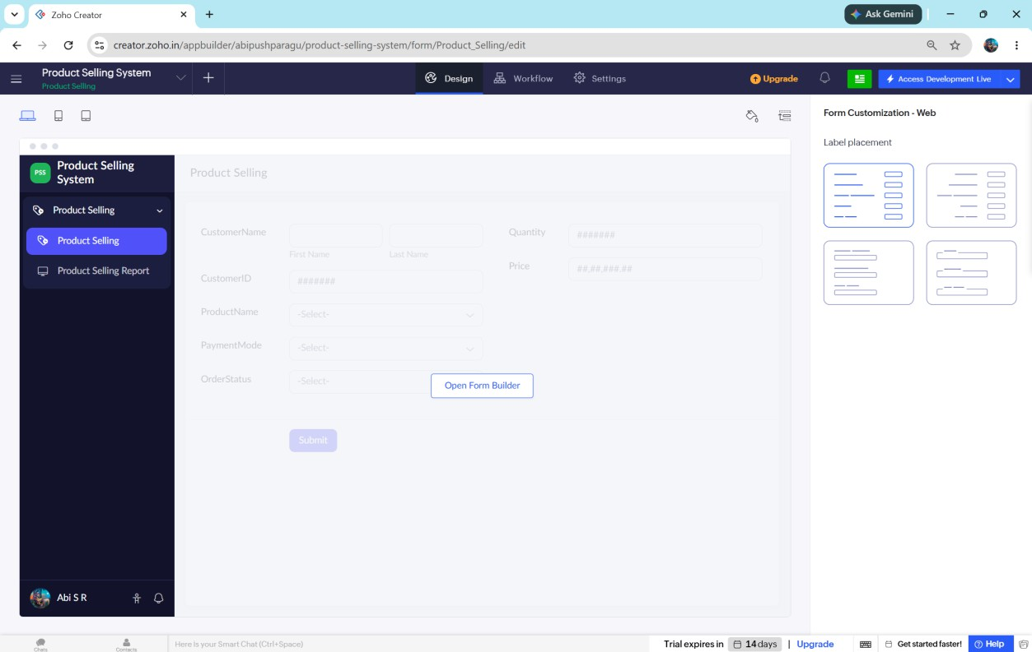
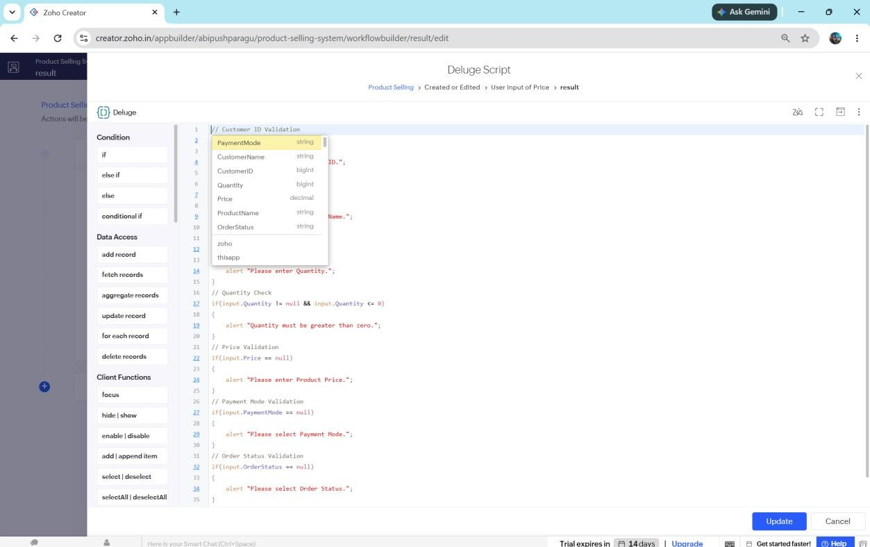

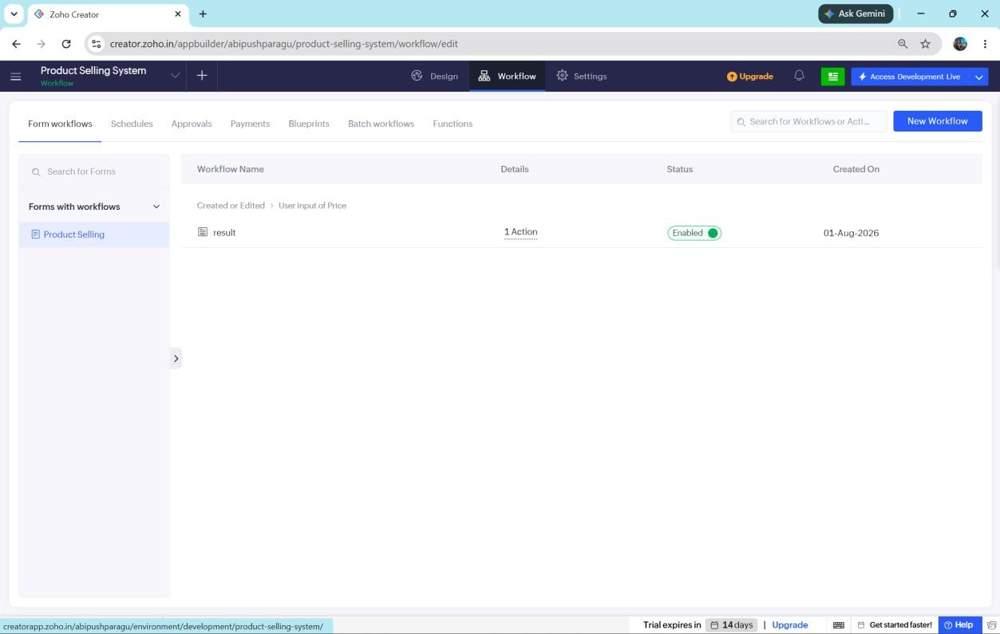
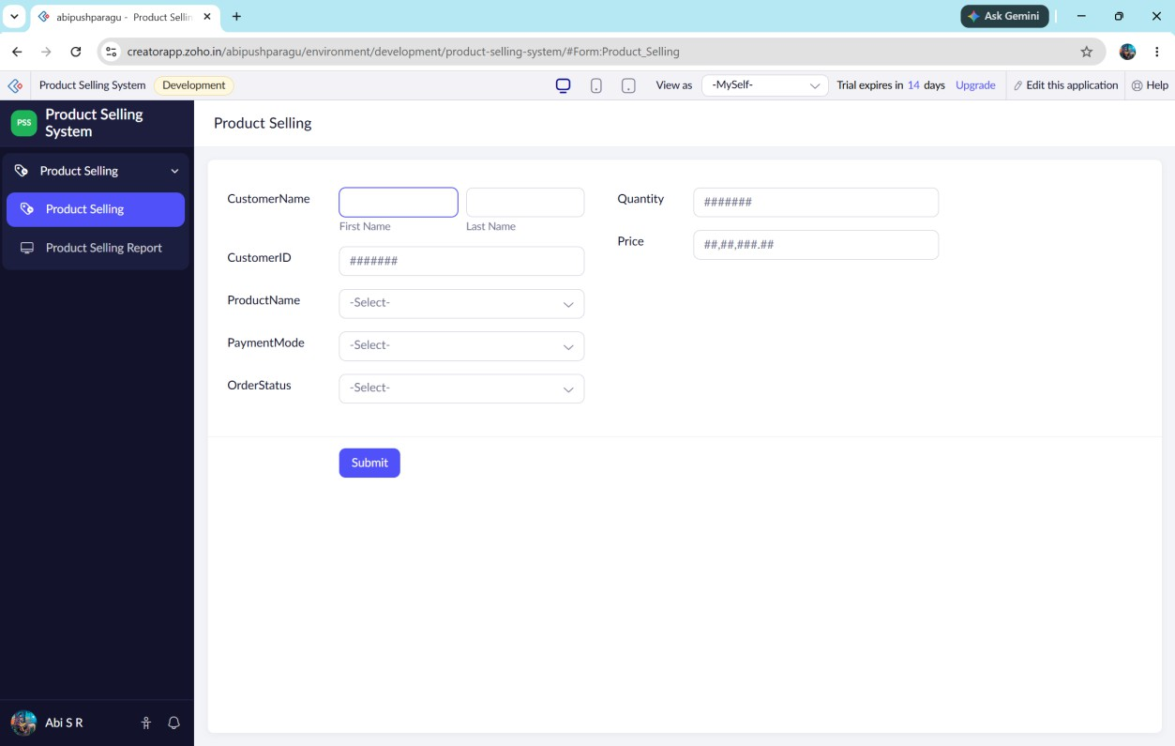

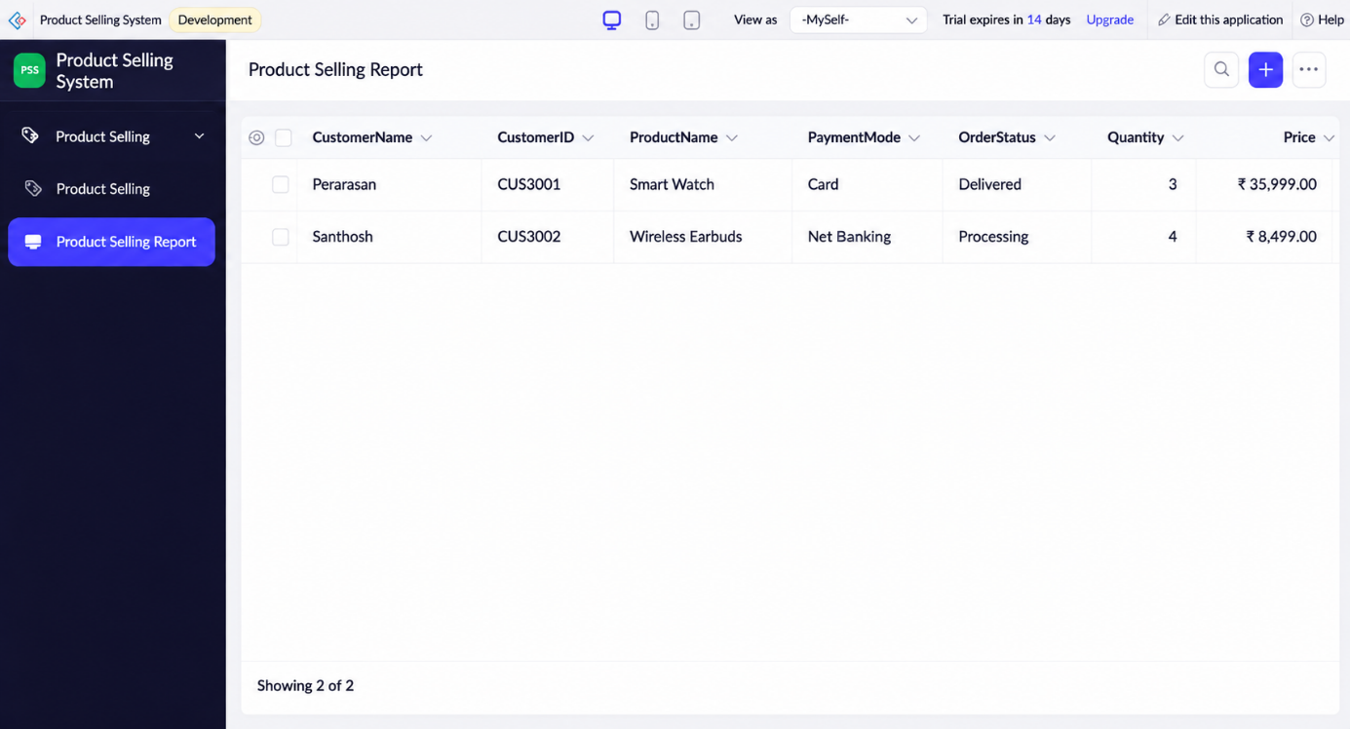
// Customer ID Validation

if(input.CustomerID == null)
{
alert "Please enter Customer ID.";
}

// Product Name Validation

if(input.ProductName == null)
{
alert "Please select Product Name.";
}

// Quantity Validation

if(input.Quantity == null)

{
alert "Please enter Quantity.";
}

// Quantity Check

if(input.Quantity != null && input.Quantity <= 0)
{
alert "Quantity must be greater than zero.";
}

// Price Validation

if(input.Price == null)
{
alert "Please enter Product Price.";
}

// Payment Mode Validation

if(input.PaymentMode == null)
{
alert "Please select Payment Mode.";
}

// Order Status Validation

if(input.OrderStatus == null)
{
alert "Please select Order Status.";

}

// Success Message

info "Product Order Submitted Successfully.";

Result:
Thus, a simple cloud-based Product Selling System was successfully developed using Zoho Creator. The application enables customers to purchase products online, stores order details securely in the cloud, and demonstrates the Software as a Service (SaaS) model.

