SIMATS ENGINEERING
ASSESSMENT TOOL 1

COURSE NAME: OBJECT ORIENTED ANALYSIS AND DESIGN
COURSE CODE: CSA1104

COURSE OUTCOME COVERED

CO2: Design UML diagrams to represent system requirements and architecture. (BL3)

Assessment Tool Weightage: 40%

QUESTIONS: Any 4 Total Marks:40

Annexure A

ANALYTICAL PROBLEM SOLVING

Code of Conduct:

I __K.Divya(192511316)__ (Name / Reg No) certify that this submission is my original work and that I have adhered to the guidelines specified for this assessment.
I understand that any violation of academic integrity rules will result in disciplinary action.

Signature of the student:
divya

Annexure A

ANALYTICAL PROBLEM SOLVING

1. Use Case Diagram Problem
A Hospital Management System allows patients to book appointments, doctors to update medical records, and administrators to manage hospital resources. The requirements are not clearly documented.
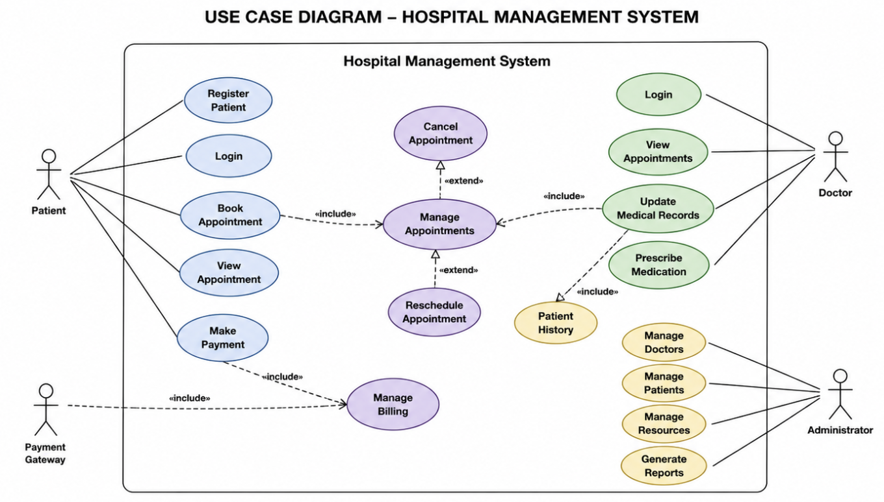

2. Class Diagram Problem
A Library Management System contains entities such as Book, Member, Librarian, and IssueRecord. The relationships among entities are not properly defined.
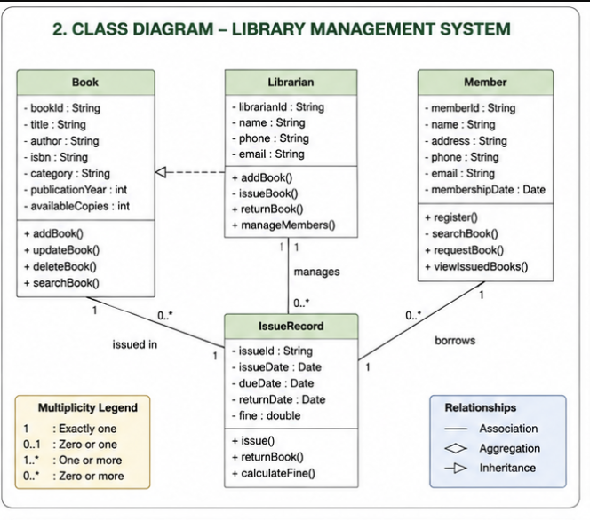

3. Sequence Diagram Problem
In an Online Food Ordering System, a customer selects food items, places an order, makes payment, and receives order confirmation. The interaction flow is unclear.

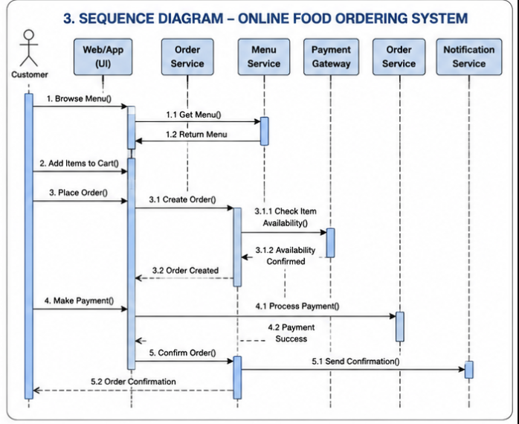

4. Activity Diagram Problem
A Student Admission System includes application submission, document verification, fee payment, and enrollment confirmation. The workflow lacks proper decision-making steps.

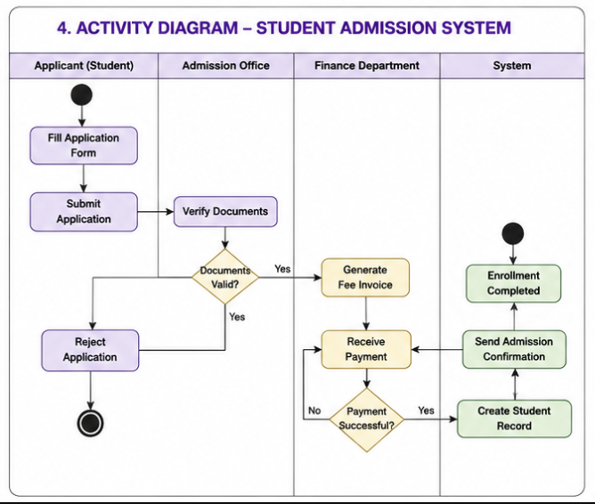

5. State Diagram Problem
A Vending Machine System operates through states such as Idle, Product Selected, Payment Received, Product Dispensed, and Transaction Completed.

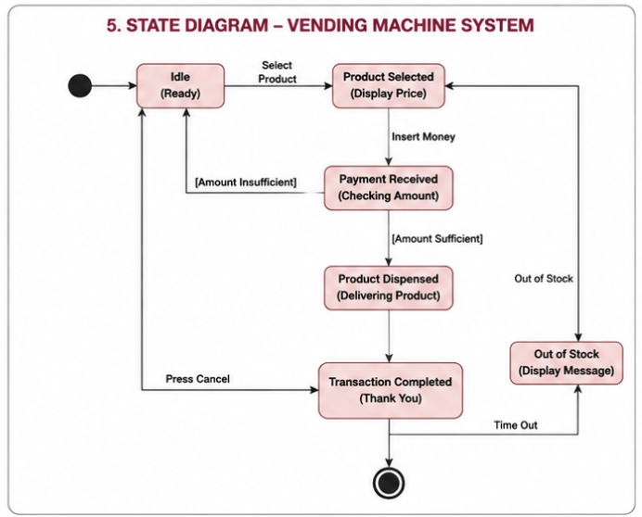

6. Component Diagram Problem
An Online Learning Platform consists of modules such as User Management, Course Management, Assessment Module, Content Delivery Module, and Notification Service.

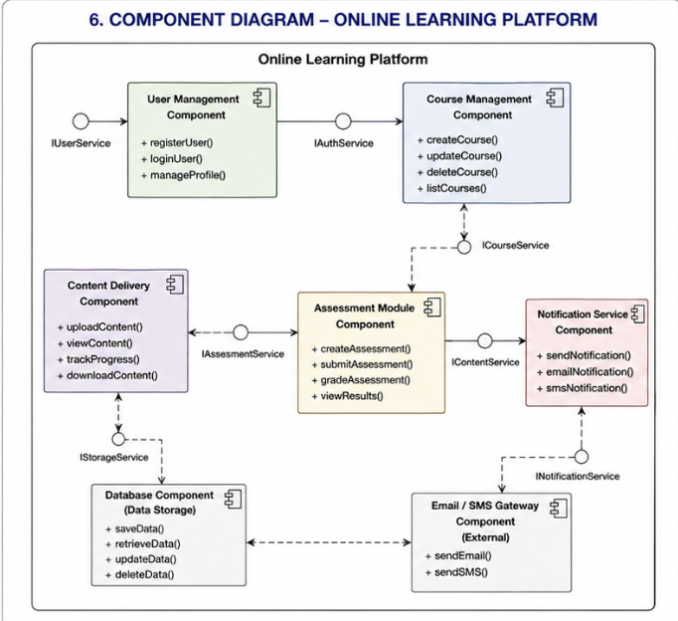

7. Deployment Diagram Problem
A Smart Traffic Monitoring System uses roadside sensors to collect vehicle data. The data is transmitted to a central cloud server where traffic authorities monitor congestion through a web dashboard. Alerts are generated during traffic violations and accidents.
