SIMATS ENGINEERING
ASSESSMENT TOOL 2

COURSE NAME: OBJECT ORIENTED ANALYSIS AND DESIGN
COURSE CODE: CSA1104

COURSE OUTCOME COVERED

CO2: Design UML diagrams to represent system requirements and architecture. (BL3)

Assessment Tool Weightage: 60%

QUESTIONS: 6 Total Marks:60

Annexure A

Application Based Questions

Code of Conduct:

I _K.Divya(192511316)____ (Name / Reg No) certify that this submission is my original work and that I have adhered to the guidelines specified for this assessment.
I understand that any violation of academic integrity rules will result in disciplinary action.

Signature of the student:
divya

Annexure A

Application Based Questions

1. Use Case Diagram Analysis
A Smart Hotel Reservation System allows guests to search rooms, make reservations, cancel bookings, and process payments. Managers handle room allocation and reports, while payment services process transactions. The current design does not clearly distinguish actor responsibilities.

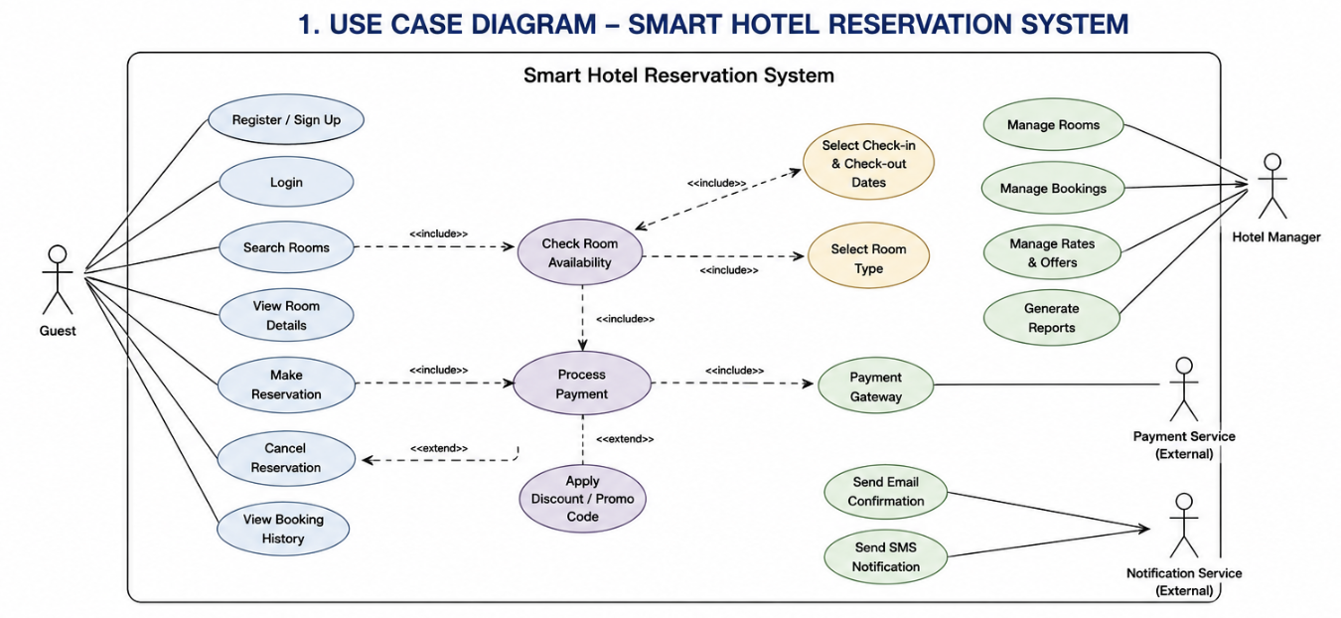

2. Class Diagram Design
A University Management System includes entities such as Student, Faculty, Course, Department, and Examination. The existing design lacks proper attributes, operations, and relationships among classes.
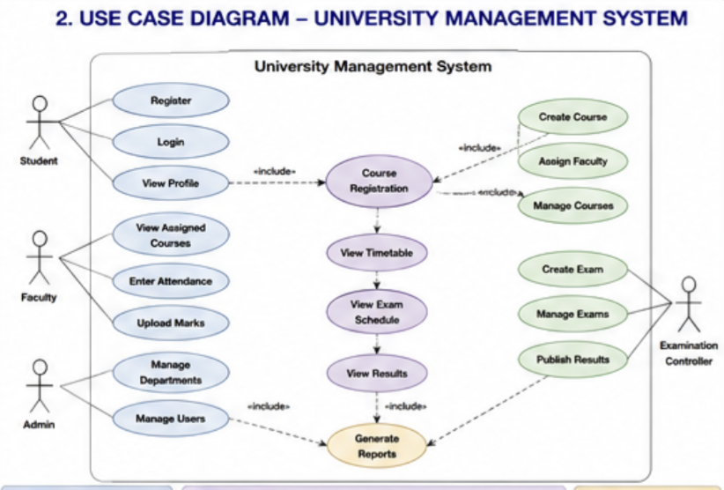

3. Sequence Diagram Evaluation
In a Vehicle Rental System, a customer searches for a vehicle, books it, makes payment, and receives a rental confirmation. The interaction among system components is incomplete and poorly documented.
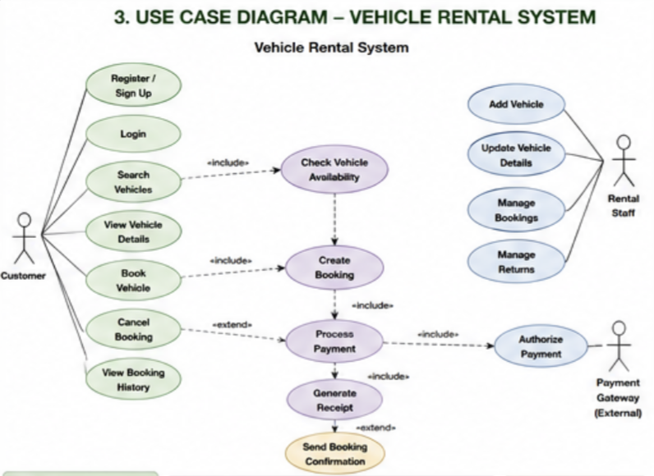

4. State Diagram Construction
A Traffic Signal Control System operates through states such as Red Signal, Green Signal, Yellow Signal, Emergency Mode, and Maintenance Mode. The transitions between states are not clearly defined.
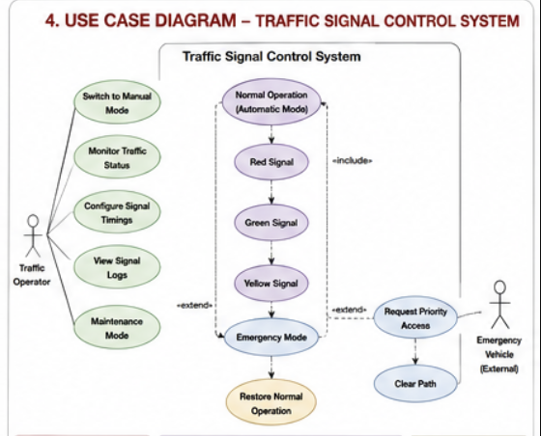

5. Component Diagram Design
A Smart Healthcare Portal consists of modules such as Patient Management, Appointment Scheduling, Medical Records, Billing, and Notification Services. The current architecture does not clearly define component interactions and dependencies.
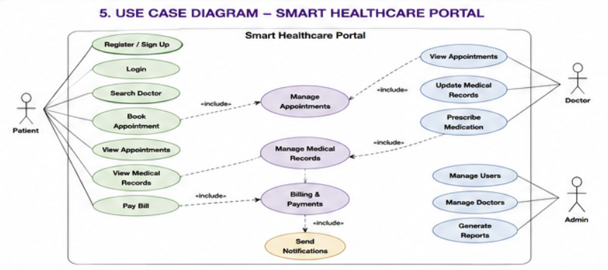

6. Deployment Diagram Design
A Smart City Waste Management System is deployed across IoT waste-bin sensors, edge devices, cloud servers, and monitoring dashboards. The current design lacks clarity regarding physical architecture and communication links.

