SIMATS ENGINEERING

ASSESSMENT TOOL 1

COURSE NAME: OBJECT ORIENTED ANALYSIS AND DESIGN COURSE CODE: CSA1104

COURSE OUTCOME COVERED

CO5: Analyze object-oriented software using quality assurance and usability testing Techniques (BL4,BL5)
Assessment Tool Weightage: 35%

QUESTIONS: 5 Total Marks:35

Annexure A

Constraint-Based Problem Solving

Code of Conduct:
I, Divya.K (192511316) (Name / Reg No) certify that this submission is my original work and that I have adhered to the guidelines specified for this assessment.
I understand that any violation of academic integrity rules will result in disciplinary action.

Signature of the student:
K.Divya

RUBRICS FOR CALCULATION:

Constraint-Based Problem Solving Assessment Rubric
Criteria | Weightag e | Level 4 (Exemplary) | Level 3 (Proficient) | Level 2 (Developing) | Level 1 (Beginning)
Problem Understanding | 25% | Clearly defines the problem and identifies all relevant constraints  accurately | Identifies most constraints with minor gaps | Partial understanding; misses key constraints | Fails to identify constraints correctly
Constraint Analysis | 25% | Analyzes constraints effectively and prioritizes them  logically | Provides reasonable analysis with some prioritization | Limited analysis; weak prioritization | No meaningful analysis or prioritization
Solution Development | 25% | Develops optimal and feasible solutions satisfying all  constraints | Develops workable solutions with minor limitations | Solutions partially satisfy constraints | Solutions do not meet constraints
Application of Concepts | 15% | Effectively applies appropriate concepts, methods, or  tools | Applies concepts with minor errors | Limited application; requires guidance | Unable to apply relevant concepts
Justification | 10% | Provides strong justification for decisions with logical  reasoning | Provides justification with some clarity | Weak or unclear justification | No justification provided

Annexure A

Constraint-Based Problem Solving

Q1. Scenario: Online Banking System

System Components:
Account Management, Fund Transfer, Bill Payment, Transaction History

Given Constraints:

- Transaction completion time < 2 seconds
- Multi-factor authentication required
- Support 5000+ concurrent users

Question:

Analyze the system using quality assurance techniques under the given constraints. Identify potential defects related to security, performance, and reliability. Propose suitable testing strategies and justify how they ensure system quality. (BL4)

Q2. Scenario: E-Commerce Shopping Application

System Features:
Product Search, Shopping Cart, Checkout, Payment Gateway

Usability Constraints:

- Checkout process within 3 steps
- Easy product navigation
- Responsive design for mobile and desktop devices

Question:

Apply usability testing techniques to evaluate the application. Identify usability challenges and recommend design improvements that satisfy the given constraints. Explain how the proposed changes improve customer satisfaction and efficiency. (BL4)

Q3. Scenario: Hospital Management System

Modules:
Patient Registration, Appointment Scheduling, Medical Records, Billing

QA Constraints:

- Patient data accuracy must be maintained
- System availability 24/7
- Simultaneous access by multiple departments

Question:

Use quality assurance practices to analyze the system. Identify critical test cases and discuss how the constraints influence testing priorities, defect prevention, and overall system reliability. (BL5)

Q4. Scenario: Smart Library Management System

Features:
Book Search, Book Reservation, Borrow/Return, Notifications

Usability Constraints:

- Search results displayed within 2 seconds
- Accessible interface for all age groups
- Minimal learning curve for first-time users

Question:

Conduct a usability evaluation using appropriate testing methods. Analyze how the given constraints impact interface design and recommend improvements to enhance usability and accessibility. (BL5)

Q5. Scenario: Airline Reservation System

Modules:
User Login, Flight Search, Seat Selection, Ticket Booking

QA & Usability Constraints:

- No booking duplication
- System must support peak holiday traffic
- Booking interface should be simple and error-free

Question:

Apply both quality assurance and usability testing techniques under the specified constraints. Identify major risks, propose suitable testing methods, and explain how the system can be optimized for reliability, performance, and user experience. (BL4)

Q1. Online Banking System Problem Understanding
The Online Banking System includes Account Management, Fund Transfer, Bill Payment, and Transaction History. The major constraints are that every transaction must be completed within 2 seconds, multi-factor authentication must be implemented, and the system must support more than 5000 concurrent users.
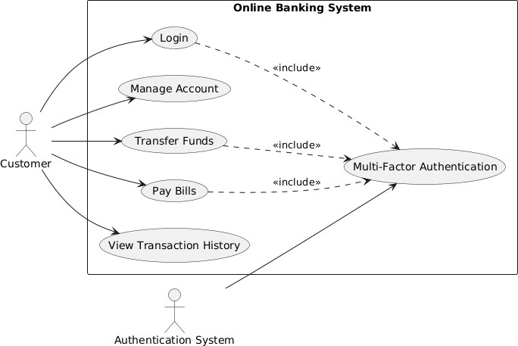

Constraint Analysis

The most critical constraints are security, performance, and reliability. Security has the highest priority because banking applications handle sensitive financial information.
Performance is also important because delays during fund transfer or payment can affect customer trust. The system must also remain stable when thousands of users access it simultaneously.

Potential Defects

Possible defects include:

- Unauthorized access due to authentication failure.
- Duplicate or incorrect fund transfers.
- Slow transaction processing during peak usage.
- Incorrect transaction history.
- Session timeout or server failure during payment.
- Failure of OTP or multi-factor authentication.

- Data inconsistency when many users perform transactions simultaneously.

Testing Strategies

- Security Testing:
Penetration testing, authentication testing, authorization testing, and session management testing should be performed. Multi-factor authentication must be verified for every sensitive transaction.

Performance Testing:
Load testing should simulate 5000 or more concurrent users. Response-time testing must confirm that transactions are completed within 2 seconds.

Stress Testing:
The system should be tested beyond the expected user load to determine its breaking point and recovery capability.

Functional Testing:
Fund transfer, bill payment, account balance updates, and transaction history should be tested using valid and invalid inputs.

Reliability and Recovery Testing:
Server failure, network interruption, and transaction recovery scenarios should be tested to ensure that incomplete transactions do not cause loss or duplication of data.

Justification

These testing strategies ensure confidentiality, integrity, availability, and consistent performance of the banking system. Security testing prevents unauthorized access, while performance and load testing ensure that the system satisfies the 2-second response-time requirement even with more than 5000 users. Reliability testing prevents transaction loss and improves customer trust.

Q2. E-Commerce Shopping Application Problem Understanding
The E-Commerce Shopping Application provides Product Search, Shopping Cart, Checkout, and Payment Gateway features. The usability constraints require checkout to be completed within three steps, easy product navigation, and responsive design for both mobile and desktop devices.

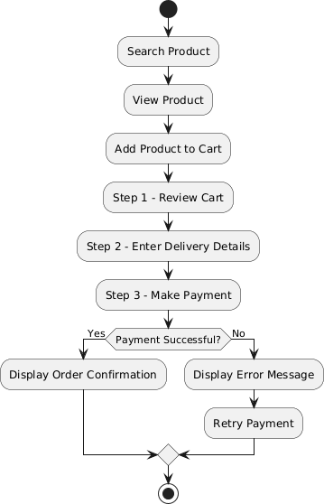

Usability Challenges

The major usability problems that may occur are:

- Complicated product navigation.
- Too many checkout screens.
- Poor visibility of cart and checkout buttons.

- Difficult product filtering and searching.
- Small buttons or text on mobile devices.
- Improper page layout on different screen sizes.
- Confusing error messages during checkout.
- Slow or unclear payment confirmation.

Usability Testing Techniques

- Task-Based Testing:
Users should be asked to search for a product, add it to the cart, and complete a purchase. The number of steps, completion time, and errors should be recorded.

Think-Aloud Testing:
Users explain what they are thinking while navigating the website. This helps identify confusing menus, buttons, and instructions.

Responsive Testing:
The interface should be tested on mobile phones, tablets, laptops, and desktop systems with different screen sizes.

A/B Testing:
Different versions of checkout buttons, menus, and page layouts can be compared to identify the design that users find easier.

User Satisfaction Testing:
Questionnaires and feedback forms can be used to measure satisfaction, ease of use, and overall experience.

Recommended Design Improvements

  - Limit checkout to three clear stages: Cart, Delivery Details, and Payment.
  - Provide a visible search bar with filters and sorting options.
  - Use simple categories and breadcrumb navigation.
  - Use large and clearly labelled buttons.
  - Provide responsive layouts for mobile and desktop screens.
  - Display clear validation and error messages.
  - Provide order summary before final payment.
  - Reduce unnecessary form fields during checkout.

Justification

These improvements reduce the time and effort required to complete a purchase. A three-step checkout minimizes user confusion and cart abandonment. Responsive design provides consistent usability across devices, while simple navigation allows customers to locate products quickly. Therefore, the proposed changes improve customer satisfaction, efficiency, and overall shopping experience.

Q3. Hospital Management System Problem Understanding
The Hospital Management System contains Patient Registration, Appointment Scheduling, Medical Records, and Billing modules. The major constraints are maintaining accurate patient data, providing 24/7 system availability, and allowing simultaneous access by multiple departments.
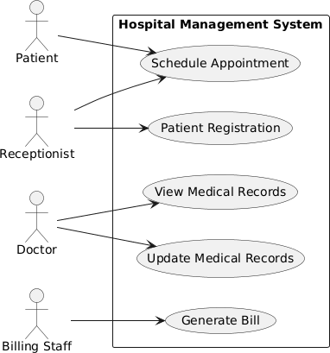

Constraint Analysis and Testing Priorities

Patient data accuracy receives the highest priority because incorrect medical information can affect diagnosis and treatment. Continuous system availability is also essential because hospitals operate throughout the day. Concurrent access must be tested because doctors, nurses, receptionists, laboratories, and billing departments may use the system simultaneously.

Critical Test Cases

Test Case 1: Patient Registration

  - Enter valid patient information.
  - Verify that the patient record is created correctly.
  - Check duplicate patient detection.

Test Case 2: Invalid Patient Data

  - Enter missing or incorrect details.
  - Verify that appropriate validation messages are displayed.

Test Case 3: Appointment Scheduling

  - Book an available appointment.
  - Verify that the same time slot cannot be assigned incorrectly to multiple patients.

Test Case 4: Medical Record Access

  - Verify that authorized doctors can access patient records.
  - Confirm that unauthorized users cannot modify sensitive information.

Test Case 5: Concurrent Access

  - Allow multiple departments to access the same patient record.
  - Verify that data remains consistent.

Test Case 6: Billing

  - Generate bills based on hospital services.
  - Verify calculation accuracy and payment status.

Test Case 7: Availability

  - Test server and database operation continuously.
  - Verify automatic recovery after system failure.

Quality Assurance Practices

  - Functional testing for each module.
  - Database testing for patient data accuracy.
  - Load and concurrency testing for simultaneous departmental access.
  - Security and access-control testing for medical records.
  - Backup and recovery testing.
  - Regression testing after system updates.
  - Continuous monitoring for availability and performance.

Defect Prevention

Input validation should prevent incorrect patient information. Role-based access control should prevent unauthorized modifications. Automated backups should protect records from data loss. Code reviews and regular regression testing should identify defects before deployment.

Justification

The testing priorities are directly influenced by the system constraints. Data accuracy testing protects patient safety, availability testing ensures uninterrupted hospital operations, and concurrency testing maintains consistency when several departments use the system simultaneously. These QA practices improve reliability, reduce operational errors, and provide dependable healthcare information.

Q4. Smart Library Management System Problem Understanding
The Smart Library Management System provides Book Search, Book Reservation, Borrow/Return, and Notification services. The usability constraints require search results to appear within 2 seconds, the interface to be accessible to all age groups, and the system to have a minimal learning curve for first-time users.
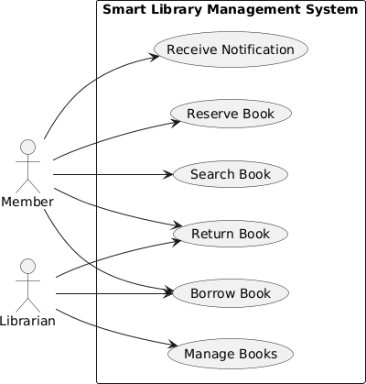

Usability Evaluation Methods

- Task-Based Usability Testing:
Users should perform activities such as searching for a book, reserving it, and checking borrowing details. Completion time and errors should be observed.

Think-Aloud Method:
Users explain their thoughts while using the system. This helps identify confusing labels, menus, and navigation.

Accessibility Testing:
The interface should be evaluated for readable text, keyboard navigation, suitable contrast, and clear labels.

Performance Testing:
Book search operations should be measured to ensure results are displayed within 2 seconds.

User Feedback:
Students, staff, elderly users, and first-time users can provide feedback about ease of use and accessibility.

Impact of Constraints on Interface Design

The 2-second search constraint requires efficient search algorithms and optimized database queries. Accessibility for all age groups requires simple language, readable fonts, clear icons, and uncomplicated navigation. A minimal learning curve requires the interface to remain consistent and predictable.

Recommended Improvements

  - Provide a clearly visible search bar on the home page.
  - Add filters based on title, author, category, and availability.
  - Use simple and familiar icons with text labels.
  - Maintain readable font sizes and good visual contrast.
  - Provide keyboard navigation.
  - Show clear confirmation after reservation or return.
  - Provide simple instructions for first-time users.
  - Display book availability directly in search results.
  - Optimize search queries to return results within 2 seconds.

Justification

The proposed improvements make the library system easier for users of different ages and technical abilities. Faster search improves efficiency, while accessible controls allow more people to use the system independently. Simple navigation reduces training requirements and enables first-time users to learn the system quickly.

Q5. Airline Reservation System Problem Understanding
The Airline Reservation System includes User Login, Flight Search, Seat Selection, and Ticket Booking. The major constraints are preventing booking duplication, supporting heavy traffic during holidays, and providing a simple and error-free booking interface.

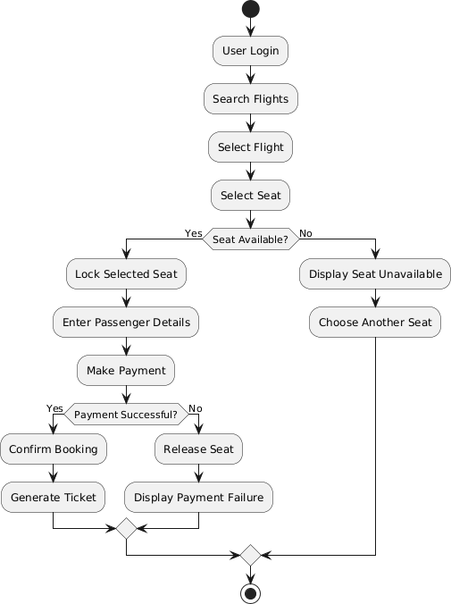

Major Risks

The major risks include:

  - Duplicate booking of the same seat.
  - Payment failure after seat reservation.
  - Incorrect flight or passenger information.
  - Server overload during peak holiday traffic.
  - Slow flight search and booking.
  - Session failure during payment.
  - Confusing seat-selection interface.
  - Incorrect fare calculation.
  - Poor error messages.
  - Loss of booking data during system failure.

Quality Assurance Testing Techniques

- Functional Testing:
Verify login, flight search, seat selection, fare calculation, payment, and ticket generation.

Concurrency Testing:
Multiple users should attempt to reserve the same seat simultaneously. The system must allow only one successful booking.

Load Testing:
Simulate a large number of users during peak periods to verify system performance.

Stress Testing:
Increase traffic beyond normal limits to identify the maximum capacity and recovery behaviour of the system.

Database Testing:
Verify that seat availability, passenger details, payment information, and booking records remain accurate.

Recovery Testing:
Simulate server, database, and network failures during booking and ensure that the system restores safely without creating duplicate bookings.

Usability Testing Techniques

  - Task-based testing for flight search and booking.
  - Think-aloud testing to identify confusing booking steps.
  - Responsive testing for mobile and desktop devices.
  - User feedback and satisfaction surveys.
  - Error-message evaluation.

System Optimization

The system can be optimized by:

  - Applying database locking or transaction control during seat booking.
  - Using load balancing during peak traffic.
  - Optimizing flight-search database queries.
  - Providing real-time seat availability.
  - Using a simple step-by-step booking interface.
  - Displaying a booking summary before payment.
  - Providing clear error and confirmation messages.
  - Automatically releasing seats when payment fails or sessions expire.

Justification

Concurrency and database testing prevent duplicate seat allocation. Load and stress testing ensure that the system continues functioning during peak holiday traffic. Recovery testing prevents loss or corruption of booking information. Usability testing simplifies the booking process and reduces user errors. Therefore, combining quality assurance and usability testing improves system reliability, performance, accuracy, and customer experience.

