SIMATS ENGINEERING ASSESSMENT TOOL 3

COURSE NAME: OBJECT ORIENTED ANALYSIS AND DESIGN COURSE CODE: CSA1104

COURSE OUTCOME COVERED

CO5: Analyze object-oriented software using quality assurance and usability testing techniques. ( BL4,BL5)
Assessment Tool Weightage: 40%

QUESTIONS: 05 Total Marks:40

Annexure A

MOCK INTERVIEW

Code of Conduct:

I Divya.K(192511316) (Name / Reg No) certify that this submission is my original work and that I have adhered to the guidelines specified for this assessment.
I understand that any violation of academic integrity rules will result in disciplinary action.

Signature of the student:
Divya.k

Annexure A

Mock Interview – Sample Questions (5 Questions)

Mock Interview Test Format for Object Oriented Analysis and Design (OOAD)

Section A | Self Introduction & Fundamentals | 3 Minutes | 5
Section B | Technical Questions (OOAD Concepts) | 7 Minutes | 10
Section C | UML Modeling & Design | 7 Minutes | 10
Section D | Case Study / Problem Solving | 8 Minutes | 10
Section E | HR & Career-Oriented Questions | 5 Minutes | 5

SECTION A – SELF INTRODUCTION (5 Marks)

Evaluation Criteria

- Communication Skills
- Confidence
- Technical Awareness
- Academic Background

Sample Questions

- Tell me about yourself.
- Why did you choose Computer Science?
- Explain your favorite subject in OOAD.
- What software development tools have you used?
- Describe a project where you applied object-oriented concepts.

SECTION B – TECHNICAL QUESTIONS (15 Marks)

Basic Level

Q1. What is Object-Oriented Analysis and Design?

Q2. Differentiate between Analysis and Design.

Q3. Explain Encapsulation with an example.

Q4. What is Inheritance? Mention its types.

Q5. Define Polymorphism and its benefits.

Q6. What is Abstraction?

Q7. Difference between Aggregation and Composition.

Q8. What is Coupling and Cohesion?

Q9. What is a Class and an Object?

Q10.Explain Object Responsibility.

SECTION C – UML MODELING (15 Marks)

Q11.What is UML?

Q12.When would you use a Use Case Diagram?

Q13.Draw and explain a Class Diagram for a Library Management System.

Q14.Differentiate Sequence Diagram and Activity Diagram.

Q15.Explain State Diagram with an example.

Q16.What is a Deployment Diagram?

Q17.How do Component Diagrams help software architects?

Q18.What is Multiplicity in UML?

SECTION D – CASE STUDY / PROBLEM SOLVING (10 Marks)

Case Study 1

A hospital wants a system to manage:

- Patients
- Doctors
- Appointments
- Billing

Questions

- Identify the classes.
- Draw a simple class diagram.
- Suggest relationships among classes.
- Which UML diagrams would you use for analysis?
- Explain how inheritance can be applied.

Case Study 2

An Online Shopping System supports:

  - Customers
  - Products
  - Cart
  - Orders
  - Payments

Questions

- Identify actors and use cases.
- Design a use case diagram.
- Suggest suitable design patterns.
- Explain how polymorphism can be used in payment processing.

SECTION E – HR & PROFESSIONAL QUESTIONS (5 Marks)

Q19.Why should we hire you?

Q20.What are your strengths and weaknesses?

Q21.How do you handle project deadlines?

Q22.Have you worked in a team project? Explain your role.

Q23.Where do you see yourself in five years?

RUBRICS FOR CALCULATION:
MOCK INTERVIEW

Criteria | Wei ghta ge | Level 4 (Exemplary) | Level 3 (Proficient) | Level 2 (Developing) | Level 1 (Beginning)
Technical Knowledge | 25 | Demonstrates strong and accurate subject knowledge with in-depth  understanding | Shows good knowledge with minor gaps | Basic knowledge with noticeable errors | Lacks fundamental technical knowledge
Problem Solving | 25 | Solves problems logically and applies concepts effectively in real  scenarios | Applies concepts with moderate accuracy | Limited problem-solving ability; requires  guidance | Unable to solve or apply concepts
Analytical Thinking | 15 | Analyzes questions critically and provides well-structured, logical  answers | Provides reasonable analysis with some  structure | Superficial or partially structured responses | No analytical thinking demonstrated
Communicati on | 15 | Communicates clearly, confidently, and professionally with  proper terminology | Communicat es well with minor hesitation | Communicatio n lacks clarity or confidence | Unable to communicate effectively
Confidence | 15 | Displays high confidence, positive attitude, and professional behavior  throughout | Shows good confidence with minor issues | Low confidence; inconsistent behavior | Lacks confidence and professionalism
Response to Questions | 10 | Responds accurately, promptly, and elaborates with  relevant examples | Responds correctly but with limited depth | Partial responses; needs prompting | Unable to respond appropriately

SECTION A – SELF INTRODUCTION

Tell me about yourself.
I am a Bioinformatics engineering student with a strong interest in software development, data analysis, and object-oriented programming. I enjoy learning how software systems are designed and modeled before implementation. Through OOAD, I have gained knowledge of object-oriented concepts such as classes, objects, inheritance, encapsulation, abstraction, and polymorphism. I have also worked with UML diagrams to represent software systems clearly. My goal is to continuously improve my technical and problem-solving skills and apply them to real-world applications.

Why did you choose Computer Science?
I chose to learn Computer Science because it provides the ability to solve real-world problems using logical thinking and technology. Programming, databases, software design, and artificial intelligence can also be applied effectively in Bioinformatics. Learning Computer Science helps me combine biological knowledge with computational techniques to develop useful and efficient solutions.

Explain your favorite subject in OOAD.
My favorite topic in OOAD is UML modeling because it provides a visual representation of a software system before implementation. UML diagrams such as use case, class, sequence, activity, state, component, and deployment diagrams help us understand the structure and behavior of a system. They also improve communication between developers, designers, and users.

What software development tools have you used?
I have used tools such as Visual Studio Code for programming, MySQL for database management, GitHub for version control and project management, and UML modeling tools such as Umbrello and draw.io. These tools help in designing, developing, testing, documenting, and maintaining software applications.

Describe a project where you applied object-oriented concepts.
I worked on software projects where the system was divided into objects representing real-world entities. For example, in a management system, entities such as User, Admin, Dataset, and Request can be represented as classes. Encapsulation protects the data of each class, inheritance allows common properties to be reused, and polymorphism provides different implementations of common operations. This approach makes the software modular, reusable, and easier to maintain.

SECTION B – TECHNICAL QUESTIONS

Q1. What is Object-Oriented Analysis and Design?
Object-Oriented Analysis and Design (OOAD) is a software development approach in which a system is analyzed and designed using objects and classes.
Object-Oriented Analysis (OOA) focuses on identifying the requirements, objects, and relationships in the problem domain.
Object-Oriented Design (OOD) converts these requirements into a software design by defining classes, methods, attributes, and interactions.
OOAD improves modularity, reusability, maintainability, and scalability.

Q2. Differentiate between Analysis and Design.
Analysis | Design
Focuses on what the system should do. | Focuses on how the system should work.
Identifies requirements. | Defines the solution.
Identifies objects and use cases. | Defines classes, methods, and architecture.
Problem-oriented. | Solution-oriented.
Performed before design. | Performed after analysis.

Q3. Explain Encapsulation with an example.
Encapsulation is the process of combining data and the methods that operate on that data into a single unit called a class. It also restricts direct access to sensitive data.
Example: A BankAccount class can keep balance as a private attribute and provide methods such as deposit() and withdraw() to access or modify it.
Thus, encapsulation provides data security, controlled access, and maintainability.

Q4. What is Inheritance? Mention its types.
Inheritance is an object-oriented concept in which one class acquires the attributes and methods of another class.
The existing class is called the parent/superclass, while the new class is called the child/subclass.
Types of inheritance:
- Single inheritance
- Multiple inheritance
- Multilevel inheritance
- Hierarchical inheritance
- Hybrid inheritance
Example: Doctor and Patient can inherit common properties such as name, age, and contact details from a Person class.

Q5. Define Polymorphism and its benefits.
Polymorphism means one interface with multiple forms or implementations. It allows the same method or operation to behave differently depending on the object.

For example, a makePayment() operation can work differently for Credit Card, UPI, and Net Banking payments.
Benefits:
  - Improves flexibility.
  - Promotes code reuse.
  - Reduces code duplication.
  - Makes systems easier to extend and maintain.

Q6. What is Abstraction?
Abstraction is the process of hiding unnecessary implementation details and displaying only essential features to the user.
For example, when a user performs an ATM withdrawal, the user only enters the amount and receives cash. Internal processes such as account verification and transaction processing are hidden.
Abstraction reduces complexity and improves software security and usability.

Q7. Difference between Aggregation and Composition.
Aggregation | Composition
Represents a weak HAS-A relationship. | Represents a strong HAS-A relationship.
Objects can exist independently. | Child object depends on parent object.
Uses a hollow diamond in UML. | Uses a filled diamond in UML.
Example: Department–Professor. | Example: House–Room.

Q8. What is Coupling and Cohesion?
Coupling represents the level of dependency between different modules or classes. Lower coupling is preferred because changes in one module have less impact on other modules. Cohesion represents how closely related the responsibilities within a module are. Higher cohesion is preferred because a class should perform a focused set of related tasks.
A good software design generally follows:
Low Coupling + High Cohesion = Better Maintainability

Q9. What is a Class and an Object?
A class is a blueprint or template that defines the attributes and methods of a particular type of entity.
An object is an instance of a class. For example:
Student is a class containing attributes such as name and register number. Student1 is an object created from the Student class.
Therefore, the class defines the structure while the object represents an actual entity.

Q10. Explain Object Responsibility.
Object responsibility refers to the tasks or duties assigned to an object in an object-oriented system.
Responsibilities mainly include:
  - Knowing information about itself.
  - Performing specific operations.
  - Communicating with other objects.
For example, an Order object may be responsible for calculating the total price, updating order status, and storing order information.
Clearly assigning responsibilities improves modularity and maintainability.

SECTION C – UML MODELING

Q11. What is UML?
UML stands for Unified Modeling Language. It is a standardized visual modeling language used to analyze, design, and document object-oriented software systems.
UML diagrams can represent both the structural and behavioral aspects of a system. Common UML diagrams include:
  - Use Case Diagram
  - Class Diagram
  - Sequence Diagram
  - Activity Diagram
  - State Diagram
  - Component Diagram
  - Deployment Diagram
UML improves communication and provides a clear blueprint before software implementation.

Q12. When would you use a Use Case Diagram?
A Use Case Diagram is mainly used during requirement analysis to represent the functional requirements of a system from the user's perspective.
It identifies:
  - Actors interacting with the system.
  - Use cases representing system functions.
  - Relationships between actors and use cases.
For example, in a Library Management System, the actor Member can perform use cases such as Search Book, Borrow Book, Return Book, and Pay Fine.

Q13. Draw and explain a Class Diagram for a Library Management System.
The main classes can be:
Library
  - libraryId
  - name
  - addBook() Book
  - bookId
  - title
  - author
  - status
  - checkAvailability() Member
  - memberId
  - name
  - borrowBook()
  - returnBook() Librarian
  - librarianId
  - name
  - addBook()
  - removeBook() Transaction
  - transactionId
  - issueDate
  - returnDate
  - createTransaction() Relationships:
  - Library contains Books.
  - Member borrows Books.
  - Librarian manages Books.
  - Transaction records borrowing and returning activities.

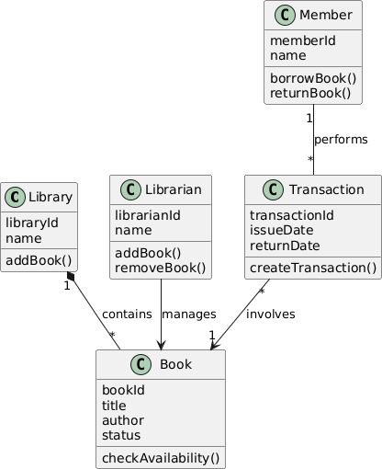

Q14. Differentiate Sequence Diagram and Activity Diagram.
Sequence Diagram | Activity Diagram
Shows interactions between objects. | Shows workflow of activities.
Focuses on message sequence. | Focuses on control flow.
Time progresses from top to bottom. | Uses actions and decision nodes.
Used to understand object communication. | Used to understand business processes.
Example: Login interaction. | Example: Order processing workflow.

Q15. Explain State Diagram with an example.
A State Diagram represents the different states of an object and the transitions between those states caused by events.
For example, an order may have the following states:
New → Confirmed → Shipped → Delivered
If the user cancels the order before shipping, its state can change to Cancelled.
State diagrams are useful when the behavior of an object depends strongly on its current state.

Q16. What is a Deployment Diagram?
A Deployment Diagram is a UML structural diagram that represents the physical deployment of software components on hardware nodes.
It shows:
  - Servers
  - Client devices
  - Databases
  - Software artifacts
  - Communication connections For example:
Client Device → Web Server → Application Server → Database Server
It helps developers understand the physical architecture and execution environment of the software.

Q17. How do Component Diagrams help software architects?
Component Diagrams represent the organization and dependencies of software components. They help architects:
  - Divide large systems into modules.
  - Identify component dependencies.
  - Understand interfaces between components.
  - Improve maintainability.
  - Support component reuse.
  - Plan system integration.
For example, an e-commerce system may contain User Management, Product Management, Payment, and Order components.

Q18. What is Multiplicity in UML?
Multiplicity specifies the number of instances of one class that can be associated with another class.
Common multiplicities are:
  - 1 – Exactly one
  - 0..1 – Zero or one
  - * – Many
  - 1..* – One or many
  - 0..* – Zero or many For example:
Customer 1 0.. Order*
This means one customer can have zero or many orders, while each order belongs to one customer.

SECTION D – CASE STUDY / PROBLEM SOLVING CASE STUDY 1 – HOSPITAL MANAGEMENT SYSTEM

Identify the classes.
The major classes are:
  - Patient
  - Doctor
  - Appointment
  - Bill
  - Person

Simple Class Diagram
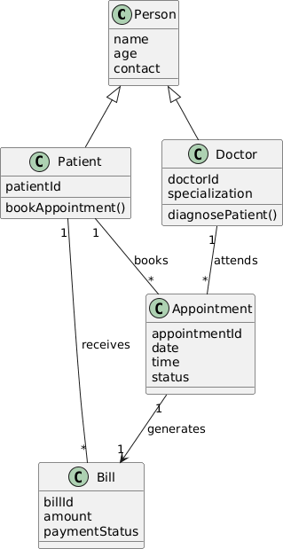

Suggest relationships among classes.
The relationships are:
  - A Patient can book multiple Appointments.
  - A Doctor can attend multiple Appointments.
  - Every Appointment connects a Patient with a Doctor.
  - An Appointment can generate a Bill.
  - A Patient can have multiple Bills.
  - Patient and Doctor inherit common attributes from Person. This design reduces duplication and clearly separates responsibilities.

Which UML diagrams would you use for analysis?
The following UML diagrams can be used:
Use Case Diagram: Represents interactions between Patient, Doctor, Admin, and the system. Class Diagram: Represents classes and their relationships.
Sequence Diagram: Shows interactions during operations such as booking an appointment. Activity Diagram: Represents workflows such as appointment booking and billing.
State Diagram: Represents changes in appointment states such as Requested, Confirmed, Completed, or Cancelled.
These diagrams together provide both structural and behavioral views of the system.

Explain how inheritance can be applied.
Inheritance can be applied by creating a superclass called Person. The Person class can contain common attributes such as:
  - name
  - age
  - address
  - contactNumber
Then Patient and Doctor can inherit these properties. Person
↓
Patient
↓
Doctor
This avoids repeating common attributes and improves code reusability and maintainability.

CASE STUDY 2 – ONLINE SHOPPING SYSTEM

Identify actors and use cases.
Actors:
  - Customer
  - Admin
  - Payment Gateway Customer Use Cases:
  - Register/Login
  - Browse Products
  - Add to Cart
  - Place Order
  - Make Payment
  - Track Order Admin Use Cases:
  - Add Product
  - Update Product
  - Remove Product
  - Manage Orders Payment Gateway:

  - Process Payment
  - Confirm Payment

Use Case Diagram
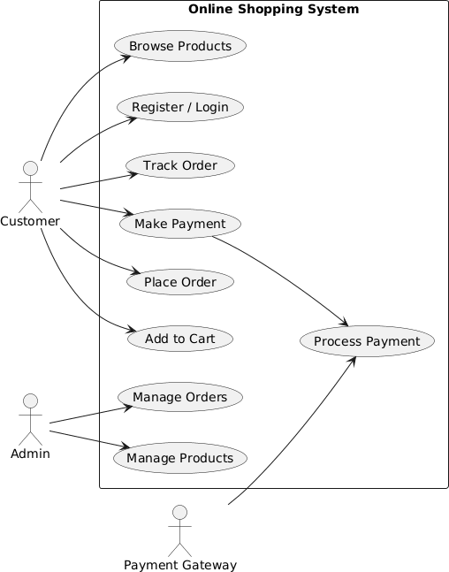

Suggest suitable design patterns.
Suitable design patterns include:
Factory Pattern: Can be used to create different payment methods such as Credit Card, UPI, and Net Banking.
Strategy Pattern: Allows the payment algorithm to be selected dynamically. Observer Pattern: Can notify customers when the order status changes.
Singleton Pattern: Can ensure that only one instance of certain system services or configuration managers exists.
These patterns improve flexibility, scalability, and maintainability.

Explain how polymorphism can be used in payment processing.
Polymorphism can be applied by defining a common Payment interface containing a method such as:
processPayment()
Different classes can implement this operation:
  - CreditCardPayment
  - UPIPayment
  - NetBankingPayment For example:
Payment → processPayment() CreditCardPayment → processPayment() UPIPayment → processPayment() NetBankingPayment → processPayment()
Although the same method name is used, each payment type provides its own implementation. Therefore, new payment methods can be added without significantly modifying the existing system.

SECTION E – HR & PROFESSIONAL QUESTIONS

Q19. Why should we hire you?
You should hire me because I am a quick learner with strong problem-solving and analytical skills. I have a good understanding of programming, databases, object-oriented concepts, and software modeling. I am willing to learn new technologies and adapt to different situations. I also work responsibly in teams and try to complete assigned tasks accurately and on time.

Q20. What are your strengths and weaknesses?
My strengths are quick learning, adaptability, logical thinking, teamwork, and willingness to improve. I remain focused while working on technical problems and try to find practical solutions.
One weakness I am working on is spending extra time perfecting certain tasks. I am improving this by prioritizing tasks, setting time limits, and focusing first on the requirements that have the greatest impact.

Q21. How do you handle project deadlines?
I handle deadlines by dividing the project into smaller tasks and prioritizing them according to importance and dependency. I set milestones and monitor my progress regularly. I also try to complete critical tasks early so that sufficient time remains for testing and correction. If I encounter a problem, I communicate it with the team instead of waiting until the deadline.

Q22. Have you worked in a team project? Explain your role.
Yes. I have worked on team-based academic projects where tasks were divided among members based on their responsibilities. My role involved understanding the requirements, contributing to the design and implementation, coordinating with team members, and checking whether the final output satisfied the project requirements. Team projects taught me

the importance of communication, responsibility, collaboration, and completing assigned tasks on time.

Q23. Where do you see yourself in five years?
In five years, I see myself working as a skilled professional in a technology-oriented field where I can apply programming, data analysis, artificial intelligence, and computational techniques. I want to continuously improve my technical knowledge, work on meaningful real-world projects, and gradually take on greater responsibilities. My long-term goal is to combine my knowledge of Bioinformatics and computing to contribute to innovative technology-driven solutions.

