SIMATS ENGINEERING
ASSESSMENT TOOL 2

COURSE CODE: CSA0408 COURSE NAME: Operating Systems

COURSE OUTCOME COVERED

CO1: Apply the concepts of Operating System types, structures, and system calls to demonstrate their functions in various computing environments. (BL2, BL3)

QUESTIONS: 5 Total Marks:100

Annexure A
Concept Mapping

Code of Conduct:

I __K.Divya(192511316)___ (Name / Reg No) certify that this submission is my original work and that I have adhered to the guidelines specified for this assessment.
I understand that any violation of academic integrity rules will result in disciplinary action.

Signature of the student:

Concept Mapping

Question 1
Show a multi-level concept map integrating:
Operating System Types → OS Structures → System Calls → OS Functions.
Your map must show cross-links

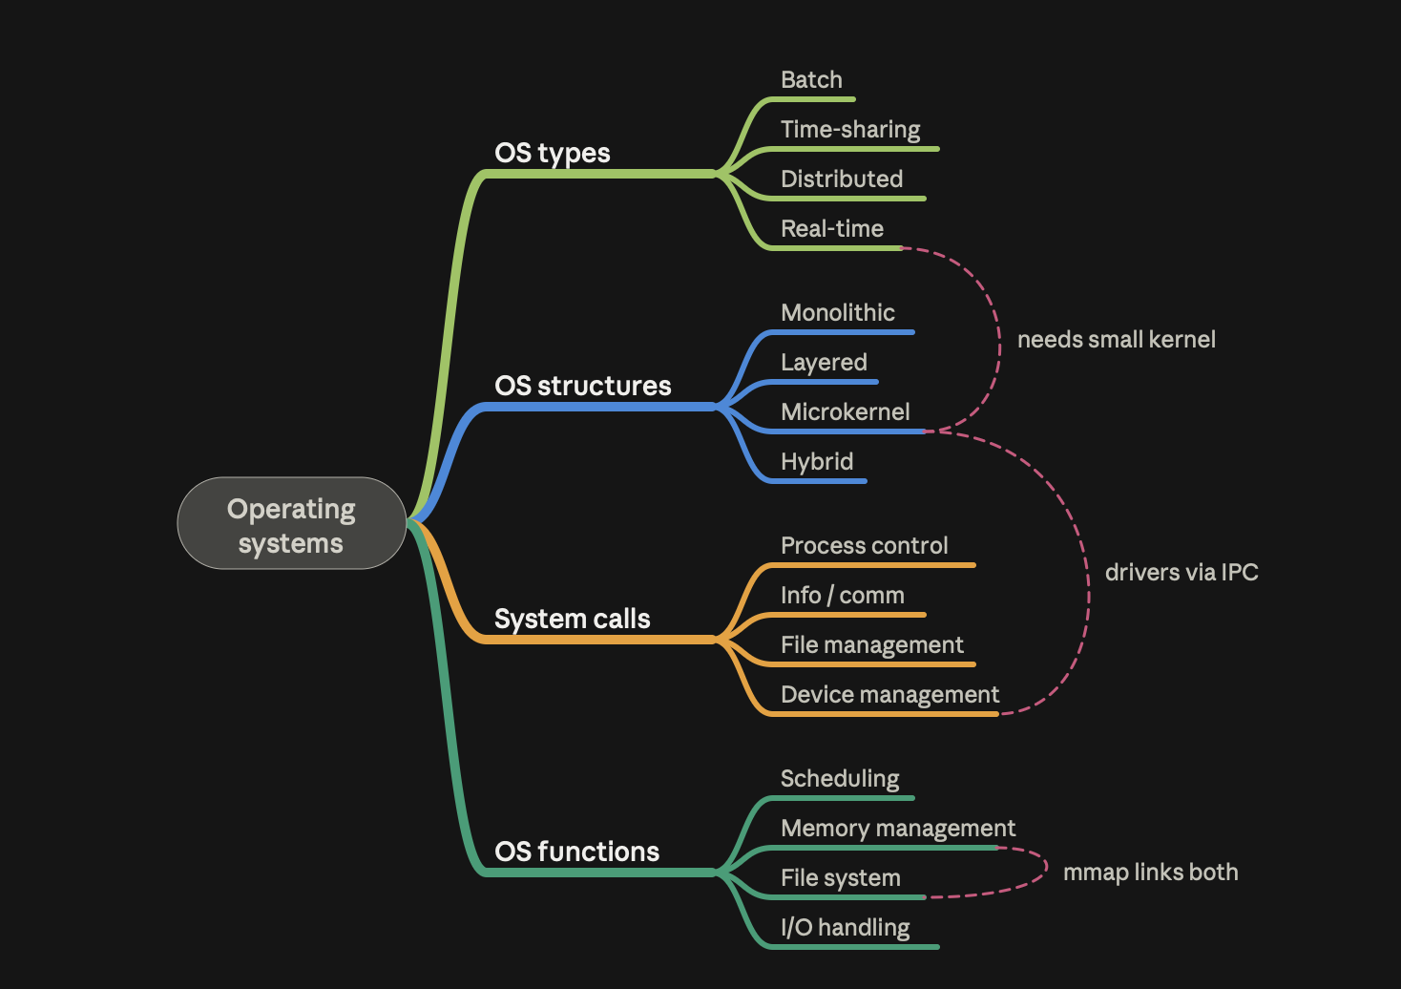

Question 2
Construct a comprehensive concept map representing:
Process Management, Memory Management, File System, and I/O System.
Include interdependencies and indicate where system calls interact with each component.
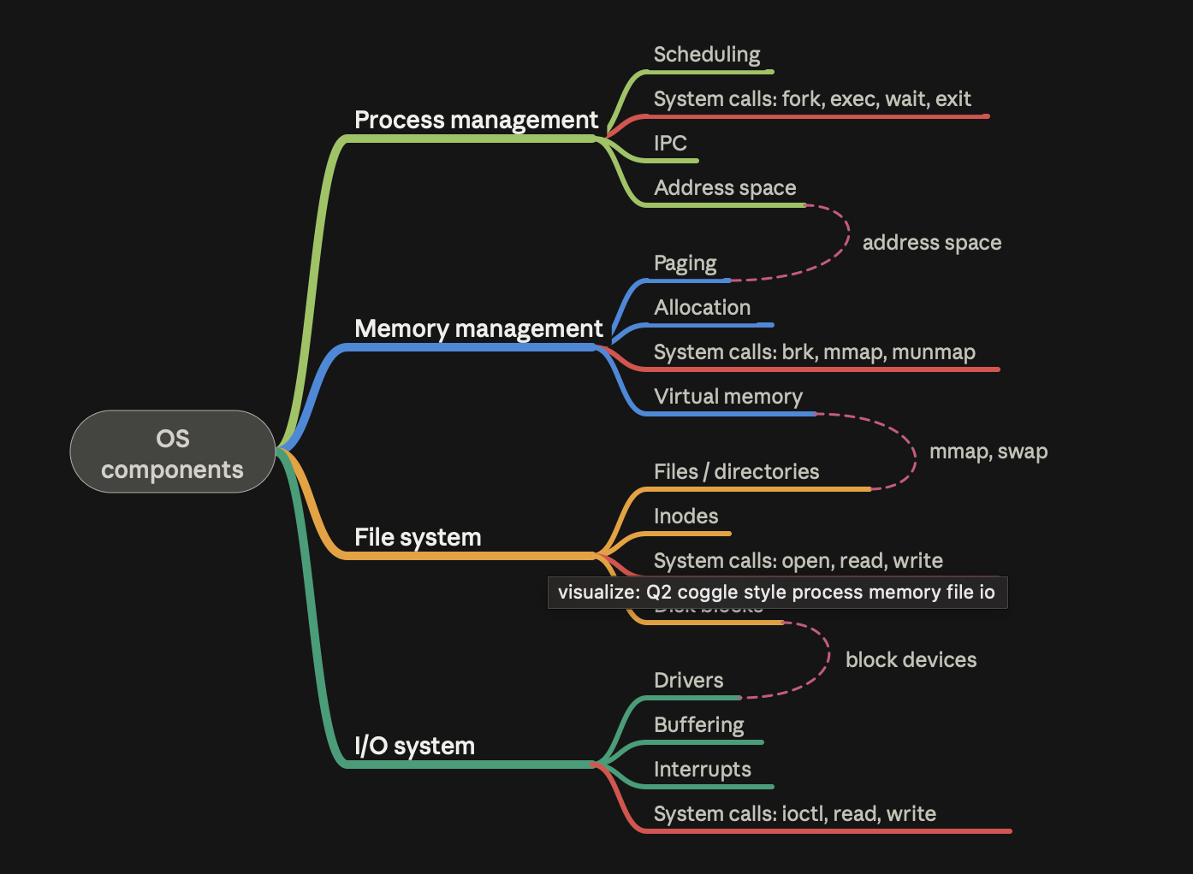

Question 3

Sketch a comparative concept map for:
Batch OS, Time-Sharing OS, Distributed OS, and Real-Time OS.
Highlight differences, similarities, advantages, and limitations using linking phrases.
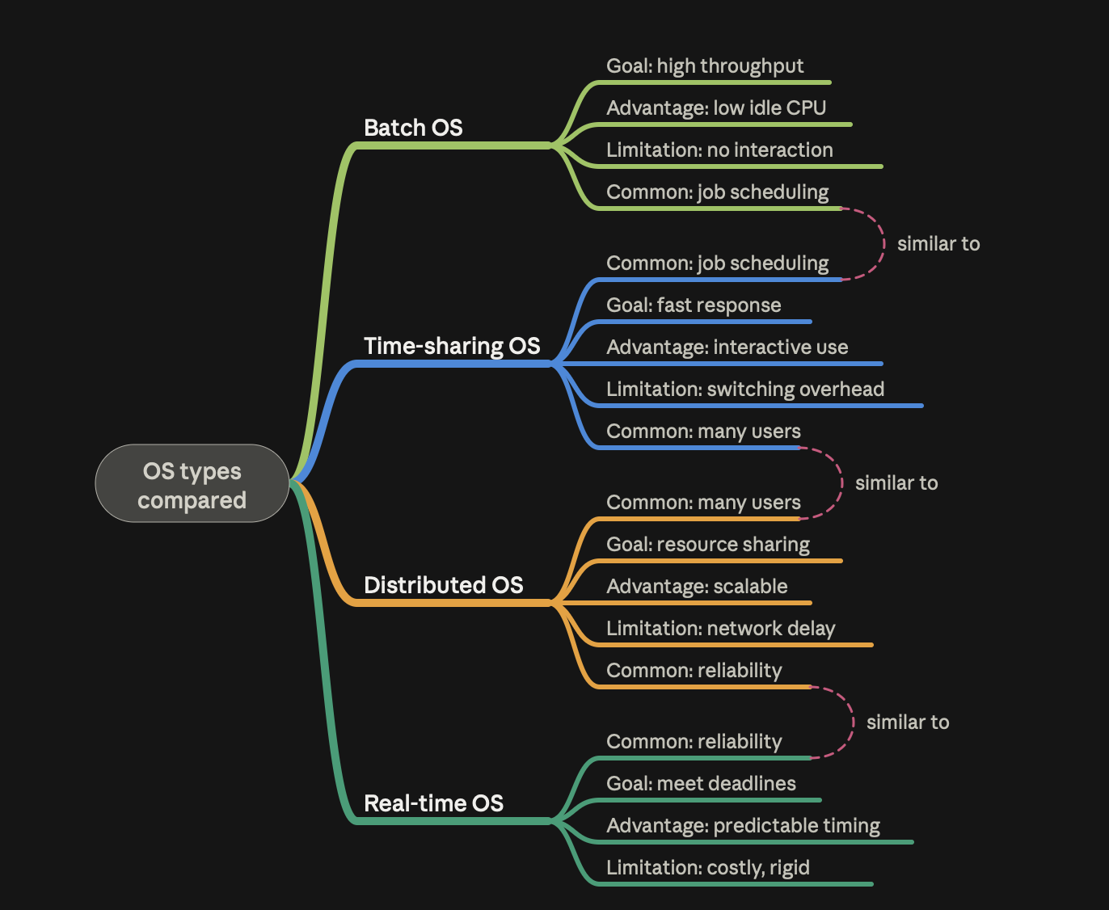

Question 4

Illustrate a dynamic concept map showing the execution flow:
User Program → API → System Call Interface → Kernel → Hardware → Response back to User.
Include feedback loops and control flow paths.
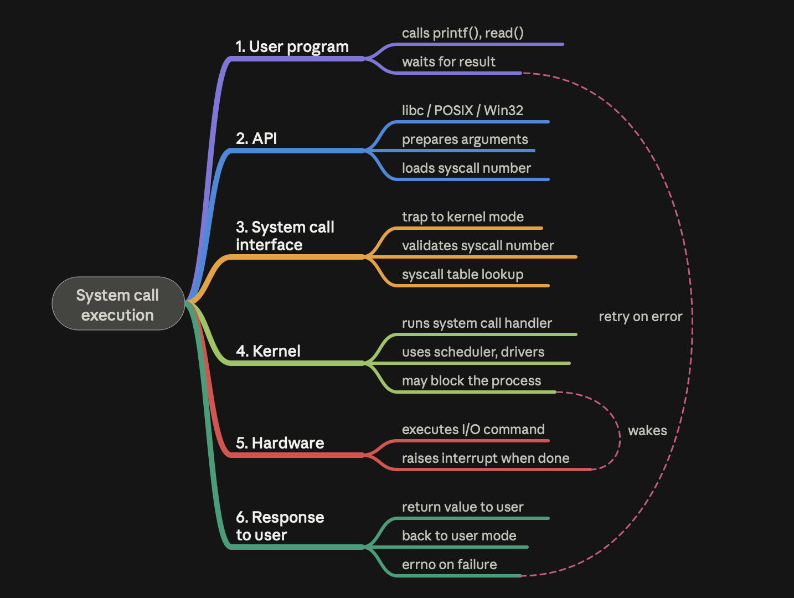

Question 5

Sketch a hierarchical + functional concept map for system calls:
Process, File, Device, and Information system calls.
Also show how they relate to OS services like scheduling, memory allocation, and device handling.
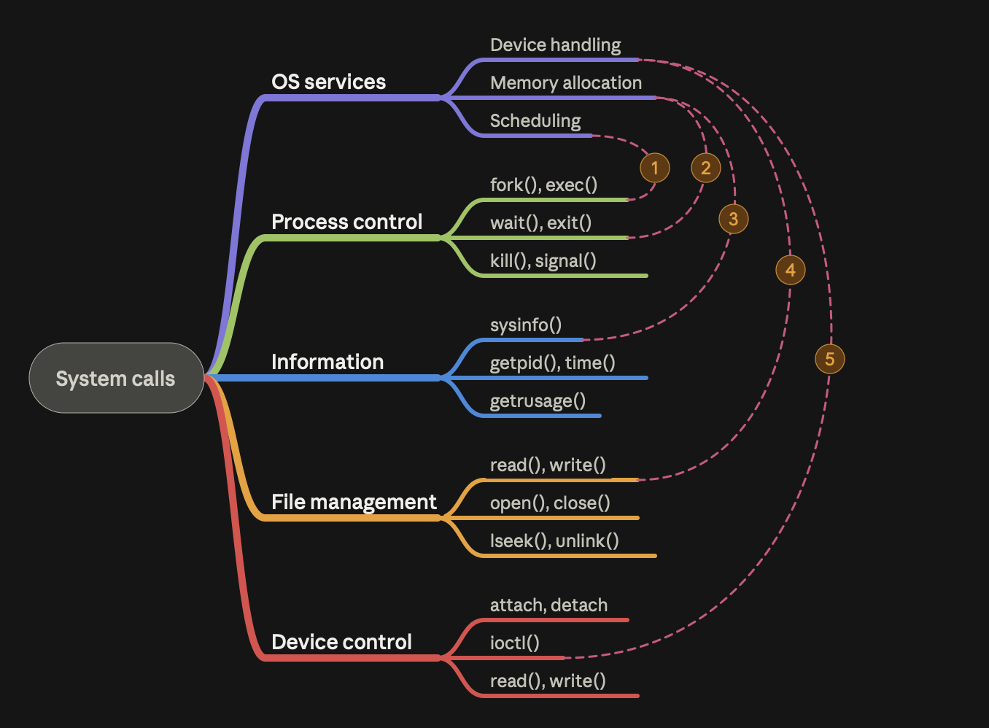

RUBRICS FOR CALCULATION

Concept Mapping
Criteria | Weightage | Level 4 (Exemplary) | Level 3 (Proficient) | Level 2 (Developing) | Level 1 (Beginning)
Concept Identification | 25% | Identifies all key concepts from literature accurately and comprehensively | Identifies most key concepts with minor omissions | Identifies limited concepts; some are irrelevant or missing | Fails to identify essential concepts
Linkages | 25% | Establishes clear, meaningful, and accurate relationships between concepts | Shows correct relationships with minor gaps | Relationships are weak, unclear, or partially incorrect | No meaningful relationships established
Organization | 20% | Concepts are well-structured hierarchically with logical flow and grouping | Mostly organized with minor structural issues | Some organization but lacks clear hierarchy | No logical organization or structure
Integration of Literature | 20% | Integrates multiple studies effectively to show connections and comparisons | Shows some integration of literature | Limited integration; mostly isolated concepts | No integration of literature evidence
Clarity | 10% | Concept map is clear, neat, visually structured, and easy to interpret | Generally clear with minor readability issues | Clarity is reduced; difficult to interpret in parts | Poorly presented and hard to understand

