ITA14 – ETHICAL HACKING
ASSIGNMENT 1 (CO1)
Design and Develop a Complete Ethical-Hacking Engagement Framework for a University’s Authorized Security-Assessment Programme
Student Details
Name | K.Divya
Register Number | 192511316
Department / Section | B.E-CSE

CO1: Apply the foundational concepts of ethical hacking, including the types of hackers, ethical principles, legal frameworks, and the role of responsible disclosure in cybersecurity.

Framework Overview and Assumptions
The Ethical-Hacking Governance Team has designed the University Ethical-Hacking Engagement Framework (UEHEF) for the University Authorized Security-Assessment Programme. The framework governs every authorized security test of the student portal, learning-management system (LMS), email service and campus network, from the first request to closure and disclosure of findings. It is built to work for the initial programme (about 20 systems and 50 staff) and to grow to the whole university and to external third-party assessors without redesign.
The following assumptions apply throughout this report:
- The university operates in India, so Indian law (IT Act, 2000 and the Digital Personal Data Protection Act, 2023) is the primary legal reference. Foreign laws are noted only for external assessors.
- No live exploitation is performed. All work is at the design, documentation and isolated-lab level. Case examples and findings used in the walkthrough are illustrative.
- A Security Governance Board (SGB) is constituted by the university management as the final authority for high-risk engagements.
- Short names used in this report: EM = Engagement Manager, SO = System Owner, DPO = Data Protection Officer, RoE = Rules of Engagement, SOC = security operations contact or team.
Table 0.1: Task index
Task | Title | Marks | Framework component
1 | Formulate – Problem, Stakeholders and Requirements | 4 | Requirements baseline
2 | Design – Governance and Authorization Model | 4 | Roles, tiers, lifecycle, gates
3 | Create – Scope Statement and Rules of Engagement | 4 | Scope and RoE
4 | Construct – Legal and Ethical Compliance Framework | 4 | Law, ethics, Gate 2
5 | Create – Hacker Classification and Threat-Actor Models | 4 | Attacker modelling
6 | Build – Responsible Disclosure and Vulnerability Handling | 5 | Disclosure process
7 | Design – Isolated Ethical-Hacking Lab | 5 | Lab environment
8 | Develop – Reusable Templates and Documents | 4 | Templates T-01 to T-06
9 | Integrate – Interaction Map and Traceability | 4 | Integration
10 | Create – Validation Walkthrough | 4 | Tabletop validation
11 | Defend – Justification, Trade-offs and Evidence | 4 | Defence

TASK 1 – FORMULATE: Problem, Stakeholders and Requirements (4 Marks)

Aim
To investigate the scenario, state the governance problem precisely, identify who is affected, and fix a measurable set of requirements that the framework must satisfy.

1.1 Problem Statement
The university will test its student portal, LMS, email service and campus network before a major upgrade, but it has not fixed how ethical-hacking engagements are governed. Tests may be requested by any department, performed by internal staff or external testers, and may touch systems holding personal data. Without a structured approach the university faces five concrete risks, listed in Table 1.1.
Table 1.1: Governance risks identified from the scenario
ID | Risk (from scenario) | How it could happen | Consequence
R1 | Unauthorized access | A tester or department starts testing without written permission, or goes beyond what was approved | Offence under the IT Act; loss of trust; disciplinary action
R2 | Legal exposure | Personal data is accessed, copied or shared during testing; third-party systems are touched without consent | Liability under data-protection and IT laws; contract breach
R3 | Damage to live systems | Intrusive testing during admissions, examinations or result publication | Outage, data corruption, reputational damage
R4 | Unclear scope | Different departments and testers interpret targets and limits differently | Scope creep, missed systems, disputes
R5 | Uncoordinated disclosure | Findings are shared informally, delayed, or leaked before fixing | Exploitation by real attackers; panic; legal issues

1.2 Stakeholder Analysis
Table 1.2: Stakeholders and their roles
Stakeholder | Interest | Main concern | Role in the framework
Management (Vice-Chancellor / Registrar) | Safe, compliant upgrade | Legal and reputational risk | Constitutes the SGB; final authority
CISO / IT Head | Secure systems | Unmanaged testing, outages | Owns the framework; provides Engagement Managers
System Owners (Exam Cell, LMS, Mail, Network admins) | Service availability | Disruption of live services | Co-sign authorization; fix findings
Legal Counsel and DPO | Compliance | Personal-data and contract exposure | Gate 2 legal review; breach assessment
Internal testers (staff) | Skill use and learning | Personal legal risk | Perform authorized tests under RoE
External assessors | Contract delivery | Unclear scope and liability | Perform tests after vetting and NDA
Requesting departments | Assurance for their system | Delay and cost | Raise requests; sponsor engagements
Students and staff (data principals) | Privacy and service | Misuse of their personal data | Protected by data-handling rules
CERT-In / vendors | Coordinated response | Late or uncoordinated reports | Receive escalations where required

1.3 Systems and Their Criticality
Table 1.3: Systems in the initial programme
System | Data / function | Sensitivity | Main impact if testing goes wrong
Student portal | Student identity, marks, fees, attendance | High (personal data) | Exposure of personal data; exam and fee disruption
Learning-management system | Course content, submissions, grades | Medium to High | Loss of submissions; teaching disruption
Email service | Credentials, personal and official mail | High | Mail exposure; account lockouts
Campus network | Connectivity for all services | High (availability) | Wide outage if disrupted

1.4 Requirements
Requirements were derived directly from the scenario statements and are numbered so that later tasks can trace back to them.
Table 1.4: Functional (FR) and non-functional (NFR) requirements
ID | Requirement | Source in scenario
FR1 | No engagement starts without written, signed and time-bound authorization | Unauthorized access concern
FR2 | Every engagement has a defined scope and Rules of Engagement before testing | Unclear scope concern
FR3 | Relevant laws and personal-data duties are checked before approval and during testing | Legal exposure; personal data
FR4 | Different attacker types are modelled to decide what to test and how deep | Types of attackers in the design challenge
FR5 | Vulnerabilities are rated, reported and disclosed through one coordinated process | Uncoordinated disclosure concern
FR6 | An isolated lab is available for hands-on and intrusive techniques | Damage to live systems; isolated lab
FR7 | Reusable forms and templates exist for every stage | Reusable components
FR8 | A single lifecycle links all components; outputs of one become inputs of the next | Integration among components
NFR1 | Scalable from 20 systems / 50 staff to the whole university and external assessors | Framework must remain usable as it grows
NFR2 | Proportionate: effort and approval level match the risk of the engagement | Different departments and testers
NFR3 | Auditable: every decision leaves a record | Evidence for every decision
NFR4 | Safe by default: no live exploitation in this programme phase; lab-first for intrusive work | No live exploitation performed

1.5 Authorized, Legal and Appropriate – Definitions
The scenario requires the framework to separate three ideas that are often confused. An activity must satisfy all three before it is allowed.
Table 1.5: Authorized vs legal vs appropriate
Term | Question it answers | Who decides | Example of failure
Authorized | Has the right person given explicit written permission for this exact activity? | System Owner, EM, SGB | Tester scans a server because a lecturer said it was fine
Legal | Does the activity comply with law, contracts and data-protection duties? | Legal Counsel and DPO | Owner authorizes testing of a vendor-hosted LMS the vendor has not consented to
Appropriate | Is it proportionate, safe and suitable for the university at this time? | SGB / EM with System Owner | Legal and authorized test run during examination week

1.6 Design Decisions Taken from the Analysis
- Tiered engagements: approval effort depends on risk (Task 2), so low-risk work is not delayed.
- Three-gate review: Authorized, Legal and Appropriate are checked separately (Tasks 2 and 4).
- Lab-first for intrusive work: techniques are rehearsed on synthetic data before touching live systems (Task 7).
- Evidence by default: every decision is recorded in templates and a central register (Task 8).

Expected Evidence to Submit
No. | Evidence item (attach / show) | What it proves to the evaluator
1 | Problem statement and risk table (Section 1.1, Table 1.1) | The five scenario risks were identified correctly
2 | Stakeholder table (Table 1.2) | All affected parties, including students and external assessors, were considered
3 | System criticality table (Table 1.3) | Risk was assessed per system, not generically
4 | Requirements table FR1–FR8, NFR1–NFR4 (Table 1.4) with scenario source column | Requirements are traceable to the scenario and measurable
5 | Authorized / legal / appropriate definitions (Table 1.5) | The mandatory distinction in the scenario is clearly made

TASK 2 – DESIGN: Governance and Authorization Model (4 Marks)

Aim
To design how an engagement is requested, risk-classified, authorized and controlled, including who is responsible at each step.

2.1 Governance Structure and Roles
Table 2.1: Roles and responsibilities
Role | Held by | Key responsibilities
Security Governance Board (SGB) | Registrar or Dean (Chair), CISO, Legal Counsel, DPO, Academic and IT representatives | Approves Tier 3 engagements; reviews policy yearly; final escalation
Engagement Manager (EM) | Nominated by CISO office | Triage and tiering; keeps register; approves Tier 1; controls execution; invokes stop
Engagement Sponsor | Head of requesting department | Raises request; confirms business reason
System Owner (SO) | Administrator accountable for the system | Confirms assets; co-signs authorization; fixes findings
Legal Counsel and DPO | University legal and data-protection staff | Gate 2 review; breach assessment; contract and NDA review
Lead Tester and Testers | Internal staff or vetted external assessors | Perform only authorized activities; record evidence; report
Lab Administrator | IT staff | Builds, resets and controls the isolated lab
Disclosure Coordinator | EM or CISO nominee | Runs notification and disclosure (Task 6)

2.2 Responsibility Matrix (RACI)
R = Responsible, A = Accountable (exactly one per activity), C = Consulted, I = Informed.
Table 2.2: RACI for the engagement lifecycle
Activity | SO / Sponsor | EM | Legal and DPO | SGB | Lead Tester
Raise request | A/R | C | – | – | –
Risk tiering | C | A/R | C | I | –
Legal and ethical review (Gate 2) | I | C | A/R | I | –
Authorization decision | C | R | C | A | I
Scope and RoE sign-off | C | A | C | I | R
Test execution | C | A | I | I | R
Reporting | I | A | C | I | R
Disclosure and remediation | R | A | C | I | C
Closure and review | C | R | C | A | C

For Tier 1 and Tier 2 engagements the SGB delegates the authorization decision to the CISO, so the SGB is not overloaded.

2.3 Engagement Tiers and Approval Matrix
Table 2.3: Tiers and approval authority
Tier | Typical engagement | Approvals required | Lab rehearsal
Tier 1 – Low | Passive or non-intrusive work; no personal data; test or staging systems. Examples: configuration review, asset discovery, scan of a test instance | EM and System Owner | Optional
Tier 2 – Medium | Active but rate-limited testing; no sensitive personal data in scope. Examples: LMS content modules, internal network segment scan | CISO, System Owner, Legal review | Recommended for new tools
Tier 3 – High | Systems with personal data (student portal, email), core network, social-engineering simulation, any intrusive technique | SGB, Legal and DPO, System Owner | Mandatory

Tier uplift rules: an engagement performed by an external assessor is raised by one tier (maximum Tier 3). An engagement that needs production testing close to a freeze period is either moved to another window or raised by one tier.
Always prohibited in every tier: denial-of-service or stress testing of production systems; destructive actions on real data; copying real personal data beyond minimal masked proof; testing third-party or vendor-hosted services without their written consent; physical intrusion; testing personal devices of students or staff; use of unapproved tools or malware; keeping credentials or data after closure; public posting of findings.

2.4 Authorization Rules
- Authorization is written and signed. Verbal or email-only approval is never valid.
- It is specific: it lists exact systems, activities, tester names and source addresses.
- It is time-bound: it states a start and end date and time, and expires automatically.
- It is non-transferable: only the named persons may act under it.
- It is revocable: the EM, System Owner or SGB may suspend it immediately.
- Anything not listed in the authorization is not authorized.

2.5 Three-Gate Decision Logic
Table 2.4: Gate review before any engagement starts
Gate | Check | Reviewer | Fail action
G1 – Authorized | Owner and sponsor consent; correct approval level for the tier; named testers; signed T-02 | EM and SGB / CISO | Return to requester
G2 – Legal | Legal basis; personal-data impact; third-party consent; NDA and contract in place | Legal and DPO | Veto: engagement cannot proceed until fixed
G3 – Appropriate | Proportionality; testing window outside freeze periods; business impact; less risky alternative considered | SGB or CISO with System Owner | Reschedule, reduce depth or reject

An engagement proceeds only when all three gates are passed. A pass in one gate never compensates for a failure in another.

2.6 Engagement Lifecycle
Figure 1 shows the seven-stage lifecycle. It is the backbone that later tasks plug into: scope and RoE (Task 3), legal review (Task 4), threat models (Task 5), disclosure (Task 6), lab (Task 7) and templates (Task 8).
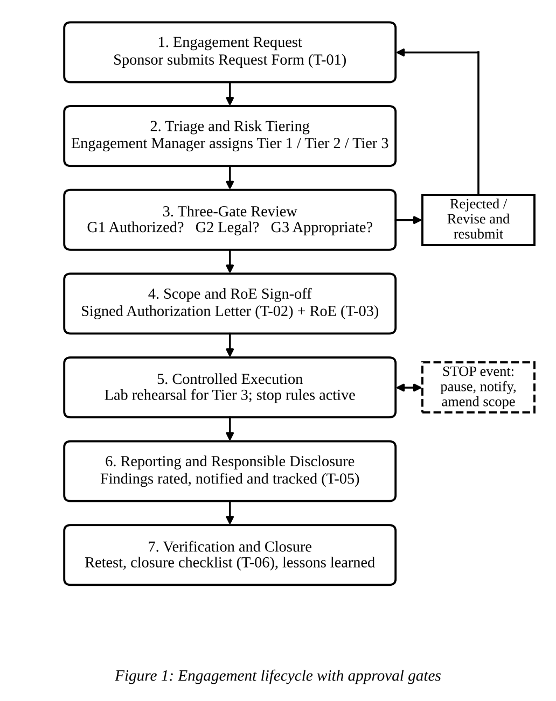

Expected Evidence to Submit
No. | Evidence item (attach / show) | What it proves to the evaluator
1 | Roles and responsibilities table (Table 2.1) and RACI (Table 2.2) | Clear accountability; one accountable owner per activity
2 | Tier and approval matrix with prohibited list (Table 2.3) | Proportionate governance that scales
3 | Authorization rules (Section 2.4) | Authorization is explicit, specific, time-bound and revocable
4 | Three-gate table (Table 2.4) | Authorized, legal and appropriate are checked separately
5 | Lifecycle diagram (Figure 1) | End-to-end workflow with rejection and stop loops

TASK 3 – CREATE: Scope Statement and Rules of Engagement (4 Marks)

Aim
To create a reusable method for defining scope and a complete Rules of Engagement (RoE) so that testers know exactly what they may and may not do. Scope states what may be tested; RoE states how it may be tested.

3.1 Scope Definition Method
- Scope is built from the university asset register: each in-scope item is named by system, environment (production, staging or test), owner and address or URL range.
- Each item is placed in one of three classes: in scope, conditionally in scope (only with an extra written approval) or out of scope.
- Anything not listed is out of scope by default.
- Scope is frozen when the Authorization Letter (T-02) is signed. Changes follow the change procedure in Section 3.5.

3.2 Scope Statement for the Initial Programme
Table 3.1: Scope statement for the four systems
System | In scope | Conditionally in scope | Out of scope | Default tier
Student portal | Test and pre-production instances; application and API as per asset register | Production instance in approved window | Payment gateway; hosted third-party components | Tier 3
LMS | Test instance; course-content modules | Production instance; vendor plugins with vendor consent | Vendor’s hosting platform | Tier 2
Email service | Configuration review; test mailboxes created for the engagement | Phishing simulation (Tier 3, SGB approval) | Real user mailboxes and content | Tier 3
Campus network | Asset discovery and scans of named segments | Core and distribution devices | ISP equipment; personal devices; hostel user devices | Tier 2 / 3

General exclusions for all engagements: systems of other institutions, cloud-provider infrastructure, personal devices of students and staff, physical premises, and any system not in the asset register.

3.3 Rules of Engagement
Table 3.2: Rules of Engagement (body of template T-03)
RoE item | Rule
Permitted activities | Only the activities written in the Authorization Letter for the approved tier, such as discovery, scanning, configuration review and authenticated testing with test accounts
Prohibited activities | All items in the always-prohibited list (Section 2.3)
Testing window | Production testing only in the approved window, normally 22:00 to 05:00 IST, outside the freeze calendar (admissions, examinations, result publication, fee deadlines)
Intensity limits | Rate-limited tools; no parallel heavy scans; tool settings approved in advance
Credentials and accounts | Test accounts created by the System Owner; no use of real user accounts; credentials disabled within 24 hours of closure
Data handling | No real personal data copied. Proof is a masked screenshot or record count. Evidence is stored encrypted (AES-256) on university storage only, never on personal devices
Source identification | Testers use registered source addresses, listed in the Authorization Letter, so the SOC can tell testing from real attacks
Communication | One point of contact per side; daily status to the EM; 24×7 emergency contacts listed in T-02
Incident during testing | If signs of a real attack are seen, testing stops and the event is handled as a security incident
Reporting | Findings recorded in template T-05 and handled under Task 6; no informal sharing
Retention and deletion | Evidence retained for three years or as per university records policy, then securely deleted
Termination | Authorization ends at the stated end time, on completion, or immediately on revocation

3.4 Stop Conditions
Table 3.3: Conditions that force immediate pause
Trigger | Tester action | Notify
Service slowdown or errors beyond the baseline set in the RoE | Stop all activity on the system | EM and SO immediately by phone; written note within 1 hour
Real personal data not covered by scope is exposed | Stop; do not copy or share; record location only | EM and DPO immediately
Evidence of a real intruder | Stop; preserve logs and screenshots | EM, SOC and CISO immediately
Discovery of an out-of-scope system or weakness | Observe and record only; do not test | EM, who decides on a scope change
Unexpected tool behaviour or loss of control | Stop and isolate the tool | EM and Lab Administrator
Authorization expired or revoked | Stop all work | EM

3.5 Scope Change Control
- A change request states the new asset, reason, risk and proposed tier.
- The same authority that approved the original engagement must approve the change in writing.
- Work on the new asset starts only after the amended Authorization Letter is issued.
- All changes are logged in the engagement register.

Expected Evidence to Submit
No. | Evidence item (attach / show) | What it proves to the evaluator
1 | Scope statement table for all four systems (Table 3.1) with general exclusions | Scope is specific and covers the scenario systems
2 | Rules of Engagement table (Table 3.2) | How testing is controlled: windows, data, credentials, communication
3 | Stop-condition table (Table 3.3) | Protection of live systems and personal data
4 | Scope change procedure (Section 3.5) | Control of scope creep
5 | Authorization Letter template T-02 and RoE template T-03 (Task 8) | Scope and RoE are captured in signed, reusable documents

TASK 4 – CONSTRUCT: Legal and Ethical Compliance Framework (4 Marks)

Aim
To construct the legal and ethical layer of the framework: which laws and standards apply, which ethical principles bind testers, and how compliance is checked before and during every engagement.

4.1 Legal and Regulatory Requirements
Table 4.1: Applicable laws and how the framework respects them
Law / instrument | Relevance to ethical hacking | Framework control
Information Technology Act, 2000 – Section 43 | Accessing, copying, damaging or disrupting a computer system without the owner’s permission attracts penalty and compensation | Written authorization (T-02); strict scope; prohibited list
IT Act – Section 66 | Doing any Section 43 act dishonestly or fraudulently is an offence (imprisonment up to three years, or fine up to five lakh rupees, or both) | Time-bound authorization; tester undertaking (T-04); revocation
IT Act – Sections 66C and 66D | Identity theft and cheating by personation using computer resources; relevant to credential use and phishing simulation | Test accounts only; phishing simulation needs Tier 3 approval
IT Act – Section 72 | Breach of confidentiality and privacy by a person with access to records | NDA (T-04); data-handling rules; encrypted evidence
IT Act – Section 70B and CERT-In Directions (April 2022) | CERT-In is the national agency; specified cyber incidents must be reported within six hours; logs to be kept for 180 days | Incident clause in RoE; DPO and CISO escalation (Task 6); log retention
Digital Personal Data Protection Act, 2023 | Duties on handling personal data, security safeguards and breach intimation | DPO review at Gate 2; no real personal data in lab; data minimization
Contracts and vendor terms | Vendor-hosted systems may forbid testing without consent | Third-party components out of scope unless written consent
Foreign laws (for example US CFAA, UK Computer Misuse Act 1990) | May apply to foreign assessors or foreign-hosted systems | External assessor vetting and legal clause in contract

Statutory references in this table are to be confirmed by the university’s legal counsel at adoption, because laws and rules are amended from time to time.

4.2 Standards and Good-Practice References
Table 4.2: Standards used to shape the framework
Standard | Used for
NIST SP 800-115 (Technical Guide to Information Security Testing and Assessment) | Planning, discovery, attack and reporting phases; testing process structure
ISO/IEC 27001:2022 (Annex A: 5.31, 8.8, 8.29) | Legal requirements, technical vulnerability management, security testing
ISO/IEC 29147:2018 and ISO/IEC 30111:2019 | Vulnerability disclosure and vulnerability handling (Task 6)
OWASP Web Security Testing Guide, PTES, OSSTMM | Test coverage and methodology references for assessors
FIRST CVSS | Severity rating of findings

4.3 Ethical Principles and Code of Conduct
Table 4.3: Ethical principles binding every tester
Principle | Meaning | Practical rule
Authorization first | No test without permission | Carry the signed T-02 during testing
Scope discipline | Respect boundaries | Observe and report out-of-scope items; never test them
Minimal harm | Avoid damage and disruption | Use least intrusive technique; obey stop conditions
Confidentiality | Protect what is found | Encrypt evidence; no sharing outside the distribution list
Privacy | Respect personal data | Mask data; never copy real records
Honesty and integrity | Report truthfully | No hiding of mistakes or inflating of findings
Accountability | Own your actions | Log all activity; accept review
Competence | Work within skill | Use approved tools; ask for help when unsure
Responsible disclosure | Fix before publicity | Follow Task 6; no public posting

These principles are consistent with the codes of ethics published by professional bodies such as EC-Council and ISC2 and are signed by every tester through template T-04.

4.4 Gate 2 Legal Checklist
Table 4.4: Questions asked at Gate 2
No. | Question | If the answer is No
1 | Is the university the owner or lawful controller of every asset in scope? | Remove the asset or obtain written consent
2 | Is any third-party or vendor-hosted component involved? Is written consent held? | Mark out of scope
3 | Will personal data be accessible to testers? Is the DPO’s approval recorded? | Use test data or reduce scope
4 | Is the tester under an NDA and code-of-conduct undertaking (T-04)? | Block until signed
5 | For external assessors: is there a contract with liability, insurance and confidentiality clauses? | Block until signed
6 | Is the incident-reporting route (CISO, DPO, CERT-In) defined for this engagement? | Add to RoE
7 | Does the authorization letter cover only lawful activities? | Amend the letter

4.5 Authorized vs Legal vs Appropriate – Worked Cases
Table 4.5: How the three tests can disagree
Case | Authorized? | Legal? | Appropriate? | Framework outcome
Tester scans a lab server with no permission slip, but the owner is a friend | No | No | No | Rejected at Gate 1
Owner permits testing of the vendor-hosted LMS platform; vendor has not consented | Yes | No | – | Gate 2 veto; vendor consent needed
Fully approved production test planned for examination week | Yes | Yes | No | Gate 3 reschedules to another window
Phishing simulation on all students with no DPO review | Yes | Doubtful | No | Rejected; redesign with DPO and SGB
Approved test of a staging copy with masked data in the approved window | Yes | Yes | Yes | Approved

Expected Evidence to Submit
No. | Evidence item (attach / show) | What it proves to the evaluator
1 | Legal requirements table (Table 4.1) with the framework control for each law | Legal frameworks are identified and turned into controls
2 | Standards table (Table 4.2) | Design follows recognised good practice
3 | Ethical principles table (Table 4.3) and tester undertaking T-04 | Ethical principles are practical and enforceable
4 | Gate 2 legal checklist (Table 4.4) | Compliance is checked before approval
5 | Authorized / legal / appropriate case table (Table 4.5) | The three-way distinction works in practice

TASK 5 – CREATE: Hacker Classification and Threat-Actor Models (4 Marks)

Aim
To classify the types of hackers, explain where the university’s testers fit, and create threat-actor models that decide what is tested and how deeply in each engagement.

5.1 Types of Hackers
Table 5.1: Hacker classification and role in the programme
Type | Intent and legality | Relevance to the programme
White hat | Authorized, ethical, legal; works to improve security | The only type that performs engagements; internal or vetted external testers
Black hat | Malicious and illegal; personal gain or damage | Modelled as the adversary; never engaged
Grey hat | No permission, usually no malicious intent; may disclose findings | Legally risky; the university invites such reports through its disclosure policy (Task 6)
Script kiddie | Low skill, uses ready-made tools, often curiosity or showing off | Modelled as the most common nuisance attacker
Hacktivist | Ideological or political motive; defacement, disruption | Modelled for public-facing services
Malicious insider | Student or staff misusing legitimate access | Modelled for portal and email privilege abuse
Cybercriminal | Financial gain through phishing, fraud, ransomware | Modelled for credential theft and data theft
State-sponsored (APT) | Long-term espionage; high skill and resources | Modelled for research data and email

Within the programme the red team (authorized assessors) simulates attackers, the blue team (university IT and SOC) defends and detects, and the EM acts as the coordinating (purple) function so that lessons pass between them.

5.2 Threat-Actor Profiles for the University
Table 5.2: Adversary profiles
Actor | Motivation | Capability | Likely target | How it is simulated in an engagement
Curious or script-kiddie student | Curiosity, grades, status | Low; public tools | LMS, portal login | Basic tool-based checks of exposed interfaces and default settings
Malicious insider | Grade change, data misuse | Medium; valid account | Portal, email | Testing with a test student or staff account to check privilege boundaries
Hacktivist | Protest, publicity | Low to medium | Public portal pages | Review of exposed web components and availability resilience (no DoS)
Cybercriminal | Money, fraud | Medium to high | Email, portal credentials, fee data | Credential-attack resistance checks; phishing simulation only with Tier 3 approval
State-sponsored (APT) | Espionage | High | Research data, email | Architecture and detection review; no full-scope simulation
Grey-hat researcher | Recognition | Medium | Any public service | Handled through the disclosure channel, not simulated

5.3 Exposure Matrix
The ratings below are a qualitative judgement of the Governance Team (H = High, M = Medium, L = Low). They are used to select which actor models are applied to which system.
Table 5.3: Actor exposure by system
Actor | Student portal | LMS | Email | Campus network
Curious / script-kiddie student | M | H | L | M
Malicious insider | H | M | M | M
Hacktivist | M | L | M | L
Cybercriminal | H | M | H | M
State-sponsored (APT) | L | L | H | M
Grey-hat researcher | M | M | L | L

5.4 How Threat Models Drive Engagement Design
- At request triage the EM selects the actor models relevant to the system using Table 5.3.
- Each selected actor sets the test objective (for example, check whether a student account can reach another student’s record) and the depth of testing within the approved tier.
- The selected models are written into the RoE as permitted activity classes, so the actor model never widens the authorization.
- Actors that cannot be simulated safely, such as full APT behaviour, are covered by design and detection review instead.
- Lab scenarios (Task 7) are built from the same models so that rehearsal matches the real test.

Expected Evidence to Submit
No. | Evidence item (attach / show) | What it proves to the evaluator
1 | Hacker classification table (Table 5.1) | Types of hackers are correctly defined and linked to the programme
2 | Adversary profile table (Table 5.2) | Attackers are modelled with motive, capability, target and simulation method
3 | Exposure matrix (Table 5.3) | Models are applied to the four scenario systems
4 | Description of model-to-RoE link (Section 5.4) | Threat modelling has a practical effect on test design and does not widen authorization

TASK 6 – BUILD: Responsible Disclosure and Vulnerability Handling (5 Marks)

Aim
To build a coordinated process for handling vulnerabilities found during engagements and for receiving reports from outside the university, so that weaknesses are fixed before they can be abused and are never disclosed in an uncoordinated way.

6.1 Principles
- Confidential until fixed: findings are shared only with the people who must act.
- Timely: notification and fix targets depend on severity.
- Coordinated: one Disclosure Coordinator manages communication for each finding.
- No leverage: findings are never used for payment demands, publicity or pressure.
- Evidence-based: every finding is validated and recorded before notification.

6.2 Disclosure Workflow
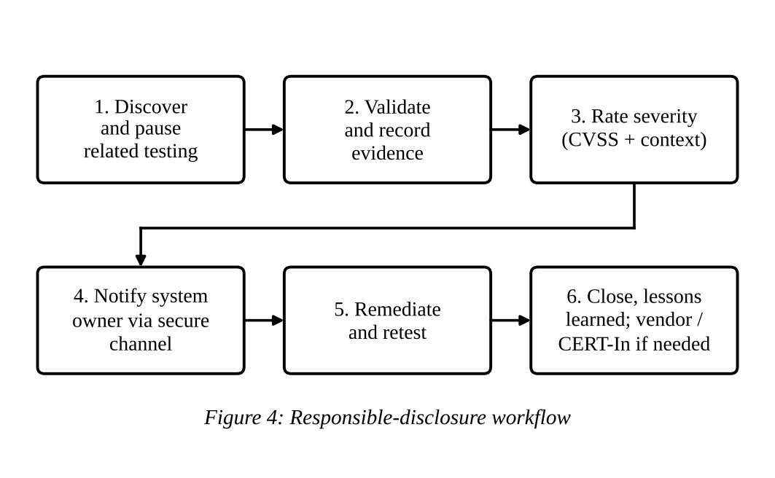
Table 6.1: Workflow steps
Step | Activity | Owner | Output
1 | Discover: tester finds a weakness and pauses related testing if it is risky | Tester | Preliminary note
2 | Validate and record: confirm safely, record masked evidence in T-05 | Tester | Finding record
3 | Rate severity using CVSS adjusted for local context (data, exposure, exploitability) | Lead Tester, EM | Severity rating
4 | Notify the System Owner through the secure channel, and DPO or CISO where required | Disclosure Coordinator | Notification record
5 | Remediate and retest | System Owner, Tester | Fix and retest result
6 | Close: update register, lessons learned; notify vendor or CERT-In if the issue lies in third-party software | EM | Closed finding

6.3 Severity, Notification and Remediation Targets
Table 6.2: Service targets by severity
Severity | CVSS score | Notify System Owner | Remediation target | Retest
Critical | 9.0 – 10.0 | Immediately by phone to EM; written within 24 hours | 7 days (compensating control within 48 hours) | Within 3 working days of fix
High | 7.0 – 8.9 | Written within 48 hours | 15 days | Within 5 working days of fix
Medium | 4.0 – 6.9 | In the engagement report | 30 days | Next cycle
Low | 0.1 – 3.9 | In the engagement report | 90 days or next maintenance | Next cycle
Informational | 0.0 | In the engagement report | Best effort | Not required

6.4 Disclosure Paths
Table 6.3: Who is told, by whom and when
Situation | Path | Rule
Weakness in a university-owned system | Tester → EM → System Owner (and CISO) | Targets as in Table 6.2
Weakness involves personal data or a confirmed breach | EM → DPO and CISO immediately | DPO assesses duties under the DPDP Act; CISO decides CERT-In reporting, which for specified incidents is within six hours of noticing
Weakness in vendor or third-party software | EM or Disclosure Coordinator → vendor security contact (or via CERT-In coordination) | Default coordination period of 90 days, extended if the vendor is actively fixing; testers never disclose publicly
Report received from an outside researcher or student | Researcher → university security contact → EM | Acknowledge within 3 working days; triage within 7 days; apply safe-harbour statement
Pressure to share findings informally | Refer to EM | Refuse; findings go only through the distribution list

6.5 Incoming Report Policy (Statement for the University Website)
The university welcomes good-faith reports of security weaknesses in its systems. Reporters should send details to the published security contact, avoid accessing or keeping personal data, avoid disrupting services, and give the university reasonable time to fix the issue before sharing it with anyone. The university will acknowledge reports within three working days, keep the reporter informed, and will not take legal action against people who act in good faith and follow this policy. Social engineering of staff or students, denial-of-service and testing of third-party services are not covered by this policy.

6.6 Confidentiality of Findings
- Findings are classified Confidential and encrypted in storage and transfer.
- The report distribution list is fixed in the Authorization Letter.
- Tester NDA obligations continue after the engagement ends.
- Retention follows the RoE; masked evidence only.

Expected Evidence to Submit
No. | Evidence item (attach / show) | What it proves to the evaluator
1 | Disclosure workflow diagram (Figure 4) and step table (Table 6.1) | A complete, ordered process from discovery to closure
2 | Severity and timeline table (Table 6.2) | Severity-based notification and fix targets
3 | Disclosure paths table (Table 6.3) | Internal, personal-data, vendor and outside-reporter cases are all covered
4 | Incoming report policy statement (Section 6.5) | The university can receive reports lawfully and safely
5 | Finding Report template T-05 (Task 8) | Findings are recorded consistently with masked evidence

TASK 7 – DESIGN: Isolated Ethical-Hacking Lab (5 Marks)

Aim
To design an isolated lab where hands-on and intrusive techniques can be practised and rehearsed safely, without any path to production systems or real personal data.

7.1 Purpose and Rules of Use
- Rehearsing Tier 3 engagements on a replica before any production activity (lab-first rule).
- Validating tool settings, rate limits and test steps so they do not harm live systems.
- Training internal staff in a safe environment.
- Building evidence that a technique is safe to apply under an approved RoE.
- The lab is not an authorization: a technique that works in the lab may be applied to production only under an approved Authorization Letter.

7.2 Lab Architecture
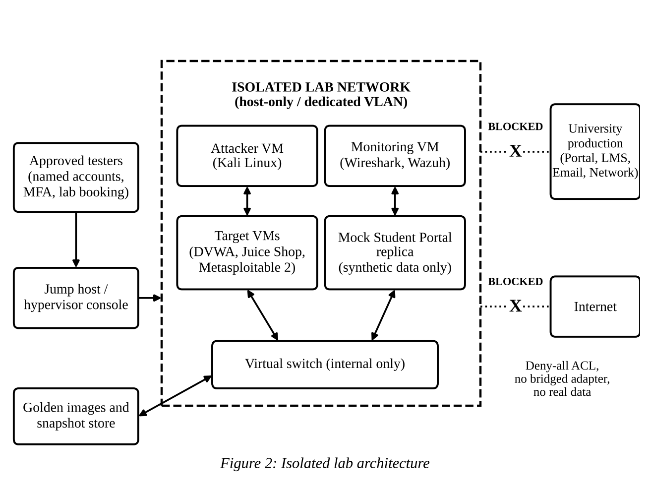
Table 7.1: Lab components
Component | Purpose | Examples
Hypervisor host | Runs all virtual machines; sits in a dedicated lab VLAN or on a standalone machine | Type 2 (VirtualBox, VMware Workstation) for small scale; Type 1 (Proxmox, ESXi) for scale-up
Attacker VM | Approved assessment tools | Kali Linux
Target VMs | Deliberately vulnerable applications for practice | DVWA, OWASP Juice Shop, WebGoat, Metasploitable 2
Mock portal replica | Replica of the student portal structure with synthetic data for Tier 3 rehearsal | Built from test build and generated records
Monitoring VM | Captures traffic and logs of every exercise | Wireshark, Wazuh
Jump host | Only entry point for approved testers | Hardened workstation with MFA
Golden images and snapshots | Clean, known-good states for quick reset | Hypervisor snapshots stored read-only

Indicative sizing for the initial programme: 16 to 32 GB RAM, 8 virtual CPUs and 500 GB SSD storage. The exact figure depends on the number of simultaneous machines.

7.3 Isolation and Safety Controls
Table 7.2: Controls and the risk each one removes
Control | Implementation | Risk removed
Network isolation | Host-only or internal virtual network, or dedicated VLAN with deny-all rules to production and the Internet; no bridged adapters | Attack traffic reaching production
Egress blocking | No outbound Internet during exercises; updates only via an approved offline process | Tools or malware escaping the lab
Synthetic data only | Generated or masked records; no real student or staff data | Personal-data exposure (DPDP Act)
Access control | Named accounts, MFA on the jump host, lab booking by approved testers only | Unauthorized use of the lab
Approved tool list | Tools downloaded from official sources, hash-verified, listed in the lab register | Tampered or unsafe tools
Snapshots and reset | Revert to golden image after each exercise | Cross-contamination between exercises
Logging and monitoring | Traffic and command logs kept for each session | Lack of accountability
Exercise approval | Every exercise is registered with purpose, tester and date | Misuse of the lab for real targets
Sanitization | Wipe or revert VMs and delete exports at the end | Residual data or tools

7.4 Lab Usage Procedure
Table 7.3: Procedure from booking to teardown
Step | Action | Owner
1 | Tester books the lab and states exercise purpose and linked engagement ID | Tester
2 | Lab Administrator approves and provisions machines from golden images | Lab Administrator
3 | Isolation checklist verified (no bridged adapter, deny-all in place, no real data) | Lab Administrator
4 | Exercise runs with monitoring and logging on | Tester
5 | Results and safe settings recorded and attached to the engagement record | Tester, EM
6 | Teardown: revert snapshots, delete exports, close session log | Lab Administrator

7.5 Lab-to-Production Rule and Scalability
- Tier 3 approval requires a lab rehearsal record (Task 2). This connects the lab directly to the authorization gate.
- As the programme grows, the lab scales by adding hypervisor nodes and cloning golden images; the same isolation checklist applies. External assessors may use the lab only through the same booking and approval route.

Expected Evidence to Submit
No. | Evidence item (attach / show) | What it proves to the evaluator
1 | Lab architecture diagram (Figure 2) | The design isolates attack traffic from production and the Internet
2 | Lab components table (Table 7.1) | Lab has the tools and replica needed for hands-on work
3 | Isolation and safety control table (Table 7.2) | Each risk has a specific control
4 | Lab usage procedure (Table 7.3) | The lab is used in a controlled, repeatable way
5 | Optional screenshots if the lab is actually built: VM list, network adapter set to host-only or internal, snapshot list, session log | Practical proof that the design was implemented

TASK 8 – DEVELOP: Reusable Templates and Documents (4 Marks)

Aim
To develop the reusable documents that make the framework usable in practice. Each template is used at a fixed lifecycle stage, produces a record for the engagement register, and feeds the next stage. Blank fields are filled in for each engagement.
Table 8.1: Template register
ID | Template | Lifecycle stage | Owner | Feeds
T-01 | Engagement Request Form | 1 Request | Sponsor | Triage and tiering
T-02 | Authorization Letter (Permission to Test) | 4 Sign-off | EM, SGB | Execution; RoE
T-03 | Rules of Engagement (body as Table 3.2 and Table 3.3) | 4 Sign-off | EM | Execution; stop conditions
T-04 | Tester NDA and Code-of-Conduct Undertaking | Before 3 Gate Review | Legal and DPO | Gate 2
T-05 | Vulnerability Finding Report | 6 Reporting | Lead Tester | Disclosure; remediation
T-06 | Engagement Closure Checklist | 7 Closure | EM | Register; lessons learned

8.1 T-01 Engagement Request Form
Field | Entry / instruction
Request ID and date | Assigned by the EM on receipt
Requesting department and sponsor | Name, designation, contact
System(s) to be tested | Name, environment (production, staging, test), owner, address or URL
Business reason | Why the test is needed (for example pre-upgrade assurance)
Type of assessment | Configuration review / vulnerability scan / web application / network / social engineering / other
Personal data involved | Yes or No; categories of data
Third-party hosted components | Yes or No; names
Proposed testers | Internal or external; names and organization
Preferred window and freeze periods | Dates and times; known examinations, admissions, result or fee dates
Sponsor declaration | I confirm I am authorized to request this test. Signature and date

8.2 T-02 Authorization Letter (Permission to Test)
Field | Entry / instruction
Authorization ID and tier | Linked to Request ID; Tier 1, 2 or 3
Issued by / issued to | Authorizing authority and title; named testers and organization
System Owner | Name, designation
In-scope assets | Exact list from the asset register (name, environment, address or URL)
Out-of-scope assets | Explicit exclusions
Permitted activities | Only those listed, matching the tier
Prohibited activities | Always-prohibited list plus any engagement-specific items
Testing window | Start and end date and time (IST)
Registered tester source addresses | Addresses to be used by the testers, shared with the SOC
Emergency contacts (24×7) | EM, System Owner, SOC contact
Data handling and report distribution | Storage location, encryption, retention, named recipients
Lab rehearsal reference | Rehearsal record ID (mandatory for Tier 3)
Authorization statement | This letter authorizes only the named persons to carry out only the listed activities on the listed assets during the stated period. Any other activity is unauthorized. It may be suspended or revoked at any time by the EM, System Owner or SGB.
Signatures | System Owner; Engagement Manager or CISO; SGB Chair (Tier 3); Legal and DPO acknowledgement; Lead Tester acknowledgement

8.3 T-03 Rules of Engagement
T-03 reuses the rule table (Table 3.2) and stop-condition table (Table 3.3). For each engagement the EM fills in the engagement-specific values: testing window, intensity limits, baseline for slowdown trigger, contacts and storage location.

8.4 T-04 Tester NDA and Code-of-Conduct Undertaking
Each tester signs an undertaking containing the following clauses:
- I will act only under a signed Authorization Letter and only within its scope and time.
- I will not test, access or disclose anything outside the scope; I will report such items to the EM.
- I will not copy, keep or share real personal data and will mask all evidence.
- I will use only approved tools and registered source addresses.
- I will stop immediately when a stop condition occurs and notify the EM.
- I will keep all findings confidential, including after the engagement ends.
- I will not publish, sell or use findings for personal gain or pressure.
- I accept that breach of this undertaking may lead to disciplinary action, contract termination and legal action.

8.5 T-05 Vulnerability Finding Report
Field | Entry / instruction
Finding ID and engagement ID | Unique reference
Title and affected asset | Short title; asset from the scope list
Description | What the weakness is and where it occurs
Evidence (masked) | Screenshot or log extract with personal data masked
Severity and CVSS vector/score | Rating from Table 6.2 with local context note
Impact and likelihood | Effect on confidentiality, integrity, availability; ease of abuse
Recommendation | Specific fix or compensating control
Reference | Relevant CWE or OWASP category
Dates | Discovered, notified, fix due, retested
Owner and status | Responsible person; open, fixed, retested, closed
Disclosure path | Internal, DPO/CERT-In, or vendor (Table 6.3)

8.6 T-06 Engagement Closure Checklist
Item | Check
Test accounts and credentials disabled or deleted | Yes / No
Tools, scripts and temporary data removed from university systems | Yes / No
Evidence archived encrypted; personal devices cleared | Yes / No
Final report delivered to the distribution list only | Yes / No
All findings entered in the register with owners and due dates | Yes / No
Retest scheduled for High and Critical findings | Yes / No
Third-party or vendor disclosures initiated where needed | Yes / No
Lessons learned recorded and framework changes proposed | Yes / No
Authorization closed; engagement register updated | Yes / No

Document control: every template carries a version number, owner and review date. The SGB reviews the template set once a year or after any serious incident.

Expected Evidence to Submit
No. | Evidence item (attach / show) | What it proves to the evaluator
1 | Template register (Table 8.1) | A complete, reusable document set linked to lifecycle stages
2 | Filled-in structure of T-01, T-02, T-05 and T-06 (Sections 8.1, 8.2, 8.5, 8.6) | Templates are practical and ready to use
3 | T-03 reference to Tables 3.2 and 3.3 and T-04 undertaking clauses (Sections 8.3, 8.4) | Rules and ethics are captured in signed documents
4 | Document control statement | Templates are managed and kept current

TASK 9 – INTEGRATE: Interaction Map and Traceability (4 Marks)

Aim
To show that the components built in Tasks 2 to 8 work together as one framework, with the output of each component becoming the input of another, rather than being isolated documents.

9.1 Component Interaction Map
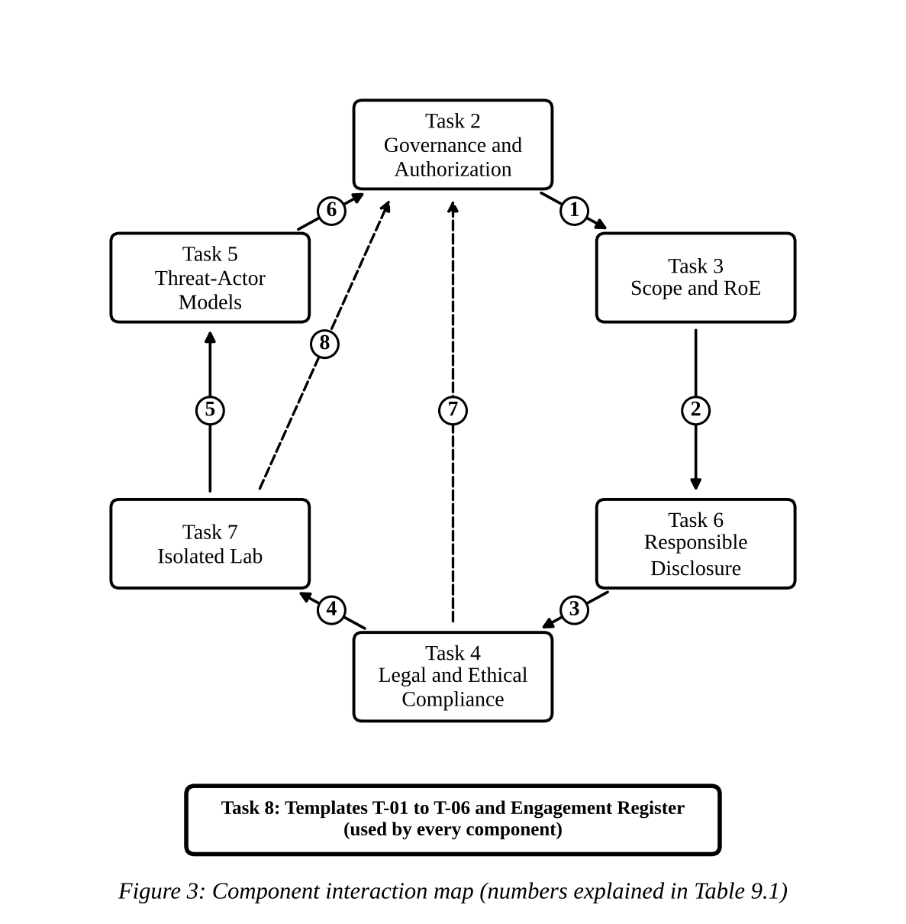
Table 9.1: Interactions shown in Figure 3
No. | From → To | What is passed | Effect on the framework
1 | Task 2 → Task 3 | Approved tier and signed authorization | Tier decides the depth of scope and RoE
2 | Task 3 → Task 6 | Scope boundaries and stop events | Decides what counts as a finding and what is an out-of-scope observation
3 | Task 6 → Task 4 | Personal-data exposure, breach, third-party issues | Triggers DPO review, CERT-In decision and vendor consent checks
4 | Task 4 → Task 7 | Data-protection and legal limits | Lab uses synthetic data only; tool and licence rules
5 | Task 7 → Task 5 | Lab observations of what is realistic and testable | Refines the threat-actor scenarios
6 | Task 5 → Task 2 | Actor models and system exposure | Informs risk tiering and test objectives
7 | Task 4 → Task 2 | Legal clearance (Gate 2) | No authorization without legal clearance
8 | Task 7 → Task 2 | Lab rehearsal record | Mandatory input for Tier 3 approval

Task 8 templates carry these outputs between components. For example, the Authorization Letter (T-02) carries tier, scope, tester addresses and lab reference, and the Finding Report (T-05) carries severity and disclosure path.

9.2 End-to-End Flow Across Components
- A department raises T-01 → the EM tiers it using asset criticality (Task 1) and actor exposure (Task 5).
- The three gates run: G1 (Task 2 rules), G2 (Task 4 checklist), G3 (appropriateness and window).
- For Tier 3, a lab rehearsal (Task 7) is completed and attached.
- Scope and RoE (Task 3) are signed in T-02/T-03.
- During testing, stop conditions (Task 3) may trigger legal and disclosure actions (Tasks 4 and 6).
- Findings follow Task 6, and T-06 closes the engagement and updates the register.

9.3 Traceability Matrix
Table 9.2: From scenario risk to control to evidence
Scenario concern | Controls in the framework | Where evidence is found
Unauthorized access (R1) | Written, specific, time-bound authorization; Gate 1; tester undertaking | Table 2.4, T-02, T-04
Legal exposure (R2) | Gate 2 checklist; law-to-control table; DPO review; NDA | Tables 4.1, 4.4
Damage to live systems (R3) | Tiering; lab-first; testing windows; intensity limits; stop conditions; prohibited list | Tables 2.3, 3.2, 3.3, 7.2
Unclear scope (R4) | Asset-register-based scope; default out-of-scope; change control | Table 3.1, Section 3.5
Uncoordinated disclosure (R5) | Single workflow; severity targets; disclosure paths; incoming report policy | Figure 4, Tables 6.2, 6.3
Personal data in testing | Masked evidence; synthetic data in lab; DPO involvement | Tables 3.2, 7.2
Different attackers | Threat-actor models drive objectives and depth | Tables 5.2, 5.3
Growth and external assessors | Tier uplift for externals; templates; register; lab booking | Table 9.3

9.4 Scalability Path
Table 9.3: How the same framework grows
Stage | Size | What stays the same | What is added
Phase 1 | About 20 systems, 50 staff | Lifecycle, gates, tiers, templates | Central engagement register; SGB meets as needed
Phase 2 | Department-wide programme | All templates and rules | Delegated EMs per faculty; ticketing for requests; shared lab calendar
Phase 3 | Whole university and external assessors | Same tiers and gates | Accredited assessor list; contract and insurance checks; periodic audit of the register

Expected Evidence to Submit
No. | Evidence item (attach / show) | What it proves to the evaluator
1 | Interaction diagram (Figure 3) and interaction table (Table 9.1) | Components exchange outputs and inputs instead of standing alone
2 | End-to-end flow (Section 9.2) | One connected process from request to closure
3 | Traceability matrix (Table 9.2) | Every scenario concern maps to controls and evidence
4 | Scalability table (Table 9.3) | The design remains usable as the programme grows

TASK 10 – CREATE: Validation Walkthrough of the Framework (4 Marks)

Aim
To validate the integrated design by walking a realistic engagement through it step by step, inserting difficult events (injects), and recording whether the framework responds correctly. This is a paper-based tabletop walkthrough. No live exploitation is performed and the findings used are illustrative.

10.1 Walkthrough Scenario
Engagement EP-01: Pre-upgrade security assessment of the student portal (web application and API). The request comes from the Controller of Examinations and IT Services. The work is to be done by an external assessor firm with one internal staff member shadowing. The portal holds personal and examination data.
Table 10.1: Step-by-step walkthrough
Step | Framework action | Component | Decision / output
1 | Sponsor submits T-01 for the portal | Task 2, 8 | Request ID EP-01 created
2 | EM triages: production system, personal data, external assessor | Task 1, 2 | Tier 3 (external uplift already at maximum)
3 | Gate 1: owner and sponsor consent; SGB approval in meeting; named testers | Task 2 | Authorization approved subject to G2 and G3
4 | Gate 2: DPO confirms personal-data handling; T-04 signed; payment gateway marked out of scope; no vendor-hosted element in scope | Task 4 | Legal clearance note issued
5 | Gate 3: window set outside result-publication freeze; proportionate depth; no social engineering | Task 2, 3 | Appropriateness confirmed; window 23:00–04:00 for five nights
6 | Threat models chosen: malicious insider and cybercriminal; APT excluded | Task 5 | Test objectives written into RoE
7 | Lab rehearsal on mock portal replica with synthetic data; rate limits validated | Task 7 | Rehearsal record attached
8 | T-02 and T-03 signed; tester addresses registered with the SOC | Task 3, 8 | Execution may start
9 | Execution with daily status to EM; SOC aware of tester addresses | Task 3 | Controlled testing
10 | Illustrative findings recorded in T-05: F-01 weak access-control check (High), F-02 missing login rate limit (Medium), F-03 verbose error messages (Low) | Task 6 | Notifications and targets set per Table 6.2
11 | Fixes done; High finding retested; T-06 completed | Task 6, 8 | Engagement closed; lessons learned logged

10.2 Challenge Events (Injects)
Table 10.2: Injects and framework response
Inject | Situation | Framework response | Result
I-1 | Tester notices the email gateway looks misconfigured (not in scope) | Observe and record only; report to EM; EM raises a scope-change request; no testing until amended T-02 | Pass
I-2 | A page unexpectedly shows real student records | Stop; no copy; masked location note; EM and DPO notified immediately; resume only after approval | Pass
I-3 | Portal response time doubles at 01:30 | Slowdown stop condition: all testing paused; SOC and owner informed; resume at reduced rate after approval | Pass
I-4 | Logs show an unknown address attacking the portal | Not a registered tester address, so treated as a real incident: stop, preserve evidence, incident response, CERT-In decision | Pass
I-5 | Department head asks for early informal sharing of findings; assessor wants to publish a blog | Refused; findings only to the distribution list; NDA and disclosure policy applied | Pass
I-6 | A weakness is found in a vendor’s LMS plugin | Gate 2 rule: no testing beyond scope; vendor disclosure path with 90-day coordination | Pass

10.3 Gaps Found and Improvements Incorporated
Table 10.3: Design improvements after the walkthrough
No. | Gap observed in first draft | Improvement made
G1 | No after-hours contact for emergency stop | 24×7 emergency contacts added to T-02
G2 | Only the SGB could pause an engagement | EM and System Owner given authority to suspend immediately
G3 | No way to tell testers from real attackers in logs | Registered tester source addresses added to T-02 and RoE
G4 | Disclosure targets did not cover third-party software | Vendor path with 90-day coordination added to Table 6.3
G5 | Lab rehearsal was not linked to approval | Lab rehearsal record made mandatory for Tier 3 approval

10.4 Validation Against Criteria
Table 10.4: Validation result
Criterion | Test applied | Result
Completeness | All seven lifecycle stages and six components used in the walkthrough | Met
Authorization clarity | Could any step start without T-02? (I-1) | Met
Legal compliance | Personal data and third-party cases handled (I-2, I-6) | Met
Safety of live systems | Slowdown and real-attack cases handled (I-3, I-4) | Met
Disclosure control | Informal sharing and vendor cases handled (I-5, I-6) | Met
Usability | Forms short, roles clear; after-hours contact gap fixed (G1–G5) | Met after improvements

Expected Evidence to Submit
No. | Evidence item (attach / show) | What it proves to the evaluator
1 | Walkthrough table (Table 10.1) | The integrated framework was exercised end to end
2 | Inject table (Table 10.2) | Framework behaves correctly under stress
3 | Gap and improvement table (Table 10.3) | Validation led to real design changes
4 | Validation criteria table (Table 10.4) | Design was judged against stated criteria
5 | Statement that no live exploitation was performed | Compliance with the assignment rule

TASK 11 – DEFEND: Justification, Trade-offs and Evidence (4 Marks)

Aim
To defend the final framework by explaining why each major governance decision was taken, what alternatives and trade-offs were considered, and how the evidence in this report supports the choice.

11.1 Major Governance Decisions
Table 11.1: Decisions, alternatives and trade-offs
Decision | Alternative considered | Why chosen | Trade-off accepted | Evidence
Three separate gates (authorized, legal, appropriate) | Authorization only | Scenario requires the three to be distinguished; real cases show they can disagree | Extra review time | Tables 1.5, 2.4, 4.5
Tiered engagements | One heavy process for all | Keeps low-risk work fast and high-risk work controlled | Need correct tiering by EM | Table 2.3
Written, time-bound, specific authorization | Verbal or email approval | Removes ambiguity and legal risk | More paperwork | Section 2.4, T-02
Central SGB for Tier 3 | Each department decides | Consistent standards; legal and data view included | Possible delay; mitigated by delegation of Tier 1–2 | Tables 2.1, 2.2
Lab-first for Tier 3 | Test directly on production | Protects live systems and personal data | Lab setup effort and cost | Figure 2, Table 7.2
Third-party systems out of scope by default | Test everything exposed | Avoids contract and legal breach | Some risk remains untested | Tables 3.1, 4.4
External assessors raised one tier | Treat same as internal | Less control over outsiders | More approvals for externals | Section 2.3, Table 9.3
Severity-based disclosure targets | Open-ended timelines | Predictable action and accountability | Targets may be tight for small teams | Table 6.2
Synthetic data in lab; masked evidence in production | Use real data for realism | Meets privacy duties | Slightly less realistic tests | Tables 3.2, 7.2
Testing windows and freeze calendar | Test any time | Avoids exam, admission and fee disruption | Narrower testing time | Table 3.2

11.2 Why the Framework Suits the Scenario
- Addresses every stated risk: unauthorized access, legal exposure, damage to live systems, unclear scope and uncoordinated disclosure each map to specific controls (Table 9.2).
- Fits the size: with about 20 systems and 50 staff, the tier model and templates avoid heavy bureaucracy while the SGB handles only high-risk work.
- Ready to grow: the same lifecycle, gates and templates extend to the whole university and to external assessors (Table 9.3).
- Integrated: components exchange outputs through templates and the register (Figure 3, Table 9.1).
- Validated: the tabletop walkthrough exercised the design and produced improvements (Tables 10.1 to 10.4).
- Safe by design: no live exploitation is required; intrusive techniques stay in the isolated lab.

11.3 Measures of Success
Table 11.2: Indicators the SGB will review
Indicator | Target
Engagements started with a signed Authorization Letter | 100%
Out-of-scope or unauthorized testing incidents | Zero
Critical findings notified within the target time | 100% (24 hours written)
Critical and High findings remediated within target | At least 90%
Tier 3 engagements with a lab rehearsal record | 100%
Engagements closed with a completed T-06 | 100%

11.4 Limitations and Residual Risks
- The framework depends on people following it; regular training and audit of the register are needed.
- The CISO office carries the EM workload; as the programme grows, faculty-level EMs are required (Table 9.3).
- Laws and rules change; the SGB reviews the legal table at least yearly.
- Validation was a tabletop exercise; the first real engagements should be reviewed closely and the framework updated.
- Some third-party-hosted risks remain untested because they need vendor consent.

11.5 Likely Questions and Defence Answers
Table 11.3: Viva questions and answers
Question | Answer
Why do you need three gates instead of one approval? | Because authorized, legal and appropriate are different tests. A fully authorized test can still be illegal (vendor-hosted LMS) or inappropriate (examination week). Table 4.5 shows these cases.
What if the System Owner approves but Legal says no? | Gate 2 is a veto. The engagement cannot start until the legal issue is fixed.
Is the lab an authorization to test production? | No. The lab only proves a technique is safe. Production testing needs a separate signed Authorization Letter.
How do external assessors fit in? | They are raised one tier, sign T-04, are covered by a contract with liability and confidentiality terms, and use registered source addresses.
What happens if a tester finds personal data? | Stop, do not copy, record the location only, notify the EM and DPO immediately, and resume only after approval (Table 3.3).
What if a vulnerability is in vendor software? | It is reported to the vendor or through CERT-In coordination with a 90-day default period. Testers never disclose publicly.
Why prohibit denial-of-service testing? | It can take down live services for the whole campus. Resilience is reviewed by design and in the lab instead.
What is the biggest weakness of the framework? | Dependence on correct human use and EM capacity. This is handled by training, audits and delegated EMs.

11.6 Conclusion
The UEHEF gives the university a single, auditable way to authorize, scope, conduct and close ethical-hacking engagements. Every major decision is supported by evidence in this report, the trade-offs are stated, and the design was tested through a walkthrough. The framework separates what is authorized, what is legal and what is appropriate, and it is ready to scale from the first 20 systems to the whole university and to external assessors.

Expected Evidence to Submit
No. | Evidence item (attach / show) | What it proves to the evaluator
1 | Decision and trade-off table (Table 11.1) | Each governance decision is justified with alternatives and evidence
2 | Suitability points (Section 11.2) and success indicators (Table 11.2) | The design fits the scenario and can be measured
3 | Limitations (Section 11.4) | Honest assessment of residual risk
4 | Viva question table (Table 11.3) | Ability to defend the design under questioning
5 | Traceability and walkthrough tables (Tables 9.2 and 10.1–10.4) | Evidence backing the defence

References
- Government of India. Information Technology Act, 2000 (as amended in 2008), Sections 43, 66, 66C, 66D, 70B and 72.
- Government of India. Digital Personal Data Protection Act, 2023, and rules made under it.
- Indian Computer Emergency Response Team (CERT-In). Directions under Section 70B(6) of the IT Act relating to information security practices, procedure, prevention, response and reporting of cyber incidents, 28 April 2022.
- NIST. Special Publication 800-115: Technical Guide to Information Security Testing and Assessment, 2008.
- ISO/IEC 27001:2022. Information security management systems – Requirements (Annex A controls 5.31, 8.8 and 8.29).
- ISO/IEC 29147:2018. Vulnerability disclosure. ISO/IEC 30111:2019. Vulnerability handling processes.
- FIRST. Common Vulnerability Scoring System (CVSS) specification.
- OWASP. Web Security Testing Guide. Penetration Testing Execution Standard (PTES). ISECOM. OSSTMM.
- EC-Council. Code of Ethics. ISC2. Code of Ethics.

