EXPERIMENT 30:
Create a Storage service using any Public Cloud Service Provider (Azure/GCP/AWS) and check the public accessibility of the stored file to demonstrate Storage as a Service.

AIM
To create and configure a cloud storage service using Microsoft Azure Blob Storage, upload a file, enable public accessibility, and verify the accessibility of the stored file through a public URL, thereby demonstrating Storage as a Service.

PROCEDURE
- Log in to the Microsoft Azure Portal using a valid Azure account.
- Create a Storage Account in Azure by providing the required subscription, resource group, storage account name, region, and performance settings.
- After the storage account is successfully created, open the storage account and navigate to Data storage → Containers.
- Create a new Blob Storage container with a suitable name.
- Configure the container's access level to allow anonymous public access to blobs.
- Upload a file such as a text file, image, or PDF into the created container.
- Select the uploaded file and view its Blob URL.
- Copy the Blob URL and open it in a separate browser window or an incognito/private browser window.
- Verify that the uploaded file can be accessed without signing in to the Azure account.
- Thus, Azure Blob Storage provides cloud-based storage and public access to the stored file, demonstrating Storage as a Service.

IMPLEMENTATION:
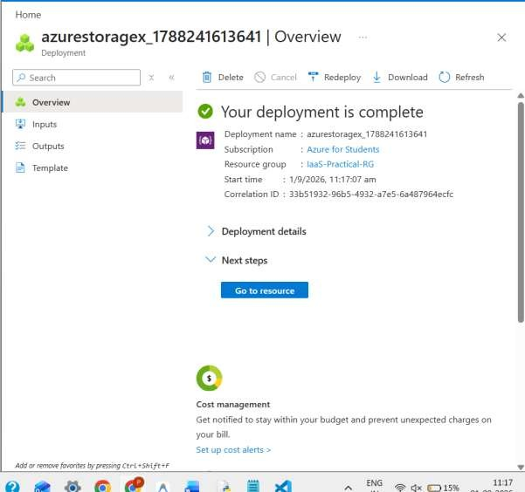
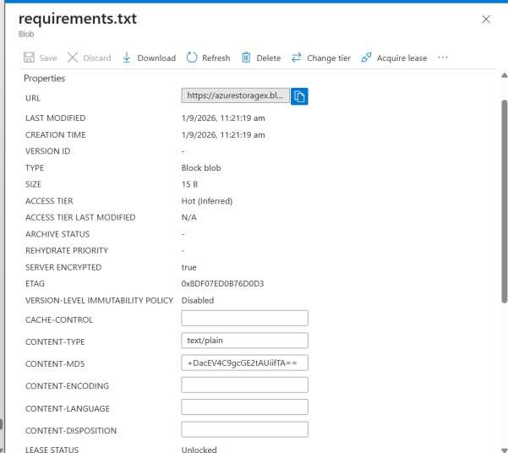

Result:
Thus, a Storage Account and Blob Storage container were successfully created in Microsoft Azure. A file was uploaded and configured for public accessibility. The file was successfully accessed using its public Blob URL, demonstrating Storage as a Service (SaaS) using Microsoft Azure.

