SIMATS ENGINEERING
ASSESSMENTTOOL1
COURSE NAME: Cryptography and Network Security
COURSE CODE: CSA5115

COURSE OUTCOME COVERED
CO3: Examine cryptographic hash algorithms, digital signature schemes, and assess Kerberos and X.509 authentication frameworks for ensuring integrity, authentication, and non-repudiation.CO (BL4 , BL5)
Assessment Tool Weightage: 40%

QUESTIONS: 5 TOTAL MARKS: 25
EXPERIMENTS

Code of Conduct:
I SWETA R 192511408 (Name / Reg No) certify that this submission is my original work and that I have adhered to the guidelines specified for this assessment.
I understand that any violation of academic integrity rules will result in disciplinary action.
Signature of the student:SWETA R

Annexure A
Experiments
- Implement and compare MD5 and Secure Hash Algorithm (SHA-256) in Python by hashing multiple input messages. Analyze their collision resistance and performance differences.
- Develop a Python program to implement a Digital Signature scheme using RSA. Demonstrate message signing and signature verification, and analyze its effectiveness in ensuring integrity and authentication.
- Write a Python program to simulate HMAC (Hash-based Message Authentication Code) using a chosen hash function. Compare its security properties with a simple hash-based integrity check.
- Implement a simplified Kerberos authentication mechanism in Python to simulate ticket generation, distribution, and validation between a client and server. Analyze its effectiveness in preventing replay attacks.
- Develop a Python-based implementation of either the ElGamal or Schnorr digital signature scheme, and evaluate its security features compared to standard digital signature approaches.
ANSWERS:
1. Implement and compare MD5 and Secure Hash Algorithm (SHA-256) in Python by hashing multiple input messages. Analyze their collision resistance and performance differences. Python code: import hashlib import time
# Multiple input messages messages = [
"Hello World",
"Cryptography",
"Computer Science",
"Secure Hash Algorithm",
"This is a test message."
]
print("MD5 and SHA-256 Hash Comparison") print("-" * 80)
for message in messages:
# MD5
start_md5 = time.perf_counter() md5_hash = hashlib.md5(message.encode()).hexdigest() end_md5 = time.perf_counter()
# SHA-256
start_sha = time.perf_counter() sha256_hash = hashlib.sha256(message.encode()).hexdigest() end_sha = time.perf_counter()
print("\nMessage:", message) print("MD5 :", md5_hash) print("SHA-256 :", sha256_hash) print("MD5 Time :", format(end_md5 - start_md5, ".10f"), "seconds") print("SHA-256 Time :", format(end_sha - start_sha, ".10f"), "seconds")
# Performance comparison using a large message large_message = "Cryptography " * 100000
print("\n" + "-" * 80) print("Performance Test with Large Input") print("-" * 80)
start = time.perf_counter() hashlib.md5(large_message.encode()).hexdigest() md5_time = time.perf_counter() - start
start = time.perf_counter() hashlib.sha256(large_message.encode()).hexdigest() sha256_time = time.perf_counter() - start
print("MD5 Time :", format(md5_time, ".6f"), "seconds") print("SHA-256 Time :", format(sha256_time, ".6f"), "seconds")
if md5_time < sha256_time:
print("Result: MD5 is faster in this test.")
else:
print("Result: SHA-256 is faster in this test.")
OUTPUT:
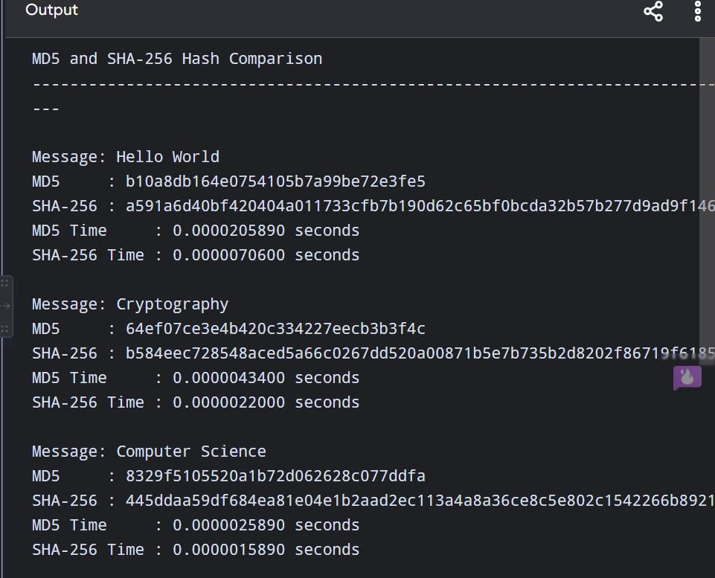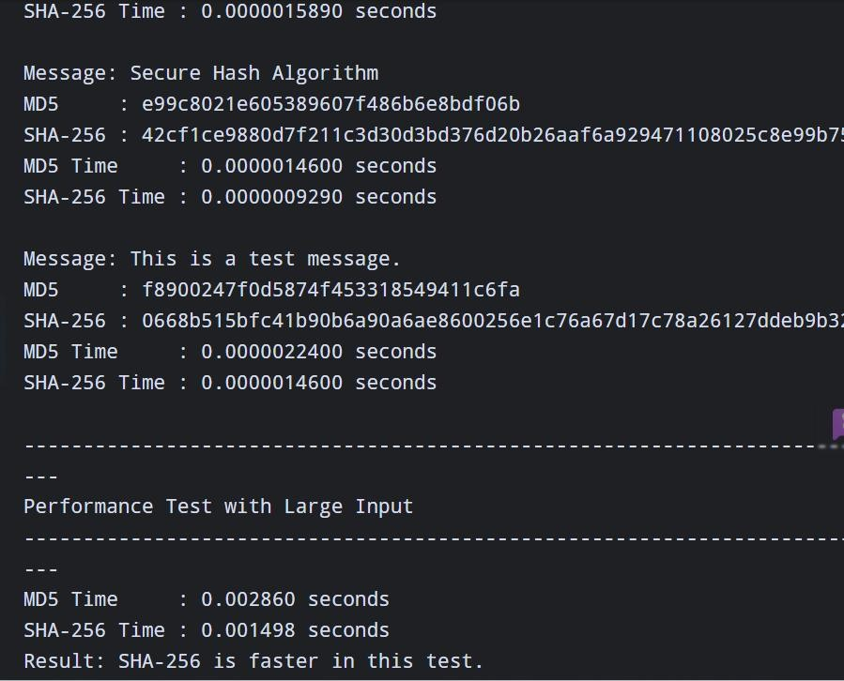
Collision Resistance Analysis:

A)MD5
MD5 produces a 128-bit hash. Practical collision attacks have been demonstrated, meaning attackers can construct different messages that produce the same MD5 hash. Therefore, MD5 should not be used for security-sensitive applications.
B)SHA-256:
SHA-256 produces a 256-bit hash and currently has no practical collision attack comparable to those against MD5. Its much larger output space provides significantly stronger collision resistance.
Performance Analysis:
MD5 generally requires less computation because it produces a smaller 128-bit digest. SHA-256 performs more processing and generates a 256-bit digest. However, the exact performance depends on the Python version, processor, OpenSSL implementation, input size, and hardware. For a meaningful experiment, use a large input and measure several iterations rather than relying on a single tiny message.
Result:
MD5 and SHA-256 were successfully implemented in Python and used to hash multiple messages. The results show that both algorithms generate fixed-length hash values, but SHA-256 provides significantly stronger collision resistance than MD5. MD5 may be faster in some environments, but it is cryptographically broken and should not be used for security applications. SHA-256 is therefore preferred when integrity and security are required.
5.Develop a Python-based implementation of either the ElGamal or Schnorr digital signature scheme, and evaluate its security features compared to standard digital signature approaches.

Algorithm

Key Generation
- Select a large prime number p.
- Select a generator g.
- Choose a private key x.
- Calculate the public key: y=g^x mod p
- Public key = (p, g, y).
- Private key = x.

Signature Generation
- Hash the message using SHA-256.
- Choose a random integer k such that:gcd(k,p−1)=1
- Calculate:r=g^k mod p
- Calculate: s=k^−1(H(m) − xr) mod (p−1)
- Signature = (r,s).
Signature Verification:
The signature is valid if: Y^r r^s mod p=g^H(m) mod p Python implementation:
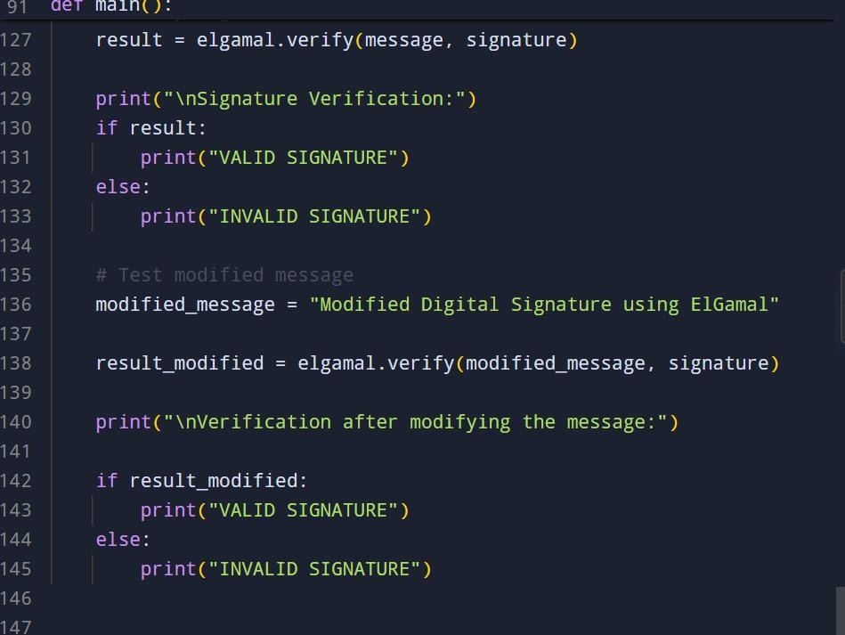
Output:
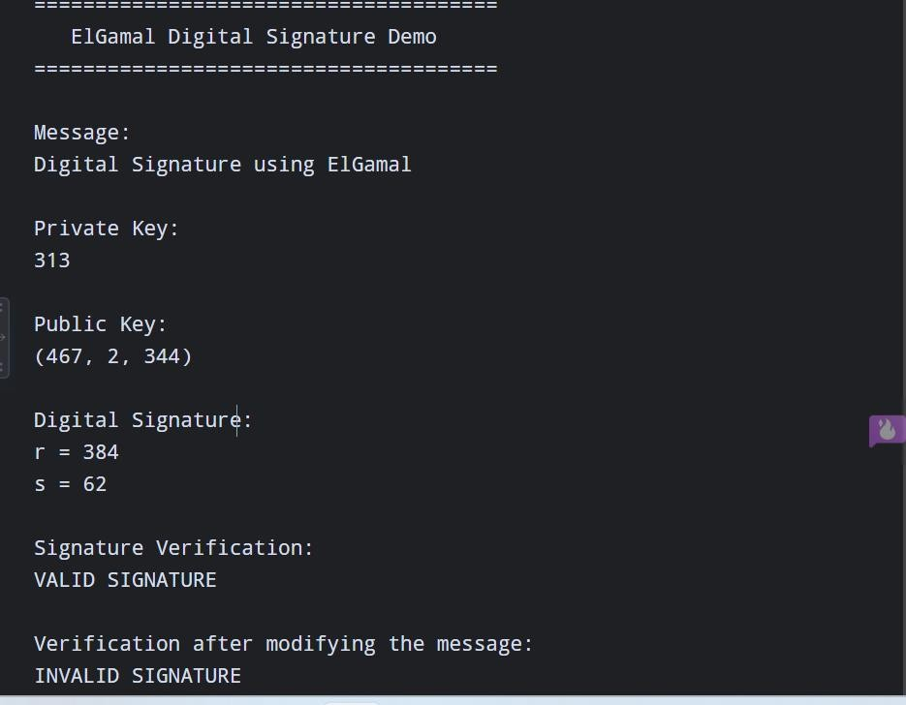

Important Security Point
- The random value k is extremely important. It must be generated securely and must never be reused for two different messages. Reusing k can expose the private key.
- The small values p = 467 and g = 2 in the program are only for classroom demonstration.
They are not secure for real-world cryptographic use.
Security Evaluation:
ElGamal provides three important security properties:
  - Authentication – confirms that the signature was generated using the holder's private key.
  - Integrity – any modification of the message causes signature verification to fail.
  - Non-repudiation – a valid signature can provide evidence that the private-key holder signed the message, assuming proper key management.
However, compared with modern approaches, traditional ElGamal signatures have disadvantages:
  - They require relatively large keys.
  - Signatures are comparatively large.
  - Signature generation requires a fresh random value.
  - Poor random-number generation can compromise the private key.
  - Modern elliptic-curve schemes provide comparable security with much smaller keys.

Applications
ElGamal-type digital signatures can be used in:
- Secure document signing
- Authentication systems
- Secure communication
- Software/package verification
- Electronic transactions
- Public-key cryptographic systems
Thus, the ElGamal Digital Signature Scheme was successfully implemented in Python using SHA-256 for message hashing. The implementation successfully generates public/private keys, creates digital signatures, and verifies their authenticity. A modified message is correctly detected as invalid. ElGamal provides authentication, integrity, and non-repudiation, but modern schemes such as RSA-PSS, ECDSA, and EdDSA are generally preferred for practical systems because of improved efficiency and smaller key/signature sizes.
RUBRICS FOR CALCULATION:
Criteria | Weighta ge | Level 4 –  Exemplary | Level 3 –  Proficient | Level 2 –  Developing | Level 1 –  Beginning
Understandi ng of  Concepts | 25 | Demonstrates thorough understanding and effectively integrates multiple concepts/technolo gies | Good  understandi ng with proper integration of most concepts | Basic understandin  g; limited or partial integration | Poor understandin g; unable to integrate concepts
Experiment al Design | 30 | Well-planned, systematic implementation with optimal solution | Correct implementat ion with minor issues | Basic implementati on with errors or  inefficiencies | Incorrect or incomplete implementati on
Use of Tools | 20 | Effective and advanced use of  tools/technologies with proper configuration | Appropriate use of tools with correct execution | Limited or inconsistent use of tools | Incorrect or minimal use of tools
Analysis of Results | 15 | Insightful analysis with accurate | Good  analysis | Basic analysis with | Poor or  incorrect

 |  | interpretation and validation of results | with reasonable  interpretatio  n | limited insights | analysis of results
Documentat  ion | 10 | Clear, wellstructured documentation with diagrams, code, and results | Organized documentati on with  necessary details | Basic documentatio n with missing details | Poor or incomplete documentatio n

