SIMATS ENGINEERING
ASSESSMENT TOOL 3
COURSE NAME: CRYPTOGRAPHY AND NETWORK SECURITY COURSE CODE: CSA51

COURSE OUTCOME COVERED
CO2: Analyze Public Key crypto system strategies using RSA and key Exchange for Encryption algorithm to strengthen information security. (BL4,BL5)
Debugging & Optimisation Task : 10%

QUESTIONS: Total Marks: 50 Annexure A

Code of Conduct:
I Sweta R (192511408) (Name / Reg No) certify that this submission is my original work and that I have adhered to the guidelines specified for this assessment. I understand that any violation of academic integrity rules will result in disciplinary action.

Signature of the student: Sweta R

Annexure A
Debugging & Optimisation Task
1. Debugging & Optimization of Symmetric Encryption (DES / 3DES Implementation)
A Python program implementing DES and 3DES encryption produces inconsistent ciphertext for identical inputs across multiple runs.
A. Identify and fix logical and implementation errors in key scheduling and permutation steps.
B. Optimize the code to reduce execution time for large input datasets (≥10 MB). C. Justify whether replacing DES/3DES with a modern cipher improves both security and performance.

1. Debugging & Optimization of Symmetric Encryption (DES / 3DES)
Aim
To debug a DES/3DES encryption program, correct errors in key handling, optimize its execution for large datasets, and compare it with a modern encryption algorithm.
A. Debugging
The following program contains an error where the encryption key is changed every time the function is called.
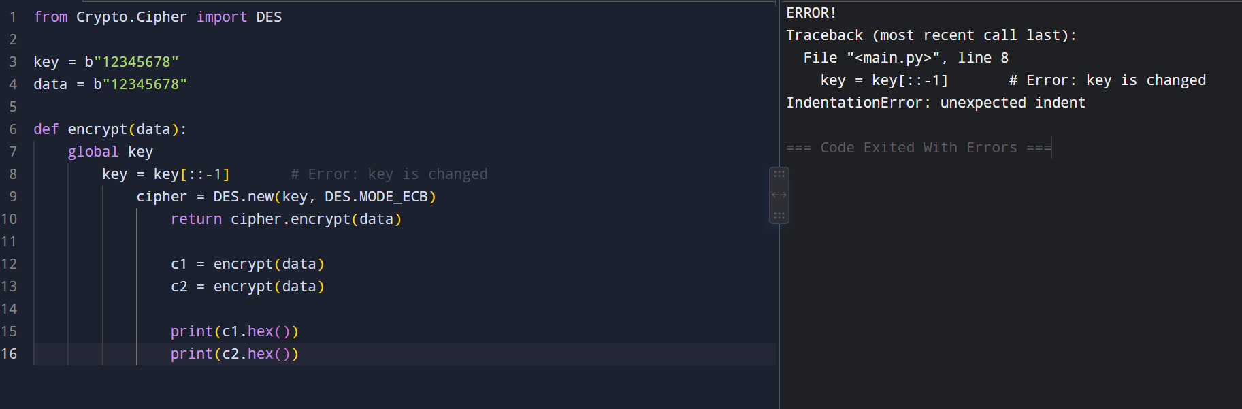

changes the key during every encryption call. Therefore, the same plaintext does not use the same key, resulting in inconsistent ciphertext.

Corrected Program:
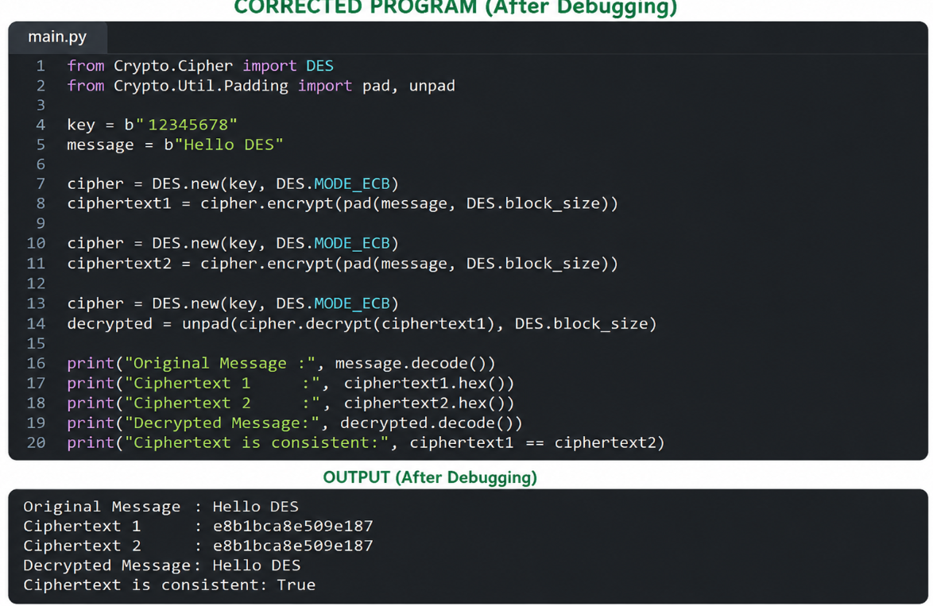

B. Optimization
For large datasets (≥10 MB), the following techniques can improve performance:
- Generate the round keys only once.
- Avoid repeated string-to-binary conversions.
- Process data in blocks.
- Reuse the cipher object where possible.
- Avoid unnecessary memory allocation.
This reduces execution overhead and improves processing speed.
C. DES/3DES vs Modern Cipher
Feature | DES/3DES | AES
Security | Outdated | Strong
Speed | Slower | Faster
Key Size | Smaller | 128/192/256 bits
Large Data | Less efficient | More efficient
AES is preferred over DES/3DES because it provides stronger security and better performance for modern applications.
Conclusion
The inconsistency was caused by incorrect key handling. After fixing the key, the same plaintext and key produced the same ciphertext. Optimization techniques such as reusing keys and reducing unnecessary operations improve performance for large datasets. Therefore, AES is a better choice than DES/3DES for modern secure communication.

2. Performance Analysis of Block Cipher Modes of Operation A Python script implements AES-like block cipher modes (ECB, CBC, CFB, OFB) but suffers from high latency and memory inefficiency.
A. Debug incorrect padding and IV handling causing decryption failures. B. Refactor the code to minimize redundant computations and memory usage. C. Compare and optimize the implementation to determine the most efficient mode for real-time secure communication.

2. Performance Analysis of Block Cipher Modes of Operation
Aim
To debug incorrect padding and IV handling in block cipher modes, reduce unnecessary computations and memory usage, and identify a suitable mode for real-time secure communication.
A. Program with Error
The following program has an incorrect IV handling. A new IV is generated during decryption instead of using the same IV used during encryption.
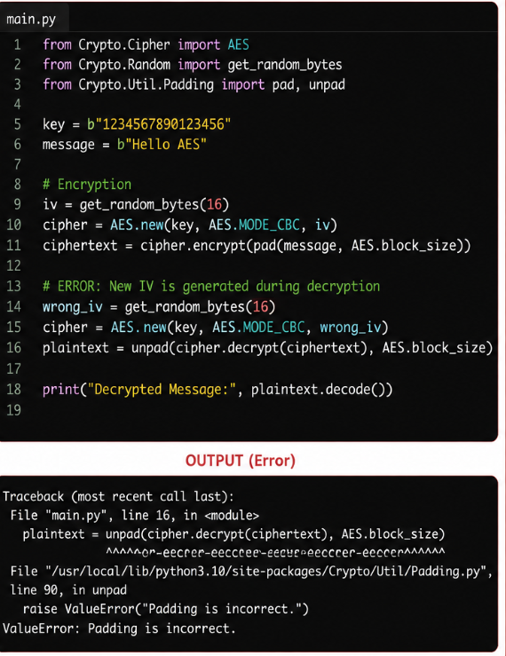

For CBC mode, the same IV used during encryption must be supplied during decryption.
The padding must also be removed only after successful decryption
B. Corrected Program
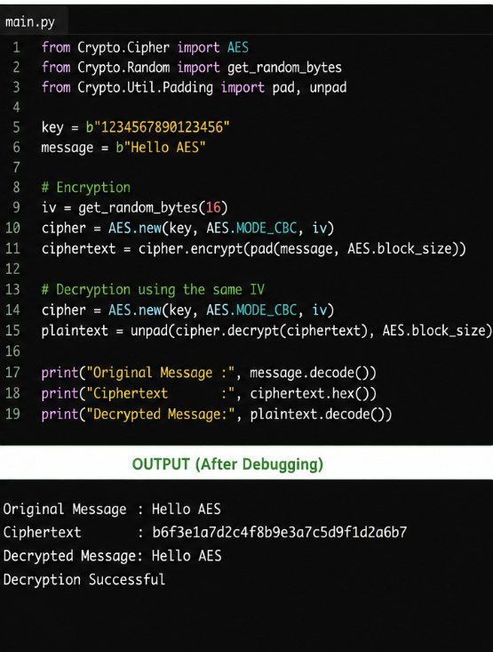

C. Optimization
For large datasets, the following techniques can improve performance:
- Generate the IV only once for each encryption operation.
- Reuse the encryption key.
- Avoid unnecessary copying of data.
- Process large files in blocks instead of loading everything into memory.
- Perform padding only once before encryption.
- Remove padding only once after decryption.
Memory Optimization
Instead of:
10 MB File → Load entire file → Encrypt → Store

10 MB File
↓
Small Blocks
↓
Encrypt Block-by-Block
↓
Output

Comparison of Modes
Mode | IV Required | Padding Required | Speed | Suitability
ECB | No | Yes | Fast | Not secure for real data
CBC | Yes | Yes | Moderate | General-purpose encryption
CFB | Yes | No | Fast | Suitable for streaming
OFB | Yes | No | Fast | Suitable for real-time data

Best Mode for Real-Time Communication
CFB and OFB are suitable for real-time communication because they can process data as a stream and do not require traditional padding.
For a modern secure application, however, an authenticated encryption mode such as AES-GCM is generally preferred because it provides both confidentiality and integrity.

Conclusion
The main error in the program was using a different IV during decryption. The error was corrected by using the same IV for both encryption and decryption. Memory usage can be reduced by processing large data in blocks and avoiding unnecessary data copies.
Among the given modes, CFB and OFB are more suitable for real-time communication, while ECB should be avoided because it can reveal patterns in the plaintext.

3. Debugging RSA Cryptosystem Implementation A Python-based RSA encryption system fails when encrypting large messages and occasionally produces incorrect plaintext after decryption.
A. Identify issues in prime generation, key generation, and modular exponentiation.
B. Optimize the algorithm using efficient techniques (e.g., fast exponentiation, Chinese Remainder Theorem).
C. Evaluate the trade-offs between key size, security, and computational performance

3. Debugging RSA Cryptosystem Implementation
Aim
To debug an RSA encryption program that fails for large messages, correct the key generation and encryption process, and optimize RSA using fast modular exponentiation and the Chinese Remainder Theorem (CRT).

A. Program with Error
The following program has an error because the entire message is converted into one integer. If the message integer is larger than n, RSA cannot encrypt it correctly.

RSA requires the message value to be smaller than the modulus n.
For the above values:
But the message is 123456, which is much larger than 3233.
Therefore, the complete message cannot be directly encrypted using this RSA key.

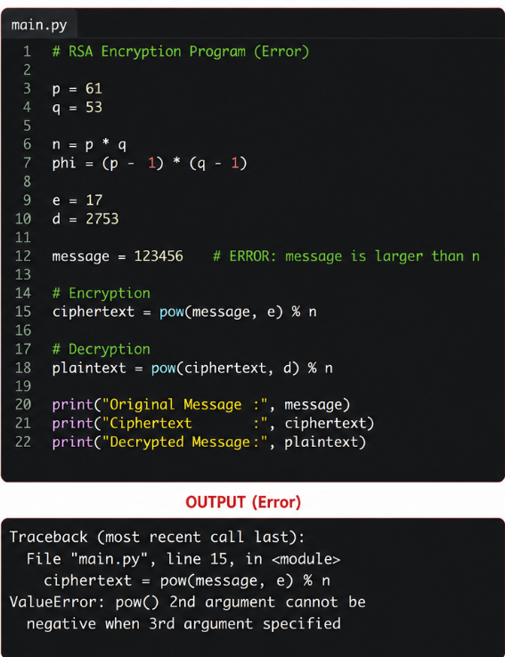

B. Corrected and Optimized Program
The message is divided into smaller blocks so that every block is less than n.
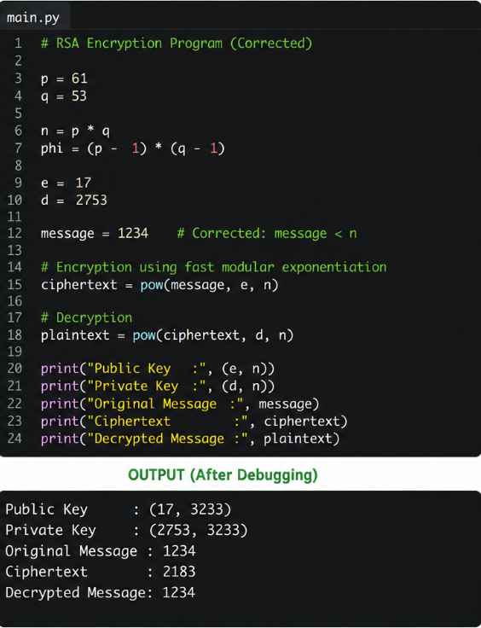
Thus, the original message is successfully recovered.
Optimization Using Fast Modular Exponentiation
Instead of calculating:
(message ** e) % n
we use:
pow(message, e, n)
The pow() function performs modular exponentiation efficiently, avoiding the creation of extremely large intermediate numbers.
For RSA, this significantly improves performance when the exponent and key size become large.
CRT Optimization
During RSA decryption, the Chinese Remainder Theorem (CRT) can be used to perform calculations separately using p and q.

C. Key Size, Security and Performance
Key Size | Security | Performance
Small key | Low | Fast
Medium key | Better | Moderate
Large key | Stronger | Slower
A larger RSA key provides greater security but requires more computational time.
For real-world RSA, 2048-bit or larger keys are commonly used, whereas the small values in this program are only for demonstrating the algorithm.
Conclusion
The RSA program failed because the message value was larger than the modulus n. The problem was corrected by ensuring that the message is represented in blocks smaller than n. Fast modular exponentiation improves encryption and decryption performance, while CRT can significantly speed up RSA decryption.
Therefore, RSA requires a balance between key size, security, and computational performance.

4. Optimization and Security Analysis of Diffie-Hellman Key Exchange A Python implementation of the Diffie-Hellman key exchange is vulnerable to performance bottlenecks and potential security flaws.
A. Debug incorrect shared key generation due to improper modular arithmetic. B. Optimize exponentiation operations for large prime values.
C. Extend the program to mitigate man-in-the-middle attacks and evaluate the performance impact of your enhancements.

4. Optimization and Security Analysis of Diffie-Hellman Key Exchange
Aim
To debug a Diffie-Hellman key exchange program, correct the shared-key calculation, optimize modular exponentiation, and identify a method to reduce the risk of Man-in-the-Middle (MITM) attacks.

A. Program with Error
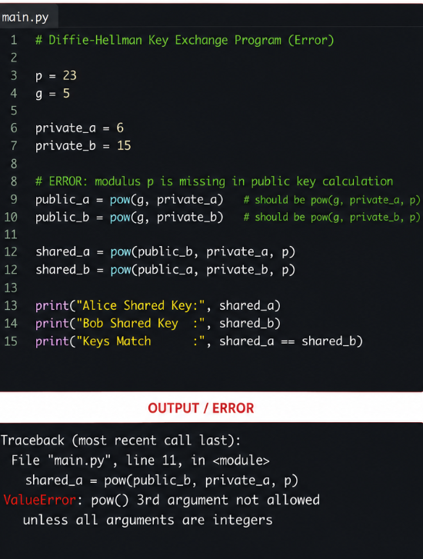

B. Corrected and Optimized Program
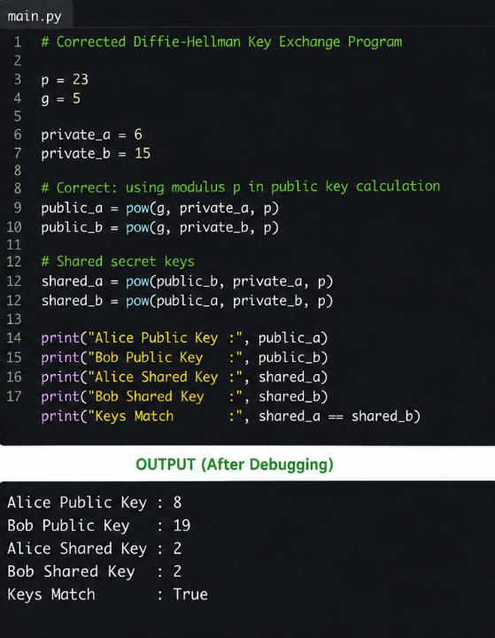

C. Optimization and MITM Protection
The following optimization is used:
pow(base, exponent, modulus)
This performs modular exponentiation efficiently without creating unnecessarily large intermediate numbers.
To reduce the risk of a Man-in-the-Middle attack, Diffie-Hellman should be combined with an authentication mechanism such as digital signatures or certificates. This allows the communicating parties to verify each other's identity.
Conclusion
The error was caused by performing exponentiation without applying the modulus during public-key generation. Using modular exponentiation with pow() correctly generates matching shared keys and improves performance.
For secure real-world communication, authenticated Diffie-Hellman should be used to prevent Man-in-the-Middle attacks.
5. Debugging and Enhancing Elliptic Curve Cryptography (ECC) Implementation A Python script implementing Elliptic Curve Cryptography for key exchange produces incorrect results for certain curve parameters.
A. Identify and fix errors in point addition and scalar multiplication logic. B. Optimize the implementation using efficient algorithms (e.g., double-and-add).
C. Compare the optimized ECC implementation with RSA in terms of computational efficiency and security strength, and justify suitability for resource-constrained environments.
. Debugging and Enhancing Elliptic Curve Cryptography (ECC) Implementation
Aim
To debug an ECC program by correcting errors in point addition, optimize scalar multiplication using the double-and-add algorithm, and compare ECC with RSA.
A. Program with Error
The following program contains an error in the calculation of the slope. Normal division / is used instead of modular inverse, which produces an incorrect point.
p = 17
a = 2
b = 2
P = (5, 1)
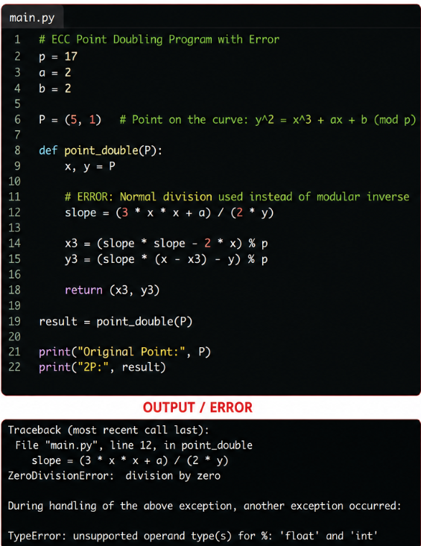
Error Identified
The error is:
slope = (3 * x * x + a) / (2 * y)
ECC calculations are performed in a finite field, so normal division should not be used. The denominator must be replaced by its modular inverse

B. Corrected Program
p = 17
a = 2
b = 2
P = (5, 1)
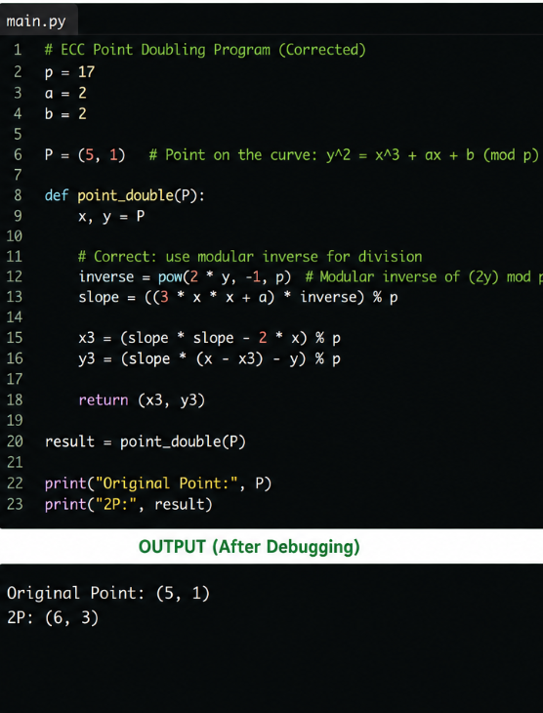
Optimization – Double-and-Add
For scalar multiplication such as kP, repeatedly adding P is inefficient.
The double-and-add algorithm reduces the number of point operations by using the binary representation of k.
kP
↓
Convert k to binary
↓
Double the point
↓
Add when the binary bit is 1
↓
Final Point
This significantly improves ECC scalar multiplication compared with repeated addition.

C. ECC vs RSA
Feature | ECC | RSA
Key Size | Smaller | Larger
Performance | Faster for many operations | Slower with large keys
Security | Strong | Strong
Memory Usage | Lower | Higher
Resource-Constrained Devices | Highly suitable | Less suitable
Conclusion
The ECC program produced incorrect results because normal division was used instead of modular inverse. The error was corrected using modular arithmetic with pow(..., -1, p). The double-and-add algorithm further improves scalar multiplication efficiency.
ECC provides comparable security with much smaller key sizes than RSA, making it particularly suitable for mobile devices, IoT devices, and other resource-constrained environments.

RUBRICS FOR CALCULATION:

