SIMATS ENGINEERING
ASSESSMENTTOOL1
COURSE CODE: CSA5115 COURSE NAME: Cryptography and Network Security

COURSE OUTCOME COVERED
CO4: Implement best security practices for IP, email, and web service using PGP,
S/MIME for enhancing email Security.CO (BL3, BL6)
Assessment Tool Weightage: 40%

QUESTIONS: 5 TOTAL MARKS: 25
Annexure A Coding Challenge

Code of Conduct:
I Sweta R 192511408 (Name / Reg No) certify that this submission is my original work and that I have adhered to the guidelines specified for this assessment.
I understand that any violation of academic integrity rules will result in disciplinary action.
Signature of the student:SWETA R

Annexure A
Coding Challenge
- Write a program to simulate the IPSec Authentication Header (AH) process that generates and verifies a message authentication code (MAC) for IP packet integrity.
- Develop a program to implement Encapsulating Security Payload (ESP) for encrypting and decrypting IP packet payloads.
- Design a program to manage Security Associations (SA) in IPSec, including creation, lookup, and deletion operations.
- Implement a simplified Pretty Good Privacy (PGP) system for secure email communication using public key encryption and digital signatures.
- Create a program to classify emails as spam or legitimate using email header analysis and content-based filtering techniques.
1. Write a program to simulate the IPSec Authentication Header (AH) process that generates and verifies a message authentication code (MAC) for IP packet integrity.
Python Code: import hmac import hashlib
# Generate MAC for the IP packet def generate_mac(packet, key):
return hmac.new( key.encode(), packet.encode(), hashlib.sha256
).hexdigest()
# Verify the received packet def verify_mac(packet, received_mac, key): calculated_mac = generate_mac(packet, key) return hmac.compare_digest(calculated_mac, received_mac)
# -------- IPSec AH Simulation --------
key = "secretkey123"
# Original IP packet data packet = "SRC=192.168.1.10|DST=192.168.1.20|DATA=Hello IPSec"
print("Original IP Packet:") print(packet)
# AH process: Generate Authentication Data (MAC) mac = generate_mac(packet, key)
print("\nGenerated AH Authentication Data (MAC):") print(mac)
# Receiver verifies the packet print("\n--- Verification of Original Packet ---")
if verify_mac(packet, mac, key):
print("MAC Verification Successful") print("Packet integrity and authenticity verified.")
else:
print("MAC Verification Failed") print("Packet may have been modified.")
# Simulate packet modification modified_packet = "SRC=192.168.1.10|DST=192.168.1.20|DATA=Hacked"
print("\n--- Verification of Modified Packet ---") print("Modified Packet:") print(modified_packet)
if verify_mac(modified_packet, mac, key): print("MAC Verification Successful") print("Packet is valid.")
else:
print("MAC Verification Failed") print("Packet has been modified!") Output:
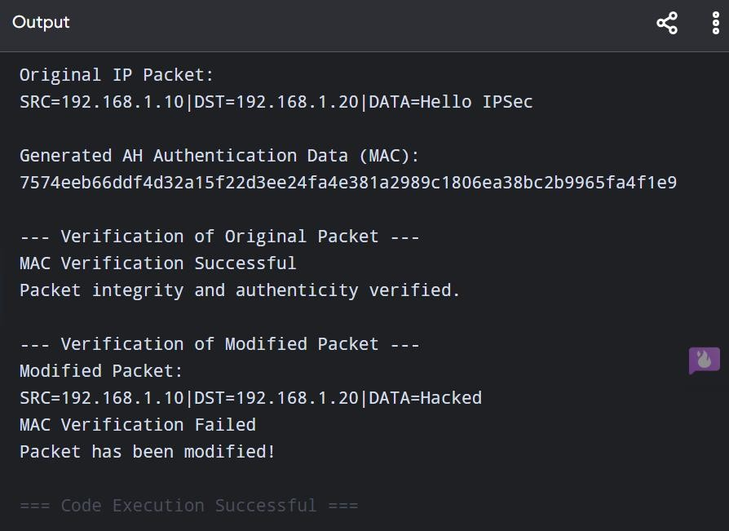

How it simulates IPSec AH
- The IP packet contains source, destination, and data.
- A secret authentication key is shared between sender and receiver.
- The sender generates an HMAC-SHA256 MAC for the packet.
- The MAC represents the Authentication Data carried by the AH.
- The receiver recalculates the MAC using the same key.
- If both MACs match, the packet is considered authentic and unmodified.
- If the packet is changed, the calculated MAC differs and verification fails.
6. Create a program to classify emails as spam or legitimate using email header analysis and content-based filtering techniques.
Python code: import re
# Spam keywords spam_keywords = [
"win", "winner", "free", "prize", "offer",
"urgent", "click here", "lottery", "money",
"congratulations", "claim", "cash", "bonus"
]
def classify_email(sender, subject, body): spam_score = 0
# ---------------- Header Analysis ----------------
# Check suspicious sender domains suspicious_domains = [
"spam.com",
"fake-mail.com",
"unknown.com",
"lottery.com"
]
sender_domain = sender.split("@")[-1].lower()
if sender_domain in suspicious_domains: spam_score += 3
# Check suspicious sender names
if re.search(r"noreply|winner|prize|lottery|admin", sender.lower()): spam_score += 1
# ---------------- Content Analysis ----------------
text = (subject + " " + body).lower()
# Check spam keywords for word in spam_keywords:
if word in text:
spam_score += 1
# Check excessive exclamation marks if text.count("!") >= 3: spam_score += 1
# Check suspicious links if "http://" in text or "bit.ly" in text or "click here" in text: spam_score += 2
# Check excessive capital letters uppercase_count = sum(1 for c in subject if c.isupper()) if uppercase_count >= 5:
spam_score += 1
# ---------------- Final Classification ----------------
if spam_score >= 4:
return "SPAM", spam_score
else:
return "LEGITIMATE", spam_score
# ---------------- Main Program ----------------
print("===== EMAIL SPAM CLASSIFIER =====")
sender = input("Enter sender email: ") subject = input("Enter email subject: ") body = input("Enter email body: ")
result, score = classify_email(sender, subject, body)
print("\n----- RESULT -----") print("Spam Score:", score) print("Classification:", result)
if result == "SPAM":
print("Warning: This email appears to be suspicious.")
else:
print("This email appears to be legitimate.")
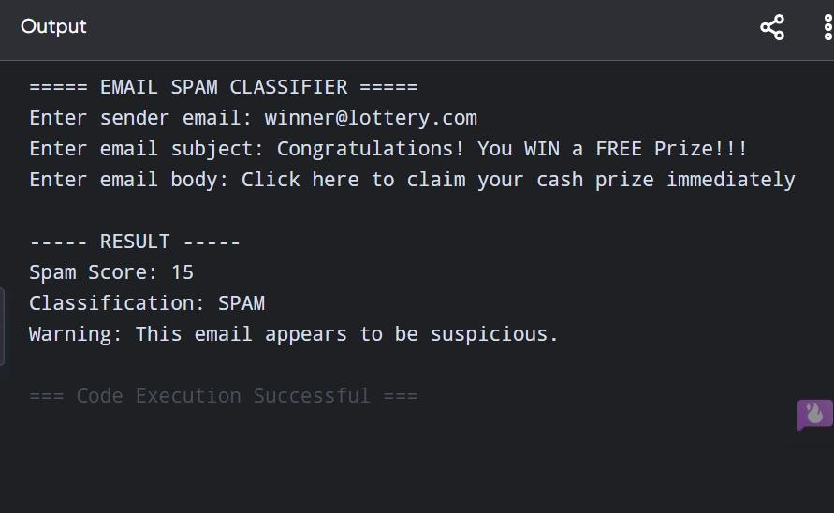

Techniques Used
- Header Analysis: Checks the sender's email domain and suspicious sender names.
- Keyword Filtering: Searches for words commonly associated with spam.
- URL Detection: Detects suspicious links such as bit.ly and http://.
- Capitalization Analysis: Identifies excessive capital letters in the subject.
- Punctuation Analysis: Detects excessive exclamation marks.
- Spam Score: Combines the detected indicators to classify the email. • Final Decision: Score ≥ 4 → SPAM, otherwise → LEGITIMATE.
RUBRICS FOR CALCULATION:
Criteria | Weigh tage | Level 4  (Exemplary) | Level 3  (Proficient) | Level 2  (Developing) | Level 1  (Beginning  )
Problem Understanding | 20% | Clearly understands problem constraints, edge cases, and competitive requirements | Understands problem with  minor gaps in constraints | Partial understanding;  misses key constraints | Misinterprets problem or constraints
Algorithm | 25% | Selects optimal algorithm with best time and space complexity for competitive constraints | Uses efficient algorithm with minor scope for improvement | Uses  basic/inefficien t approach | No clear  algorithmic approach
Code  Implementation | 20% | Writes correct, efficient, and clean code that passes all constraints | Code works with minor errors or inefficiencies | Partially correct code; fails for some cases | Code does not execute or gives incorrect results
Competitive Performance | 20% | Solves problem within time limits and handles large inputs effectively | Solves within acceptable time with minor delays | Struggles with time limits or larger inputs | Unable to solve within time constraints
Test Case Handling | 15% | Handles all test cases including edge and hidden cases | Handles most test cases | Misses important edge cases | Fails on multiple test cases

