Exp 28 : Write a Prolog Program for STUDENT-TEACHER-SUB-CODE.
Aim
To write a Prolog program to represent the relationship between students, teachers, and subjects and retrieve the corresponding information using queries.
Objectives
- To understand relationships between different entities in Prolog.
- To represent student, teacher, and subject information using facts.
- To create rules for finding the teacher and subject associated with a student.
Algorithm
- Start the Prolog program.
- Define facts for students, teachers, and subjects.
- Define a relationship between a student, teacher, and subject.
- Create rules to find the teacher or subject for a given student.
- Load the program into the Prolog interpreter.
- Execute queries to retrieve the required information.
- Display the results.
- Stop the program.

PROGRAM:
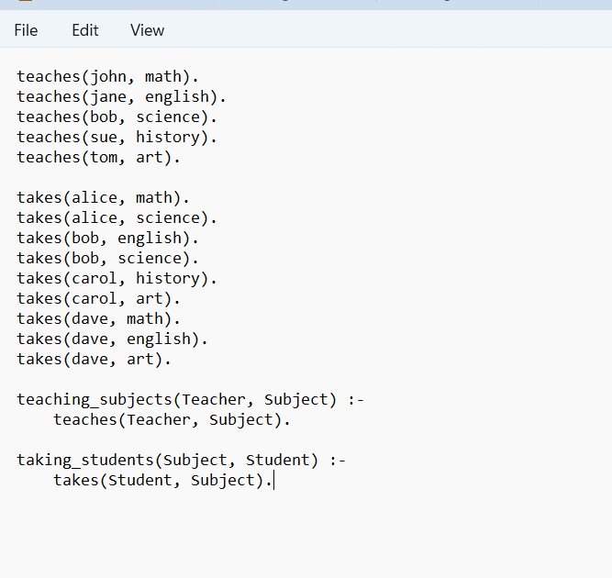
OUTPUT:
Output:
Student = alice ;
Student = dave ;
Student = carol.
RESULT:
Hence Prolog Program for STUDENT-TEACHER-SUB-CODE is done.

