Exp 27: Write a Prolog Program for A DB WITH NAME,DOB.
Aim
To write a Prolog program to create and query a database containing a person's Name and Date of Birth (DOB).
Objectives
  - To understand facts and queries in Prolog.
  - To create a simple database using Prolog facts.
  - To retrieve a person's DOB using their name.
  - To learn how Prolog performs logical matching and searching.
Algorithm
  - Start the Prolog program.
  - Define facts containing the name and date of birth of persons.
  - Create a rule to find the DOB corresponding to a given name.
  - Load the program into the Prolog interpreter.
  - Enter a person's name as a query.
  - Prolog searches the database and displays the corresponding DOB.
  - Stop the program.

PROGRAM:
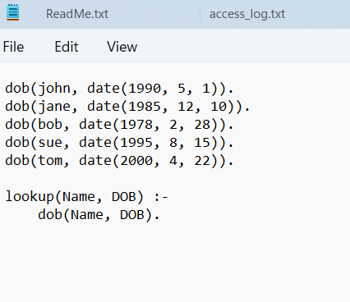

OUTPUT:
- 