Smart Waste Collection and Recycling Management System

CODE — MODULE 1
"""
MODULE 1 - CO2: Control flow, string operations, and functions
Used to validate and process waste-related text/number input.
"""

def normalize_text(text):
return text.strip().title()

def is_valid_name(text):
text = text.strip()
return text.replace(" ", "").isalpha() and len(text) > 0

def is_valid_number(text):
try:
float(text)
return True
except ValueError:
return False

def format_table(headers, rows):
"""Builds an aligned text table using string methods (ljust)."""
widths = []
i = 0
while i < len(headers):
widths.append(len(headers[i]))
i += 1

for row in rows:
i = 0
while i < len(row):
cell_len = len(str(row[i]))
if cell_len > widths[i]:
widths[i] = cell_len
i += 1

line_parts = []
i = 0
while i < len(headers):
line_parts.append(headers[i].ljust(widths[i]))
i += 1
line = " ".join(line_parts)
sep = "-" * len(line)

out = [line, sep]
for row in rows:
row_parts = []
i = 0
while i < len(row):
row_parts.append(str(row[i]).ljust(widths[i]))
i += 1
out.append(" ".join(row_parts))

return "\n".join(out)

PSEUDOCODE — MODULE 1
MODULE module1_string_ops

FUNCTION normalize_text(text):
text = REMOVE leading/trailing spaces from text
text = CONVERT text to Title Case
RETURN text

FUNCTION is_valid_name(text):
text = REMOVE leading/trailing spaces from text
temp = REMOVE all spaces from text
IF temp contains only alphabetic characters AND length of text > 0 THEN
RETURN True
ELSE
RETURN False
END IF

FUNCTION is_valid_number(text):
TRY:
CONVERT text to float
RETURN True
CATCH error:
RETURN False
END TRY

FUNCTION format_table(headers, rows):
widths = EMPTY LIST
FOR each header IN headers:
APPEND length of header TO widths
END FOR

FOR each row IN rows:
FOR i FROM 0 TO length of row - 1:
IF length of row[i] > widths[i] THEN
widths[i] = length of row[i]
END IF
END FOR
END FOR

line = JOIN each header padded to widths[i] with 2 spaces
separator = "-" repeated (length of line) times
output = LIST containing [line, separator]

FOR each row IN rows:
row_line = JOIN each cell padded to widths[i] with 2 spaces
APPEND row_line TO output
END FOR

RETURN output joined by newlines
END MODULE

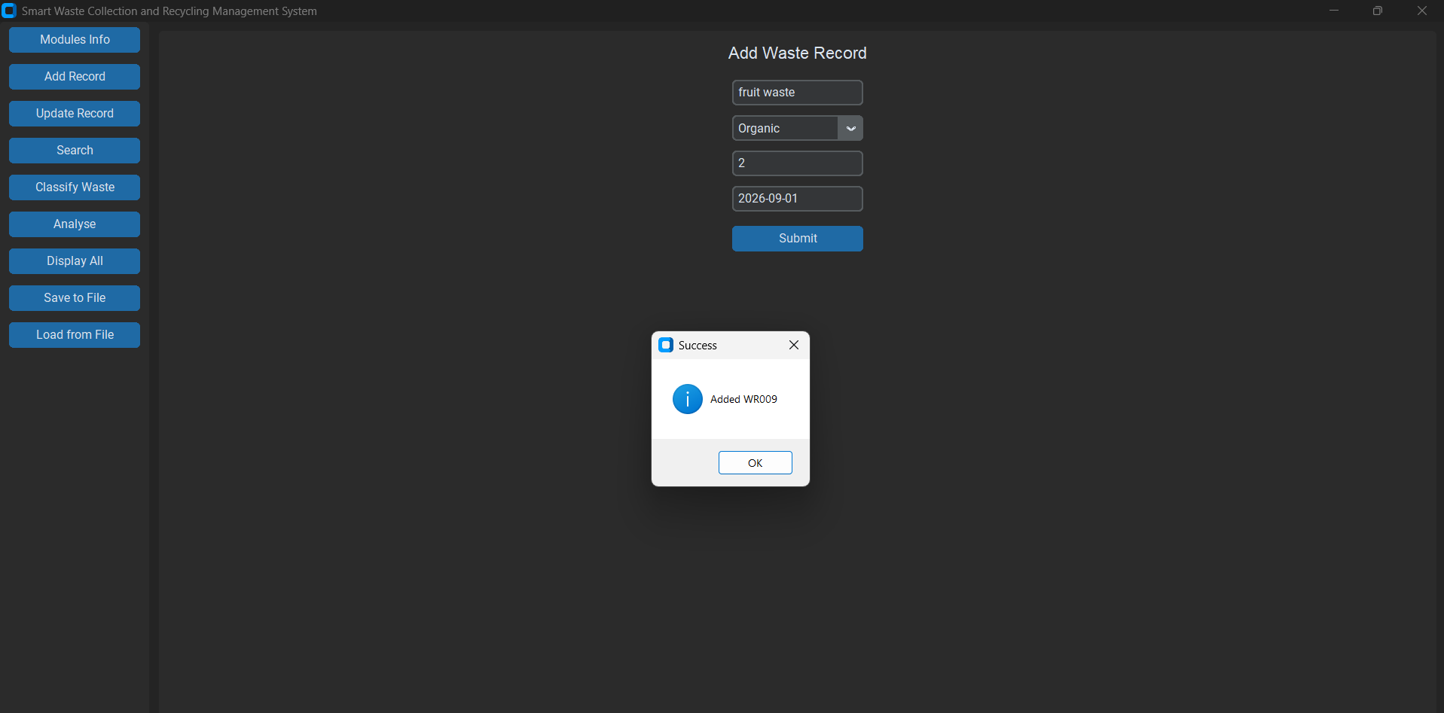

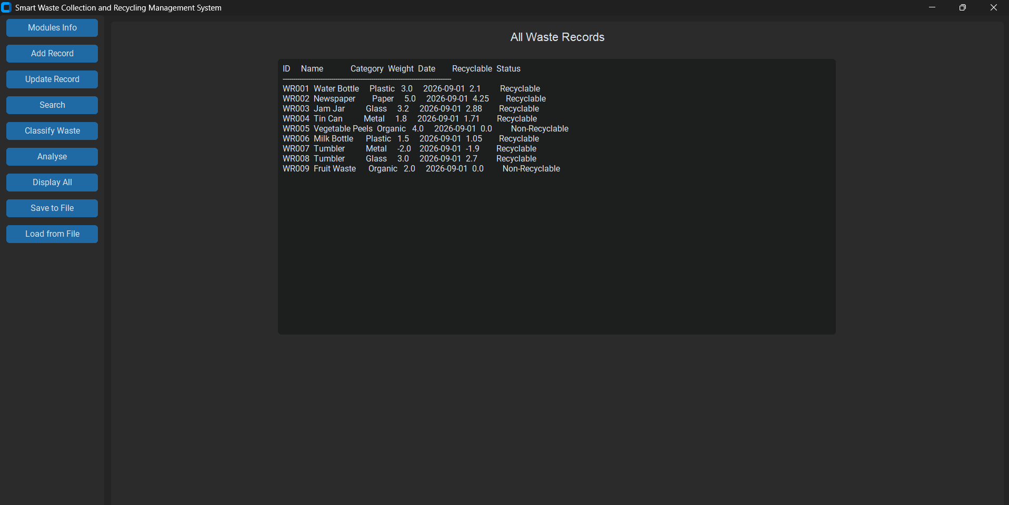

CODE — MODULE 2
"""
MODULE 2 - CO3: Data structures using ONLY nested lists
(no tuple / dict / set anywhere). Simulates a table, a lookup,
and a set using plain nested lists.
"""
import module1_string_ops as m1

# "reference table" simulated as nested list instead of a dict
# each row: [category_name, recycle_rate_percent]
CATEGORIES = [
["Plastic", 70],
["Paper", 85],
["Glass", 90],
["Metal", 95],
["Organic", 0],
]

# "database" simulated as nested list instead of list-of-dicts
# each record: [id, name, category, weight, date, recyclable_qty, status]
records = []

def get_recycle_rate(category_name):
category_name = category_name.strip().lower()
for row in CATEGORIES:
if row[0].lower() == category_name:
return row[1]
return 0

def generate_id():
return "WR" + str(len(records) + 1).zfill(3)

def add_record(name, category, weight, date_str):
name = m1.normalize_text(name)
category = m1.normalize_text(category)
if not m1.is_valid_name(name):
return [None, "Invalid name."]
if not m1.is_valid_number(weight):
return [None, "Invalid weight."]
rate = get_recycle_rate(category)
weight = float(weight)
recyclable_qty = round(weight * rate / 100, 2)
status = "Recyclable" if rate > 0 else "Non-Recyclable"

record = [generate_id(), name, category, weight, date_str, recyclable_qty, status]
records.append(record)
return [record, "OK"]

def update_record(record_id, name=None, category=None, weight=None, date_str=None):
record_id = record_id.strip().upper()
for row in records:
if row[0] == record_id:
if name:
row[1] = m1.normalize_text(name)
if category:
row[2] = m1.normalize_text(category)
if weight and m1.is_valid_number(weight):
row[3] = float(weight)
if date_str:
row[4] = date_str
rate = get_recycle_rate(row[2])
row[5] = round(row[3] * rate / 100, 2)
row[6] = "Recyclable" if rate > 0 else "Non-Recyclable"
return True
return False

def search_records(keyword):
keyword = keyword.strip().lower()
results = []
for row in records:
if keyword in row[0].lower() or keyword in row[1].lower() or keyword in row[2].lower():
results.append(row)
return results

def get_unique_categories():
"""Manual dedup = simulating a 'set' with a plain list."""
unique = []
for row in records:
if row[2] not in unique:
unique.append(row[2])
return unique

def classify_waste():
"""Returns nested list: [[category, [record, record, ...]], ...]"""
grouped = []
for cat_row in CATEGORIES:
cat_name = cat_row[0]
items = []
for row in records:
if row[2] == cat_name:
items.append(row)
grouped.append([cat_name, items])
return grouped

def analyse_data():
"""Returns a nested list: [totals, overall_weight, overall_recyclable]"""
totals = [] # [category, count, total_weight, total_recyclable]
overall_weight = 0
overall_recyclable = 0

for cat_row in CATEGORIES:
cat_name = cat_row[0]
count = 0
total_weight = 0
total_recyclable = 0
for row in records:
if row[2] == cat_name:
count += 1
total_weight += row[3]
total_recyclable += row[5]
totals.append([cat_name, count, round(total_weight, 2), round(total_recyclable, 2)])
overall_weight += total_weight
overall_recyclable += total_recyclable

return [totals, round(overall_weight, 2), round(overall_recyclable, 2)]

PSEUDOCODE — MODULE 2
MODULE module2_data_structures

IMPORT module1_string_ops AS m1

CATEGORIES = NESTED LIST:
["Plastic", 70]
["Paper", 85]
["Glass", 90]
["Metal", 95]
["Organic", 0]

records = EMPTY LIST // each record: [id, name, category, weight, date, recyclable_qty, status]

FUNCTION get_recycle_rate(category_name):
category_name = LOWERCASE(TRIM(category_name))
FOR each row IN CATEGORIES:
IF LOWERCASE(row[0]) == category_name THEN
RETURN row[1]
END IF
END FOR
RETURN 0

FUNCTION generate_id():
RETURN "WR" + (length of records + 1) PADDED to 3 digits with zeros

FUNCTION add_record(name, category, weight, date_str):
name = m1.normalize_text(name)
category = m1.normalize_text(category)

IF NOT m1.is_valid_name(name) THEN
RETURN [None, "Invalid name."]
END IF
IF NOT m1.is_valid_number(weight) THEN
RETURN [None, "Invalid weight."]
END IF

rate = get_recycle_rate(category)
weight = CONVERT weight TO float
recyclable_qty = ROUND(weight * rate / 100, 2)
status = "Recyclable" IF rate > 0 ELSE "Non-Recyclable"

new_record = [generate_id(), name, category, weight, date_str, recyclable_qty, status]
APPEND new_record TO records
RETURN [new_record, "OK"]

FUNCTION update_record(record_id, name, category, weight, date_str):
record_id = UPPERCASE(TRIM(record_id))
FOR each row IN records:
IF row[0] == record_id THEN
IF name is provided THEN row[1] = m1.normalize_text(name)
IF category is provided THEN row[2] = m1.normalize_text(category)
IF weight is provided AND m1.is_valid_number(weight) THEN row[3] = float(weight)
IF date_str is provided THEN row[4] = date_str

rate = get_recycle_rate(row[2])
row[5] = ROUND(row[3] * rate / 100, 2)
row[6] = "Recyclable" IF rate > 0 ELSE "Non-Recyclable"
RETURN True
END IF
END FOR
RETURN False

FUNCTION search_records(keyword):
keyword = LOWERCASE(TRIM(keyword))
results = EMPTY LIST
FOR each row IN records:
IF keyword IN LOWERCASE(row[0]) OR keyword IN LOWERCASE(row[1]) OR keyword IN LOWERCASE(row[2]) THEN
APPEND row TO results
END IF
END FOR
RETURN results

FUNCTION get_unique_categories():
unique = EMPTY LIST
FOR each row IN records:
IF row[2] NOT IN unique THEN
APPEND row[2] TO unique
END IF
END FOR
RETURN unique

FUNCTION classify_waste():
grouped = EMPTY LIST
FOR each cat_row IN CATEGORIES:
cat_name = cat_row[0]
items = EMPTY LIST
FOR each row IN records:
IF row[2] == cat_name THEN
APPEND row TO items
END IF
END FOR
APPEND [cat_name, items] TO grouped
END FOR
RETURN grouped

FUNCTION analyse_data():
totals = EMPTY LIST
overall_weight = 0
overall_recyclable = 0

FOR each cat_row IN CATEGORIES:
cat_name = cat_row[0]
count = 0
total_weight = 0
total_recyclable = 0
FOR each row IN records:
IF row[2] == cat_name THEN
count = count + 1
total_weight = total_weight + row[3]
total_recyclable = total_recyclable + row[5]
END IF
END FOR
APPEND [cat_name, count, ROUND(total_weight,2), ROUND(total_recyclable,2)] TO totals
overall_weight = overall_weight + total_weight
overall_recyclable = overall_recyclable + total_recyclable
END FOR

RETURN [totals, ROUND(overall_weight,2), ROUND(overall_recyclable,2)]
END MODULE



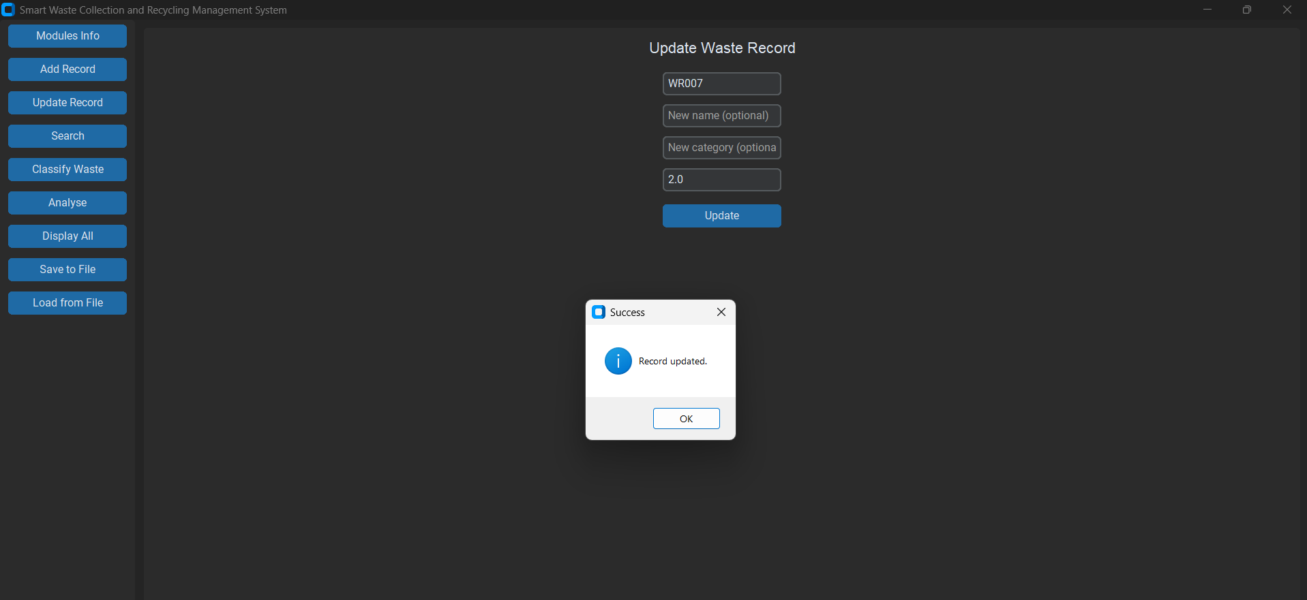

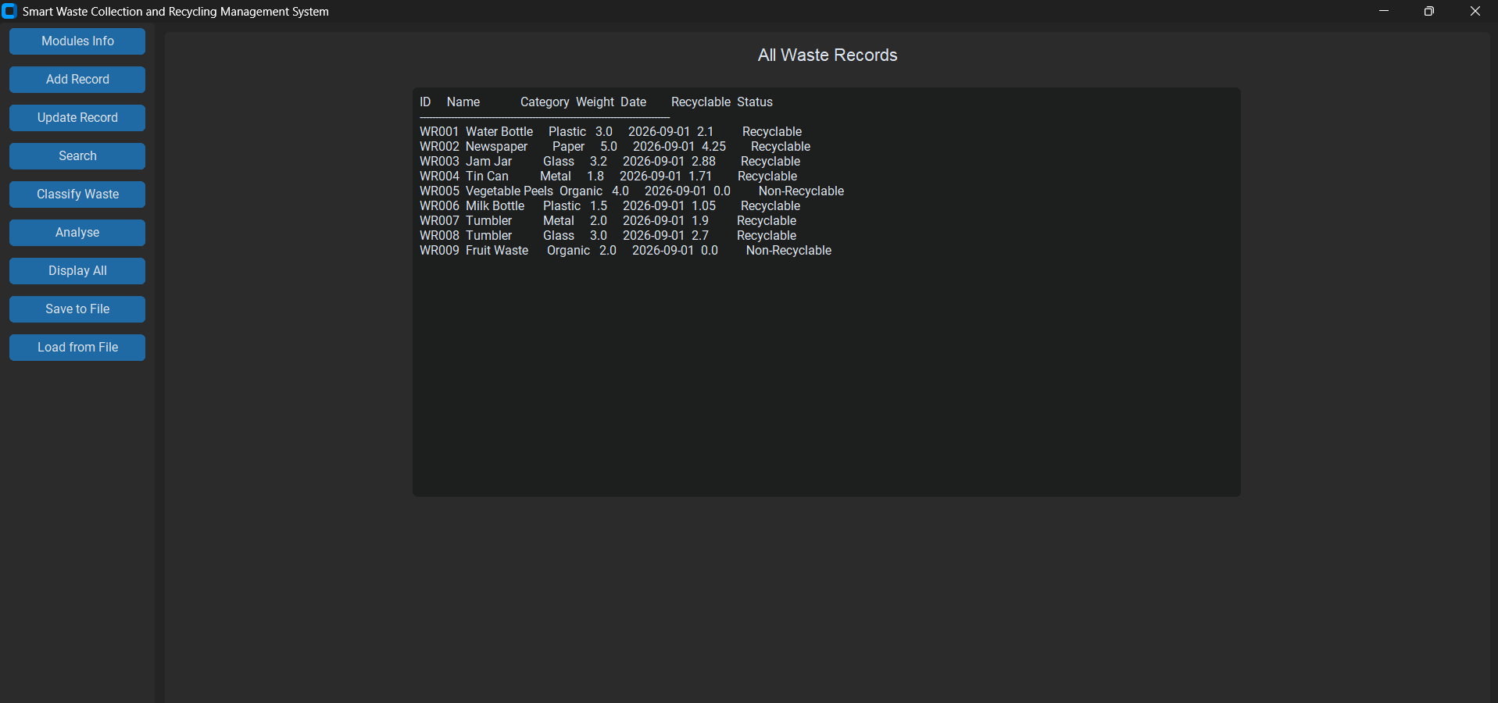

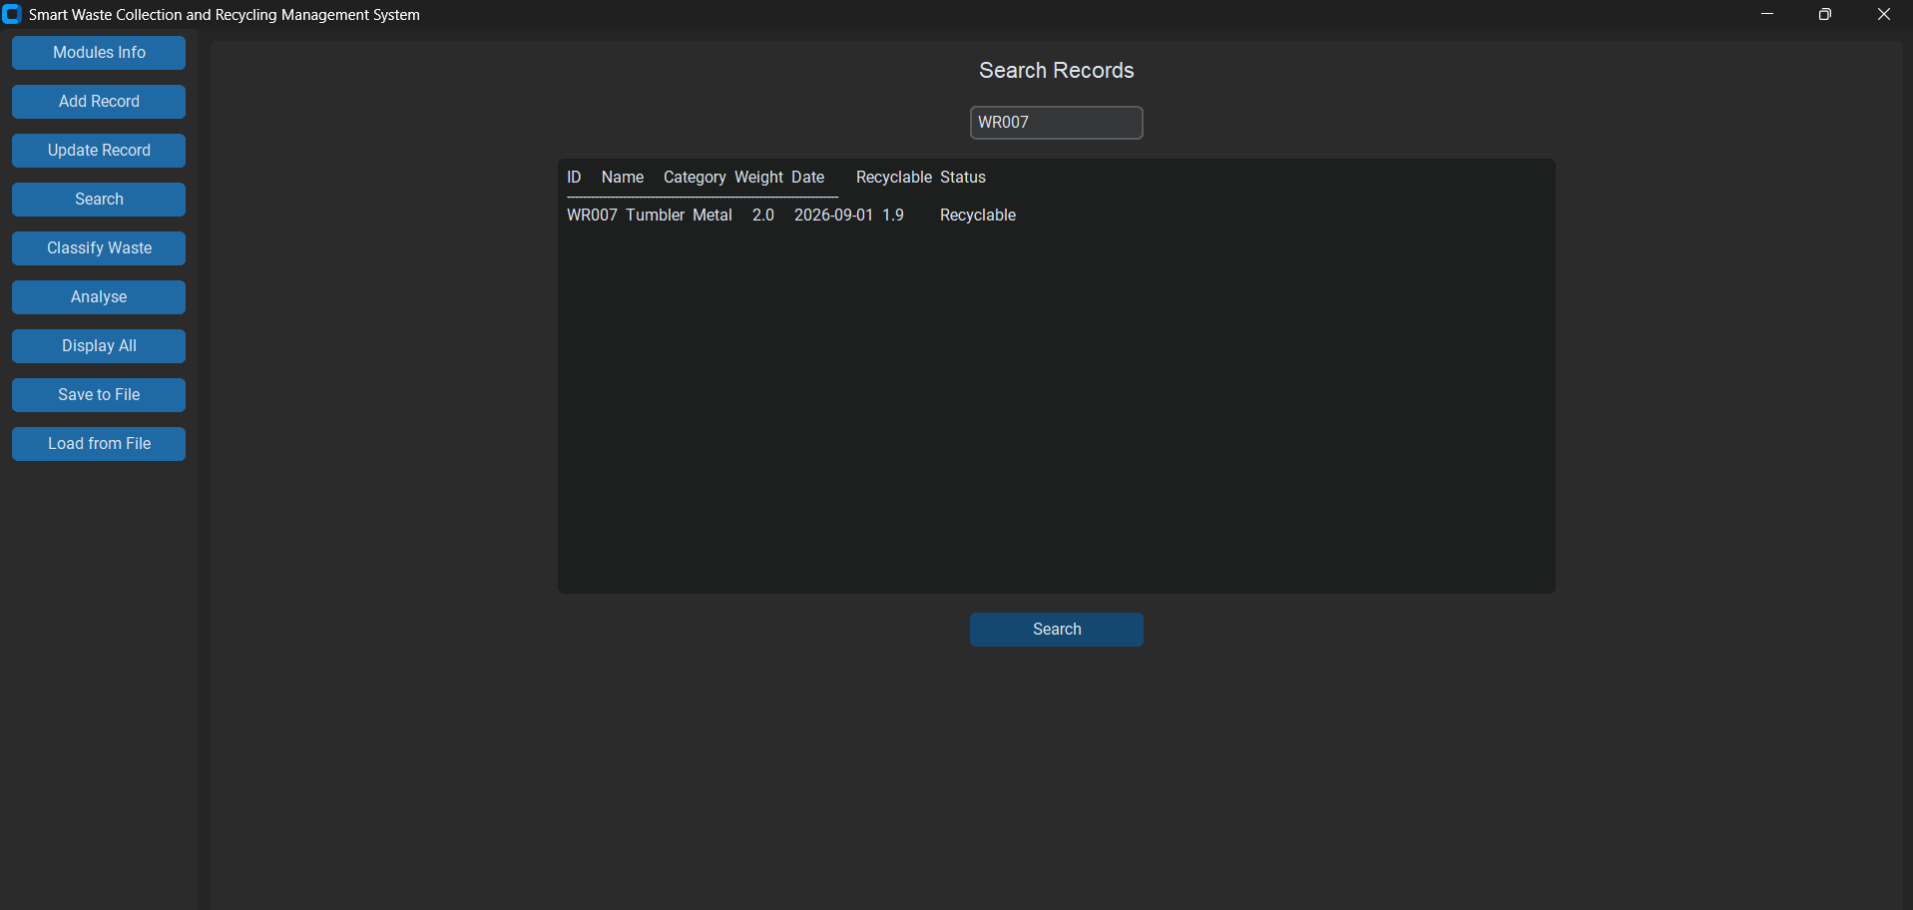

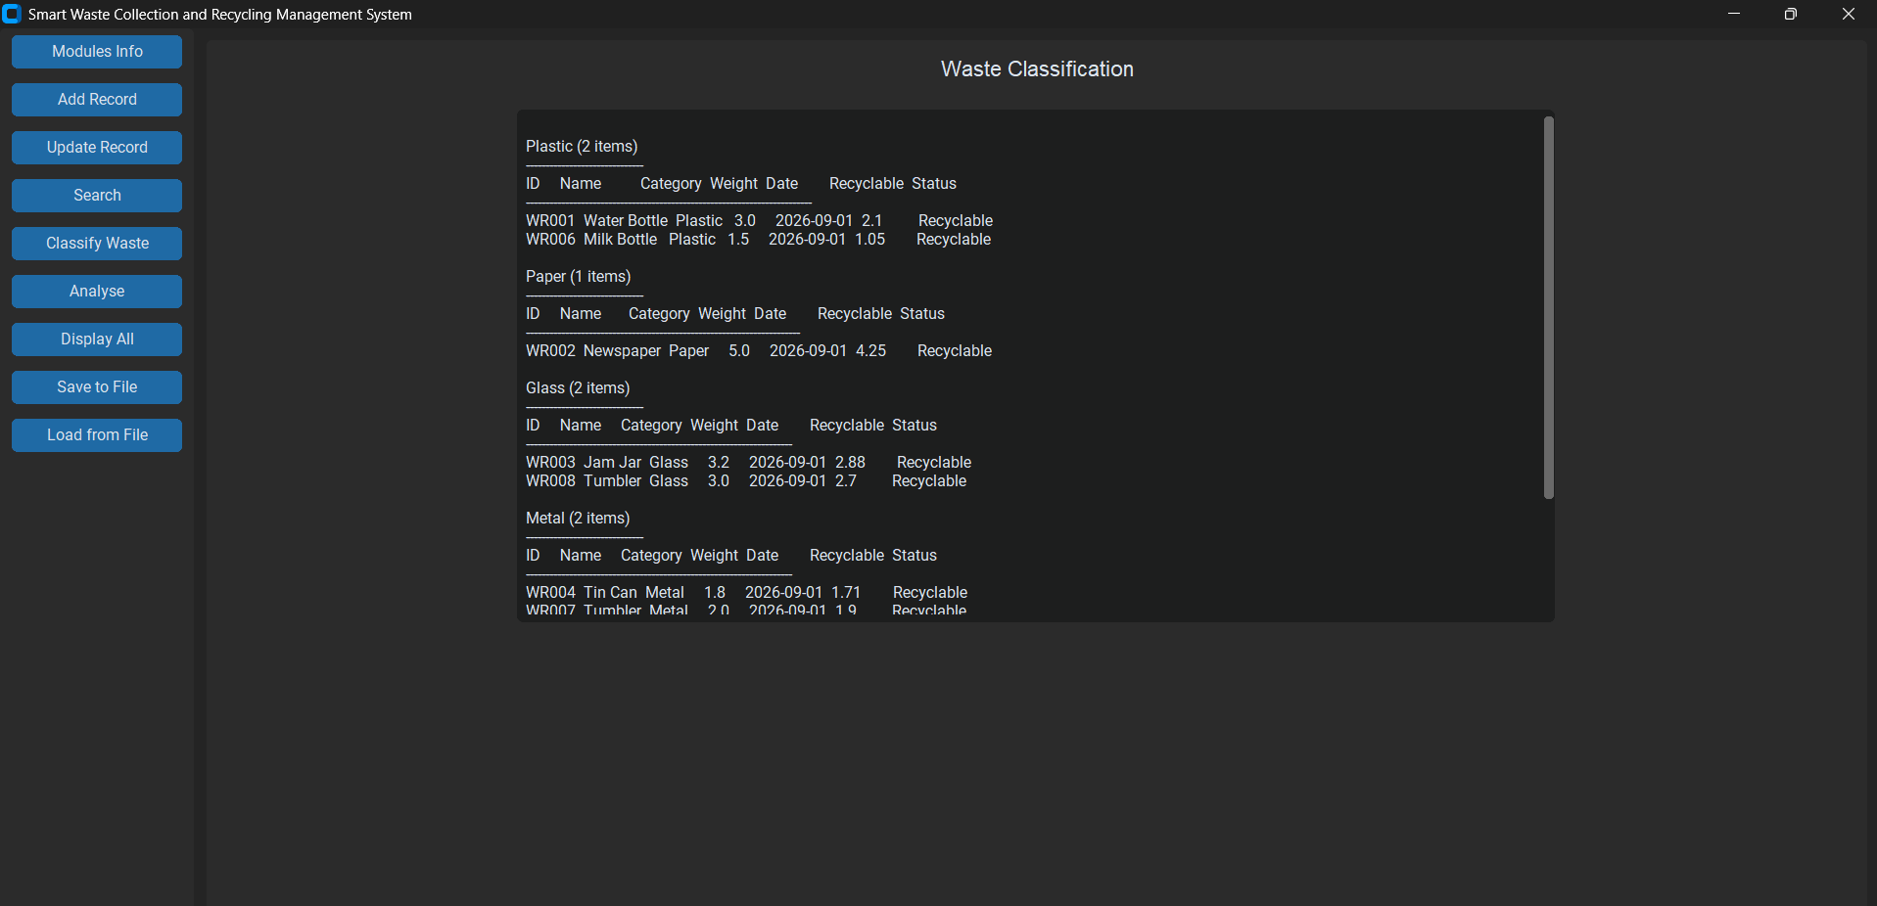

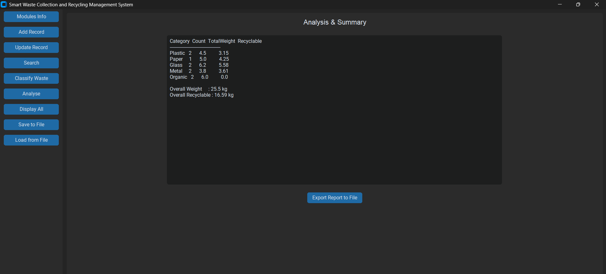

CODE — MODULE 3
"""
MODULE 3 - CO4: File handling using csv, os, datetime modules/packages.
Uses csv.reader/csv.writer (list-based) - never DictReader/DictWriter.
"""
import csv
import os
import datetime

FILE_NAME = "waste_records.csv"
REPORT_NAME = "waste_report.txt"

def save_records_to_file(records, filename=FILE_NAME):
with open(filename, "w", newline="") as f:
writer = csv.writer(f)
writer.writerow(["ID", "Name", "Category", "Weight", "Date", "RecyclableQty", "Status"])
for row in records:
writer.writerow(row)
return len(records)

def load_records_from_file(filename=FILE_NAME):
loaded = []
if not os.path.exists(filename):
return loaded
with open(filename, "r", newline="") as f:
reader = csv.reader(f)
next(reader, None) # skip header row
for row in reader:
if len(row) == 7:
row[3] = float(row[3])
row[5] = float(row[5])
loaded.append(row)
return loaded

def generate_report_file(totals, overall_weight, overall_recyclable, filename=REPORT_NAME):
timestamp = datetime.datetime.now().strftime("%Y-%m-%d %H:%M:%S")
with open(filename, "w") as f:
f.write("SMART WASTE MANAGEMENT - SUMMARY REPORT\n")
f.write("Generated: " + timestamp + "\n")
f.write("=" * 45 + "\n")
for row in totals:
line = row[0].ljust(10) + " Count:" + str(row[1]).ljust(4)
line += " Weight:" + str(row[2]).ljust(8) + " Recyclable:" + str(row[3])
f.write(line + "\n")
f.write("-" * 45 + "\n")
f.write("Total Weight : " + str(overall_weight) + " kg\n")
f.write("Total Recyclable : " + str(overall_recyclable) + " kg\n")
return filename

PSEUDOCODE — MODULE 3
MODULE module3_file_handling

IMPORT csv, os, datetime

FILE_NAME = "waste_records.csv"
REPORT_NAME = "waste_report.txt"

FUNCTION save_records_to_file(records, filename = FILE_NAME):
OPEN filename FOR writing AS f
WRITE header row: ["ID","Name","Category","Weight","Date","RecyclableQty","Status"]
FOR each row IN records:
WRITE row TO f
END FOR
CLOSE f
RETURN length of records

FUNCTION load_records_from_file(filename = FILE_NAME):
loaded = EMPTY LIST
IF file DOES NOT EXIST THEN
RETURN loaded
END IF

OPEN filename FOR reading AS f
SKIP header row
FOR each row IN f:
IF length of row == 7 THEN
row[3] = CONVERT row[3] TO float
row[5] = CONVERT row[5] TO float
APPEND row TO loaded
END IF
END FOR
CLOSE f
RETURN loaded

FUNCTION generate_report_file(totals, overall_weight, overall_recyclable, filename = REPORT_NAME):
timestamp = CURRENT DATE AND TIME formatted as "YYYY-MM-DD HH:MM:SS"

OPEN filename FOR writing AS f
WRITE "SMART WASTE MANAGEMENT - SUMMARY REPORT"
WRITE "Generated: " + timestamp
WRITE separator line

FOR each row IN totals:
WRITE row[0] + " Count:" + row[1] + " Weight:" + row[2] + " Recyclable:" + row[3]
END FOR

WRITE separator line
WRITE "Total Weight : " + overall_weight + " kg"
WRITE "Total Recyclable : " + overall_recyclable + " kg"
CLOSE f
RETURN filename
END MODULE

