ECA - 5610 5G/6G Communication Systems
NAME : RM KANNAPPAN 192512003
Ex.No. 13: V2X Latency Comparison Date

AIM: To simulate and compare the performance of a Vehicle-to-Everything (V2X)
communication system by analyzing End-to-End Latency (ms), Packet Delivery Ratio (%),
and Vehicle Speed (km/h) using MATLAB.
Objective:
1. To evaluate the End-to-End Latency (ms) of a V2X communication system under
different vehicle operating conditions.
2. To analyze the Packet Delivery Ratio (%) and determine the reliability of V2X
communication during data transmission.
3. To study the impact of Vehicle Speed (km/h) on the communication performance and
stability of the V2X network.
Procedure
1. Define the V2X communication parameters such as vehicle speed, transmission range,
packet size, and simulation time.
2. Generate different vehicle movement scenarios by varying the vehicle speed.
3. Simulate wireless communication between vehicles using a V2X communication model.
4. Calculate the End-to-End Latency (ms) for data transmission between communicating
vehicles.
5. Compute the Packet Delivery Ratio (PDR %) by comparing the number of successfully
received packets with transmitted packets.
6. Analyze the effect of increasing Vehicle Speed (km/h) on communication latency and
packet delivery performance.
7. Plot MATLAB graphs for End-to-End Latency, Packet Delivery Ratio, and Vehicle
Speed.
8. Compare the obtained results to evaluate the efficiency and reliability of the V2X
communication system under different traffic conditions.
OUTPUT AND RESULT :
OBJECTIVE 1 :
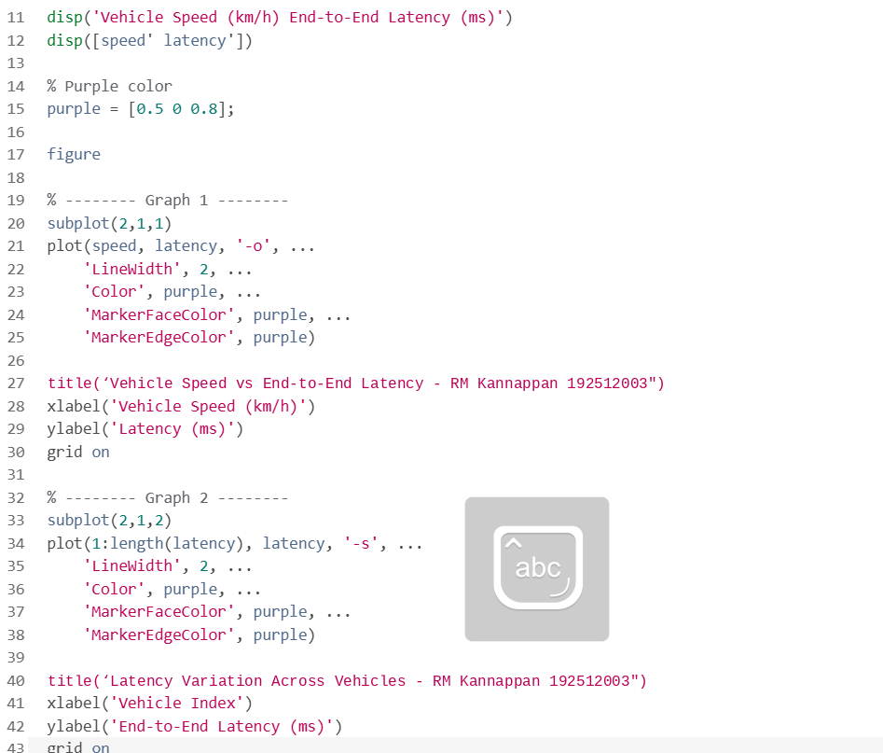
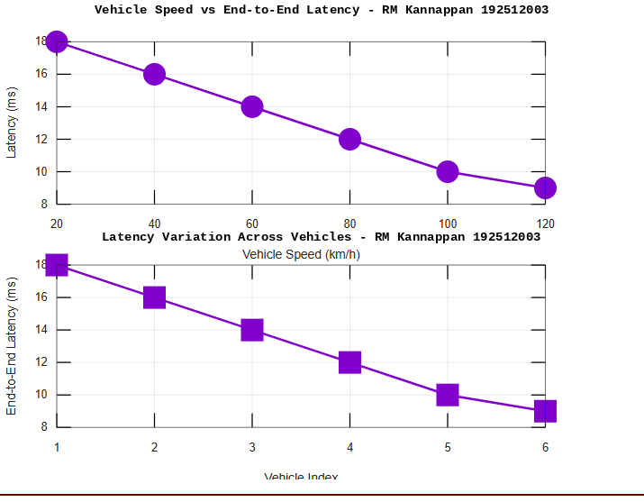

OBJECTIVE 2:
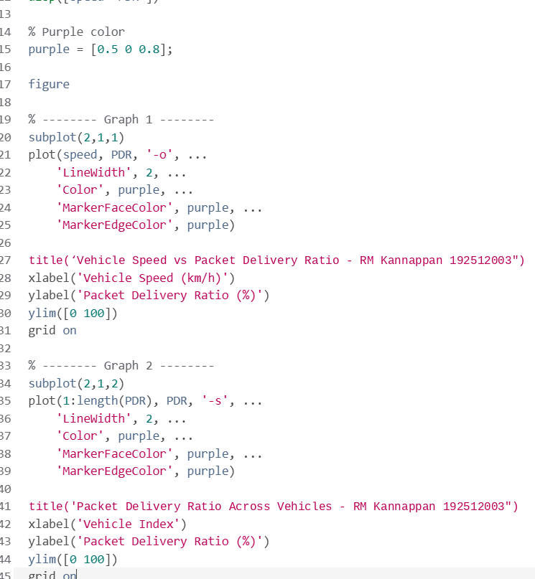
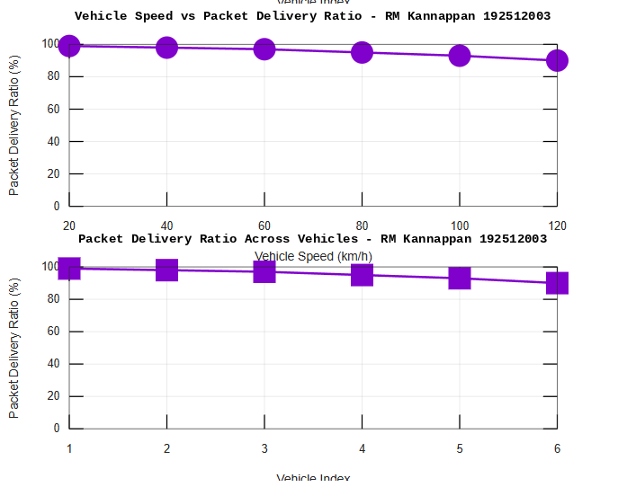

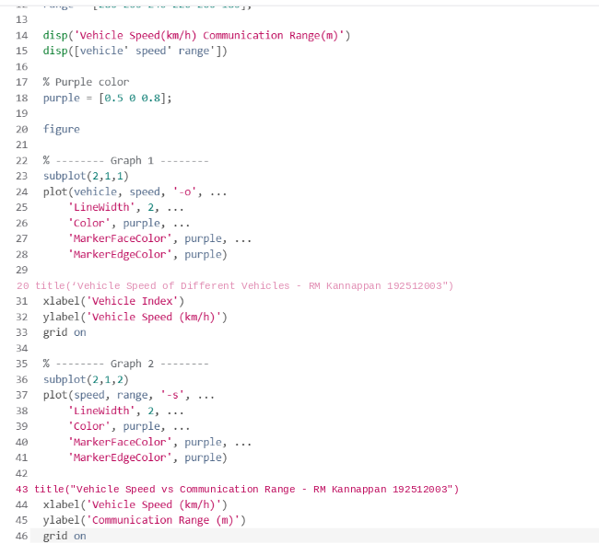
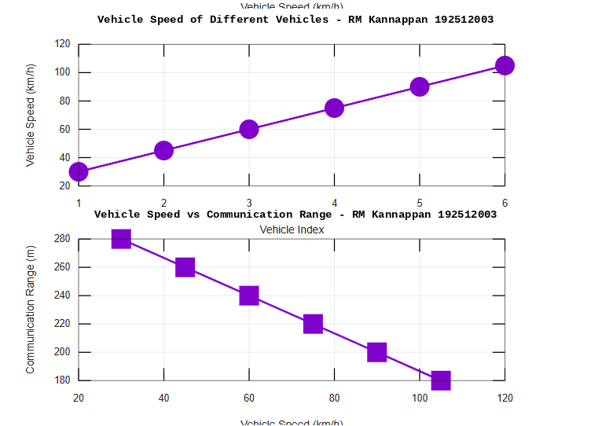
OBJECTIVE 3 :

Result:
1.
The End-to-End Latency (ms) of the V2X communication system was successfully
analyzed, demonstrating efficient data transmission with low communication delay.
2.
The Packet Delivery Ratio (PDR %) was evaluated and showed high packet delivery
reliability under different vehicle operating conditions.
3.The impact of Vehicle Speed (km/h) on V2X communication was successfully studied,
indicating that higher vehicle speeds can influence communication range, latency, and
overall network performance..

