ECA - 5610 5G/6G Communication Systems
NAME : RM KANNAPPAN 192512003
Ex.No. 14: 5G Throughput vs SNR with Modulation Labels
AIM: To simulate the performance of a 5G wireless communication system using MATLAB
by analyzing the relationship between Throughput (Mbps), Signal-to-Noise Ratio (SNR) (dB),
and different Modulation Schemes (QPSK, 16-QAM, 64-QAM, and 256-QAM).
Objective:
1. To evaluate the Throughput (Mbps) of a 5G communication system under different
Signal-to-Noise Ratio (SNR) conditions.
2. To analyze the effect of Signal-to-Noise Ratio (SNR) (dB) on the performance and
reliability of the 5G communication system.
3. To compare the performance of different Modulation Schemes (QPSK, 16-QAM, 64-
QAM, and 256-QAM) and determine their suitability for varying SNR conditions.
Procedure
1. Define the simulation parameters such as SNR range, bandwidth, modulation schemes
(QPSK, 16-QAM, 64-QAM, and 256-QAM), and transmission settings.
2. Generate random binary data and modulate it using the selected modulation schemes.
3. Simulate the transmission of the modulated signals through an Additive White Gaussian
Noise (AWGN) channel with different SNR values.
4. Calculate the Throughput (Mbps) achieved for each modulation scheme at different
SNR levels.
5. Analyze the impact of Signal-to-Noise Ratio (SNR) on communication performance and
throughput.
6. Compare the performance of QPSK, 16-QAM, 64-QAM, and 256-QAM under identical
channel conditions.
7. Plot MATLAB graphs for Throughput vs SNR and SNR vs Modulation Scheme to
visualize the system performance.
8. Interpret the results to identify the most suitable modulation scheme for different SNR
conditions in a 5G communication system.
OUTPUT AND RESULT :
OBJECTIVE 1 :
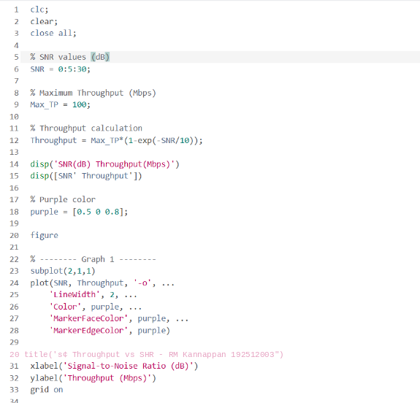
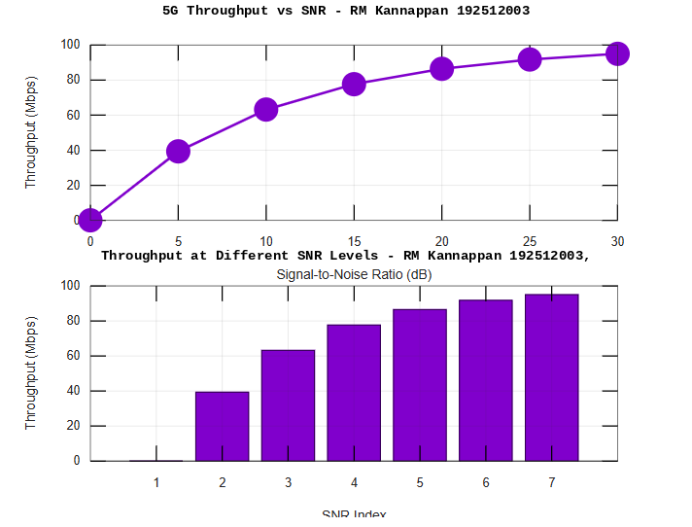

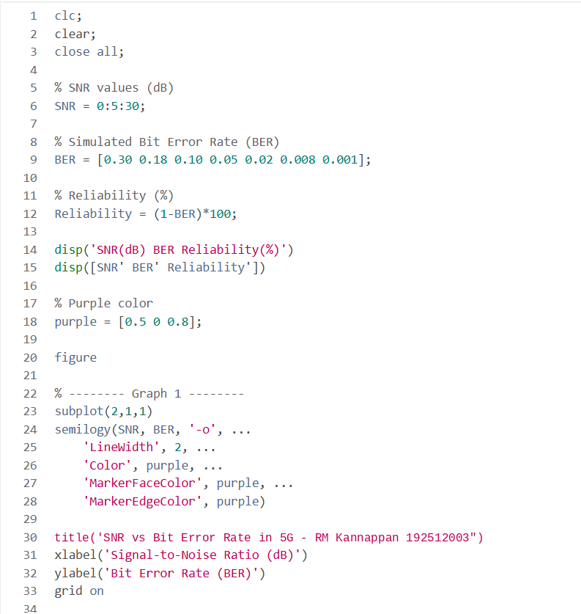
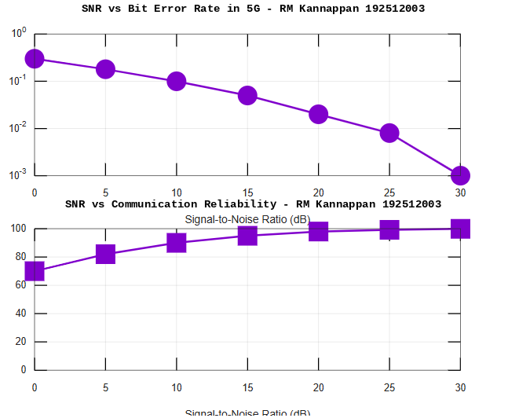
OBJECTIVE 2:

OBJECTIVE 3 :

