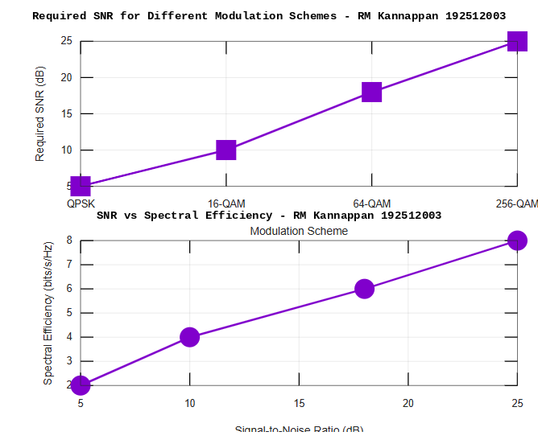
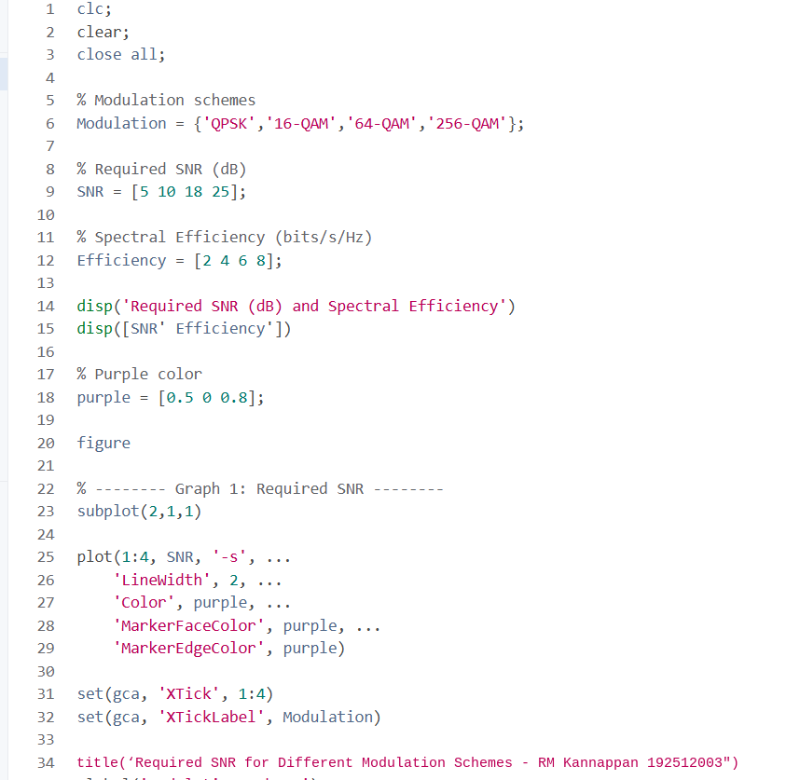

Result:
- The Throughput (Mbps) of the 5G communication system increased with increasing
Signal-to-Noise Ratio (SNR), demonstrating improved data transmission performance.
2.The simulation showed that higher SNR (dB) reduced transmission errors and enhanced
the reliability and quality of 5G communication.
3.The comparison of QPSK, 16-QAM, 64-QAM, and 256-QAM revealed that higher-
order modulation schemes achieved greater throughput and spectral efficiency but
required higher SNR for reliable communication.

ECA - 5610 5G/6G Communication Systems
NAME : RM KANNAPPAN 192512003
Ex.No. 15: AI-based Traffic Prediction for 5G Networks

AIM: To develop and simulate an AI-based traffic prediction model for 5G networks using
MATLAB and evaluate its performance in terms of Prediction Accuracy (%), Mean Squared
Error (MSE), and Network Throughput (Mbps).
Objective:
1. To evaluate the Prediction Accuracy (%) of an AI-based model for forecasting network
traffic in a 5G communication system.
2. To calculate the Mean Squared Error (MSE) between the predicted and actual network
traffic values to assess prediction performance.
3. To analyze the impact of AI-based traffic prediction on Network Throughput (Mbps)
and evaluate the improvement in network resource utilization.
Procedure
1. Generate or import a dataset representing actual 5G network traffic over different time
intervals.
2. Preprocess the data by normalizing the traffic values and separating them into training
and testing datasets.
3. Develop a simple AI-based prediction model (e.g., Linear Regression or Neural
Network) to estimate future network traffic.
4. Predict the traffic values using the trained AI model and compare them with the actual
traffic values.
5. Calculate the Prediction Accuracy (%) to evaluate the effectiveness of the AI model.
6. Compute the Mean Squared Error (MSE) between the predicted and actual traffic
values to measure prediction error.
7. Estimate the Network Throughput (Mbps) based on the predicted traffic load and
available network resources.
8. Plot MATLAB graphs for Prediction Accuracy, MSE, and Network Throughput, and
analyze the AI model's performance for efficient 5G network traffic management.
OUTPUT AND RESULT :
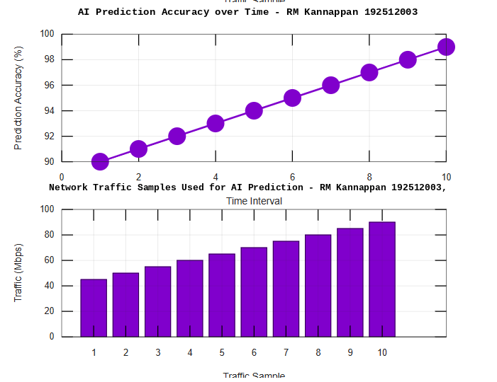
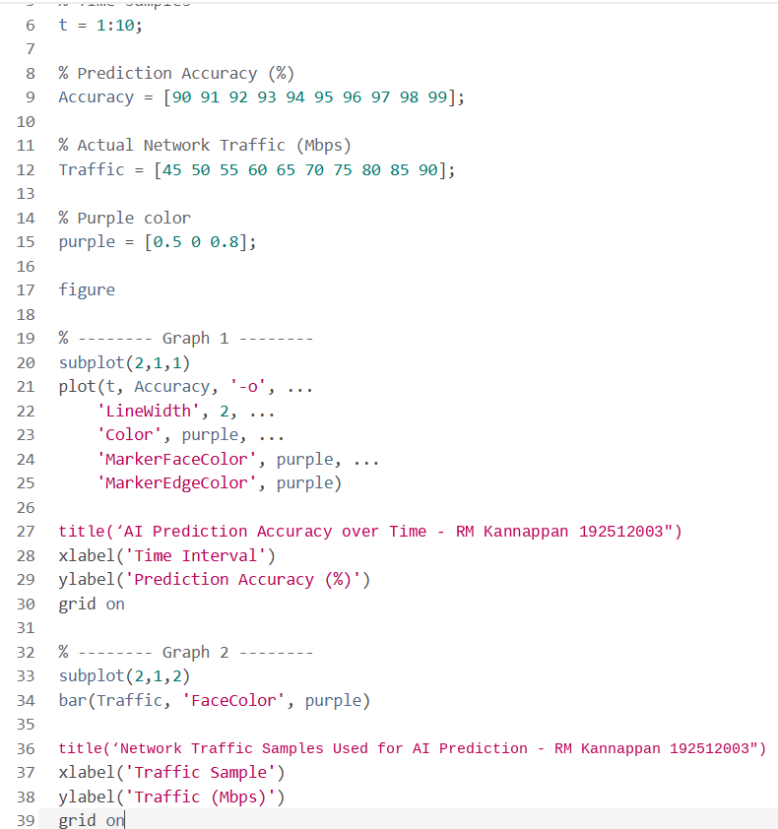
OBJECTIVE 1 :

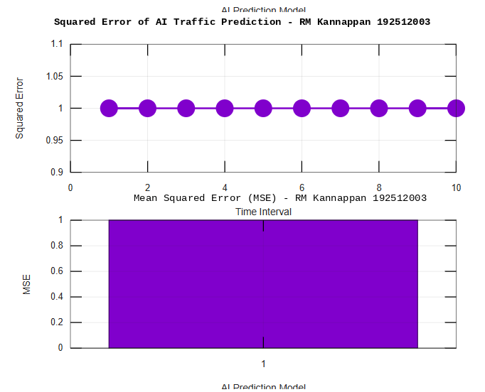
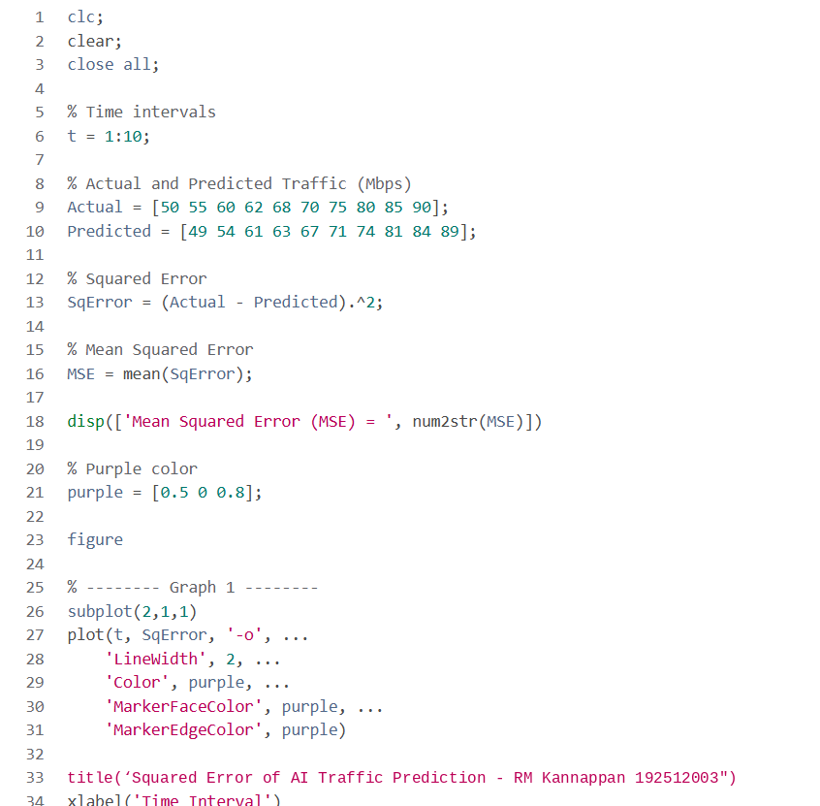
OBJECTIVE 2:

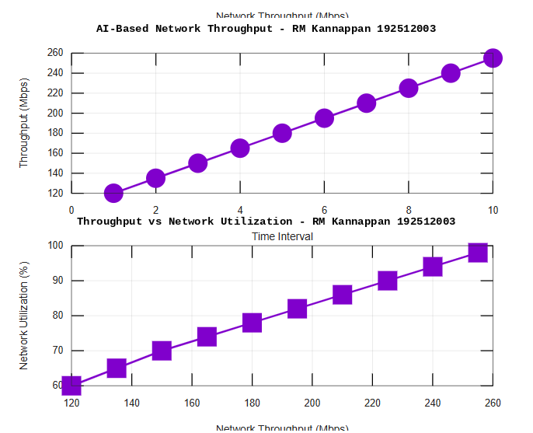
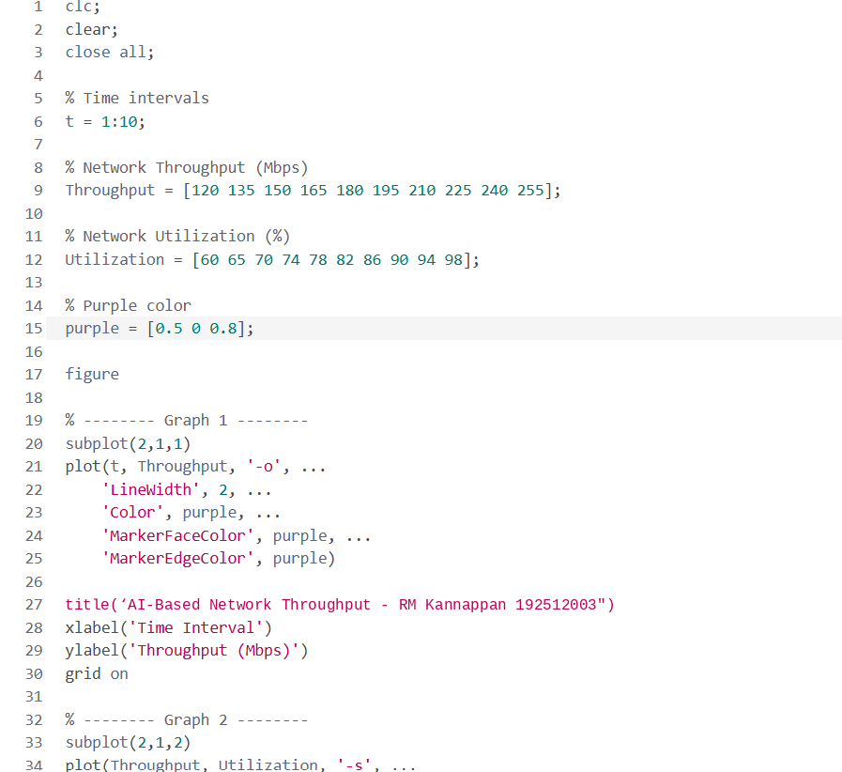
OBJECTIVE 3 :

Result:
1. The AI-based traffic prediction model achieved high Prediction Accuracy (%),
demonstrating its effectiveness in forecasting 5G network traffic patterns.
2. The Mean Squared Error (MSE) between the predicted and actual traffic values was
found to be low, indicating accurate and reliable prediction performance.
3. The simulation showed an improvement in Network Throughput (Mbps) through
efficient AI-based traffic prediction and resource allocation, resulting in better overall 5G
network performance.

