ECA - 5610 5G/6G Communication Systems
NAME :RM Kannappan 192512003
Ex.N.3: Spectrum Analysis of Sub-1 GHz, Mid-band & mmWave by Plotting Propagation
Loss.
AIM: To analyze the propagation loss characteristics of different frequency bands (Sub-1 GHz, Mid-band, and mmWave) in wireless communication systems and compare their performance over varying distances using MATLAB.
Objective :
1. To compute the Propagation Loss (dB) for Sub-1 GHz, Mid-band, and mmWave
frequency ranges using standard path loss models.
2. To evaluate the impact of different Operating Frequencies (GHz) on signal attenuation
and coverage performance.
3. To analyze how Communication Distance (km) affects propagation loss across
different spectrum bands.
Procedure
1. Define frequency bands: Sub-1 GHz (0.9 GHz), Mid-band (3.5 GHz), and mmWave (28
GHz).
2. Set communication distance range (e.g., 0.1 km to 5 km).
3. Use Free Space Path Loss (FSPL) formula to compute propagation loss:
PL(dB)=20log⁡10(d)+20log⁡10(f)+32.44
4. Calculate propagation loss for each frequency band over varying distances.
5. Plot distance vs propagation loss curves for comparison.
6. Analyze how higher frequencies experience higher attenuation.
7. Compare coverage efficiency of each spectrum band.

8. Display results using MATLAB plots.
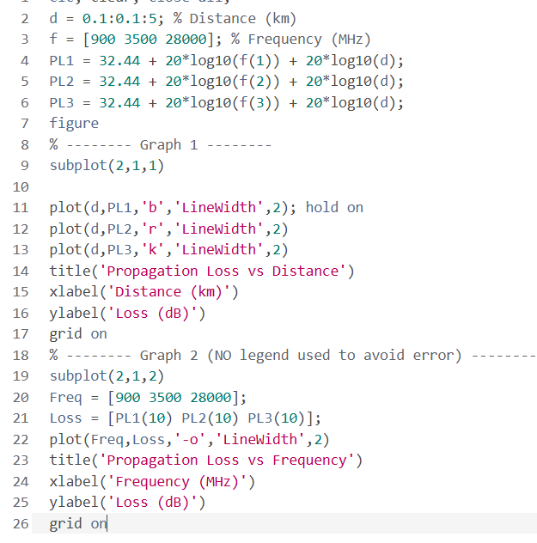
OUTPUT AND RESULT :
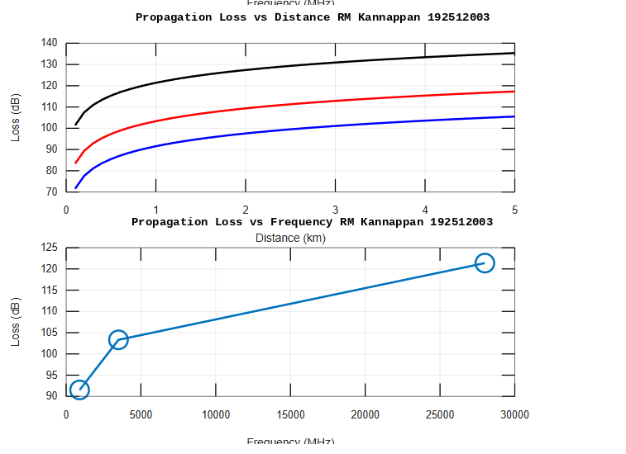
OBJECTIVE 1 :

OBJECTIVE 2 :
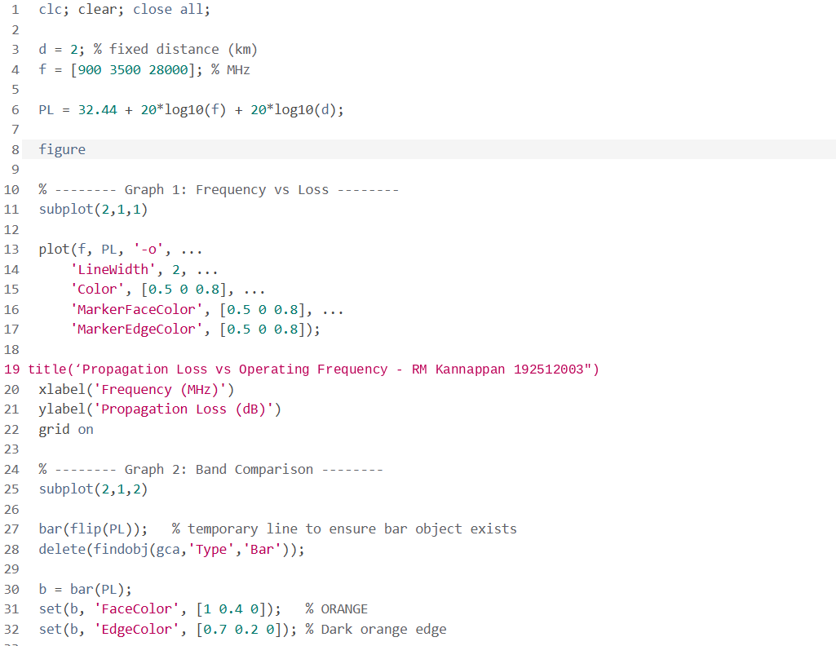
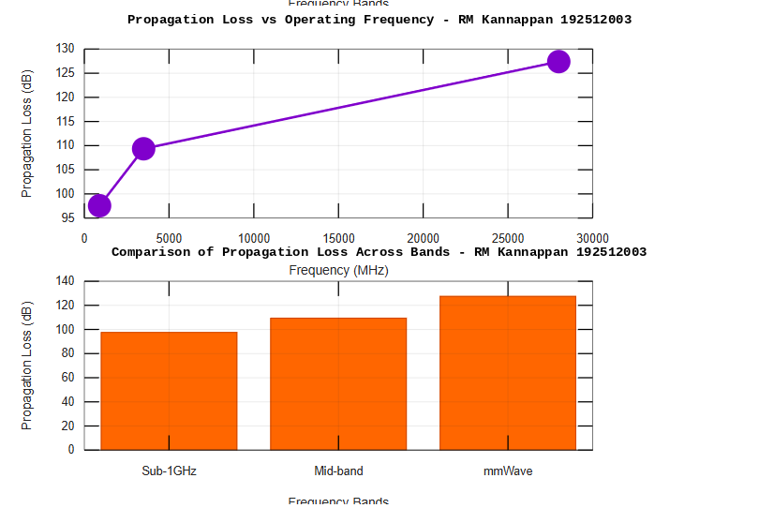

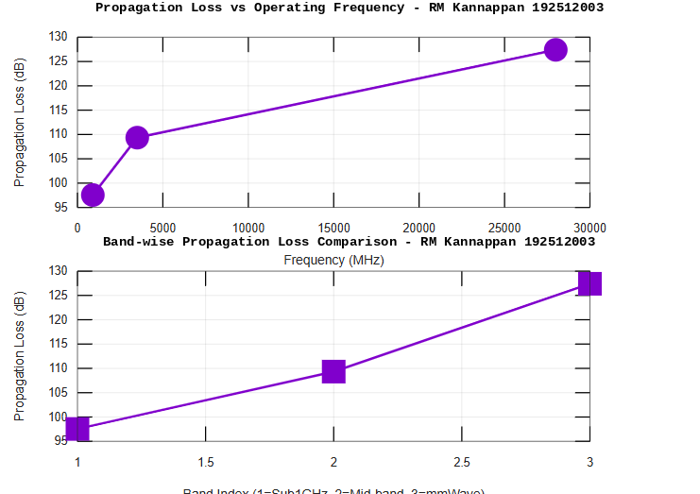
OBJECTIVE 3 :
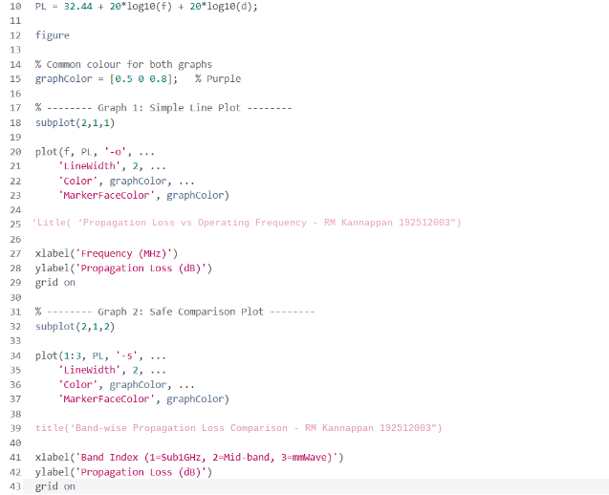

RESULT :
Result:
1. The propagation loss was successfully computed for Sub-1 GHz, Mid-band, and
mmWave frequency bands using the Free Space Path Loss (FSPL) model.
2. It was observed that propagation loss increases with increase in operating frequency, with
mmWave showing the highest attenuation and Sub-1 GHz showing the lowest loss.
3. The comparative analysis of spectrum bands clearly demonstrates that lower frequency
bands are more suitable for long-range communication, while higher frequency bands
require advanced techniques like beamforming for efficient performance.

