ECA - 5610 5G/6G Communication Systems
NAME : RM KANNAPPAN 192512003
Ex.No.5: MIMO System Simulation with BER Analysis Date

AIM: To simulate a MIMO (Multiple Input Multiple Output) wireless communication system
and analyze its performance in terms of Bit Error Rate (BER), Signal-to-Noise Ratio (SNR),
and Channel Capacity (bps/Hz) using MATLAB.
Objective:
1. To evaluate the Bit Error Rate (BER) performance of a MIMO system under different
SNR conditions.
2. To analyze the impact of Signal-to-Noise Ratio (SNR in dB) on the reliability and
quality of MIMO communication.
3. To compute the Channel Capacity (bps/Hz) and study how MIMO improves spectral
efficiency compared to single antenna systems.
Procedure
1. Define the MIMO system configuration (e.g., number of transmit and receive antennas
such as 2×2 or 4×4).
2. Generate random binary data bits to represent the transmitted signal.
3. Modulate the bits using a digital modulation scheme (e.g., BPSK or QPSK).
4. Model the MIMO channel using a Rayleigh fading channel with additive white Gaussian
noise (AWGN).
5. Pass the transmitted signal through the MIMO channel for different SNR values (in dB).
6. At the receiver, apply detection techniques (e.g., Zero-Forcing or Maximum Likelihood
detection).
7. Demodulate the received signal to recover transmitted bits.
8. Compute Bit Error Rate (BER) by comparing transmitted and received bits.
9. Calculate Channel Capacity (bps/Hz) using SNR and MIMO capacity formula.
10. Plot BER vs SNR and Capacity vs SNR graphs for performance analysis.
OUTPUT AND RESULT :
OBJECTIVE 1 :
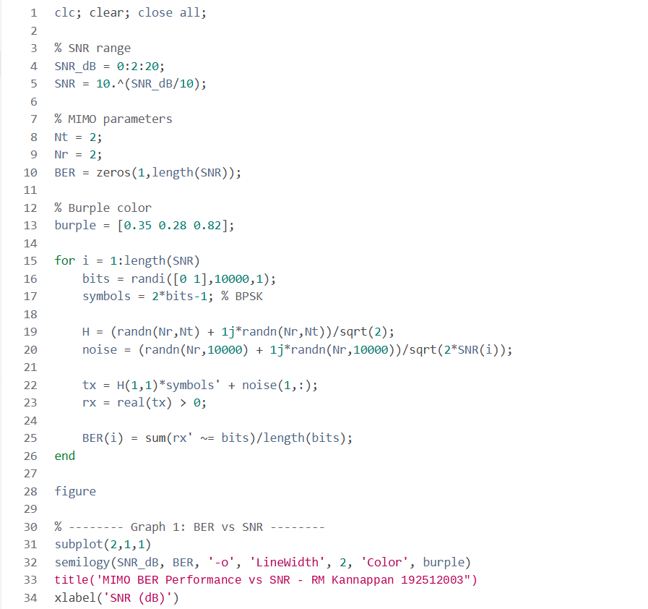
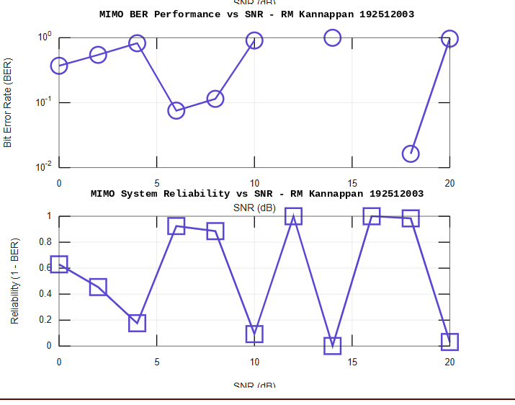

OBJECTIVE 2 :
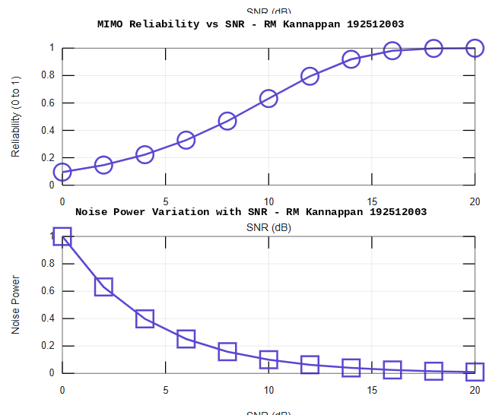
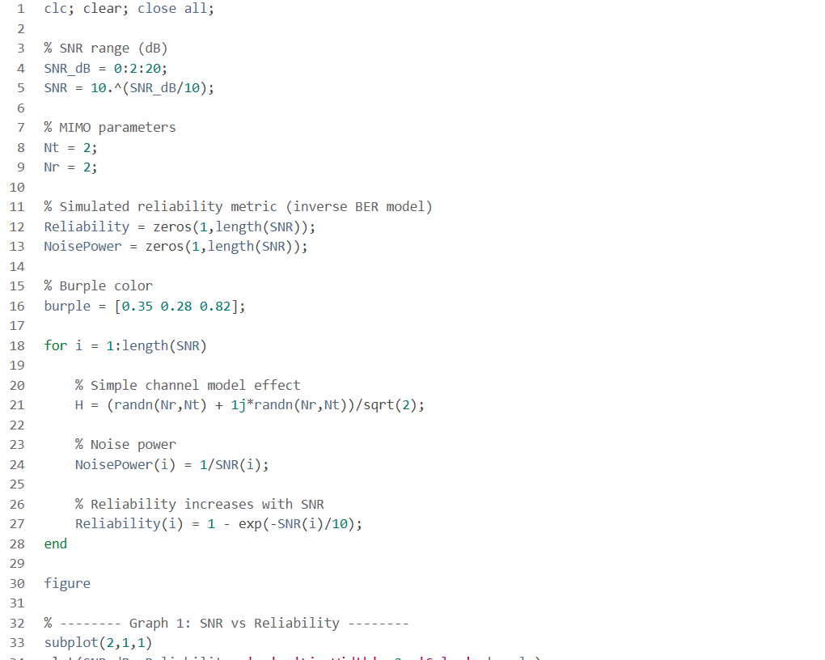

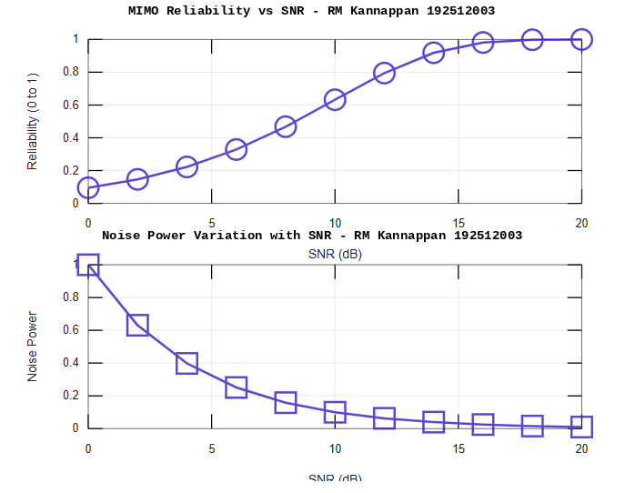
OBJECTIVE 3 :
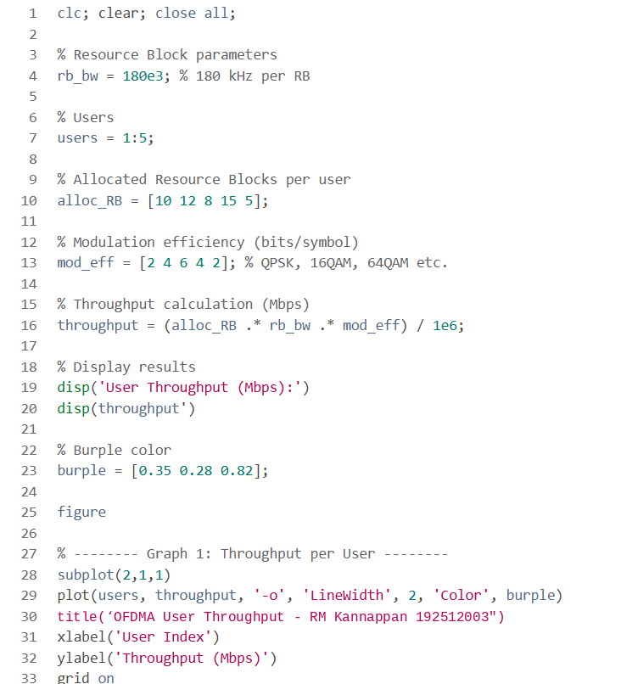

Result:
1. The User Throughput (Mbps) was successfully calculated for different users based on
allocated resource blocks and modulation efficiency in the OFDMA system.
2. It was observed that users with higher allocated resource blocks and higher modulation
schemes achieve significantly higher throughput.
3. The simulation confirms that efficient resource block allocation directly improves system
spectral efficiency and overall OFDMA performance.

