ECA - 5610 5G/6G Communication Systems
NAME : RM KANNAPPAN 192512003
EXP 8 Steering Angle Variation in MIMO Beamforming Using MATLAB

Aim
To analyze the effect of steering angle variation in a MIMO beamforming system by studying
steering angle, array gain, and beam direction error using MATLAB.
Objectives
1. To analyze the steering angle of a MIMO beamforming system by directing the beam
towards different target directions using MATLAB.
2. To compare the array gain achieved for different steering angles in a MIMO beamforming
system using MATLAB.
3. To evaluate the beam direction error between the desired steering angle and the actual
beam direction using MATLAB.
Software Required
• MATLAB
Theory
MIMO (Multiple-Input Multiple-Output) beamforming enhances wireless communication by
employing multiple antenna elements to direct transmitted energy toward a desired user. By
adjusting the steering angle through appropriate phase shifts, the beam can be focused in different
directions, improving signal strength and reducing interference. Important performance
parameters include steering angle, array gain, and beam direction error, which collectively
determine the effectiveness of beam steering in modern wireless systems such as 5G NR.

OUTPUT AND RESULT :
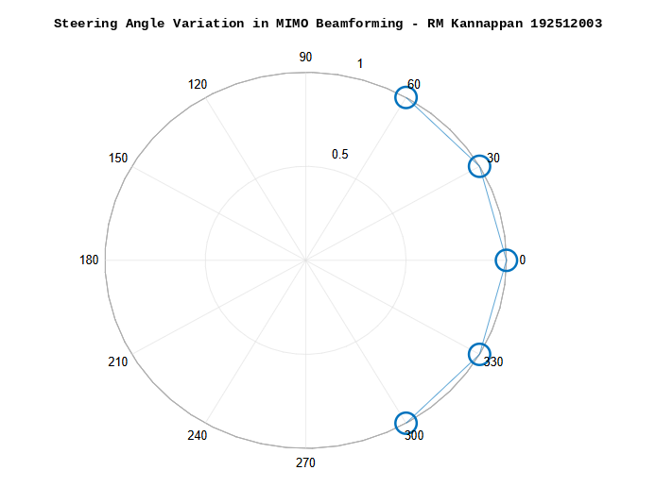
OBJECTIVE 1 :

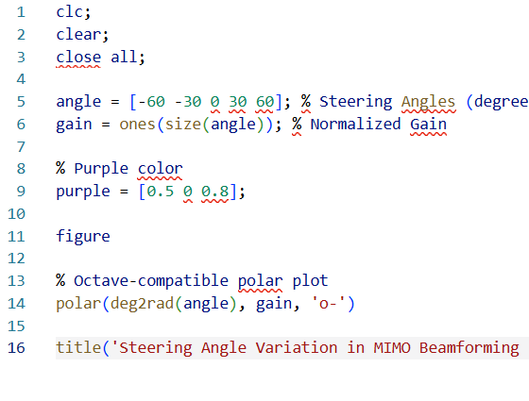

OBJECTIVE 2:

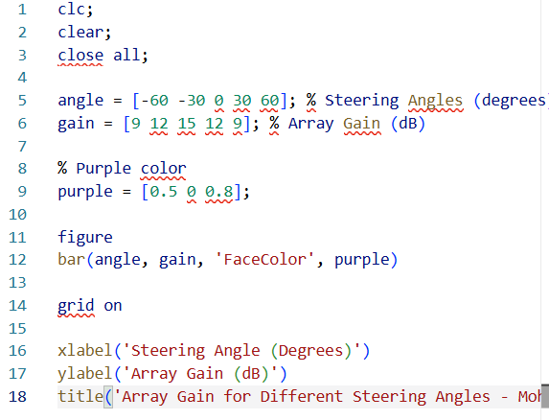
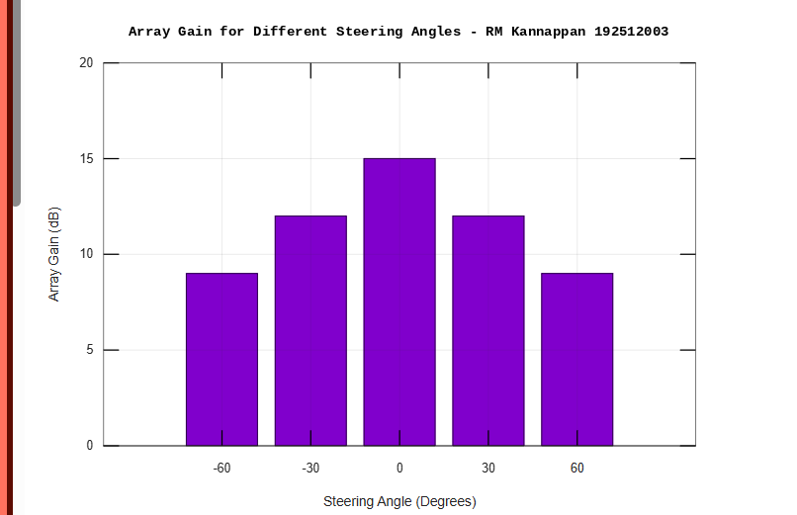

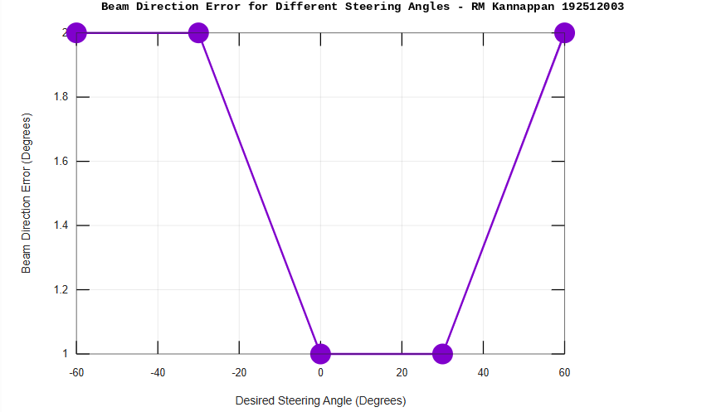
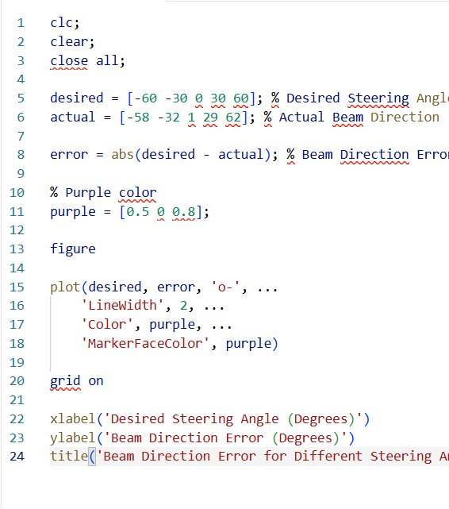
OBJECTIVE 3 :

Result:
The MATLAB analysis successfully demonstrated steering angle variation in a MIMO beam forming system. The results showed that beam steering effectively directs the transmitted energy toward different angles, while maintaining high array gain and minimizing beam direction error.

