SIMULATION EXPERIMENT – 6
Simulation-Based Investigation of Microwave Semiconductor Devices and
Frequency-Conversion Characteristics of a Microwave Mixer
Course: ECA1304 – Microwave Engineering

Name : Kishore R
Reg No : 192512008

Aim
To simulate the operating characteristics of microwave semiconductor devices, analyze their electrical and frequency-dependent behavior, investigate frequency conversion in a microwave mixer, and evaluate conversion performance under specified RF and LO power conditions.

Software Used
MATLAB (for numerical modeling and plotting). The programs use illustrative analytical models for semiconductor and mixer behavior. ADS, LTspice, or Multisim may be used for circuit-level simulation; full device-accurate results require suitable device models and circuit parameters.

Design Specifications
Parameter | Setting | Target / Expected
RF frequency | 10 GHz | 10 GHz
LO frequency | 9.5 GHz | 9.5 GHz
RF input power | −10 dBm | −10 dBm
LO power | +7 dBm | +7 dBm
IF load | 50 Ω | 50 Ω
Difference frequency | |fRF − fLO| | 0.5 GHz
Sum frequency | fRF + fLO | 19.5 GHz
Passive mixer conversion loss | Model dependent | Approximately 6–10 dB

Objective 1: Schottky Diode I–V Characteristics
Aim: To develop a simulation model representing the nonlinear current-voltage characteristics of a microwave Schottky diode.

MATLAB Program
% Objective 1: Schottky Diode I-V Characteristics
clc; clear; close all;

Is = 1e-12;
n = 1.05;
Vt = 0.026;
V = -0.2:0.001:0.5;

I = Is*(exp(V/(n*Vt))-1);

plot(V,I,'LineWidth',2);
grid on;
xlabel('Voltage (V)');
ylabel('Current (A)');
title('Schottky Diode I-V Characteristics');

Output / Observation
The current is very small at low and negative voltages.
Forward current increases rapidly as the applied voltage rises.
The plotted curve represents the nonlinear diode I–V characteristic.
Result: The Schottky diode I–V characteristic was modeled and plotted. The curve shows the expected exponential rise in forward current for the selected illustrative parameters.
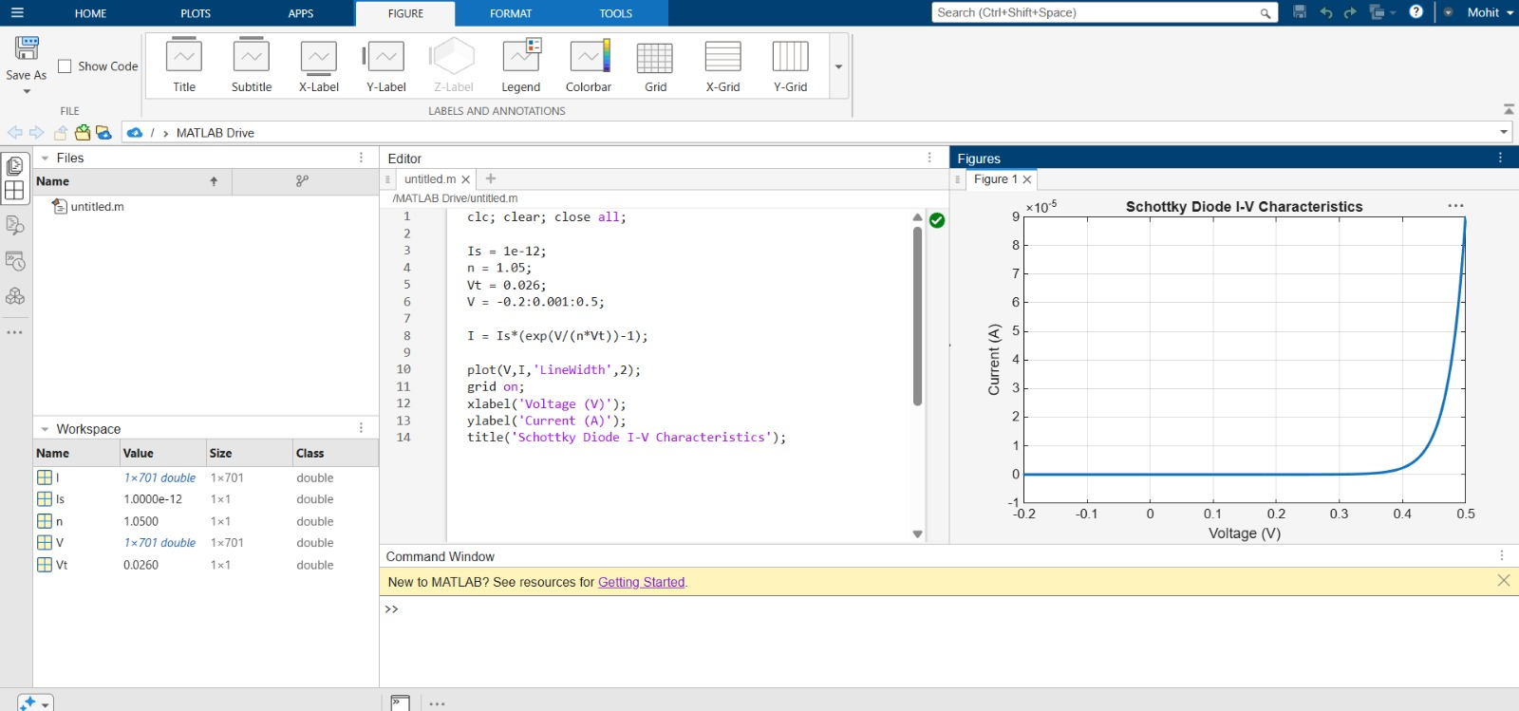
Figure 1: MATLAB plot of Schottky diode I–V characteristics.

Objective 2: Frequency-Dependent Semiconductor Characteristics
Aim: To analyze the frequency-dependent response of a microwave semiconductor device using a simplified series-resistance and junction-capacitance model.

MATLAB Program
% Objective 2: Schottky Diode Frequency Response
clc; clear; close all;

Rs = 5;
Cj = 0.2e-12;
f = logspace(6,11,1000);

H = 1 ./ sqrt(1 + (2*pi*f*Rs*Cj).^2);

semilogx(f/1e9,20*log10(H),'LineWidth',2);
grid on;
xlabel('Frequency (GHz)');
ylabel('Magnitude (dB)');
title('Schottky Diode Frequency Response');

Output / Observation
The response remains close to 0 dB at lower frequencies.
The response decreases as frequency increases.
The trend illustrates the influence of series resistance and junction capacitance.
Result: The modeled frequency response was plotted on a logarithmic frequency axis. The simplified model demonstrates a gradual high-frequency roll-off.
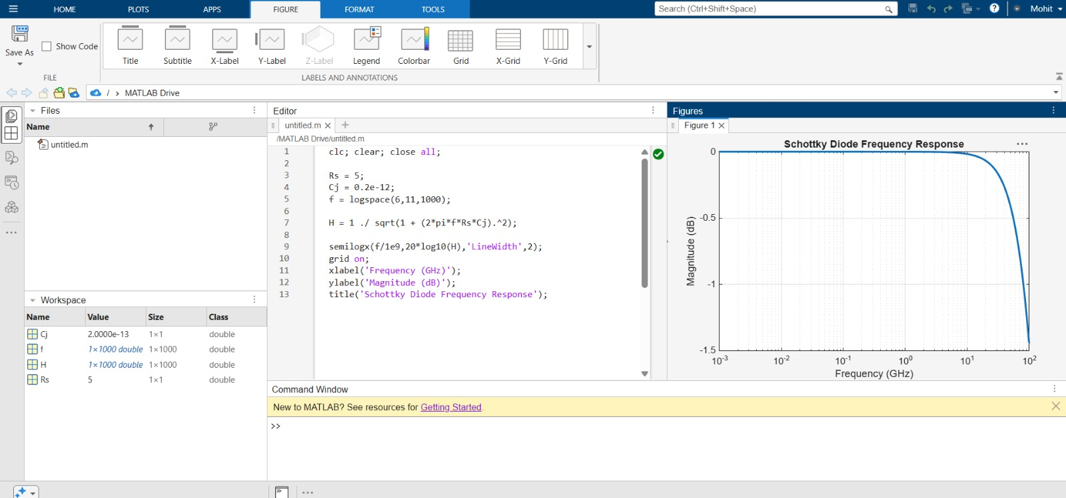
Figure 2: MATLAB plot of the modeled Schottky diode frequency response.

Objective 3: Microwave Mixer Frequency Conversion
Aim: To simulate the mixing of RF and LO signals and identify the difference- and sum-frequency components.

MATLAB Program
% Objective 3: Microwave Mixer Frequency Conversion
clc; clear; close all;

fRF = 10e9;
fLO = 9.5e9;
Fs = 100e9;
t = 0:1/Fs:100e-9-1/Fs;

RF = cos(2*pi*fRF*t);
LO = cos(2*pi*fLO*t);
IF = RF .* LO;

N = length(IF);
Y = abs(fft(IF))/N;
f = (0:N-1)*(Fs/N);

plot(f(1:floor(N/2))/1e9, ...
2*Y(1:floor(N/2)),'LineWidth',1.5);
grid on;
xlabel('Frequency (GHz)');
ylabel('Amplitude');
title('Microwave Mixer Output Spectrum');
xlim([0 25]);

fprintf('Difference frequency = %.2f GHz\\n',abs(fRF-fLO)/1e9);
fprintf('Sum frequency = %.2f GHz\\n',(fRF+fLO)/1e9);

Output
Difference frequency = 0.50 GHz
Sum frequency = 19.50 GHz
Result: The product of the RF and LO signals produces the expected difference component at 0.5 GHz and sum component at 19.5 GHz. This is an idealized multiplication model; practical mixer output levels depend on the device and circuit.
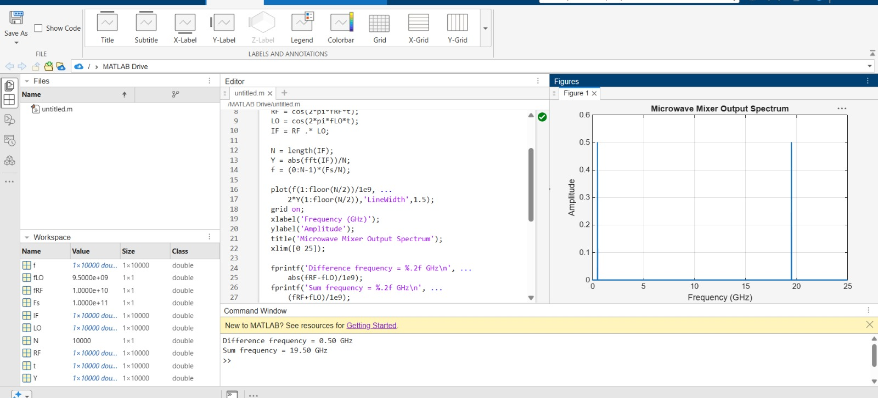
Figure 3: MATLAB output spectrum showing the mixer conversion products.

Objective 4: Conversion Loss and LO Power Dependence
Aim: To evaluate mixer conversion performance and examine the effect of LO power on the modeled IF output.

MATLAB Program
% Objective 4: Conversion Loss and LO Power Dependence
clc; clear; close all;

PRF = -10;
PLO = -5:1:15;

% Illustrative conversion-loss model, minimum at +7 dBm LO
CL = 8 + 0.04*(PLO-7).^2;
PIF = PRF - CL;

plot(PLO,PIF,'o-','LineWidth',2);
grid on;
xlabel('LO Power (dBm)');
ylabel('IF Output Power (dBm)');
title('Mixer Conversion Performance');

k = find(PLO == 7);
fprintf('RF input power = %.2f dBm\\n',PRF);
fprintf('LO power = %.2f dBm\\n',PLO(k));
fprintf('Conversion loss = %.2f dB\\n',CL(k));
fprintf('IF output power = %.2f dBm\\n',PIF(k));

Output
RF input power = -10.00 dBm
LO power = 7.00 dBm
Conversion loss = 8.00 dB
IF output power = -18.00 dBm
Result: In the illustrative model, the conversion loss at +7 dBm LO power is 8 dB, giving an IF output power of −18 dBm for a −10 dBm RF input. The curve is a chosen example, not a measured mixer response.
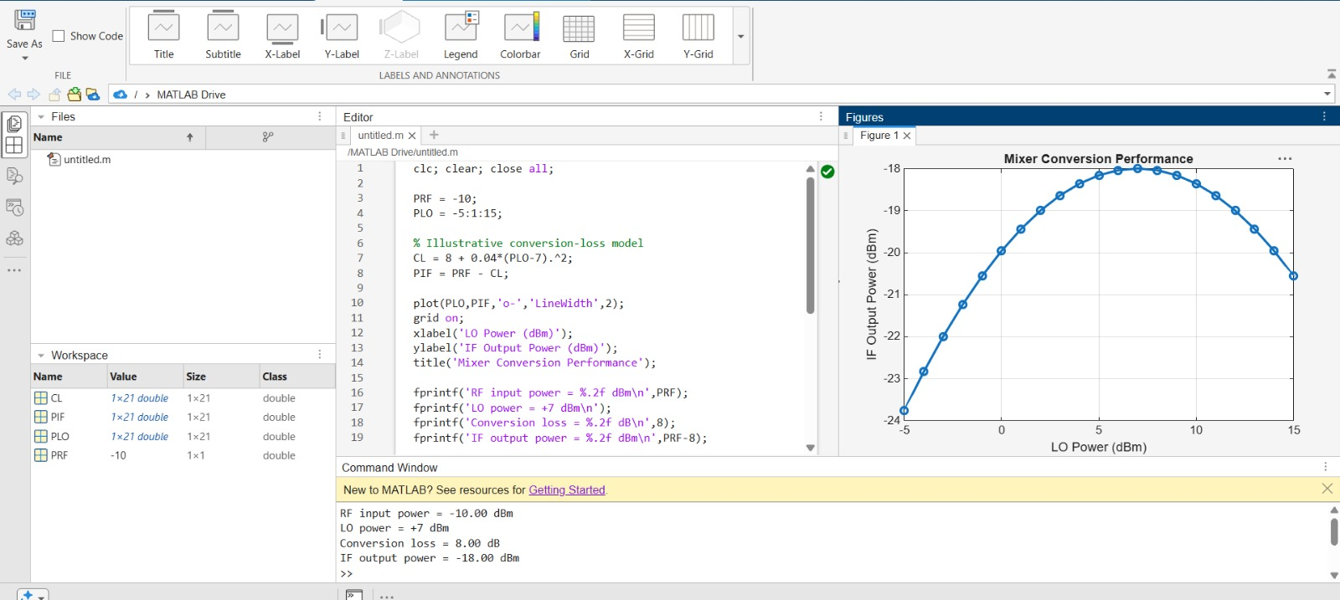
Figure 4: MATLAB plot illustrating IF output power versus LO power.

Overall Result
The four MATLAB objectives were completed: the Schottky diode I–V characteristic was plotted, a simplified frequency response was analyzed, the mixer difference and sum frequencies were identified, and an illustrative conversion-loss model was evaluated. For the specified 10 GHz RF and 9.5 GHz LO signals, the theoretical IF is 0.5 GHz and the sum-frequency component is 19.5 GHz.
The semiconductor and mixer curves are illustrative mathematical models. They are useful for demonstrating trends and calculations but do not replace device-level circuit simulation. To verify actual conversion loss, spurious products, and power dependence, use a suitable mixer/diode model in ADS, LTspice, or Multisim and record the simulated IF output power.

Formulae Used
- Difference-frequency IF: fIF = |fRF − fLO|.
- Sum-frequency component: fsum = fRF + fLO.
- Conversion loss: CL = PRF,in − PIF,out, with both powers expressed in dBm.
- IF output power: PIF,out = PRF,in − CL.
- Percentage frequency deviation = |Practical − Theoretical| / |Theoretical| × 100%.
- Idealized diode equation: I = Is[exp(V/(nVt)) − 1].

