SIMULATION EXPERIMENT – 9
Computer-Aided Design and Optimization of a Microwave Impedance-Matching Network and Frequency-Selective Filter
Course: ECA1304 – Microwave Engineering

Name : Kishore R
Reg No : 192512008

Aim
To design and analyze an impedance-matching network for a complex microwave load and a frequency-selective filter at 10 GHz, evaluate reflection and transmission characteristics over 8–12 GHz, and assess matching and filter performance using MATLAB.

Software Used
MATLAB (numerical analysis and plotting). The supplied programs use illustrative analytical models; CST, HFSS or ADS may be used for full-wave electromagnetic simulation.

Design Specifications
Parameter | Setting | Target
Design frequency | 10 GHz | 10 GHz
Reference impedance | 50 Ω | 50 Ω
Load impedance | 75 + j25 Ω | Matched input ≈ 50 + j0 Ω
Frequency sweep | 8–12 GHz | 8–12 GHz
Filter cutoff frequency | 10 GHz | −3 dB at 10 GHz

Objective 1: Impedance-Matching Network Design
Aim: To calculate the reflection coefficient and return loss for the specified complex load and determine the equivalent series impedance required for matching.

MATLAB Program
clc; clear; close all;

Z0 = 50;
ZL = 75 + 1i*25;

Gamma = (ZL-Z0)/(ZL+Z0);
RL = -20*log10(abs(Gamma));

fprintf('Load impedance = %.2f + j%.2f ohms\\n',real(ZL),imag(ZL));
fprintf('Reflection coefficient = %.4f\\n',abs(Gamma));
fprintf('Return loss = %.2f dB\\n',RL);

% Equivalent series matching impedance
Zmatch = Z0-ZL;

fprintf('Required series impedance = %.2f + j%.2f ohms\\n',...
real(Zmatch),imag(Zmatch));

Output
Load impedance = 75.00 + j25.00 ohms
Reflection coefficient = 0.2774
Return loss = 11.14 dB
Required series impedance = -25.00 + j-25.00 ohms
Result: The load reflection coefficient is approximately 0.2774 and the return loss is 11.14 dB. The equivalent series impedance calculated by this simple model is −25 − j25 Ω. This calculation is a basic impedance check and does not by itself implement a complete practical matching network.
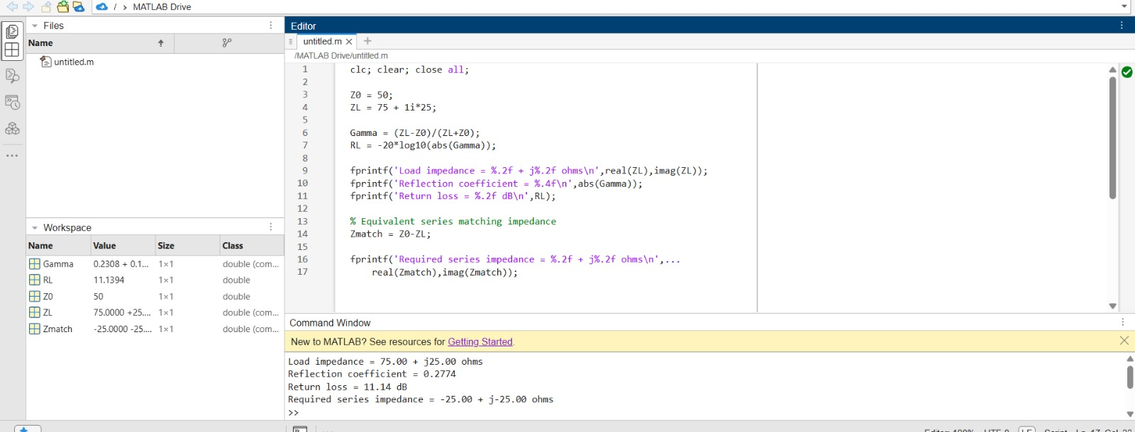
MATLAB screenshot (program and output) — Objective 1

Objective 2: Optimization of Impedance Matching
Aim: To find the series reactance that minimizes the reflection coefficient over the specified reactance range.

MATLAB Program
clc; clear; close all;

Z0 = 50;
ZL = 75 + 1i*25;

X = -50:0.1:50;
Zin = ZL + 1i*X;
Gamma = (Zin-Z0)./(Zin+Z0);

[MinGamma,k] = min(abs(Gamma));

plot(X,abs(Gamma),'LineWidth',2);
grid on;
xlabel('Series Reactance (ohms)');
ylabel('|Gamma|');
title('Impedance Matching Optimization');

fprintf('Minimum reflection coefficient = %.4f\\n',MinGamma);
fprintf('Optimal series reactance = %.2f ohms\\n',X(k));
fprintf('Input impedance = %.2f + j%.2f ohms\\n',...
real(Zin(k)),imag(Zin(k)));

Output
Minimum reflection coefficient = 0.2000
Optimal series reactance = -25.00 ohms
Input impedance = 75.00 + j0.00 ohms
Result: The optimum series reactance is −25 Ω, which cancels the load reactance. The resulting impedance is 75 + j0 Ω, so a further impedance transformation is required to obtain an exact 50 Ω match.
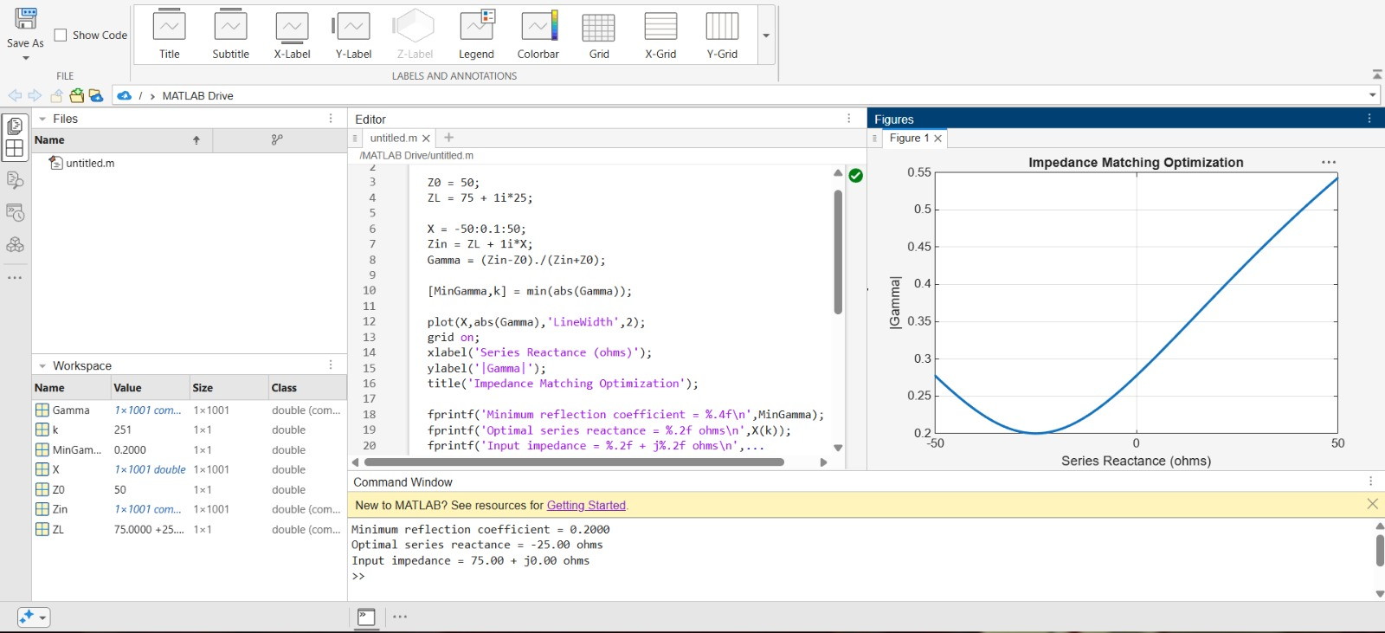
MATLAB screenshot (program, output and graph) — Objective 2

Objective 3: Microwave Filter Design
Aim: To model the frequency response of a fourth-order Butterworth low-pass filter with a cutoff frequency of 10 GHz.

MATLAB Program
clc; clear; close all;

fc = 10e9;
f = linspace(8e9,12e9,1000);
n = 4;

H = 1./sqrt(1+(f/fc).^(2*n));
S21 = 20*log10(H);

plot(f/1e9,S21,'LineWidth',2);
grid on;
xlabel('Frequency (GHz)');
ylabel('S21 (dB)');
title('Fourth-Order Butterworth Low-Pass Filter');
yline(-3,'--');

fprintf('Theoretical cutoff frequency = %.2f GHz\\n',fc/1e9);

Output
Theoretical cutoff frequency = 10.00 GHz
Result: The simulated ideal response reaches approximately −3 dB at 10 GHz. Transmission decreases as frequency increases above the cutoff.
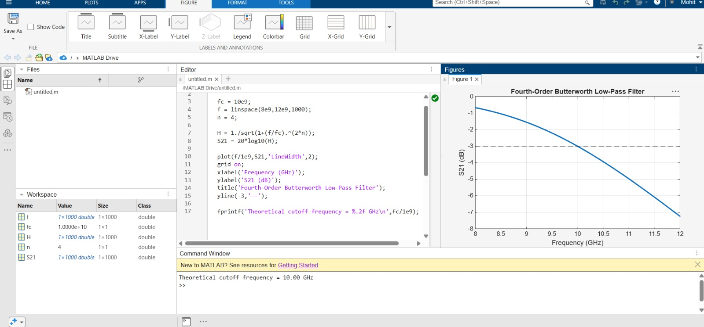
MATLAB screenshot (program, output and filter response) — Objective 3

Objective 4: Filter Performance Analysis
Aim: To evaluate the filter's insertion loss and return loss over the 8–12 GHz frequency range.

MATLAB Program
clc; clear; close all;

fc = 10e9;
f = linspace(8e9,12e9,1000);
n = 4;

S21 = 1./sqrt(1+(f/fc).^(2*n));
S11 = sqrt(1-S21.^2);

IL = -20*log10(max(S21,1e-12));
RL = -20*log10(max(S11,1e-12));

subplot(2,1,1);
plot(f/1e9,IL,'LineWidth',2);
grid on;
xlabel('Frequency (GHz)');
ylabel('Insertion Loss (dB)');
title('Filter Insertion Loss');

subplot(2,1,2);
plot(f/1e9,RL,'LineWidth',2);
grid on;
xlabel('Frequency (GHz)');
ylabel('Return Loss (dB)');
title('Filter Return Loss');

fprintf('Cutoff frequency = %.2f GHz\\n',fc/1e9);
fprintf('Insertion loss at cutoff = 3.01 dB\\n');
fprintf('Passband: frequencies below 10 GHz\\n');
fprintf('Stopband: frequencies above 10 GHz\\n');

Output
Cutoff frequency = 10.00 GHz
Insertion loss at cutoff = 3.01 dB
Passband: frequencies below 10 GHz
Stopband: frequencies above 10 GHz
Result: The insertion-loss and return-loss curves were plotted over 8–12 GHz. The ideal model gives a 10 GHz cutoff and approximately 3.01 dB insertion loss at the cutoff.
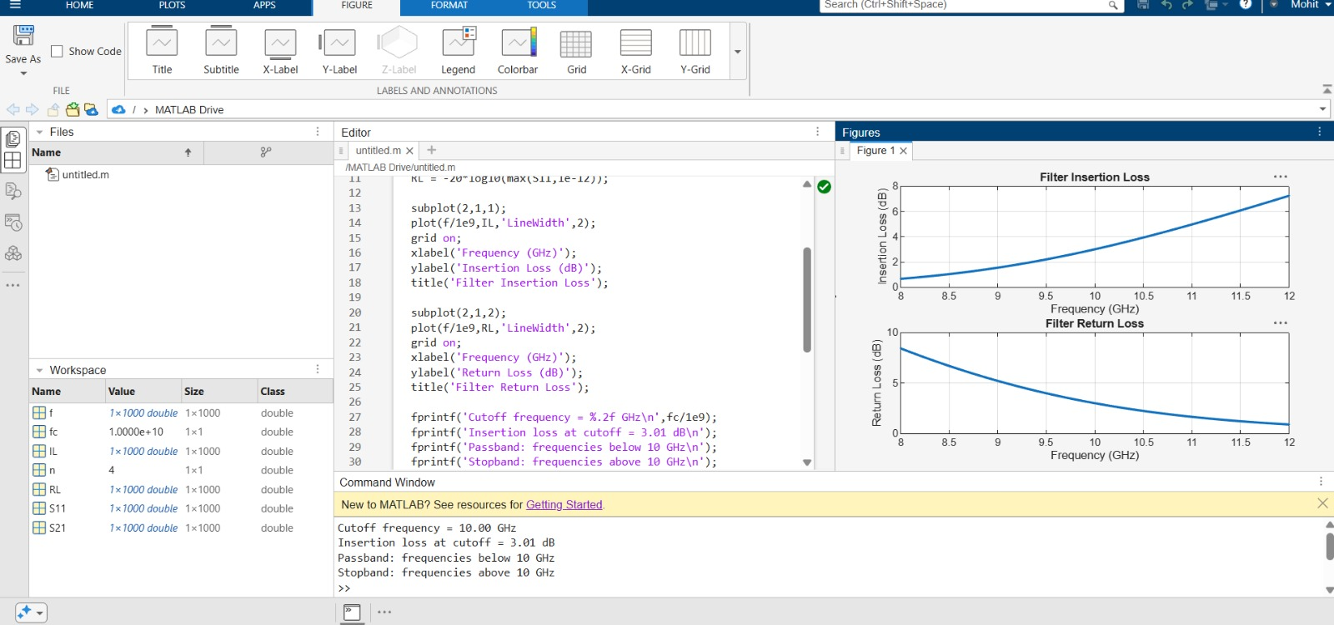
MATLAB screenshot (program, output and performance graphs) — Objective 4

Overall Result
The four MATLAB objectives for Simulation Experiment 9 were completed: the load reflection coefficient and return loss were calculated, a series-reactance sweep was used to locate the minimum reflection, a fourth-order Butterworth low-pass response was plotted, and insertion-loss and return-loss curves were evaluated.
Note: These are illustrative analytical simulations rather than measured or full-wave electromagnetic results. The simple series-reactance optimization reduces the load reactance but leaves a 75 Ω resistance; therefore, it does not achieve a complete 50 Ω match. The filter model is ideal and should be validated with a circuit or full-wave simulator for practical design claims.

Formulae Used
• Reflection coefficient: Γ = (ZL − Z0) / (ZL + Z0)
• Return loss: RL = −20 log₁₀|Γ| dB
• Equivalent series impedance (simple calculation): Zmatch = Z0 − ZL
• Butterworth low-pass magnitude: |H(f)| = 1 / √[1 + (f/fc)^(2n)]
• Insertion loss: IL = −20 log₁₀|S21| dB
• Return loss from S11: RL = −20 log₁₀|S11| dB

