Experiment 4
Evaluate Low-Power CMOS-Inspired RTL Architectures Using Switching-Activity Reduction
Aim
To compare a conventional 8-bit adder register with a low-switching version that uses operand isolation and an enable control, and to verify through behavioral simulation how the low-power design reduces unnecessary switching activity.
Software Used
Xilinx Vivado Design Suite 2024.1 (XSim simulator).
Conventional Design
module conventional_power_design (
input wire clk,
input wire rst,
input wire [7:0] a,
input wire [7:0] b,
output reg [7:0] y
);

always @(posedge clk or posedge rst) begin
if (rst)
y <= 8'b0;
else
y <= a + b;
end

endmodule
Low-Switching Design
Operand isolation is included so that the arithmetic inputs become zero when computation is disabled.
module low_power_design (
input wire clk,
input wire rst,
input wire enable,
input wire [7:0] a,
input wire [7:0] b,
output reg [7:0] y
);

wire [7:0] a_iso;
wire [7:0] b_iso;
wire [7:0] sum;

assign a_iso = enable ? a : 8'b0;
assign b_iso = enable ? b : 8'b0;

assign sum = a_iso + b_iso;

always @(posedge clk or posedge rst) begin
if (rst)
y <= 8'b0;
else if (enable)
y <= sum;
end

endmodule
Testbench Code
`timescale 1ns/1ps
module tb_low_power;
reg clk;
reg rst;
reg enable;
reg [7:0] a,b;
wire [7:0] y_conv;
wire [7:0] y_low;

conventional_power_design D1 (
.clk(clk),
.rst(rst),
.a(a),
.b(b),
.y(y_conv)
);

low_power_design D2 (
.clk(clk),
.rst(rst),
.enable(enable),
.a(a),
.b(b),
.y(y_low)
);

always #5 clk = ~clk;

initial begin
clk=0;
rst=1;
enable=0;
a=0;
b=0;
#10 rst=0;
enable=1;
a=10; b=20;
#10;
a=15; b=25;
#10;
enable=0;
a=50; b=60;
#10;
a=100; b=100;
#10;
enable=1;
a=30; b=40;
#10;
$finish;
end
endmodule
Output
Results at each rising clock edge (values in decimal, hexadecimal in brackets):
Clock edge (ns) | enable | a | b | y_conv | y_low
5 (reset) | 0 | 0 | 0 | 0 | 0
15 | 1 | 10 | 20 | 30 (1E) | 30 (1E)
25 | 1 | 15 | 25 | 40 (28) | 40 (28)
35 | 0 | 50 | 60 | 110 (6E) | 40 (28) held
45 | 0 | 100 | 100 | 200 (C8) | 40 (28) held
55 | 1 | 30 | 40 | 70 (46) | 70 (46)
Simulation waveform (Vivado behavioral simulation):
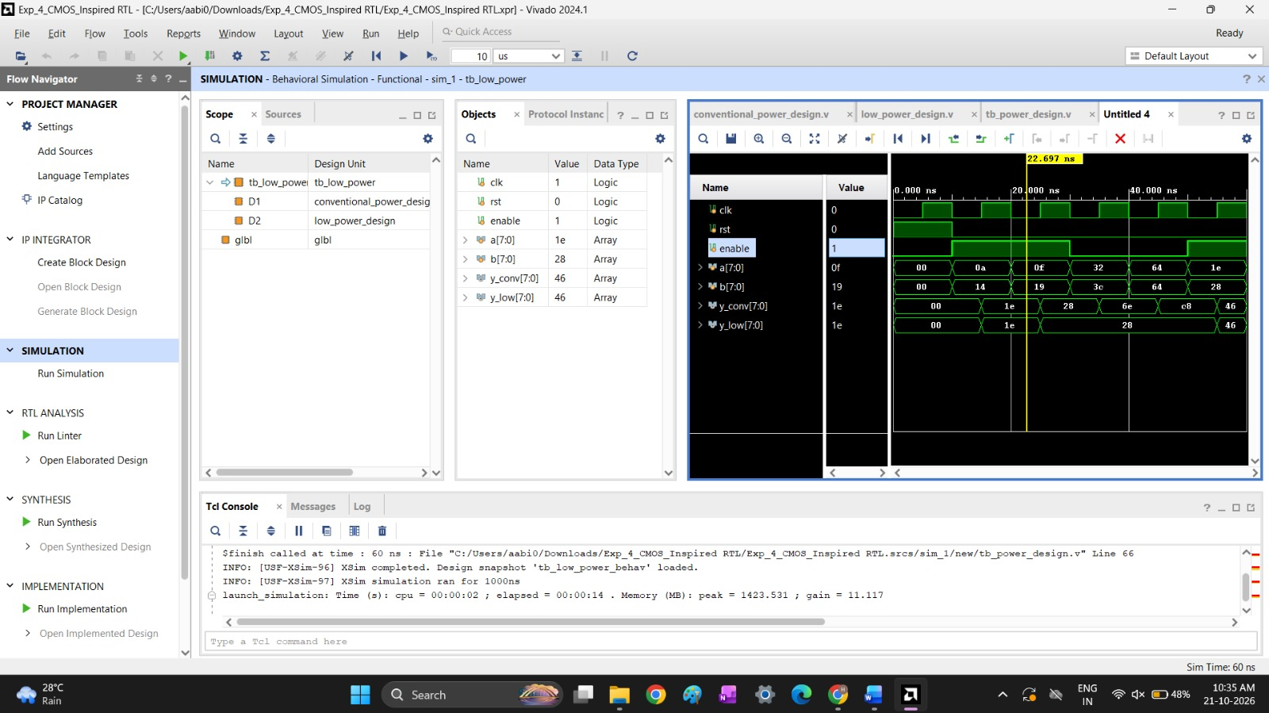
Fig. 1: Behavioral simulation of tb_low_power (simulation time 60 ns)
Observation
While enable = 1, both designs give the same output (30, 40 and 70). While enable = 0 (30 ns to 50 ns), the conventional design keeps adding the changing inputs, so y_conv changes to 110 and then 200. In the low-power design the adder inputs are forced to zero and the output register is not updated, so y_low holds its previous value of 40. This removes the unnecessary switching in the adder and register, which lowers dynamic power. Simulation shows the reduced activity only; the actual power saving would be measured with Vivado power analysis.
Result
The conventional and low-switching designs were simulated. The low-power design gives the same results as the conventional design when enabled and holds its output with no input-driven switching when disabled, which verifies the switching-activity reduction.

