Experiment 2
Analyze CMOS Inverter Transfer Characteristics and Investigate the Effect of Transistor Sizing
Aim
To model a parameterized CMOS inverter in Verilog HDL with low, medium and high drive strengths, compare the three versions through behavioral simulation, and investigate the effect of transistor sizing (drive strength) on the inverter.
Software Used
Xilinx Vivado Design Suite 2024.1 (XSim simulator).
Verilog Code (Parameterized Inverter)
module parameterized_inverter #(
parameter DRIVE_STRENGTH = 1
)(
input wire a,
output wire y
);

(* keep = "true" *) wire [DRIVE_STRENGTH-1:0] inv;
genvar i;
generate
for(i=0; i<DRIVE_STRENGTH; i=i+1) begin : INV_STAGE
assign inv[i] = ~a;
end
endgenerate

assign y = inv[0];

endmodule
Comparison Module
module inverter_comparison (
input wire a,
output wire y_low,
output wire y_medium,
output wire y_high
);

parameterized_inverter #(.DRIVE_STRENGTH(1))
LOW (
.a(a),
.y(y_low)
);

parameterized_inverter #(.DRIVE_STRENGTH(2))
MEDIUM (
.a(a),
.y(y_medium)
);

parameterized_inverter #(.DRIVE_STRENGTH(3))
HIGH (
.a(a),
.y(y_high)
);

endmodule
Testbench Code
`timescale 1ns/1ps
module tb_inverter_comparison;
reg a;
wire y_low;
wire y_medium;
wire y_high;

inverter_comparison DUT (
.a(a),
.y_low(y_low),
.y_medium(y_medium),
.y_high(y_high)
);

initial begin
$monitor("TIME=%0t A=%b LOW=%b MEDIUM=%b HIGH=%b",
$time,a,y_low,y_medium,y_high);
a=0;
#20 a=1;
#20 a=0;
#20 a=1;
#20 a=0;
#20 $finish;
end
endmodule
Output
Console output of the testbench ($monitor):
TIME=0 A=0 LOW=1 MEDIUM=1 HIGH=1
TIME=20 A=1 LOW=0 MEDIUM=0 HIGH=0
TIME=40 A=0 LOW=1 MEDIUM=1 HIGH=1
TIME=60 A=1 LOW=0 MEDIUM=0 HIGH=0
TIME=80 A=0 LOW=1 MEDIUM=1 HIGH=1
Input and output levels obtained from simulation:
Time (ns) | A (input) | y_low | y_medium | y_high
0 – 20 | 0 | 1 | 1 | 1
20 – 40 | 1 | 0 | 0 | 0
40 – 60 | 0 | 1 | 1 | 1
60 – 80 | 1 | 0 | 0 | 0
80 – 100 | 0 | 1 | 1 | 1
Simulation waveform (Vivado behavioral simulation):
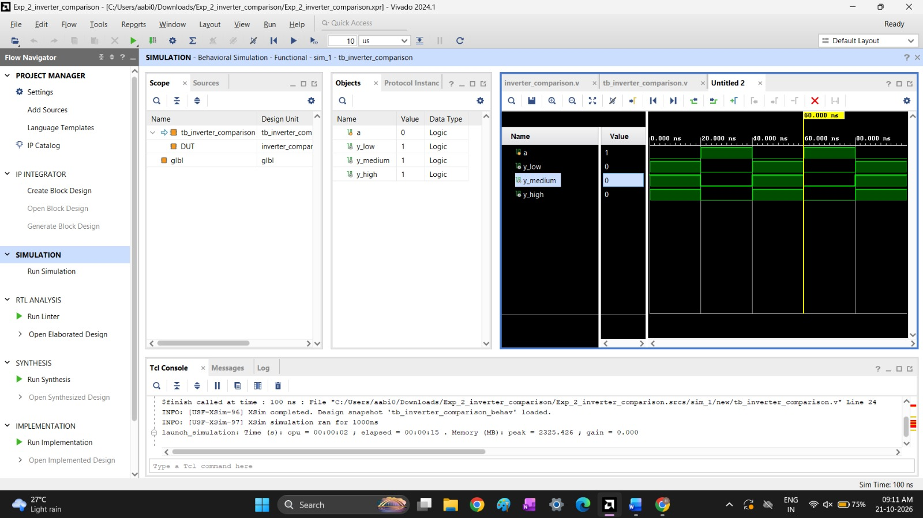
Fig. 1: Behavioral simulation of tb_inverter_comparison (simulation time 100 ns)
Observation
For every change of the input A, the three outputs y_low, y_medium and y_high switch together to the complement of A. In behavioral simulation all three inverters give the same logic response, because drive strength changes only the number of parallel inverter stages and not the logic function. The effect of transistor sizing (current drive, delay and area) appears in the synthesized or implemented design, not in the functional waveform.
Result
The parameterized inverter was simulated for drive strengths 1, 2 and 3. The outputs are the logical inverse of the input in all cases, which verifies the inverter transfer behavior.

