Experiment 3
Evaluate Logical Effort and Multistage Delay Optimization for Large Capacitive Loads
Aim
To implement a 3-input AND function as single-stage, two-stage and three-stage Verilog designs, verify their functionality through behavioral simulation, and study how splitting the logic into multiple stages relates to logical effort and delay optimization.
Software Used
Xilinx Vivado Design Suite 2024.1 (XSim simulator).
Single-Stage Design
module single_stage (
input wire a,
input wire b,
input wire c,
output wire y
);

assign y = a & b & c;

endmodule
Two-Stage Design
module two_stage (
input wire a,
input wire b,
input wire c,
output wire y
);

(* keep = "true" *) wire s1;

assign s1 = a & b;
assign y = s1 & c;

endmodule
Three-Stage Design
module three_stage (
input wire a,
input wire b,
input wire c,
output wire y
);

(* keep = "true" *) wire s1;
(* keep = "true" *) wire s2;

assign s1 = a & b;
assign s2 = s1 & c;
assign y = s2;

endmodule
Testbench Code
`timescale 1ns/1ps
module tb_multistage;
reg a,b,c;
wire y1,y2,y3;

single_stage A1(a,b,c,y1);
two_stage A2(a,b,c,y2);
three_stage A3(a,b,c,y3);

initial begin
$monitor("T=%0t A=%b B=%b C=%b Y1=%b Y2=%b Y3=%b",
$time,a,b,c,y1,y2,y3);
a=0;b=0;c=0;
#10 a=1;
#10 b=1;
#10 c=1;
#10 a=0;
#10 b=0;
#10 c=0;
#10 $finish;
end
endmodule
Output
Console output of the testbench ($monitor):
T=0 A=0 B=0 C=0 Y1=0 Y2=0 Y3=0
T=10 A=1 B=0 C=0 Y1=0 Y2=0 Y3=0
T=20 A=1 B=1 C=0 Y1=0 Y2=0 Y3=0
T=30 A=1 B=1 C=1 Y1=1 Y2=1 Y3=1
T=40 A=0 B=1 C=1 Y1=0 Y2=0 Y3=0
T=50 A=0 B=0 C=1 Y1=0 Y2=0 Y3=0
T=60 A=0 B=0 C=0 Y1=0 Y2=0 Y3=0
Input and output levels obtained from simulation:
Time (ns) | A | B | C | Y1 | Y2 | Y3
0 – 10 | 0 | 0 | 0 | 0 | 0 | 0
10 – 20 | 1 | 0 | 0 | 0 | 0 | 0
20 – 30 | 1 | 1 | 0 | 0 | 0 | 0
30 – 40 | 1 | 1 | 1 | 1 | 1 | 1
40 – 50 | 0 | 1 | 1 | 0 | 0 | 0
50 – 60 | 0 | 0 | 1 | 0 | 0 | 0
60 – 70 | 0 | 0 | 0 | 0 | 0 | 0
Simulation waveform (Vivado behavioral simulation):
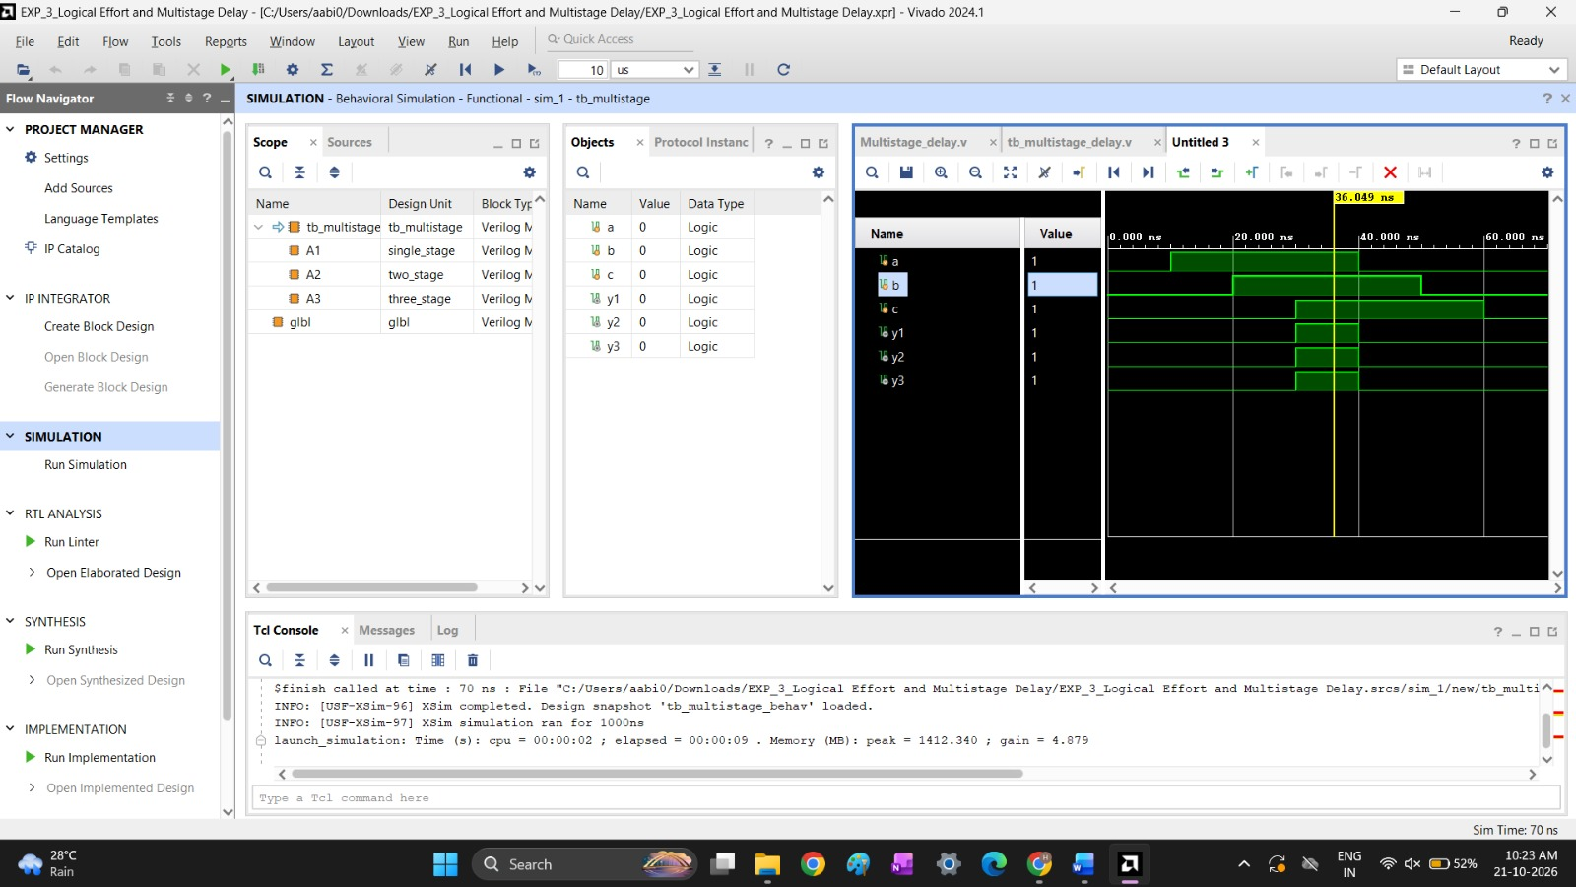
Fig. 1: Behavioral simulation of tb_multistage (simulation time 70 ns)
Observation
The outputs Y1, Y2 and Y3 of the single-stage, two-stage and three-stage designs are identical. Each goes high only when A, B and C are all 1 (30 ns to 40 ns) and is low otherwise. In behavioral simulation the stages add no delay, so splitting the logic changes only its structure, not its function. The delay and logical-effort benefit of multistage design, especially for large capacitive loads, is seen in synthesis and timing analysis of the implemented design.
Result
The single-stage, two-stage and three-stage implementations of y = a & b & c were simulated. All three give the same logical output for every input combination, which verifies the functional correctness of the designs.

