Experiment 1
Evaluate CMOS Logic-Gate Implementations Using Verilog HDL and FPGA Synthesis
Aim
To model the basic CMOS logic gates (NOT, NAND, NOR, AND, OR, XOR and XNOR) in Verilog HDL, verify their functionality using a testbench through behavioral simulation, and prepare the design for FPGA synthesis and implementation.
Software Used
Xilinx Vivado Design Suite 2024.1 (XSim simulator).
Verilog Code (Design Module)
module cmos_logic_gates (
input wire a,
input wire b,
output wire y_not,
output wire y_nand,
output wire y_nor,
output wire y_and,
output wire y_or,
output wire y_xor,
output wire y_xnor
);

assign y_not = ~a;
assign y_nand = ~(a & b);
assign y_nor = ~(a | b);
assign y_and = a & b;
assign y_or = a | b;
assign y_xor = a ^ b;
assign y_xnor = ~(a ^ b);

endmodule
Testbench Code
`timescale 1ns/1ps
module tb_cmos_logic_gates;
reg a, b;
wire y_not, y_nand, y_nor;
wire y_and, y_or, y_xor, y_xnor;

cmos_logic_gates DUT (
.a(a),
.b(b),
.y_not(y_not),
.y_nand(y_nand),
.y_nor(y_nor),
.y_and(y_and),
.y_or(y_or),
.y_xor(y_xor),
.y_xnor(y_xnor)
);

initial begin
$display("A B | NOT NAND NOR AND OR XOR XNOR");
$display("----------------------------------");
a=0; b=0; #10;
$display("%b %b | %b %b %b %b %b %b %b",
a,b,y_not,y_nand,y_nor,y_and,y_or,y_xor,y_xnor);
a=0; b=1; #10;
$display("%b %b | %b %b %b %b %b %b %b",
a,b,y_not,y_nand,y_nor,y_and,y_or,y_xor,y_xnor);
a=1; b=0; #10;
$display("%b %b | %b %b %b %b %b %b %b",
a,b,y_not,y_nand,y_nor,y_and,y_or,y_xor,y_xnor);
a=1; b=1; #10;
$display("%b %b | %b %b %b %b %b %b %b",
a,b,y_not,y_nand,y_nor,y_and,y_or,y_xor,y_xnor);
$finish;
end
endmodule
Output
Console output (Tcl Console) of the testbench:
A B | NOT NAND NOR AND OR XOR XNOR
----------------------------------
0 0 | 1 1 1 0 0 0 1
0 1 | 1 1 0 0 1 1 0
1 0 | 0 1 0 0 1 1 0
1 1 | 0 0 0 1 1 0 1
Truth table obtained from simulation:
A | B | NOT (A) | NAND | NOR | AND | OR | XOR | XNOR
0 | 0 | 1 | 1 | 1 | 0 | 0 | 0 | 1
0 | 1 | 1 | 1 | 0 | 0 | 1 | 1 | 0
1 | 0 | 0 | 1 | 0 | 0 | 1 | 1 | 0
1 | 1 | 0 | 0 | 0 | 1 | 1 | 0 | 1
Simulation waveform (Vivado behavioral simulation):
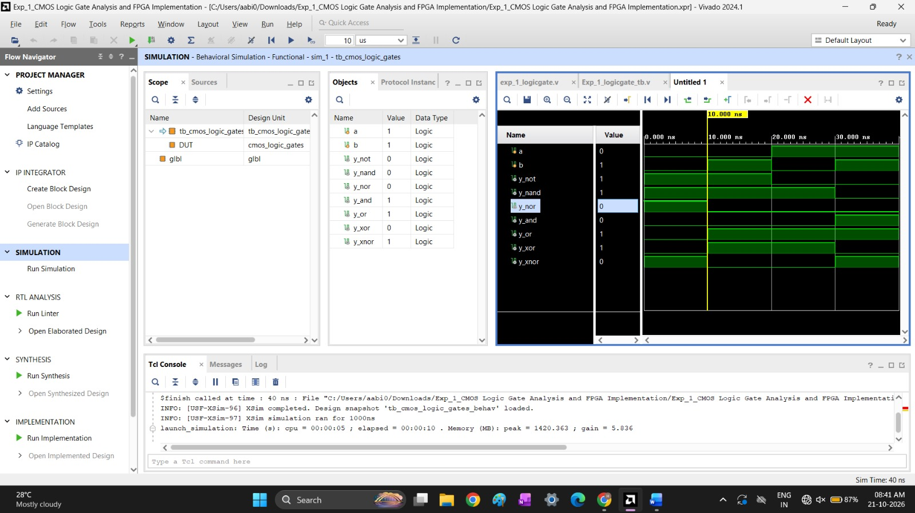
Fig. 1: Behavioral simulation of tb_cmos_logic_gates (simulation time 40 ns)
Result
The CMOS logic gates were described in Verilog HDL and simulated in Vivado. The waveforms and the console output match the expected truth tables of NOT, NAND, NOR, AND, OR, XOR and XNOR for all input combinations of A and B, which verifies the functional correctness of the design.

