SIMATS ENGINEERING
Saveetha Institute of Medical and Technical Sciences
ECA56 Advanced Wireless Communication Systems
Assignment – 1 (CO1)
Integrated 5G/6G-Ready Communication Network for a Six-State Smart-City Deployment
Cellular Network Evolution, Cellular Planning and Spectrum Allocation
Engineering Design Report
Name: | S. Hari Prasath
Register Number: | 192512041
Course: | ECA5603 AdvancedWirelessCommunication Systems
Assessment: | Open-ended engineering design report (100 marks)
Date of submission: | 28 October 2026

Executive Summary
This report develops a 5G/6G-ready network design for a six-state smart-city consortium covering Tamil Nadu, Karnataka, Kerala, Maharashtra, Gujarat and Uttar Pradesh. The work follows the order requested in the assignment: requirements, analysis, calculations, comparison and recommendation. Every number in the report comes either from the planning data in the question, from a standard (3GPP, ITU-R) or from a stated assumption, and the assumptions are listed so they can be changed and the calculations repeated.
The main findings are the following. First, no single spectrum band or cell type fits all six states: busy-hour demand density in this model ranges from 0.4 to about 7,800 Mbps/km², which is more than four orders of magnitude, so sub-1 GHz macro cells, mid-band macro and small cells, and mmWave hotspots each have a clear and different role. Second, the Erlang B calculation at a 2% blocking target shows that with 32 available traffic channels per cell, Tamil Nadu, Karnataka and Maharashtra exceed the target clearly (5.3%, 9.6% and 19.5%) and need between 4 and 14 additional channels or load relief, while Gujarat is marginal (2.2%). Third, a macro-only design leaves only 37–65% of dense-urban demand served and gives a regional-cloud round-trip latency of 24.5 ms, against 9.0 ms when the user-plane function and compute are placed at a metro edge.
Architecture B (heterogeneous: 24,803 macro sites, 6,030 mmWave small cells and 48 edge nodes) is selected over the macro-only alternative. The weighted decision matrix gives 4.02 against 3.03 out of 5. The recommendation is deployment with modifications: a phased roll-out, pilot measurements of mmWave blockage and real traffic before full commitment, and slice-based protection of public-safety and ultra-reliable traffic. Indicative capital cost is about ₹13,197 crore, compared with ₹16,420 crore for a macro-only network densified far enough to carry the same urban load.

1. Introduction and Approach
The consortium wants one integrated network that can carry very different kinds of traffic at the same time: autonomous-vehicle messaging that must arrive within a few milliseconds, high-definition video that needs sustained throughput, remote-healthcare sessions that must not drop, factory control loops, millions of low-rate sensors and emergency communication that must work when the commercial load is at its worst. The question asks for a design that is justified by calculation rather than by description, so the report is built around a small set of quantitative models that are reused from one section to the next.
The models are an Erlang B traffic-channel model, a hexagonal-cell planning model that takes the larger of the coverage-limited and the capacity-limited cell count, a Shannon-based spectrum and spectral-efficiency model, a latency budget, a mobility and handover model, and a 24-hour system-level simulation of an AI-assisted resource manager against two baselines. The calculations were done in Python (NumPy and Matplotlib); the scripts are simple enough to be reproduced in a spreadsheet or MATLAB.

1.1 Data and assumptions
The problem statement supplies the structure of the planning data but not every number. In particular, the Erlang B section refers to a supplied subscriber count, busy-hour traffic per subscriber and available traffic channels, and no values are given in the question paper. Representative planning values have therefore been assumed and are stated in the place where they are used. Subscriber counts per cell, planned service areas and demand densities are assumptions chosen to be plausible for each state; they are not survey data. Unit costs are planning figures in Indian rupees (₹) and are not vendor quotations. If the instructor's data set differs, only the input tables need to change.

1.2 Organisation of the report
Section 2 interprets the evolution from 1G to 6G, including the idealised channel-count comparison. Sections 3 to 8 follow Stages 1 to 6 of the assignment. Section 9 gives the conclusion. Each stage ends with its design decision, and each numerical result is followed by a short interpretation.

2. Evolution of Mobile Communication Systems (1G–6G)
Each generation changed the multiple-access method, and with it the way channels are counted, how often spectrum can be reused and what the network can offer. Table 1 summarises the progression using commonly quoted figures from the standards.
Table 1. Evolution of mobile communication systems, 1G to 6G.
Generation | Access / duplex | Channel bandwidth | Peak data rate | Latency | Main advance
1G (1980s) | FDMA / FDD, analogue FM | 30 kHz | ≈ 2.4 kbps (voice only) | ≈ 100s of ms (circuit) | Voice only; no encryption; poor spectral efficiency
2G (1991) | TDMA / FDD (GSM), 8 slots per carrier | 200 kHz | 9.6–14.4 kbps (GPRS ≈ 171 kbps) | ≈ 300–500 ms | Digital voice, SMS, encryption, SIM-based authentication
3G (2001) | WCDMA / FDD, reuse 1 | 5 MHz | 384 kbps (HSPA+ ≈ 42 Mbps) | ≈ 50–200 ms | Mobile data, soft handover, packet core
4G (2010) | OFDMA downlink, SC-FDMA uplink | up to 20 MHz per carrier (100 MHz with aggregation) | ≈ 100 Mbps–1 Gbps | ≈ 10–30 ms | All-IP, VoLTE, MIMO, carrier aggregation
5G (2019) | CP-OFDM, scalable numerology, massive MIMO, TDD and FDD | 100 MHz (mid-band), 400 MHz (mmWave) | up to 20 Gbps (IMT-2020 target) | 1–10 ms (URLLC target 1 ms) | eMBB, URLLC, mMTC, slicing, service-based core, edge
6G (≈ 2030) | Candidate: AI-native air interface, ISAC, sub-THz, non-terrestrial integration | ≥ 1 GHz (sub-THz candidate) | 50–200 Gbps (IMT-2030 indicative) | 0.1–1 ms | Sensing + communication, AI-native networking, 10⁶–10⁸ devices/km²

The trend has three parts. Channels got narrower in time and frequency but more of them were packed together (FDMA to TDMA to CDMA to OFDMA). Frequency reuse relaxed from a cluster of 7 or 12 cells in 1G and 2G to reuse of 1 in 3G, 4G and 5G, so that every cell can use the whole carrier, with interference handled by coding, scheduling and beamforming instead of by geography. And the service model widened from voice to data to three coexisting service classes in 5G. ITU-R M.2083 and M.2410 define the 5G (IMT-2020) targets; ITU-R M.2160 sets the framework for IMT-2030 (6G) [1]–[3].

2.1 Channel allocation and spectrum utilisation
For comparison, the number of orthogonal channels available to one operator can be estimated by dividing the spectrum allocation by the bandwidth of one channel:
N_{ch} = B / B_{ch} (1)
where B is the operator's allocation in one direction (MHz) and B_{ch} is the channel bandwidth (MHz). For 1G and 2G the cluster size K divides the channels among cells, so the channels available in one cell are N_{ch}/K. The operator allocations used here (12.5 MHz for 1G and 2G, 5 MHz for one 3G carrier, and a single carrier of 20, 100, 400 and 1000 MHz for 4G, 5G mid-band, 5G mmWave and the assumed 6G case) are representative values and not the exact allocation of any one operator.
Table 2. Idealised channel counts for 1G–6G per operator and direction.
Generation | B (MHz) | Channel unit | B_{ch} | Idealised count B/B_{ch} | Practical count | Reuse → channels per cell
1G | 12.5 | FDMA voice channel | 30 kHz | 416 | ≈ 395 (about 21 control channels) | K = 7 → 59
2G | 12.5 | GSM carrier × 8 TDMA slots | 200 kHz (25 kHz per slot) | 62 carriers → 496 slots | fewer: BCCH and signalling slots | K = 12 → 41
3G | 5 | WCDMA carrier (codes) | 5 MHz | 1 carrier ≈ 49 voice users* | lower: pilot, control and soft-handover load | K = 1 → 49
4G | 20 | Physical resource block (PRB) | 180 kHz | 111 | 100 PRBs (10% guard) | K = 1
5G mid-band | 100 | PRB, 30 kHz spacing | 360 kHz | 277 | 273 PRBs (1.7% guard) | K = 1
5G mmWave | 400 | PRB, 120 kHz spacing | 1.44 MHz | 277 | 264 PRBs (5% guard) | K = 1
6G (assumed) | 1000 | PRB, 480 kHz spacing (assumed) | 5.76 MHz | 173 | not standardised | K = 1

* For 3G the count is a code-division capacity, not a frequency count: with a chip rate of 3.84 Mcps and a 12.2 kbps voice codec the processing gain is about 315, and with a required E_{b}/N₀ of 5 dB (3.16) the pole capacity is about 315/3.16 ≈ 100 users, or ≈ 49–50 at a 50% load factor.
Stated assumption. The channel counts in Table 2 are idealised. Guard bands at the edge of the allocation, duplex separation and the FDD pairing of uplink and downlink spectrum, TDD guard periods, control and broadcast channels (BCCH, PDCCH, SSB, RACH), pilot and reference-signal overhead, cyclic-prefix overhead and adjacent-operator protection are ignored in the simple division. The column headed ‘Practical count’ shows how much these overheads matter where the standard gives a number: LTE keeps 100 of the 111 ideal resource blocks (a guard loss of about 10%), NR at 100 MHz keeps 273 of 277 (about 1.7%) and NR at 400 MHz keeps 264 of 277 (about 5%) [4]. For FDD systems the count is per direction, so the paired spectrum use is twice as large.
Using the Erlang B model of Section 5.4, a cell with 59 channels (1G, K = 7) can carry about 48.7 E at 2% blocking, a 2G cell with 41 channels about 31.9 E, and a 3G cell with 49 users about 39.3 E. These are voice-only capacities. For 4G and 5G the resource block is shared dynamically between voice, data and control, so the idealised count is a resource inventory and not a call count, and the capacity is instead found from spectral efficiency (Section 5.2). The practical consequence is that 5G capacity comes mostly from more bandwidth per carrier, reuse of 1 and spatial multiplexing, and not from more channels.

2.2 Interpretation for this design
The comparison shows why the six-state design cannot simply scale up a 4G-style plan. The 5G mid-band carrier offers about five times the bandwidth of one LTE carrier, but the real step in capacity is the use of massive MIMO and mmWave bandwidth, and both of these cost more in site density, power and backhaul. The 6G column is deliberately labelled as assumed: no 6G air interface is standardised yet, so the design in Section 7 treats 6G as a set of provisions (fibre-rich sites, upgradeable radio units, edge compute and a sensing-ready architecture) and not as a deployed technology.

3. Requirements Analysis and Problem Formulation (Stage 1)

3.1 Application classification
Table 3 classifies the six application groups in the planning data into the three 5G service categories. The classification matters because eMBB is limited by bandwidth, URLLC by latency and reliability, and mMTC by connection density and energy; one design lever rarely helps all three.
Table 3. Classification of applications by service category.
Application | Service category | Requirement (typical, from 3GPP TS 22.261 [5])
High-definition and 4K video | eMBB | 5–25 Mbps per stream; latency tolerant (< 100 ms); loss tolerant with buffering
Autonomous transportation (V2X, cooperative perception) | URLLC (with eMBB uplink for sensor sharing) | Latency ≤ 10 ms end to end; reliability 99.999%; 5–10 Mbps uplink per vehicle
Remote healthcare | URLLC (tele-surgery, monitoring); eMBB (video consultation) | Latency ≤ 10–20 ms; reliability 99.999%; 6–10 Mbps per session
Industrial automation | URLLC | Cycle 1–4 ms; reliability 99.999–99.9999%; jitter < 1 ms
Massive IoT (meters, sensors, logistics) | mMTC | 10⁵–10⁶ devices/km²; 10-year battery; payloads of 10–1000 bytes
Emergency and public-safety communication | Critical communication (URLLC and mMTC behaviour, with priority and pre-emption) | Coverage first; set-up time < 300 ms; works during congestion and partial failure

3.2 State-wise requirements matrix
The six states differ in user density, application demand and infrastructure. Table 4 lists the principal challenge in each state and a measurable target. The qualitative descriptions are general knowledge of the regions; the numerical targets are engineering targets proposed in this report.
Table 4. State-wise requirements matrix.
State | Profile | Main challenges | Measurable targets
Tamil Nadu | Chennai–Hosur–Coimbatore industrial belt; long coastline; cyclone exposure | Industrial URLLC latency; coastal emergency coverage; Erlang blocking above target | Industrial slice E2E ≤ 5 ms; availability ≥ 99.99%; blocking ≤ 2%; coastal outdoor coverage ≥ 99%
Karnataka | Very dense technology and urban core (Bengaluru); AV and video demand | Dense-urban capacity and interference; backhaul load | DL ≥ 100 Mbps and UL ≥ 50 Mbps at the 5th percentile in dense urban; blocking ≤ 2%
Kerala | High settlement density along the coast; hilly Western Ghats; heavy rain and floods | Coverage in hilly terrain; resilience; tele-health | Outdoor coverage ≥ 95%; tele-health latency ≤ 20 ms; ≥ 8 h power backup at all sites, 72 h at critical ones
Maharashtra | Largest traffic (Mumbai–Pune), ports, expressways | Peak capacity and handover along fast corridors | Dense-urban demand ≈ 7,800 Mbps/km²; handover interruption ≈ 0 ms for V2X; blocking ≤ 2%
Gujarat | Industrial and petrochemical clusters, ports, long highways | mMTC density and industrial URLLC; long backhaul links | ≥ 10⁵ devices/km² in clusters; industrial latency ≤ 5 ms; microwave-backed backhaul
Uttar Pradesh | Largest population; mixed urban and rural; Delhi NCR growth | Wide-area rural coverage at low cost per subscriber | ≥ 99% population coverage with ≥ 10 Mbps downlink; cost per covered km² minimised

3.3 Constraints
The design is bounded by the following constraints, each of which is given a number later in the report:
- Coverage: outdoor coverage of at least 95% of the planned area and 99% of the population, with rural coverage limited by link budget and site cost.
- Throughput and capacity: busy-hour demand density, not the average, sizes the network.
- Latency and reliability: 10 ms and 99.999% for V2X and 1–5 ms for industrial control, which fixes where the user plane must be.
- Interference: reuse of 1 means co-channel interference has to be controlled actively; TDD adds cross-link interference.
- Energy: radio equipment is the largest part of operating energy, so capacity must be added with sleep modes in mind.
- Security and public safety: authentication, encryption, slice isolation and guaranteed emergency service.
- Cost: capital cost (sites, radios, fibre, edge) and operating cost (energy, rent, maintenance) in a six-state footprint.

3.4 Interactions between requirements
Table 5. Interactions between requirements.
Design change | Effect on other requirements
Cell densification | Capacity up; interference, backhaul, site acquisition, cost and energy up
Higher frequency (mmWave) | Bandwidth and capacity up; range, blockage tolerance and indoor coverage down
More massive-MIMO layers | Spectral efficiency up; power, processing, cost and beam-management complexity up
Ultra-low latency | Needs edge compute and robust coding; lower spectral efficiency and higher cost per bit
Ultra-high reliability | Needs redundancy and low code rates; reduces capacity per cell
Network sleep modes | Energy down; capacity headroom and recovery time worse if prediction is wrong
Open and AI-driven control | Efficiency up; adds an attack surface and a need for secure data handling

3.5 Problem formulation
The design is posed as a constrained optimisation. The design variables are the number of macro, small and mmWave cells in each morphology (N_{m}, N_{s}, N_{mm}), the carrier bandwidth and band assigned to each layer (B_{k}), the number of MIMO layers, the number and location of edge nodes (N_{e}), the share of radio resources reserved for each slice (x_{j}) and the sleep-mode policy. The objective is to minimise a weighted sum of normalised capital cost, annual energy use and unserved demand:
min J = w₁·CAPEX/CAPEX₀ + w₂·E/E₀ + w₃·(1 – served/demand) (2)
subject to the constraints below, where D is the busy-hour demand, C the cell capacity, γ the SINR and T the latency:
- coverage: Cov(N_{m}, N_{s}) ≥ 95% of area and 99% of population;
- capacity: Σ C_{cell} ≥ D in every morphology of every state;
- traffic channels: P_{B}(A, N) ≤ 0.02;
- link quality: γ_{edge} ≥ γ_{min} for the modulation and coding scheme used;
- latency and reliability: T_{E2E} ≤ target and P_{loss} ≤ 10^{–5} for URLLC slices;
- spectrum: Σ B_{k} ≤ spectrum licensed in the band; energy: E ≤ E_{max}; budget: CAPEX ≤ the funded envelope.

3.6 Performance indicators
Table 6. Key performance indicators used to evaluate the final design.
Indicator | Target | Evaluation method
Population / geographic coverage | ≥ 99% population, ≥ 95% area (outdoor), state-wise | Link budget, drive test
Cell-edge (5th percentile) DL / UL throughput | ≥ 100 / 50 Mbps dense urban; ≥ 10 / 2 Mbps rural | System simulation
Blocking probability (guaranteed-rate pool) | ≤ 2% normal; public safety 0% by pre-emption | Erlang B
End-to-end latency, 99th percentile | ≤ 10 ms V2X; ≤ 5 ms industrial; ≤ 20 ms tele-health | Latency budget
Reliability / packet loss (URLLC) | ≥ 99.999% within the latency bound | HARQ and diversity analysis
Network availability | ≥ 99.99% (≥ 99.999% for critical slices) | Redundancy model
PRB utilisation at busy hour | ≤ 70% normal; ≤ 85% alarm threshold | Traffic simulation
Energy per delivered bit and total energy | Reduction ≥ 20% against always-on baseline | Power model
Handover success and interruption | ≥ 99.9% success; ≈ 0 ms for V2X | Mobility analysis

3.7 Design Decision 1: priority among conflicting requirements
Reliability and latency for safety-related traffic (V2X, remote surgery, industrial control and public safety) come first, because a failure here has consequences that no throughput gain can offset. Coverage comes second: without coverage no service class works, and sub-1 GHz coverage also carries the emergency and mMTC services. Capacity in dense areas is third, because it can be added in steps (more carriers, small cells, mmWave) as demand appears. Energy and cost are the final constraints that shape how each of the first three is met. In practice the conflicts are resolved in two ways: slicing and priority give guaranteed resources to the critical classes before the rest are shared, and the expensive measures (small cells, mmWave, edge nodes) are placed only where the calculations show a shortfall, so that cost grows with need.

4. Spectrum, Radio Access and Cellular Network Planning (Stage 2)

4.1 Spectrum bands compared
Free-space path loss grows with 20 log₁₀(f) for a given distance, so moving from 0.7 GHz to 3.5 GHz costs 14 dB, from 3.5 GHz to 28 GHz another 18 dB, and from 0.7 GHz to 28 GHz a total of 32 dB. Table 7 combines this with typical bandwidth, range and cost for the three bands. The India-specific band numbers are examples of bands offered in Department of Telecommunications auctions [6]; availability for any given operator has to be confirmed.
Table 7. Comparison of sub-1 GHz, mid-band and mmWave spectrum.
Band | Typical bandwidth | Free-space loss at 1 km | Practical range | Penetration | Cost per covered area | Suitable use
Sub-1 GHz (e.g. n28 at 700 MHz, 900 MHz) | 10–20 MHz | 89.4 dB | 5–10 km | Best | Lowest per km² | Rural wide-area coverage, IoT, emergency, deep indoor
Mid-band, 1–6 GHz (e.g. 1800, 2300, 3300–3670 MHz) | 20–100 MHz per carrier | 103.3 dB (3.5 GHz) | 0.5–2 km | Good | Moderate | Urban, suburban, industrial and transport capacity layer
mmWave, > 24 GHz (e.g. 26/28 GHz) | 200–400 MHz (up to 1 GHz) | 121.4 dB (28 GHz) | 50–150 m | Poor (blockage, O2I loss) | High per km², but only needed in hotspots | Dense hotspots, stadiums, fixed wireless and high-capacity links

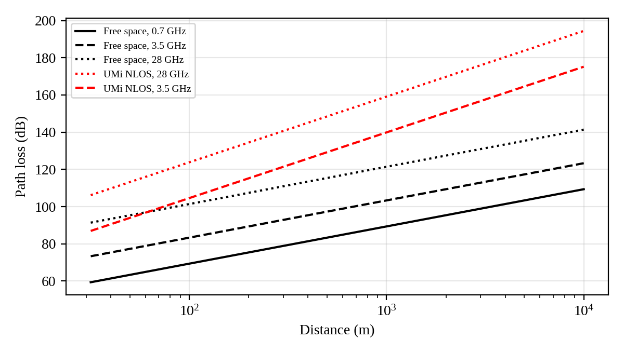
Figure 1. Path loss against distance for the three bands (free space and 3GPP urban-micro NLOS model).
Using the 3GPP TR 38.901 urban-micro non-line-of-sight model [7] with a maximum allowable path loss of 121.5 dB (uplink-limited, 28 GHz, 23 dBm terminal, array gain at both ends, margins for shadowing, interference and blockage), the range is about 86 m. For 3.5 GHz with a 120 dB budget the same model gives about 270 m, and the rural-macro NLOS model gives about 2.4 km for 700 MHz at a 131 dB budget. Line-of-sight conditions in open rural terrain extend this considerably, and the design radius of 5 km used for rural cells is a compromise between the two. These ranges are the reason mmWave is restricted to hotspots, and why sub-1 GHz is the only band that can be used economically over the rural area of a large state.

4.2 Cell types
Table 8. Comparison of macro, micro, pico, femto and mmWave small cells.
Cell type | Transmit power | Radius | Capacity | Relative cost | Typical role
Macro | 40–80 W (46–49 dBm) | 0.5–8 km | Large; 3 sectors, massive MIMO | 1.0 (reference) | Wide-area coverage, corridors, backbone of the plan
Micro | 5–10 W | 100–500 m | Medium | ≈ 0.25 | Street-level capacity, industrial estates
Pico | 0.25–1 W | 30–100 m | Small | ≈ 0.10 | Indoor hotspots, malls, stations, hospitals
Femto / indoor DAS | ≤ 0.1 W | 10–30 m | Small, indoor | ≈ 0.04 | Buildings and factory floors; private networks
mmWave small cell | 0.5–2 W EIRP with arrays | 50–150 m | Very high (400 MHz) | ≈ 0.24 | Dense urban hotspots; fixed wireless access

4.3 Effect of OFDMA, massive MIMO, beamforming and frequency reuse
OFDMA. The 5G NR carrier is divided into subcarriers with spacing 15·2^{μ} kHz (15, 30, 60 or 120 kHz). Twelve subcarriers form one resource block, so the block width is 180, 360, 720 or 1440 kHz. Users are scheduled on separate blocks and the scheduler can pick the blocks where each user's channel is best, which raises capacity without extra spectrum. Wider spacing shortens the slot (0.5 ms at 30 kHz, 0.125 ms at 120 kHz) and so helps latency, and it tolerates the larger Doppler shift at high frequency.
Massive MIMO. An array with M elements gives an array gain of 10 log₁₀(M) dB, which is about 18 dB for M = 64. Using the spatial dimension for multi-user MIMO serves several users on the same resource blocks, which is why the cell-average spectral efficiency used in this report (6 b/s/Hz) is well above the 1.5–2.5 b/s/Hz typical of 4G. The IMT-2020 requirement for urban-macro average downlink efficiency is 7.8 b/s/Hz [3].
Beamforming. Beamforming concentrates the radiated energy toward the user. A net gain of 12 dB in a path-loss environment with exponent n = 3.5 extends the range by 10^{12/(10×3.5)} ≈ 2.2 times, or equivalently it recovers much of the extra loss at mid-band frequencies. Broadcast and synchronisation signals still have to be swept across beams, so coverage for initial access is the practical limit.
Frequency reuse. For a hexagonal layout with cluster size K = i² + ij + j², the co-channel reuse ratio is D/R = √(3K), and with six first-tier interferers the signal-to-interference ratio is approximately
SIR ≈ (D/R)^{n} / 6 = (3K)^{n/2} / 6 (3)
Table 9. Co-channel SIR for different cluster sizes (path-loss exponent n = 4).
Cluster size K | D/R | SIR (linear) | SIR (dB) | Spectrum per cell (fraction of band)
1 | 1.73 | 1.5 | 1.8 | 1.00
3 | 3.00 | 13.5 | 11.3 | 0.33
4 | 3.46 | 24.0 | 13.8 | 0.25
7 | 4.58 | 73.5 | 18.7 | 0.14

A larger cluster gives cleaner signals but divides the band: at K = 7 each cell gets only 1/7 of the spectrum, while reuse of 1 gives the whole carrier but only about 1.8 dB of SIR. 5G NR works with K = 1 and recovers the lost SIR using beamforming, power control, scheduling coordination and fractional frequency reuse at the cell edge.

4.4 Estimation of the number of cells
Each morphology needs enough cells for coverage and enough for capacity, and the larger of the two is taken. For a hexagonal cell of radius R the area is 2.598R², so:
N_{cov} = A / (2.598 R²), N_{cap} = ρ_{D}·A / C_{site}, N = max(N_{cov}, N_{cap}) (4)
where A is the planned area (km²), ρ_{D} the busy-hour demand density (Mbps/km²) and C_{site} the usable capacity of one site (Mbps). The site capacity is the product of bandwidth, cell-average spectral efficiency, the downlink share of the frame and one minus the overhead:
C_{site} = B · η · f_{DL} · (1 – o) (5)
For one 100 MHz mid-band carrier with η = 6 b/s/Hz, f_{DL} = 0.70 (TDD) and 25% overhead, C_{site} = 100 × 6 × 0.70 × 0.75 = 315 Mbps. A macro with two mid-band carriers (200 MHz in total) has 630 Mbps. A sub-1 GHz macro with 20 MHz FDD, η = 2.5 b/s/Hz and 20% overhead has 20 × 2.5 × 0.8 = 40 Mbps. A mmWave small cell with 400 MHz, η = 4 b/s/Hz, f_{DL} = 0.70 and 25% overhead has 840 Mbps. These efficiencies are planning assumptions typical of 3GPP-class system-level results; they should be refined by simulation or field measurement.
The planned service areas and busy-hour demand densities used for each state are in Table 10. The areas are the parts of each state that are planned for service (urban cores, suburban and industrial belts, and rural and highway areas), not the full administrative area. Demand densities are base values of 6,000, 600 and 0.5 Mbps/km² for dense urban, suburban and rural areas, scaled by a state factor from 0.75 (Uttar Pradesh) to 1.30 (Maharashtra).
Table 10. Planning inputs: planned area (km²) and busy-hour demand density (Mbps/km²) by morphology (assumed).
State | Dense urban area | Suburban / industrial area | Rural / highway area | Dense urban demand | Suburban demand | Rural demand
Tamil Nadu | 220 | 1,800 | 20,000 | 5,700 | 570 | 0.47
Karnataka | 250 | 1,500 | 22,000 | 6,600 | 660 | 0.55
Kerala | 90 | 2,500 | 9,000 | 4,800 | 480 | 0.40
Maharashtra | 450 | 3,500 | 40,000 | 7,800 | 780 | 0.65
Gujarat | 260 | 2,200 | 30,000 | 5,400 | 540 | 0.45
Uttar Pradesh | 320 | 4,200 | 80,000 | 4,500 | 450 | 0.38

Worked example, Tamil Nadu suburban belt. Demand is 1,800 km² × 570 Mbps/km² = 1,026,000 Mbps. With a 1.5 km coverage radius, N_{cov} = 1,800/(2.598 × 1.5²) = 308 sites, but N_{cap} = 1,026,000/630 = 1,629 sites. The area is capacity-limited, and the effective cell radius is then about 0.65 km. Dense urban, Tamil Nadu. Demand is 1,254,000 Mbps over 220 km². With a 500 m inter-site distance each macro covers 0.866 × 0.5² = 0.22 km², giving 1,017 macro sites with 630 Mbps each, i.e. 640,710 Mbps. The remaining 613,290 Mbps requires 731 mmWave small cells at 840 Mbps each.
Table 11. Estimated cell counts for the heterogeneous design (Architecture B).
State | Dense urban macro | Dense urban mmWave small cells | Suburban macro | Rural macro (sub-1 GHz) | Total macro | Total small cells
Tamil Nadu | 1,017 | 731 | 1,629 | 308 | 2,954 | 731
Karnataka | 1,155 | 1,099 | 1,572 | 339 | 3,066 | 1,099
Kerala | 416 | 203 | 1,905 | 139 | 2,460 | 203
Maharashtra | 2,079 | 2,620 | 4,334 | 650 | 7,063 | 2,620
Gujarat | 1,201 | 771 | 1,886 | 462 | 3,549 | 771
Uttar Pradesh | 1,479 | 606 | 3,000 | 1,232 | 5,711 | 606
Total | 7,347 | 6,030 | 14,326 | 3,130 | 24,803 | 6,030

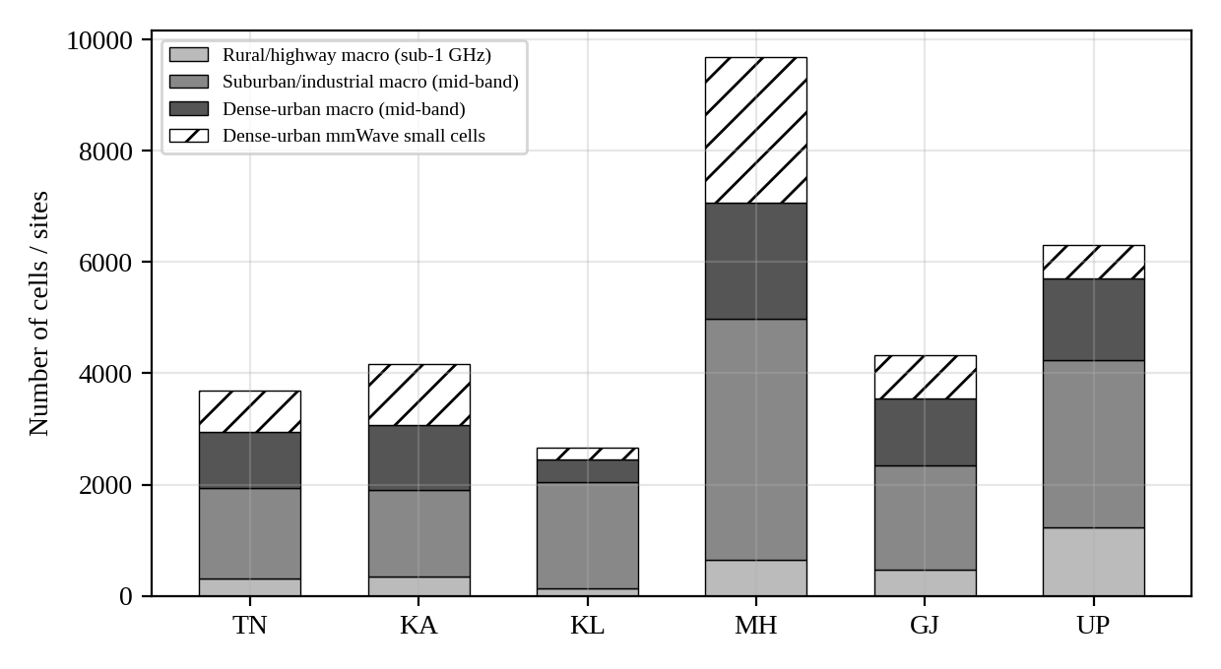
Figure 2. Estimated number of cells by type and state (Architecture B).
Two points follow from Table 11. Suburban and industrial areas need the most macro sites even though they carry lower demand density, because they are large; and the small cells are concentrated in Maharashtra, Karnataka and Tamil Nadu, where dense-urban demand is highest. Uttar Pradesh needs the most rural macros because of its large rural area, which is a cost issue and not a capacity one.

4.5 Capacity enhancement: cell splitting and sectoring
Table 12. Capacity-enhancement strategies compared.
Strategy | Capacity gain | Interference and technical effect | Cost | Where used
Sectoring (3 × 120°) | ≈ 2.5–3× per site | Interferers reduce from 6 to about 2 (≈ +4.8 dB SIR) | Low | First step on any busy macro site
Cell splitting (radius ÷ 2) | 4× per km² | Needs transmit power reduced by 2^{n} (≈ 12 dB for n = 4); handover rate doubles | High (4× sites) | Used where macro sites cannot meet demand
Massive MIMO (64T64R) | ≈ 3–4× over 4T4R | Spatial reuse, null steering | Moderate; more power and processing | Default on mid-band macros
Small-cell overlay (mmWave / mid-band) | 840 / 210 Mbps per cell | Offloads hotspots, must be coordinated with macro | Moderate per cell, many cells | Dense urban hotspots

Sectoring is the cheapest step and is already part of the macro design. Cell splitting multiplies the number of sites by four for every halving of the radius; it is shown in Section 6 to be the costliest way to meet dense-urban demand, which is why mmWave small cells are preferred in this plan.

4.6 Co-channel and adjacent-channel interference
Co-channel interference arises because cells on the same carrier overlap at their edges. With reuse of 1 the edge SIR is close to 0–2 dB (Table 9), so edge users are limited to about 1 b/s/Hz. Adjacent-channel interference comes from the leakage of a transmitter into the neighbouring carrier and from the imperfect selectivity of the receiver. The combined protection is the adjacent-channel interference ratio:
1/ACIR = 1/ACLR + 1/ACS (6)
With the NR base-station leakage ratio ACLR = 45 dB and a terminal selectivity ACS = 33 dB [4], 1/ACIR = 10^{–4.5} + 10^{–3.3} = 5.33 × 10^{–4}, so ACIR ≈ 32.7 dB. The weaker receiver term dominates, which is why guard bands between different operators or between TDD networks with different frame structures remain necessary even though the idealised channel count of Section 2 ignores them.
Mitigation techniques used in the design are:
- fractional frequency reuse and inter-cell interference coordination (ICIC) on the macro layer, with power control for edge users;
- coordinated scheduling and, where fronthaul allows, coordinated multipoint (CoMP) in dense macro clusters;
- beam management with null steering and narrow beams, which gives mmWave cells natural isolation;
- synchronised TDD frame configuration across neighbouring operators and layers to avoid cross-link interference, with guard periods sized for the cell radius;
- antenna tilt and power optimisation by the AI controller, and spectrum separation between macro and small-cell layers where co-channel deployment would cause damaging overlap.

4.7 State-wise spectrum and radio-access planning matrix
Table 13. State-wise spectrum and radio-access planning matrix.
State | Sub-1 GHz role | Mid-band role | mmWave role | Cell architecture
Tamil Nadu | n28 / 900 MHz on coast and rural; IoT, emergency | n78 + 1800/2300 MHz macros in Chennai–Hosur–Coimbatore; private 5G in industrial estates | Chennai CBD hotspots (731 cells) | Macro-led, industrial small cells
Karnataka | n28 for rural and IoT | Two mid-band carriers on macros; small cells in tech corridors | Bengaluru core, 1,099 mmWave cells | Heterogeneous in the core
Kerala | n28 and 900 MHz as the main coverage layer in hills | Mid-band in the continuous coastal urban strip | Limited (203 cells: ports, stadiums) | Macro-led, resilience-first
Maharashtra | n28 for rural and Ghats | Two mid-band carriers; dense macros along Mumbai–Pune | Largest mmWave use (2,620 cells) | Heterogeneous, highest density
Gujarat | n28 / NB-IoT or RedCap for wide-area IoT | Mid-band private networks in industrial clusters, ports | Selective (771 cells) | Macro + industrial small cells
Uttar Pradesh | n28 and 900 MHz carry the majority of sites | Mid-band in cities and NCR | Selective (606 cells) | Macro-led, cost-optimised, infrastructure sharing

4.8 Design Decision 2: spectrum and cell architecture
The recommendation is a layered design: sub-1 GHz as the coverage layer everywhere, mid-band macro and small cells as the capacity layer in cities, suburbs, industrial belts and corridors, and mmWave only in the dense-urban hotspots that the calculation in Section 4.4 shows cannot be served by mid-band alone. The states differ in how much of each layer they receive: Maharashtra, Karnataka and Tamil Nadu need the most small cells; Kerala is resilience and coverage driven; Gujarat is driven by industrial private networks; Uttar Pradesh by wide-area coverage cost.
A uniform band or cell type would be wrong for three reasons. First, demand density in the model differs by a factor of about 12,000 between dense-urban and rural areas (6,000 against 0.5 Mbps/km²), so a design sized for one is either wasteful or inadequate in the other. Second, propagation makes it impossible to cover large rural areas with mmWave at any sensible cost, or to meet the dense-urban capacity with sub-1 GHz carriers of 10–20 MHz. Third, the economics differ: a uniform mid-band macro grid at 500 m spacing would be unnecessary over most of the six states, while a rural sub-1 GHz grid of 5 km radius would carry only a few tens of Mbps per site.

5. Quantitative Capacity, Latency and Reliability Models (Stage 3)

5.1 Aggregate traffic demand
A bottom-up estimate was made for four application categories: high-definition video, autonomous vehicles, remote healthcare and industrial IoT. For each state the busy-hour throughput T of a category is the number of active users or devices times the average rate per user:
T_{cat} = N_{active} × r (7)
The assumptions are: concurrent HD video users equal to 0.8% of the subscribers inside the planned areas at an average of 4 Mbps (a mix of HD and 4K streams with adaptive bitrate); connected vehicles at 10 Mbps each (cooperative perception and map uplink); concurrent tele-health sessions at 6 Mbps; and industrial IoT devices at 50 kbps with 10% active in the busy hour. Subscribers inside the planned areas were taken as 38, 36, 22, 62, 34 and 45 million for the six states in the order of the table, which are assumptions. Table 14 gives the result in Gbps and compares it with the top-down demand from the area model of Section 4.
Table 14. Bottom-up busy-hour traffic by application category (Gbps) and comparison with the area-based model.
State | HD video | Autonomous vehicles | Remote healthcare | Industrial IoT | Bottom-up total | Top-down total | Share
Tamil Nadu | 1,216 | 180 | 150 | 30 | 1,576 | 2,290 | 69%
Karnataka | 1,152 | 220 | 120 | 25 | 1,517 | 2,652 | 57%
Kerala | 704 | 120 | 90 | 10 | 924 | 1,636 | 56%
Maharashtra | 1,984 | 400 | 210 | 45 | 2,639 | 6,266 | 42%
Gujarat | 1,088 | 300 | 120 | 35 | 1,543 | 2,606 | 59%
Uttar Pradesh | 1,440 | 350 | 240 | 40 | 2,070 | 3,360 | 62%

Video accounts for most of the identified traffic, as expected, and the bottom-up total is 42–69% of the top-down figure; the rest is background mobile broadband (web, social, cloud, software updates) that is not itemised. The IoT volume is small, below 50 Gbps in every state. Its importance lies in the connection count (between 2 and 9 million devices per state) and the energy and coverage requirements, not in throughput. The vehicle traffic is also small in volume but has the strictest latency limit, so it matters for placement and not for capacity.

5.2 Spectrum, spectral efficiency and data rate
The theoretical limit for a single spatial stream is the Shannon capacity, and the achieved rate is approximated by the product of bandwidth and spectral efficiency:
C = B log₂(1 + SNR), R = Bη (8)
Table 15 evaluates the first expression for four typical cases and applies a factor of 0.6 to represent the loss from interference, implementation limits, protocol overhead and scheduling. The 0.6 factor is an assumption in line with link-level results; with spatial multiplexing the single-stream value is multiplied by the number of layers.
Table 15. Shannon capacity and estimated practical rate for a single stream.
B (MHz) | SNR (dB) | C (Mbps) | η_{Shannon} (b/s/Hz) | Practical ≈ 0.6C (Mbps)
10 | 10 | 34.6 | 3.46 | 20.8
100 | 20 | 665.8 | 6.66 | 399.5
100 | 10 | 345.9 | 3.46 | 207.6
400 | 15 | 2011.1 | 5.03 | 1206.7

The relationship between bandwidth, efficiency and rate is linear in B but only logarithmic in SNR. Doubling the bandwidth doubles the rate, while a 10 dB rise in SNR adds about 3.3 b/s/Hz at high SNR. This is the reason the plan adds bandwidth (mid-band and mmWave) and spatial layers instead of relying on higher modulation. Table 16 shows how the position of a user in the cell affects efficiency.
Table 16. Effect of SINR (cell position) on spectral efficiency.
SINR (dB) | Shannon η (b/s/Hz) | Practical η (0.6×)
-5 | 0.40 | 0.24
0 | 1.00 | 0.60
10 | 3.46 | 2.08
20 | 6.66 | 3.99
30 | 9.97 | 5.98

An edge user at 0 dB gets about 0.6 b/s/Hz while a user near the site at 20–30 dB can get 4–6 b/s/Hz, so cell-edge performance is the more demanding design target and the reason for interference coordination and beamforming. As an example of the spectrum requirement, consider the dense-urban macro in Tamil Nadu. The demand per site is 5,700 Mbps/km² × 0.22 km² = 1,234 Mbps, and the bandwidth needed with η = 6, f_{DL} = 0.70 and 25% overhead is
B = R / (η f_{DL}(1 – o)) = 1,234 / (6 × 0.70 × 0.75) ≈ 392 MHz (9)
This is about four times one 100 MHz carrier. For Maharashtra, with a demand density of 7,800 Mbps/km², the same calculation gives about 536 MHz. Two mid-band carriers (200 MHz) cover about half of this, and mmWave small cells with 400 MHz of bandwidth supply the rest, which is the reason the dense-urban plan is heterogeneous.

5.3 Propagation loss, cell radius, interference and user distribution
Propagation loss (Figure 1) sets the coverage radius, and for a given transmit power the received SNR falls as 10n log₁₀(d) with the path-loss exponent n between 3 and 4 in urban areas. Free-space loss at 100 m, 500 m and 1 km is 83.3, 97.3, 103.3 dB at 3.5 GHz and 101.4, 115.4, 121.4 dB at 28 GHz, and non-line-of-sight conditions add substantially more. Smaller cells improve SNR by shortening the signal path, but they also raise the interference from neighbours, so the benefit saturates once the system becomes interference-limited. User distribution matters because demand is uneven: in cities a small share of the area (stadiums, stations, business districts) carries a large share of the traffic. A plan based on average density would leave those hotspots congested while wasting capacity elsewhere, which is why the hotspots are treated separately with small cells.

5.4 Erlang B traffic-channel model

5.4.1 Model
The Erlang B model gives the probability that a call finds all N traffic channels busy when calls arrive at random, holding times are exponential and blocked calls are cleared. It applies to the guaranteed-rate, circuit-like part of the network: voice (VoNR), critical-communication sessions and the reserved URLLC resource pool. Best-effort eMBB data is elastic and is sized by the capacity model of Section 5.2, not by Erlang B. For an offered traffic A (erlangs) and N channels the blocking probability is
P_{B}(A, N) = (A^{N}/N!) / Σ_{k=0}^{N} (A^{k}/k!) (10)
and is computed numerically with the stable recursion P_{B}(A, 0) = 1, P_{B}(A, n) = A·P_{B}(A, n–1) / (n + A·P_{B}(A, n–1)). The offered traffic is the number of subscribers per cell U times the busy-hour traffic per subscriber a: A = U·a.

5.4.2 Input parameters
The subscriber counts are assumptions for the average planning cell in each state (900, 1,000, 700, 1,200, 800 and 650 for Tamil Nadu, Karnataka, Kerala, Maharashtra, Gujarat and Uttar Pradesh). The busy-hour traffic per subscriber is 0.030 E (108 seconds of channel use in the hour), a common planning value, and the number of available traffic channels is 32 per cell. The blocking target is 2%.

5.4.3 Results
Table 17. Erlang B results: channels required for 2% blocking and blocking with 32 available channels.
State | Subscribers per cell | Offered traffic A (E) | Channels for 2% | P_{B} with 32 channels | Status | Extra channels | Channels if load is halved
Tamil Nadu | 900 | 27.0 | 36 | 5.32% | Exceeds 2% | 4 | 21
Karnataka | 1000 | 30.0 | 39 | 9.63% | Exceeds 2% | 7 | 23
Kerala | 700 | 21.0 | 29 | 0.60% | Meets 2% | 0 | 17
Maharashtra | 1200 | 36.0 | 46 | 19.52% | Exceeds 2% | 14 | 26
Gujarat | 800 | 24.0 | 33 | 2.21% | Marginal | 1 | 19
Uttar Pradesh | 650 | 19.5 | 28 | 0.25% | Meets 2% | 0 | 16

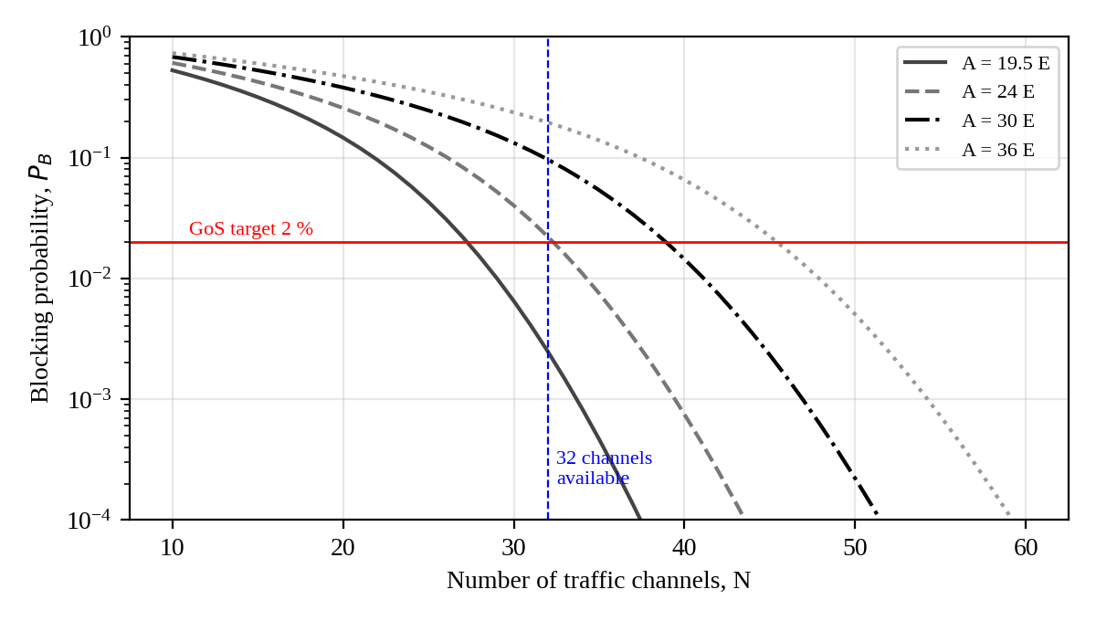
Figure 3. Erlang B blocking probability against number of channels for four offered loads.

5.4.4 Interpretation
Kerala and Uttar Pradesh meet the 2% target with 32 channels (0.6% and 0.25%). Gujarat is marginal at 2.21% and needs a single extra channel. Tamil Nadu (5.3%), Karnataka (9.6%) and Maharashtra (19.5%) fail the target, and in Maharashtra roughly one call in five would be blocked. The curves in Figure 3 show how steeply blocking falls once N passes A: adding about 20–25% more channels than the offered load in erlangs brings blocking to a few per cent, and the last few channels bring it below 2%. The channel count also shows a trunking gain. At 2% blocking a pool of 20 channels carries 13.2 E (0.66 E per channel), 32 channels carry 23.7 E (0.74 E per channel) and 111 channels carry 98.7 E (0.89 E per channel). Larger shared pools are therefore used more efficiently, which supports pooling guaranteed resources across sectors and carriers and not partitioning them into small fixed groups.
In practice the correction in the three failing states is a mix of three things: extra channels in the reserved pool (4, 7 and 14 respectively), load relief by cell splitting or small-cell offload (halving the load, last column, cuts the requirement to 21, 23 and 26 channels for the three states), and traffic management in which non-critical sessions are moved to eMBB bearers. Limitations of the model are the Poisson-arrival and exponential-holding assumptions, the assumption that traffic does not change by hour, and the neglect of retries after blocking, which makes the real blocking somewhat higher.

5.5 Latency and reliability
Table 18. Latency and reliability targets for critical applications.
Application | End-to-end latency | Reliability | Compute location
V2X cooperative driving | ≤ 10 ms | 99.999% | Metro edge
Industrial motion control | ≤ 5 ms (cycle 1–4 ms) | 99.999–99.9999% | Far edge (on-premise)
Remote healthcare / tele-surgery | ≤ 20 ms (≤ 10 ms for haptics) | 99.999% | Far or metro edge
HD video / eMBB | ≤ 100 ms | 99.9% | Regional or CDN cache
Public-safety voice and data | set-up < 300 ms | 99.999% | Metro edge with local survivability

The round-trip latency is the sum of the radio link (uplink and downlink, including scheduling and retransmission opportunities), RAN processing, backhaul and transport, user-plane processing in the core, propagation to the compute location and application processing. Propagation in fibre is about 5 µs per km one way, so a data centre 1,500 km away adds 15 ms to the round trip and that alone exceeds the V2X target. Table 19 and Figure 4 compare a regional-cloud case with a metro-edge case.
Table 19. Round-trip latency budget (ms) for cloud and edge placement.
Component | Regional cloud (≈ 1,500 km) | Metro edge (≈ 30 km)
Radio (UL+DL) | 2.0 | 2.0
gNB / RAN processing | 1.0 | 1.0
Backhaul / transport | 1.0 | 0.3
5GC (UPF) processing | 0.5 | 0.5
Transport to compute | 15.0 | 0.2
Application processing | 5.0 | 5.0
Total round trip | 24.5 | 9.0

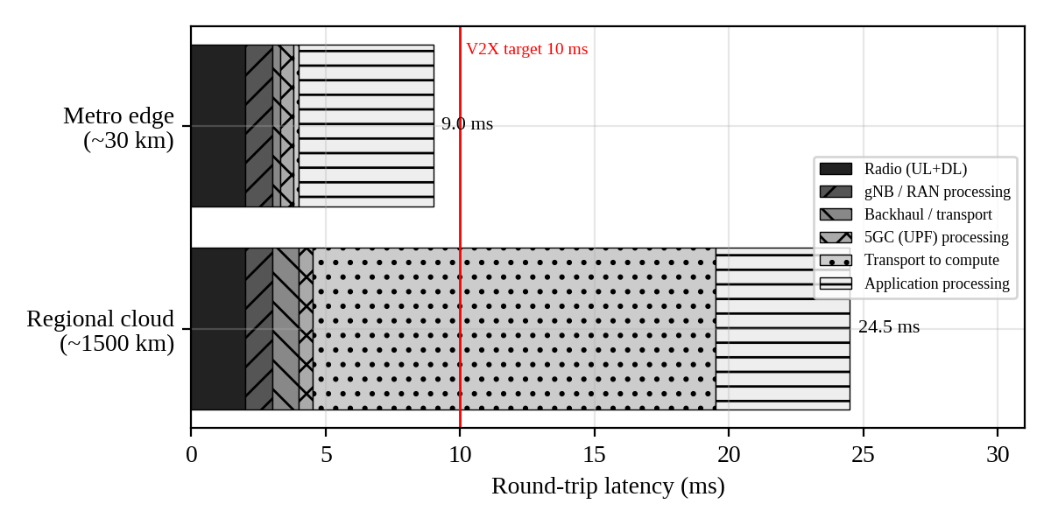
Figure 4. Latency budget with and without edge computing.
The cloud placement gives 24.5 ms and fails the 10 ms V2X target by a wide margin, while the metro edge gives 9.0 ms and meets it with 1 ms to spare. The only large term that changes is transport to the compute location (15.0 ms against 0.2 ms), and the radio link is then the largest remaining fixed item. For factory control with a 5 ms limit, even the metro edge is too far, so industrial applications use far-edge compute at the site (user-plane function and application on the premises). The 5 ms application-processing time is an assumption and should be reduced by software optimisation for the safety-critical functions. The radio component assumes a 30 kHz or 120 kHz numerology with mini-slot scheduling and pre-configured grants for uplink.
Radio reliability depends on retransmission. If a transmission fails with probability 10^{–1} (the usual first-transmission target for eMBB) and the failures are independent, the loss after n attempts is 10^{–n}. With the 0.5 ms retransmission time of the 30 kHz numerology, the number of attempts that fit inside the budget is limited:
Table 20. Residual loss probability after repeated transmissions (independent attempts).
Transmissions n | Loss probability | Time used (0.5 ms per attempt)
1 | 10^{–1} | 0.50 ms
2 | 10^{–2} | 1.00 ms
3 | 10^{–3} | 1.50 ms
4 | 10^{–4} | 2.00 ms
5 | 10^{–5} | 2.50 ms

Five attempts give 10^{–5}, which is the URLLC target, and take about 2.5 ms. In practice URLLC uses a low-BLER modulation and coding scheme (10^{–3} to 10^{–4} on the first attempt), repetition and spatial diversity so that the target can be met in fewer attempts, and dual connectivity with two independent links raises availability: two links of 99.9% availability each give 1 – (0.001)² = 99.9999%. Independence is optimistic when both links share a mast or fibre route, so the plan puts the redundant links on different sites and backhaul paths.

5.6 Mobility and handover continuity
For a vehicle moving at speed v on a straight road through cells of radius R, the time spent in a cell is about 2R/v and the handover rate is its inverse. At 120 km/h (v = 33.3 m/s):
Table 21. Dwell time and handover rate at 120 km/h.
Cell type | Radius (km) | Speed (km/h) | Dwell time (s) | Handovers per minute
Mid-band macro | 1.5 | 120 | 90.0 | 0.7
Urban macro | 0.3 | 120 | 18.0 | 3.3
mmWave small cell | 0.1 | 120 | 6.0 | 10.0

Mid-band macro cells give a handover every 90 seconds, which is easy to manage. mmWave cells would need one every 6 seconds, which is not sustainable as the primary link for a vehicle, so mmWave on corridors is used only as a secondary carrier under a mid-band or sub-1 GHz anchor (dual connectivity). Doppler shift is f_{d} = v f/c, which is small compared with the subcarrier spacing in all cases below:
Table 22. Doppler shift and its ratio to subcarrier spacing.
Carrier (GHz) | Speed (km/h) | Doppler shift (Hz) | Share of subcarrier spacing
3.5 | 120 | 389 | 1.3%
3.5 | 300 | 972 | 3.2%
28 | 120 | 3,111 | 2.6%

Service continuity is achieved with Xn-based handover with hysteresis and time-to-trigger tuned to the speed, conditional handover (in which target cells are prepared in advance), and dual active protocol stack handover, in which the terminal stays connected to the source cell until the target is established, giving close to zero interruption. The 3GPP Release-16 procedures are used for this [8], [12]. At the core, the session management function relocates the user-plane anchor when the vehicle leaves the area of one edge node, using uplink classifier or session-and-service-continuity mode 3 so that the application session continues without a gap.

5.7 Congestion, service availability and thresholds
Delay grows quickly with utilisation. In a simple M/M/1 queue the mean delay scales as 1/(1 – ρ), where ρ is the utilisation, so the thresholds below are placed before the steep part of the curve. They are the performance thresholds used by the AI controller and the admission-control rules.
Table 23. PRB utilisation thresholds and delay growth (M/M/1 estimate).
Utilisation ρ | Delay factor 1/(1 – ρ) | Operating state and action
50% | 2.0 × | Normal
70% | 3.3 × | Warning: AI pre-activates capacity
85% | 6.7 × | Critical: admission control, eMBB throttled, public safety protected
95% | 20.0 × | Critical: admission control, eMBB throttled, public safety protected

Service-availability thresholds are: blocking at or below 2% for the reserved guaranteed-rate pool in normal operation; blocking at or below 5% for non-critical sessions during a failure, with public-safety blocking held at 0% by pre-emption; and a 99th-percentile eMBB user rate of at least 10 Mbps in dense-urban cells at busy hour.

5.8 Design Decision 3: bottleneck and intervention by state
Table 24. Main bottleneck and chosen intervention in each state.
State | Main bottleneck | Intervention | Supporting evidence
Tamil Nadu | Industrial URLLC latency and traffic-channel blocking (5.3%) | Edge UPF and private 5G slice in industrial estates; +4 traffic channels | Latency 24.5 ms → 9.0 ms; Erlang B
Karnataka | Dense-urban capacity: macro-only serves 44% of demand; blocking 9.6% | mmWave small cells (1,099), second mid-band carrier, +7 channels | Cell-count model; Erlang B
Kerala | Coverage in hills and resilience (capacity is adequate: blocking 0.6%) | Sub-1 GHz coverage layer, ring backhaul, extended power backup | Link budget; Table 7
Maharashtra | Capacity: macro-only serves 37% of demand; blocking 19.5% | Largest small-cell programme (2,620), sectoring or splitting on busiest macros, traffic prioritisation | Cell-count model; Erlang B
Gujarat | mMTC density and backhaul distance; blocking 2.2% (marginal) | RedCap / NB-IoT on sub-1 GHz, microwave backhaul, +1 channel | Erlang B; traffic model
Uttar Pradesh | Rural coverage cost: 1,232 rural macros (coverage-limited) | Sub-1 GHz macros, infrastructure sharing, solar-hybrid power | Cell-count model; cost model

The interventions differ because the bottlenecks differ. In Maharashtra, Karnataka and Tamil Nadu the problem is dense-urban capacity, and the cheapest effective response is the combination of small cells and prioritisation; in Kerala it is coverage and resilience; in Gujarat it is device density and backhaul; in Uttar Pradesh it is the cost of covering a very large rural area.

5.9 Assumptions and limitations
- Subscriber counts, planned areas, demand densities and the number of channels are assumed; real values from operators would change the counts but not the method.
- Spectral efficiencies (6, 4 and 2.5 b/s/Hz), the 70% downlink share and the 25% overhead are planning values; massive-MIMO gains depend on channel conditions and the number of users.
- Hexagonal cells and straight-line mobility are idealisations; real terrain, shadowing and building structure vary widely.
- The Erlang B model assumes Poisson arrivals and exponential holding times, and ignores retries.
- Latency components other than propagation (radio, processing) are typical figures and need measurement. Costs and the grid emission factor are indicative.
- All results are calculated for a representative cell and then scaled by area; spatial correlation of traffic and interference between neighbouring states is not modelled.

6. Network Architecture Evaluation and Selection (Stage 4)

6.1 Alternatives
Two architectures are compared, with a third variant of the first added because it is the fair alternative when capacity is held equal.
- Architecture A: macro-cell-focused deployment using sub-1 GHz and mid-band spectrum, sized for coverage and with the same macro sites as B, no small cells, no mmWave and no edge nodes (compute in regional cloud).
- Architecture A′: the same as A but densified with additional macro sites until it carries the full dense-urban demand.
- Architecture B: heterogeneous deployment of macro cells (sub-1 GHz and mid-band), mmWave small cells in dense-urban hotspots, and metro and far-edge computing.
Table 25. Quantitative comparison of the alternative architectures.
Criterion | A (macro only) | A′ (densified macro) | B (heterogeneous)
Macro sites | 24,803 | 32,840 | 24,803
mmWave small cells | 0 | 0 | 6,030
Edge nodes | 0 (regional cloud) | 0 (regional cloud) | 48
Dense-urban demand served | 37–65% | 100% | 100%
Round-trip latency to compute (ms) | 24.5 | 24.5 | 9.0
Indicative CAPEX (₹ crore) | 12,402 | 16,420 | 13,197
Annual energy (GWh) | 565 | 748 | 581 (461 with AI sleep modes)
CO₂ (kt per year, 0.71 t/MWh) | 401 | 531 | 413 (328)
Deployment complexity | Low | Medium (site acquisition) | High (many small cells, edge, RIC)
Meets V2X 10 ms target | No | No | Yes

The unit costs used are ₹0.50 crore per macro site, ₹0.12 crore per small cell and ₹1.5 crore per edge node; average power is 2.6 kW per macro, 0.25 kW per small cell and 8 kW per edge node. Both are planning assumptions. Energy is converted to CO₂ with a grid emission factor of about 0.71 tonnes per MWh, also an assumption. The macro-only network A is cheapest but leaves between 35% and 63% of dense-urban demand unserved and cannot meet the V2X latency. Making A carry that demand (A′) requires about 8,037 more macro sites and costs ₹16,420 crore, which is 20% more than B. B costs 6% more than A but meets both the capacity and latency requirements.

6.2 Weighted decision matrix
The criteria and weights are given in Table 26. Capacity has the highest weight (0.20) because it is the most frequently binding requirement in the three largest states. Coverage, latency and reliability carry 0.15 each, since they decide whether the service exists at all and whether the critical services are safe. Scalability is weighted at 0.10, cost at 0.10, deployment simplicity at 0.08 and energy at 0.07. Scores run from 1 (poor) to 5 (best) and are the author's engineering judgement supported by Table 25; for cost and deployment simplicity a higher score means cheaper or simpler. Architecture A′ is not scored separately because it differs from A only in capacity and cost.
Table 26. Weighted decision matrix (score × weight).
Criterion | Weight | A score | A weighted | B score | B weighted
Coverage | 0.15 | 5 | 0.75 | 4 | 0.60
Capacity | 0.20 | 2 | 0.40 | 5 | 1.00
Latency | 0.15 | 2 | 0.30 | 5 | 0.75
Reliability | 0.15 | 3 | 0.45 | 4 | 0.60
Scalability | 0.10 | 2 | 0.20 | 5 | 0.50
Deployment simplicity | 0.08 | 4 | 0.32 | 2 | 0.16
Energy efficiency | 0.07 | 3 | 0.21 | 3 | 0.21
Cost (CAPEX/OPEX) | 0.10 | 4 | 0.40 | 2 | 0.20
Total | 1.00 |  | 3.03 |  | 4.02

Architecture B scores 4.02 against 3.03 for A. A sensitivity check shows how the result depends on the weights (Table 27).
Table 27. Sensitivity of the decision to the weights.
Weighting scenario | A | B | Preferred
Base weights (Table 26) | 3.03 | 4.02 | B
Rural coverage dominant (coverage 0.40, others reduced) | 3.85 | 3.65 | A (rural areas)
Ultra-reliable vehicle communication dominant (latency 0.30, reliability 0.30) | 2.85 | 4.20 | B
Urban video throughput dominant (capacity 0.35) | 2.60 | 4.30 | B

6.3 Trade-offs
Wider coverage and higher capacity pull in different directions. Coverage is cheapest at low frequency and with large cells, and capacity is cheapest with high bandwidth and small cells; the mix of the two has to be chosen area by area. B reduces operational simplicity: it adds tens of thousands of small-cell sites to manage, a set of edge nodes, and an AI control layer. In exchange it removes the need for the macro densification that A′ would need. The extra operational complexity is manageable only with automation, which is one reason the AI controller of Section 7 is part of the design and not an option.

6.4 Network slicing
Slicing is evaluated for the four service types plus V2X (Table 28). Isolation is achieved in the radio network by reserving resource-block shares, and in the core by using separate user-plane functions and session policies per slice. A guaranteed share protects critical slices without stranding capacity, because unused resources can be lent to eMBB and reclaimed at once.
Table 28. Slice evaluation.
Slice | Main need | Radio resource treatment | Behaviour in congestion
eMBB | Capacity, cell-edge rate | Large pool, elastic, can borrow unused capacity | Throttled first in congestion
URLLC (industrial, healthcare) | Latency, reliability | Reserved share, mini-slots, low-BLER MCS | Protected; far-edge UPF
V2X | Latency, handover continuity | Reserved on corridors, dual connectivity | Protected; metro-edge UPF
mMTC | Density, energy, coverage | Small reserved share on sub-1 GHz | Delay-tolerant; can be deferred
Public safety | Availability, pre-emption | Dedicated share, highest priority | Never pre-empted; local survivability

6.5 Edge-computing locations
Table 29. Edge-computing tiers and their effect on latency.
Tier | Location | Added transport round trip | Hosts | Count
Far edge | Factory, hospital or gNB site | < 1 ms | Industrial control, tele-surgery, local AI inference | On demand at customer sites
Metro edge | Aggregation sites in large cities and corridors (20–50 km) | 0.2–0.5 ms | V2X, video cache, AI inference, local UPF | 8 per state (48 total)
Regional data centre | State capital or major hub | 5–10 ms | 5G core control plane, central UPF, AI model training, OSS/BSS | 1–2 per state

The latency effect follows from Table 19: moving compute from a regional cloud to the metro edge removes about 14.8 ms of transport delay, and moving it to the far edge removes nearly all of the remaining transport term. The placement rule is that each application is hosted at the farthest tier that still meets its latency budget, so that expensive far-edge resources are used only for the 1–5 ms services.

6.6 Failures, backhaul congestion and demand surges
Three stress cases were assessed. A fibre cut isolates a site or ring segment; the design uses ring topology with microwave backup that is assumed to carry 40% of the normal load, and with dual-homed small cells. Backhaul congestion arises when many mmWave cells aggregate on a single metro node, so aggregation links are sized for at least 150% of the measured busy-hour load and the AI controller can shift load between cells. A sudden surge, such as an event in a stadium, was tested in the simulation of Section 8, where an event surge pushes the load above the capacity of a single carrier. The detailed numbers are in Section 8.

6.7 Selection and Design Decision 4
Architecture B is selected. Architecture A is rejected because it cannot serve the dense-urban load (37–65% served) and because its regional-cloud latency of 24.5 ms fails the V2X and industrial targets; the variant A′ meets the capacity but costs 20% more than B, uses 29% more energy and still fails latency. The selection depends on the dominant requirement: if rural coverage were dominant (weights in Table 27), A scores higher (3.85 against 3.65), so rural zones should follow the macro-first design with sub-1 GHz and with no mmWave or edge; in other words the heterogeneous elements are used only where the urban, industrial and corridor needs justify them. If ultra-reliable vehicle communication were dominant, B's advantage grows (4.20 against 2.85) and the plan would add roadside units and more edge nodes along corridors, extend dual connectivity and shorten the time-to-trigger. If urban video throughput were dominant, mmWave and mid-band capacity would be extended further.

7. Integrated 5G/6G Network Design (Stage 5)

7.1 Overall architecture
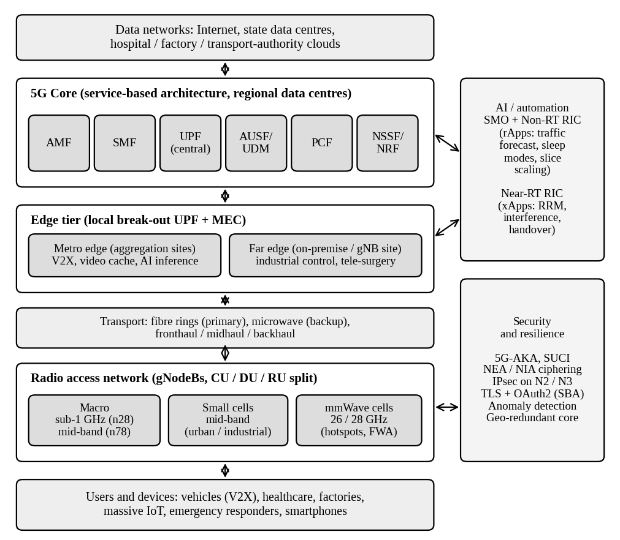
Figure 5. Architecture of the integrated six-state network: users, RAN, transport, edge tier, 5G core and the AI and security planes.
Devices attach to a layered RAN. The traffic is carried by fibre rings with microwave backup to the edge tier, where local user-plane functions break out the latency-critical flows. Everything else goes to the core in regional data centres. The AI and automation plane sits beside the network and acts on every layer; the security plane applies to every interface.

7.2 State-wise radio-access architecture
The state-wise cell counts are in Table 11 and Figure 2, and the spectrum roles in Table 13. Site placement follows five principles. (1) Macro sites are placed on a hexagonal grid in cities (inter-site distance about 500 m in the core, about 1.3 km in suburban areas) and linearly along highways and railways with 1–2 km spacing and sector azimuths along the route. (2) Mid-band and sub-1 GHz share sites where possible to cut the number of masts. (3) mmWave cells sit on street furniture at 6–10 m height, with line of sight to expected user areas and spacing of about 100 m. (4) In industrial estates and ports, small cells and private networks are placed inside the premises with the far-edge node. (5) Along the Western Ghats in Kerala and coastal districts, towers are sited first for coverage and resilience, with elevated sites, extra battery and elevated equipment against flooding.

7.3 5G core and traffic handling
Table 30. 5G core functions and placement [8].
Function | Role | Placement
AMF | Registration, connection and mobility management; N1/N2 termination; slice-aware access | Regional DCs, pooled and geo-redundant
SMF | Session establishment, UPF selection, IP allocation, QoS and charging control | Regional DCs; edge-aware UPF selection
UPF | Packet forwarding, QoS enforcement, local break-out, uplink classifier | Central (internet), metro edge, far edge
AUSF / UDM / UDR | Authentication (5G-AKA, EAP-AKA′), subscription data, SUCI de-concealment | Regional DCs, active-active
PCF | Policy, slice-level QoS, pre-emption rules for public safety | Regional DCs
NSSF / NRF | Slice selection; service discovery in the service-based architecture | Regional DCs
NEF / NWDAF | Exposure of capabilities to applications; analytics data for the AI layer | Regional DCs

Control-plane signalling is handled by pooled AMF and SMF instances in at least two regional data centres per state group, so that if one site fails the other takes over. User-plane traffic follows the slice: S2, S3 and S5 are anchored at an edge UPF and use local break-out to local applications; S1 uses the central or metro UPF to the internet; S4 uses regional UPFs because its traffic is small and delay-tolerant. The session management function selects the UPF using the slice identity, the user's location and the data-network name.

7.4 Network slices
Table 31. Logical network slices (SST: slice/service type).
Slice | SST | Key performance targets | Radio treatment | User plane
S1 eMBB | 1 | 100 Mbps cell-edge (dense urban); 99.9% availability | Flexible; 70% of PRBs, can borrow | Central and metro UPF
S2 URLLC (industrial, healthcare) | 2 | ≤ 5 ms / ≤ 20 ms; 99.999–99.9999% | Reserved ≈ 15% (shared with S3) | Far-edge UPF
S3 V2X | 4 | ≤ 10 ms; 99.999%; ≈ 0 ms handover | Reserved on corridors | Metro-edge UPF
S4 mMTC / IoT | 3 | 10⁵ devices/km² (clusters); 10-year battery | Reserved ≈ 5%, sub-1 GHz | Regional UPF
S5 Public safety | 2 (dedicated) | Set-up < 300 ms; 99.999%; pre-emption | Reserved ≈ 10%, may exceed | Metro-edge UPF with local survivability

The reserved shares total about 30% of the radio resources in normal operation (public safety 10%, URLLC and V2X 15%, mMTC 5%), and the flexible eMBB slice takes the remaining 70% plus any unused reserved capacity. The values were chosen so that the reserved shares exceed the normal busy-hour demand of each critical slice with a margin of about two times, and they are checked in the failure scenario of Section 8.

7.5 Edge-computing resources
Edge resources follow Table 29. Vehicle communication runs on 48 metro-edge nodes (eight per state) located at aggregation sites in the largest cities and at junctions of the main corridors, each with local UPF, containerised V2X application servers and GPU capacity for perception inference. Industrial control and remote healthcare are served by far-edge nodes at the premises, with a local UPF so that the traffic never leaves the building. If the link to the regional core fails, the far edge continues to operate with locally cached subscriber data for the slice.

7.6 Mobility management and service continuity
Handover uses the mechanisms of Section 5.6: conditional handover and dual active protocol stack handover on corridors, dual connectivity with a mid-band or sub-1 GHz anchor where mmWave is used, and hysteresis and time-to-trigger values set by the controller according to measured speed. Corridor cells are planned as chains with pre-configured neighbour relations and overlapping coverage of at least 10% of the cell radius. At the core, SMF relocates the UPF anchor with make-before-break behaviour when the vehicle leaves the area of one edge node, so the application sees no interruption.

7.7 AI-enabled resource management
AI is placed in two control loops following the Open RAN architecture [15]. The non-real-time loop (rApps in the service management and orchestration layer, time scale above one second) forecasts traffic per cell, plans sleep and wake-up of capacity carriers, and rescales slice shares. The near-real-time loop (xApps, 10 ms to 1 s) handles radio-resource allocation, interference mitigation, load balancing and handover optimisation. The forecasting model combines the previous days' load profile with an exponentially weighted correction of recent error and with scheduled events as a feature; a recurrent neural network or gradient-boosted model would replace it in operation, but the principle is the same. Congestion response: when forecast utilisation exceeds 80%, the controller activates the second carrier or the mmWave layer before the 85% alarm is reached; when it falls below 35%, the booster carrier is put to sleep. Inputs are cell-level counters and measurement reports, and the data are anonymised and kept inside the operator's network. The effect of this loop is tested in Section 8.

7.8 Security and resilience
- Authentication and privacy: 5G-AKA or EAP-AKA′ with concealed permanent identifiers (SUCI), mutual authentication of network and terminal [9].
- Encryption and integrity: 128-bit NEA/NIA algorithms over the air; IPsec on N2 and N3 backhaul interfaces; TLS with OAuth2 authorisation between service-based functions, and a security edge protection proxy at roaming boundaries.
- Slice isolation: separate security policies, key hierarchies and user-plane functions per slice, with network exposure only through the exposure function.
- Anomaly detection: machine-learning monitoring of signalling and user-plane statistics for signalling storms, denial-of-service and rogue base stations, feeding a response playbook.
- Redundancy: geo-redundant, pooled core functions in active-active mode; ring backhaul with microwave backup; N+1 power with 8 hours of battery at every site and generator or fuel-cell cover for critical ones.
- Recovery: target recovery time of 15 minutes for regional core failure through automatic fail-over, near-zero loss of subscriber data via replicated databases, and periodic recovery drills.

7.9 Sustainability
Energy is the largest operating cost and the main environmental impact of the radio network [13]. The design uses carrier shut-down and deep sleep of the booster carrier when forecast load is low, MIMO layer and symbol-level muting, efficient resource allocation that fills the PRBs of active cells instead of spreading load thinly, solar hybrid power at rural sites, and infrastructure sharing (shared masts, and shared radio networks in low-demand rural areas) which cuts the number of sites and the associated embodied and operating energy. The simulation in Section 8 gives an energy saving of 24.3% on a site that has the booster carrier, and applying it to the dual-carrier macros gives a network-wide reduction from 581 to 461 GWh per year, or about 21%, which is about 85 kt of CO₂ per year at the assumed emission factor.

7.10 Emerging 6G concept: integrated sensing and communication
Integrated sensing and communication (ISAC) uses the same radio signals, spectrum and hardware for communication and for radar-like sensing [14]. It is justified here for the transport corridors. A roadside gNB or small cell can detect vehicles, pedestrians and obstacles that are not connected (animals, debris, vehicles without V2X) and feed them into the cooperative-perception service, which a communication-only network cannot do. The cost is shared with the communication infrastructure that is already being built, and it can also support traffic monitoring and flood or landslide detection on sensitive routes. The practical provisions today are radio units with wide bandwidth and high-accuracy synchronisation, fibre to the sites, and edge GPUs that can run sensing algorithms. A second provision is AI-native networking, for which the RIC data pipeline in Section 7.7 provides the foundation. Terahertz communication is a longer-term option for fixed links and very short-range hotspots and is not part of the initial deployment.

7.11 Validation methodology
The design is validated at three levels. Analytical models (Erlang B, link budget, cell-count and latency budget) give the first estimate and are checked in Section 8. System-level simulation in Python, MATLAB or ns-3, using the 3GPP TR 38.901 channel model, one-day traffic traces at 15-minute resolution and at least 100 Monte Carlo runs with 95% confidence intervals, tests throughput, utilisation, blocking, latency and energy. Field validation in pilot clusters measures the KPIs of Table 6 with drive tests, counters and active probes before the full rollout.

7.12 Design Decision 5: how the components work together
The components form a chain in which each addresses a different state. In Maharashtra, Karnataka and Tamil Nadu, mid-band macros and mmWave small cells carry the urban load, the metro edge reduces latency, and AI sleep modes recover energy. In Kerala, the sub-1 GHz layer, resilient backhaul and public-safety slice meet the coverage and disaster-response needs. In Gujarat, industrial private networks and far-edge nodes serve factories and ports while a sub-1 GHz layer carries IoT. In Uttar Pradesh, the sub-1 GHz layer, shared infrastructure and solar power make wide rural coverage affordable. Slicing makes it possible for the same network to meet very different needs at the same time. Table 32 separates what can be implemented now from the future 6G capabilities.
Table 32. Currently implementable 5G capabilities and proposed 6G capabilities.
Area | Implementable now (5G) | Proposed future (6G)
Core network | Standalone 5G core, service-based architecture, slicing, edge UPF | AI-native core, compute-communication convergence
Radio | Mid-band massive MIMO, mmWave (26/28 GHz), URLLC features of Rel-15/16 | Extreme MIMO, upper mid-band (7–24 GHz) and sub-THz candidates, reconfigurable surfaces
Sensing | Positioning only; roadside cameras and radar are separate | Integrated sensing and communication (ISAC)
AI | Open RAN RIC with xApps and rApps; analytics function | AI-native air interface and network functions
Coverage | Terrestrial, plus early non-terrestrial support (Rel-17) | Fully integrated terrestrial and non-terrestrial network
Latency / reliability | 1–10 ms; 99.999% | 0.1–1 ms; higher reliability (IMT-2030 indicative)

8. Validation and Final Deployment Decision (Stage 6)

8.1 Validation of principal calculations
The main calculations were recomputed by an independent route, as shown in Table 33.
Table 33. Cross-checks of the principal calculations.
Quantity | Check method | Result | Outcome
Erlang B, A = 27 E, N = 32 | Recursion against closed-form factorial sum | 5.32% and 5.32% (difference 1.4e-17) | Consistent
Channels for 2% at 27 E | Search until P_{B}≤ 0.02 | 36 channels; 1.78% at 36, 2.41% at 35 | Consistent
Tamil Nadu dense-urban capacity | Supplied capacity against demand | 1,254,750 Mbps against 1,254,000 Mbps (100%) | Demand covered
Bandwidth for a dense-urban macro | B = R / (η f_{DL}(1–o)) | ≈ 392 MHz needed; 200 MHz plus mmWave supplied | Consistent
Shannon spot check | 100 MHz × log₂(1 + 100) | 665.8 Mbps (6.66 b/s/Hz); practical ≈ 0.6 of this | Consistent
Latency sum | Sum of components | 24.5 ms (cloud); 9.0 ms (metro edge) | Consistent; metro edge meets 10 ms

8.2 Selected architecture against the alternative
The comparison is in Table 25. On the principal criteria, B serves all of the dense-urban demand against 37–65% for A, meets the 10 ms latency target at 9.0 ms against 24.5 ms, and costs 20% less than the macro network that would be needed to match its capacity.

8.3 Simulation method and results
A time-step simulation of one macro site over 24 hours with 15-minute resolution was written in Python. The offered load is normalised to the capacity of one 100 MHz carrier (1.0 equals 315 Mbps). It is the sum of a base daily profile with a midday and an evening peak, random noise and a scheduled event around 19:15 that adds 0.5 of a carrier's capacity for about an hour, giving a peak of 1.11 (above the single-carrier capacity). Three controllers are compared. The fixed controller never adds capacity. The reactive baseline adds a second 0.5-capacity layer when utilisation has been above 85% for two consecutive intervals and removes it when it is below 60%. The AI controller forecasts the next interval from the previous day's profile, a smoothed correction of the recent forecast error and the scheduled-event feature, and activates the layer when the forecast exceeds 0.80 and sleeps it otherwise. Site power is modelled as 1.8 kW plus 1.2 kW × utilisation, and the booster carrier adds 1.0 kW when active.
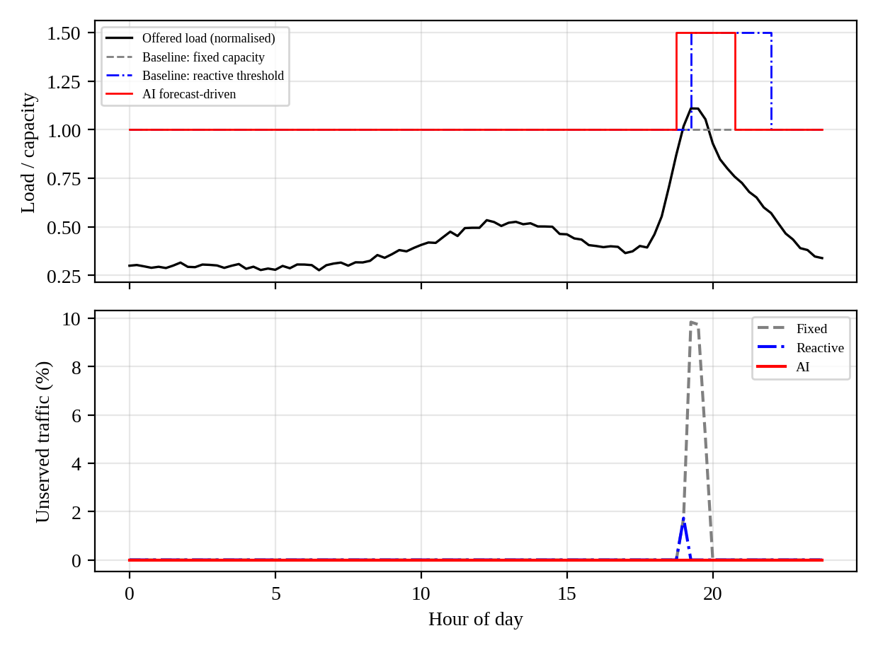
Figure 6. Peak-hour congestion scenario: offered load and capacity (top) and unserved traffic (bottom) for the three controllers.
Table 34. Simulation results for the peak-hour congestion scenario.
Controller | Unserved traffic (% of daily total) | Hours above 85% utilisation | Peak unserved (%) | Energy (kWh/day)
Fixed single carrier | 0.66% | 1.5 | 9.8% | —
Reactive threshold (baseline) | 0.04% | 0.5 | 1.7% | 58.0
AI forecast-driven | 0.00% | 0.0 | 0.0% | 57.4
Static dual carrier, always on (energy reference) | 0.00% | 0.0 | 0.0% | 75.9

Interpretation: the fixed carrier leaves about 9.8% of traffic unserved at the peak of the event, the reactive controller is late by two intervals and loses a small part of the surge, and the AI controller, which activates capacity ahead of the surge, serves all the traffic and spends no time above the 85% threshold. The forecast has a mean absolute percentage error of 4.8%. Because it removes the booster when it is not needed, the AI controller uses 24.3% less energy than the static dual-carrier reference and 1.0% less than the reactive controller. The advantage over the reactive baseline is mostly due to the event calendar, and an unscheduled surge would reduce it toward the reactive result. The simulation uses a synthetic load profile, so the results show the direction and approximate size of the gain, not a field measurement.

8.4 Scenario 2: infrastructure failure
In the second scenario, one of three neighbouring macro sites fails and backhaul to the remaining cluster is degraded by 40%. The normal cluster capacity of 1,890 Mbps falls to 756 Mbps, which is 40% of normal, while the demand stays at 1,285 Mbps. With strict priority for public safety and URLLC, a guaranteed minimum for mMTC and the rest for eMBB (Table 35), all critical slices are fully served and only eMBB degrades; without slicing, every service would receive about 59% of its demand, and the critical services would fail their targets.
Table 35. Failure scenario: demand and served traffic by slice (Mbps).
Slice | Demand | Served with slicing | Share served | Share served without slicing
eMBB | 1,040 | 510 | 49% | 59%
URLLC | 113 | 113 | 100% | 59%
mMTC | 76 | 76 | 100% | 59%
Public safety | 57 | 57 | 100% | 59%

8.5 AI allocation against a baseline
The AI controller was compared with the reactive threshold controller, a standard baseline in current networks. The result is in Table 34. The comparison is limited to one cell, to a synthetic load, and to an event calendar that the AI controller is allowed to use. Further validation requires multi-cell simulation, real traces and unscheduled surges, and it should include an evaluation of the forecast error in the tails.

8.6 Design limitations, assumptions and risks
The principal limitations are those listed in Section 5.9: assumed inputs, idealised geometry and single-cell simulation. The implementation risks are in Table 36.
Table 36. Implementation risks and mitigation.
Risk | Impact | Mitigation
mmWave blockage and foliage losses larger than assumed | More small cells needed; cost up | Pilot measurements in each city before commitment
Traffic demand lower or higher than the assumed densities | Over- or under-build | Phase the rollout; recalibrate with operator counters
Spectrum availability (26 GHz and sub-1 GHz) and licence conditions | Plan changes | Confirm licences; keep mid-band fallback
Site acquisition, right-of-way, fibre availability | Delay and cost | Infrastructure sharing; use existing poles and ducts
Grid reliability and power cost | Availability, OPEX | Battery, solar hybrid, sleep modes
AI model errors and security of the AI pipeline | Wrong decisions, attack surface | Guard-rails, fallback to rule-based control, model signing and monitoring
Interoperability of multi-vendor open RAN | Integration cost, delay | Staged integration, conformance testing

Unresolved requirements are the exact subscriber and traffic data, licensed spectrum by state, mmWave propagation in each city, real backhaul topology, and the end-to-end latency of the application software.

8.7 Specification-verification table
Table 37. Specification-verification table.
Requirement | Design response | Evidence | Status
Coverage ≥ 95% area, 99% population | Sub-1 GHz layer with 5 km rural radius; capacity-limited mid-band | Cell-count model, Table 11 | Met (calculated); field data needed
Dense-urban capacity | Two mid-band carriers + mmWave small cells | 100% of demand served; Section 4.4 | Met (calculated)
Blocking ≤ 2% | Add 4, 7, 14 and 1 channels in TN, KA, MH, GJ or reduce load | Erlang B, Table 17 | Met after correction
V2X latency ≤ 10 ms | Metro-edge UPF and compute | 9.0 ms, Table 19 | Met (budget); needs measurement
Industrial latency ≤ 5 ms | Far-edge UPF and private 5G | Edge removes transport term; application time assumed | Partly met (needs testing)
Reliability 99.999% | Low-BLER MCS, repetition, dual connectivity | HARQ analysis, Section 5.5 | Met (analysis); needs field test
Handover continuity | DAPS, conditional handover, anchor layer | Table 21 | Met (analysis)
Congestion thresholds, PRB ≤ 85% | AI forecast-driven capacity activation | Simulation, Table 34 | Met (simulated)
Public safety available in failure | Dedicated slice with pre-emption | Table 35 | Met (simulated)
Security | 5G-AKA, NEA/NIA, IPsec, anomaly detection | Section 7.8 | Designed; to be audited
Energy reduction ≥ 20% | AI sleep modes of the booster carrier | 24.3% per dual-carrier site; 21% network-wide | Met (simulated)
6G readiness | Fibre, upgradeable radios, ISAC-ready edge, RIC data | Section 7.10 | Provisioned

8.8 Final deployment decision
Recommendation: deployment with modifications. The heterogeneous Architecture B is technically sound, meets the critical latency, reliability and public-safety requirements in the analysis and simulation, and avoids the cost of macro densification. It should not be deployed in one step, because several inputs are assumptions. The modifications are: (1) deploy in three phases, starting with the sub-1 GHz and mid-band macro layer and the public-safety slice (phase 1), then small cells and metro-edge nodes in the three highest-demand states (phase 2), then far-edge, industrial private networks and ISAC trials (phase 3); (2) put the 48 metro-edge nodes first on the corridors and in the largest cities; (3) start the AI controller in advisory mode and switch to closed-loop control only after the forecast error and fail-over behaviour have been verified in pilot clusters; (4) add the extra Erlang channels or load relief in Tamil Nadu, Karnataka, Maharashtra and Gujarat as the first capacity action.
The key engineering assumptions that must be verified before implementation are the busy-hour demand densities and subscriber counts, the spectral efficiencies (6, 4 and 2.5 b/s/Hz), the mmWave range (about 90–100 m) in real street conditions, the 5 ms application time, and the unit costs. The additional measurements are the traffic counters of existing networks, drive tests for mid-band and mmWave in pilot clusters of each state, latency tests between candidate edge sites and the radio network, and backhaul capacity and route diversity. The proposal balances the five objectives as follows. Coverage is secured by the sub-1 GHz layer and the capacity-limited mid-band grid. Capacity is delivered where it is needed by small cells and not everywhere. Reliability comes from edge placement, low-BLER coding, dual connectivity, redundancy and slice priority. Spectral efficiency is raised by massive MIMO, beamforming and interference coordination. Infrastructure cost is held at about ₹13,197 crore, which is 20% below macro densification, with energy use cut by the AI-controlled sleep modes.

9. Conclusion
The report analysed the requirements of a six-state 5G/6G-ready network and turned them into a quantified design. The evolution from 1G to 5G shows capacity coming from wider channels, reuse of 1 and spatial multiplexing instead of simply more channels, and the idealised channel counts, which ignore guard bands, duplexing and control overhead, overstate the practical counts by about 2–10% in the 4G and 5G cases. The Erlang B model showed that three of the six states exceed the 2% blocking target with 32 channels per cell and need extra channels or load relief. The planning model estimated about 24,803 macro sites and 6,030 mmWave small cells for the heterogeneous design, and the latency budget showed that edge computing is required to meet the 10 ms vehicle target. The heterogeneous architecture scored highest in the weighted decision matrix, and the simulation indicated that forecast-driven resource control can remove congestion during a surge and reduce energy use. The recommended decision is phased deployment with modifications, backed by the measurements listed in Section 8.8.

References
[1] ITU-R, Recommendation M.2083-0, “IMT Vision – Framework and overall objectives of the future development of IMT for 2020 and beyond,” 2015.
[2] ITU-R, Recommendation M.2160-0, “Framework and overall objectives of the future development of IMT for 2030 and beyond,” 2023.
[3] ITU-R, Report M.2410-0, “Minimum requirements related to technical performance for IMT-2020 radio interface(s),” 2017.
[4] 3GPP, TS 38.104 and TS 38.101-1, “NR; Base Station and User Equipment radio transmission and reception.”
[5] 3GPP, TS 22.261, “Service requirements for the 5G system.”
[6] Department of Telecommunications, Government of India, “Notice Inviting Applications for Auction of Spectrum,” 2022.
[7] 3GPP, TR 38.901, “Study on channel model for frequencies from 0.5 to 100 GHz.”
[8] 3GPP, TS 23.501, “System architecture for the 5G System (5GS).”
[9] 3GPP, TS 33.501, “Security architecture and procedures for 5G System.”
[10] T. S. Rappaport, Wireless Communications: Principles and Practice, 2nd ed. Prentice Hall, 2002.
[11] A. Goldsmith, Wireless Communications. Cambridge University Press, 2005.
[12] E. Dahlman, S. Parkvall and J. Sköld, 5G NR: The Next Generation Wireless Access Technology, 2nd ed. Academic Press, 2020.
[13] G. Auer et al., “How much energy is needed to run a wireless network?” IEEE Wireless Communications, vol. 18, no. 5, pp. 40–49, 2011.
[14] F. Liu et al., “Integrated sensing and communications: Toward dual-functional wireless networks for 6G and beyond,” IEEE J. Sel. Areas Commun., vol. 40, no. 6, pp. 1728–1767, 2022.
[15] O-RAN Alliance, “O-RAN Architecture Description.”

