EXPERIMENT 1
IOE-BASED ONLINE EXAMINATION MONITORING: SUSPICIOUS ACTIVITY DATA ACQUISITION AND PREPROCESSING USING PYTHON IN GOOGLE COLAB
Aim
To implement IoE sensor data acquisition, preprocessing, normalization, and visualization of online examination monitoring data using Python in Google Colab, and to identify suspicious student behaviour during an exam.
Software Requirements
- Google Colab
- Python 3
- Pandas Library
- NumPy Library
- Matplotlib Library
- Scikit-learn Library
Theory
The Internet of Everything (IoE) connects people, devices, sensors, data, and processes to enable intelligent decision-making. In an IoE-based online examination monitoring system, connected devices such as webcams, microphones, and browser-activity trackers continuously collect behavioural data about a student during an exam, such as exam duration, number of screen switches, face-detection confidence, and mouse-click activity.
Raw sensor data of this kind often contains inconsistencies such as duplicate records, missing values, and different measurement scales. Therefore, preprocessing is essential before the data can be analysed or used to flag suspicious behaviour.
The preprocessing steps include:
1. Creating the exam-monitoring sensor dataset.
2. Checking for missing values.
3. Removing duplicate records.
4. Normalizing data using Min-Max Scaling.
5. Visualizing the normalized Suspicious Score.
Normalization converts all values into the range 0 to 1, making different sensor readings comparable regardless of their original scale.
The Min-Max normalization formula is:
Xnorm = (X − Xmin) / (Xmax − Xmin)
where:
- X = Original value
- Xmin = Minimum value
- Xmax = Maximum value
Procedure
1. Import required Python libraries.
2. Create the IoE exam-monitoring sensor dataset.
3. Convert the dataset into a Pandas DataFrame.
4. Display the original dataset.
5. Check for missing values.
6. Remove duplicate records.
7. Normalize all sensor values using MinMaxScaler.
8. Display the normalized dataset.
9. Plot the normalized Suspicious Score graph.
10. End the program.
Code
import pandas as pd
import numpy as np
import matplotlib.pyplot as plt
from sklearn.preprocessing import MinMaxScaler

# Create sample dataset
data = {
"ExamDuration(min)": [60, 75, 90, 80, 70, 85, 95, 88, 76, 82],
"ScreenSwitches": [2, 5, 1, 4, 3, 6, 8, 5, 2, 4],
"FaceDetections": [100, 98, 100, 97, 99, 96, 95, 97, 100, 99],
"MouseClicks": [150, 180, 165, 170, 160, 190, 210, 185, 155, 175],
"SuspiciousScore": [5, 20, 3, 15, 8, 30, 45, 25, 6, 18]
}

df = pd.DataFrame(data)

# Display original data
print("Original Dataset:")
print(df)

# Check missing values
print("\nMissing Values:")
print(df.isnull().sum())

# Remove duplicates
df = df.drop_duplicates()

# Normalize data
scaler = MinMaxScaler()
df[df.columns] = scaler.fit_transform(df)

print("\nNormalized Dataset:")
print(df)

# Plot Suspicious Score
plt.plot(df["SuspiciousScore"], marker='o')
plt.title("Normalized Suspicious Score")
plt.xlabel("Student Sample")
plt.ylabel("Suspicious Score")
plt.grid(True)
plt.show()
Output
Original Dataset (first columns shown):
ExamDuration(min) ScreenSwitches FaceDetections MouseClicks SuspiciousScore
0 60 2 100 150 5
1 75 5 98 180 20
2 90 1 100 165 3
3 80 4 97 170 15
4 70 3 99 160 8
5 85 6 96 190 30
6 95 8 95 210 45
7 88 5 97 185 25
8 76 2 100 155 6
9 82 4 99 175 18
Missing Values: 0 for all columns (no missing values found).
Normalized Dataset (Min-Max Scaled, 0 to 1):
ExamDuration ScreenSwitches FaceDetections MouseClicks SuspiciousScore
0 0.000000 0.142857 1.000000 0.000000 0.047619
1 0.428571 0.571429 0.600000 0.500000 0.404762
2 0.857143 0.000000 1.000000 0.250000 0.000000
3 0.571429 0.428571 0.400000 0.333333 0.285714
4 0.285714 0.285714 0.800000 0.166667 0.119048
5 0.714286 0.714286 0.200000 0.666667 0.642857
6 1.000000 1.000000 0.000000 1.000000 1.000000
7 0.800000 0.571429 0.400000 0.583333 0.523810
8 0.457143 0.142857 1.000000 0.083333 0.071429
9 0.628571 0.428571 0.800000 0.416667 0.357143
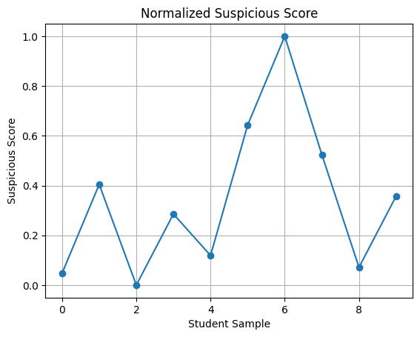
Result
The IoE-based online examination monitoring dataset was successfully created and preprocessed using Python in Google Colab. Missing values were checked, and no missing values were found. Duplicate records were removed successfully (if any existed). The sensor data — exam duration, screen switches, face detections, mouse clicks, and suspicious score — was normalized using the Min-Max Scaling technique, converting all values into the range of 0 to 1. Finally, the normalized Suspicious Score values were visualized using a line graph, enabling easy identification of student samples with a higher likelihood of suspicious activity (Sample 6 shows the highest normalized suspicious score of 1.0).

