EXPERIMENT NO. 2(A)
REAL-TIME ONLINE EXAM MONITORING USING MQTT
(GOOGLE COLAB VERSION)
Aim
To design and implement a real-time online examination monitoring system using the MQTT protocol and Python in Google Colab, with live monitoring of student focus score and tab-switch activity for detecting suspicious examination behavior.
Objectives
➢ Generate real-time online examination monitoring data.
➢ Publish focus score and tab-switch values using MQTT.
➢ Subscribe to MQTT messages and receive monitoring data.
➢ Detect suspicious activity based on tab-switch behavior.
➢ Display a live monitoring dashboard and graph.
➢ Calculate statistical measures such as average, maximum, and minimum focus score.
➢ Store the collected monitoring data for future analysis.
Software Required
➢ Google Colab
➢ Python 3
➢ Public MQTT Broker (HiveMQ)
➢ paho-mqtt
➢ pandas
➢ matplotlib
Theory
MQTT (Message Queuing Telemetry Transport) is a lightweight publish-subscribe messaging protocol widely used in IoT applications. It enables monitoring devices and applications to exchange data through an MQTT broker.
Communication model:
Publisher → MQTT Broker → Subscriber
In this experiment, the publisher simulates an online examination client by generating focus score and tab-switch values. The MQTT broker receives and forwards the messages to the subscriber. The subscriber stores the received values in a Pandas DataFrame and performs real-time analysis.
Monitoring logic:
➢ Focus Score is generated between 60 and 100.
➢ Tab Switches are generated between 0 and 10.
➢ If Tab Switches > 5, the activity is classified as Suspicious.
➢ Otherwise, the activity is classified as Normal.
The collected values are visualized using Matplotlib. The dashboard displays the latest records, average focus score, average tab switches, maximum and minimum focus score, total messages, and suspicious cases.
Procedure
➢ Start the Google Colab program.
➢ Install and import the paho-mqtt library and required Python libraries.
➢ Configure the MQTT broker, port, and topic.
➢ Create publisher and subscriber MQTT clients.
➢ Generate focus score and tab-switch values continuously.
➢ Publish the monitoring values as JSON messages.
➢ Subscribe to the same MQTT topic.
➢ Receive and decode incoming MQTT messages.
➢ Store focus score, tab-switch count, and time values.
➢ Classify activity as Normal or Suspicious.
➢ Display the live monitoring table and graph.
➢ Calculate summary statistics.
➢ Stop monitoring using KeyboardInterrupt.
Algorithm
1. Initialize MQTT broker, port, topic, and data storage.
2. Create MQTT publisher and subscriber clients.
3. Connect the clients to the public MQTT broker.
4. Generate a random focus score and tab-switch count.
5. Publish the values as a JSON message.
6. Receive the message at the subscriber.
7. Store the received values.
8. Check whether tab switches are greater than 5.
9. If true, mark the record as Suspicious; otherwise mark it Normal.
10. Update the monitoring table and graph.
11. Repeat the process continuously until the user stops the program.
Google Colab Code
# ============================================================
# EXPERIMENT 2(A) - REAL-TIME ONLINE EXAM MONITORING USING MQTT
# ============================================================

import sys
import subprocess
import importlib
import json
import random
import threading
import time
import pandas as pd
import matplotlib.pyplot as plt
from IPython.display import clear_output

# ---------------- Install / Load paho-mqtt ----------------
def ensure_paho_mqtt():
try:
import paho.mqtt.client as mqtt_module
return mqtt_module
except ModuleNotFoundError:
print("Installing paho-mqtt ...")
result = subprocess.run(
[sys.executable, "-m", "pip", "install", "-q", "paho-mqtt"],
capture_output=True, text=True
)
if result.returncode != 0:
print(result.stdout)
print(result.stderr)
raise RuntimeError("paho-mqtt installation failed.")

importlib.invalidate_caches()
import paho.mqtt.client as mqtt_module
return mqtt_module

mqtt = ensure_paho_mqtt()

# ---------------- MQTT Configuration ----------------
BROKER = "broker.hivemq.com"
PORT = 1883
TOPIC = "IoT_AI_LAB/OnlineExamMonitoring"

# ---------------- Data Storage ----------------
focus_data = []
tabswitch_data = []
timestamps = []
lock = threading.Lock()

# ---------------- Version-Safe Client ----------------
def make_client():
if hasattr(mqtt, "CallbackAPIVersion"):
return mqtt.Client(mqtt.CallbackAPIVersion.VERSION1)
return mqtt.Client()

publisher = make_client()
subscriber = make_client()

# ---------------- Publisher ----------------
def start_publisher():
try:
publisher.connect(BROKER, PORT, 60)
except Exception as e:
print("Publisher connect failed:", e)
return

publisher.loop_start()

while True:
try:
focus = round(random.uniform(60, 100), 2)
tabswitch = random.randint(0, 10)

payload = {
"focus_score": focus,
"tab_switches": tabswitch
}

publisher.publish(TOPIC, json.dumps(payload))
except Exception as e:
print("Publish error:", e)

time.sleep(1)

# ---------------- Subscriber Callbacks ----------------
def on_connect(client, userdata, flags, rc):
print("Subscriber connected with result code:", rc)
client.subscribe(TOPIC)

def on_message(client, userdata, msg):
try:
data = json.loads(msg.payload.decode())

if "focus_score" not in data or "tab_switches" not in data:
return

with lock:
focus_data.append(float(data["focus_score"]))
tabswitch_data.append(int(data["tab_switches"]))
timestamps.append(len(timestamps) + 1)

except (json.JSONDecodeError, UnicodeDecodeError, KeyError, ValueError):
pass

subscriber.on_connect = on_connect
subscriber.on_message = on_message

# ---------------- Start Subscriber ----------------
try:
subscriber.connect(BROKER, PORT, 60)
except Exception as e:
print("Subscriber connect failed:", e)
raise SystemExit(1)

subscriber.loop_start()

# Start publisher in background
threading.Thread(target=start_publisher, daemon=True).start()

# ---------------- Live Dashboard ----------------
try:
while True:
time.sleep(2)

with lock:
n = len(focus_data)

if n >= 5:
clear_output(wait=True)

with lock:
df = pd.DataFrame({
"Time": timestamps.copy(),
"Focus Score": focus_data.copy(),
"Tab Switches": tabswitch_data.copy()
})

df["Status"] = df["Tab Switches"].apply(
lambda x: "Suspicious" if x > 5 else "Normal"
)

print("=" * 60)
print("REAL-TIME ONLINE EXAM MONITORING USING MQTT")
print("=" * 60)
print(df.tail())

print("\nAverage Focus Score :",
round(df["Focus Score"].mean(), 2))
print("Average Tab Switches:",
round(df["Tab Switches"].mean(), 2))
print("Maximum Focus Score :",
df["Focus Score"].max())
print("Minimum Focus Score :",
df["Focus Score"].min())
print("Total Messages :",
len(df))
print("Suspicious Cases :",
(df["Status"] == "Suspicious").sum())

# ---------------- Graph ----------------
fig = plt.figure(figsize=(10, 5))

plt.plot(
df["Time"], df["Focus Score"],
marker="o", linewidth=1.5,
label="Focus Score"
)

plt.plot(
df["Time"], df["Tab Switches"],
marker="s", linewidth=1.5,
label="Tab Switches"
)

suspicious = df[df["Status"] == "Suspicious"]

plt.scatter(
suspicious["Time"],
suspicious["Tab Switches"],
color="red",
s=100,
label="Suspicious"
)

plt.title("Real-Time Online Exam Monitoring")
plt.xlabel("Time")
plt.ylabel("Values")
plt.grid(True, alpha=0.3)
plt.legend()
plt.tight_layout()
plt.show()
plt.close(fig)

except KeyboardInterrupt:
print("\nMonitoring stopped by user.")

finally:
try:
subscriber.loop_stop()
subscriber.disconnect()
except Exception:
pass

try:
publisher.loop_stop()
publisher.disconnect()
except Exception:
pass

print("\nExperiment Completed Successfully.")
Input
➢ Focus Score = Random value between 60 and 100
➢ Tab Switches = Random integer between 0 and 10
➢ MQTT Broker = broker.hivemq.com
➢ MQTT Port = 1883
➢ MQTT Topic = IoT_AI_LAB/OnlineExamMonitoring
Output
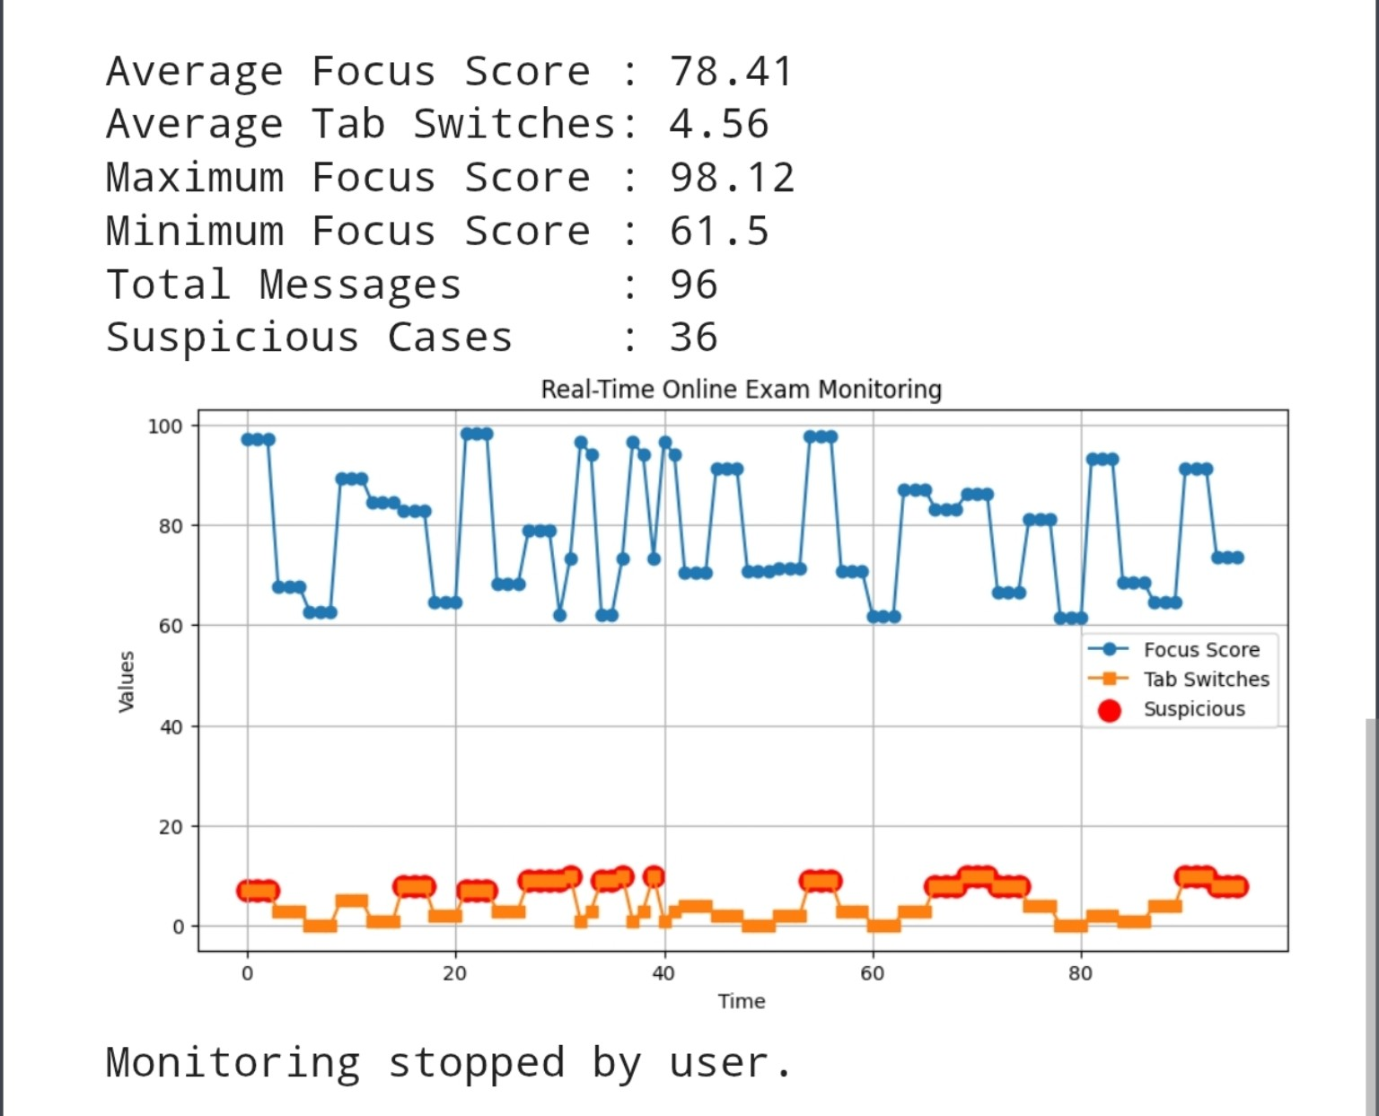
Figure: Real-Time Online Exam Monitoring Output

Result
The Real-Time Online Exam Monitoring System was successfully simulated using Python and MQTT in Google Colab. The system generated focus score and tab-switch data, transmitted the values through an MQTT broker, received the messages using a subscriber, classified suspicious activity, calculated monitoring statistics, and displayed the results using a live graph. Thus, the experiment successfully demonstrated MQTT-based real-time monitoring and suspicious activity detection for an online examination environment.

