EXPERIMENT 2
IOE-BASED SMART PARKING SYSTEM: PARKING SLOT OCCUPANCY DATA ACQUISITION AND MONITORING USING PYTHON IN GOOGLE COLAB
Aim
To implement IoE sensor-based smart parking slot monitoring and data acquisition using Python in Google Colab, and to identify the occupancy status (Vacant/Occupied) of parking slots along with the overall traffic status of the parking area.
Software Requirements
- Google Colab
- Python 3
- Random Library
- Pandas Library
- Matplotlib Library
Theory
The Internet of Everything (IoE) connects people, devices, sensors, data, and processes to enable intelligent decision-making. In an IoE-based smart parking system, connected devices such as ultrasonic sensors, infrared sensors, or cameras installed at each parking slot continuously monitor whether the slot is vacant or occupied. This real-time sensor data helps drivers locate available parking spaces quickly and enables the parking management system to monitor overall traffic load.
In this experiment, occupancy sensor data for 100 parking slots is simulated, with each slot having a 70% probability of being Occupied and a 30% probability of being Vacant, representing a realistic parking scenario. The acquired data is organized into a Pandas DataFrame, and a parking summary is generated showing the total number of slots, the number of occupied and vacant slots, and the list of vacant and occupied slot numbers.
Based on the number of occupied slots, the parking status is classified as follows:
- HIGH TRAFFIC — if occupied slots exceed 85
- NORMAL — otherwise
The slot-wise occupancy is also visualized using a colour-coded bar chart, where red bars represent occupied slots and green bars represent vacant slots.
Procedure
1. Import required Python libraries (random, pandas, matplotlib).
2. Define the total number of parking slots (100).
3. Simulate sensor data for each slot with random occupancy status (70% Occupied, 30% Vacant).
4. Store the slot numbers and their status in lists.
5. Convert the collected data into a Pandas DataFrame.
6. Display the parking slot dataset.
7. Compute the parking summary — total, occupied, and vacant slot counts.
8. Display the list of vacant slot numbers and occupied slot numbers.
9. Determine the parking status (HIGH TRAFFIC / NORMAL) based on the occupied slot threshold.
10. Save the dataset as a CSV file.
11. Visualize the slot occupancy using a colour-coded bar chart.
12. End the program.
Code
import random
import pandas as pd
import matplotlib.pyplot as plt

num_slots = 100

slot_number = []
status = []

vacant_slots = []
occupied_slots = []

for i in range(1, num_slots + 1):

# 70% Occupied, 30% Vacant
if random.random() < 0.7:
s = "Occupied"
occupied_slots.append(i)
else:
s = "Vacant"
vacant_slots.append(i)

slot_number.append(i)
status.append(s)

# Create DataFrame
df = pd.DataFrame({
"Parking Slot": slot_number,
"Status": status
})

print(df)

print("\n========== PARKING SUMMARY ==========")
print("Total Slots :", num_slots)
print("Occupied Slots :", len(occupied_slots))
print("Vacant Slots :", len(vacant_slots))

print("\nVacant Slot Numbers:")
print(vacant_slots)

print("\nOccupied Slot Numbers:")
print(occupied_slots)

if len(occupied_slots) > 85:
print("\nParking Status : HIGH TRAFFIC")
else:
print("\nParking Status : NORMAL")

# Save CSV
df.to_csv("parking_slots.csv", index=False)

# Plot
plt.figure(figsize=(14,4))

colors = ['red' if x=="Occupied" else 'green' for x in status]

plt.bar(slot_number, [1]*num_slots, color=colors)

plt.xlabel("Parking Slot Number")
plt.title("Smart Parking Occupancy")
plt.yticks([])

plt.show()
Output
Parking Slot Status
0 1 Vacant
1 2 Occupied
2 3 Occupied
3 4 Vacant
4 5 Vacant
.. ... ...
95 96 Occupied
96 97 Occupied
97 98 Occupied
98 99 Vacant
99 100 Occupied

[100 rows x 2 columns]

========== PARKING SUMMARY ==========
Total Slots : 100
Occupied Slots : 74
Vacant Slots : 26

Vacant Slot Numbers:
[1, 4, 5, 6, 9, 32, 37, 40, 43, 58, 59, 61, 62, 64, 67, 68, 71, 73, 75, 77, 81, 83, 90, 92, 95, 99]

Occupied Slot Numbers:
[2, 3, 7, 8, 10, 11, 12, 13, 14, 15, 16, 17, 18, 19, 20, 21, 22, 23, 24, 25, 26, 27, 28, 29, 30, 31, 33, 34, 35, 36, 38, 39, 41, 42, 44, 45, 46, 47, 48, 49, 50, 51, 52, 53, 54, 55, 56, 57, 60, 63, 65, 66, 69, 70, 72, 74, 76, 78, 79, 80, 82, 84, 85, 86, 87, 88, 89, 91, 93, 94, 96, 97, 98, 100]

Parking Status : NORMAL
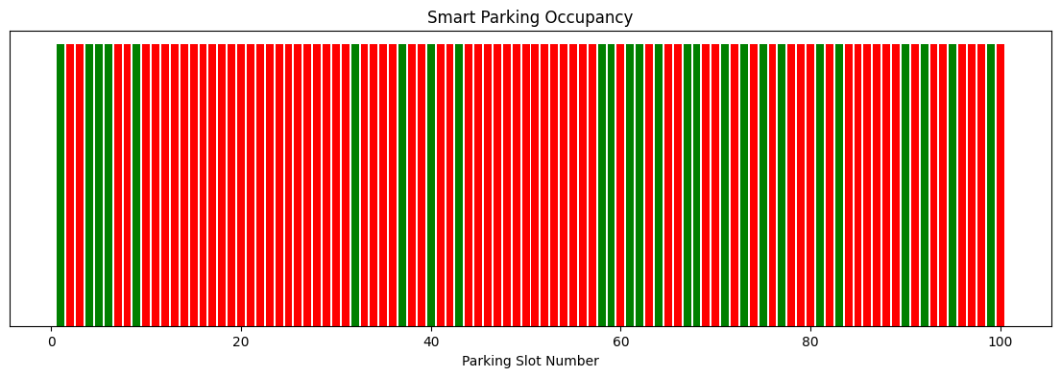
Result
The IoE-based smart parking monitoring system was successfully implemented using Python in Google Colab. Sensor data for 100 parking slots was simulated and acquired, giving 74 occupied slots and 26 vacant slots. The system successfully identified and listed the vacant and occupied slot numbers, and the parking status was determined as NORMAL since the number of occupied slots (74) did not exceed the high-traffic threshold of 85. The slot-wise occupancy was also visualized using a colour-coded bar chart, enabling quick identification of available parking slots.

