EXPERIMENT 4
EDGE-CLOUD SYNCHRONIZATION AND DATA ANALYTICS FOR SMART IRRIGATION MONITORING (SIMULATION):
SMART IRRIGATION MONITORING SYSTEM USING PYTHON IN GOOGLE COLAB
Aim
To simulate edge-cloud synchronization of an IoT-based smart irrigation monitoring system using Python in Google Colab, and to analyse the synchronized soil moisture data at the cloud level to compute statistical trends, detect dry soil conditions, and visualize the moisture trend over time.
Software Requirements
- Google Colab
- Python 3
- Pandas Library
- NumPy Library
- Matplotlib Library
Theory
In an Edge-Cloud IoT architecture, sensor data collected by an edge device is first stored locally before being synchronized with a cloud platform for centralized storage and advanced analytics. The edge device typically has limited processing capability and performs basic data acquisition, while the cloud performs computationally intensive tasks such as statistical analysis, trend detection, and alert generation.
In this experiment, a smart irrigation monitoring system is simulated. A soil moisture sensor at the edge device continuously records the moisture level of the soil. Each reading is stored locally at the edge and simultaneously synchronized to the cloud storage. At the cloud level, analytics are performed on the accumulated data to compute the mean moisture level, a 5-sample moving average, and the standard deviation, which together describe the overall trend and variability of the soil moisture. If the current moisture level falls below a critical threshold of 20%, the system flags the status as "DRY SOIL - IRRIGATION NEEDED"; otherwise, it is marked "NORMAL". The moisture trend is visualized using a line graph, with the critical threshold marked for quick identification, enabling timely irrigation decisions.
Procedure
1. Import required Python libraries (pandas, numpy, matplotlib, time, IPython.display).
2. Initialize empty lists to represent edge storage, cloud storage, and time data.
3. Define a realistic time-series dataset of soil moisture readings (50 samples).
4. For each incoming reading, store the value at the edge device.
5. Synchronize the same reading from the edge device to the cloud storage.
6. At the cloud level, compute the mean, 5-sample moving average, and standard deviation of the synchronized data.
7. Classify the current status as "NORMAL" or "DRY SOIL - IRRIGATION NEEDED" based on a 20% critical threshold.
8. Display the edge device status and cloud analytics for each reading.
9. Plot the soil moisture trend in real time, marking the critical threshold line.
10. Save the synchronized cloud dataset as a CSV file.
11. End the program.
Code
# Experiment 4: Edge-Cloud Synchronization and Data Analytics
# Scenario: Smart Irrigation Monitoring System

import random
import pandas as pd
import numpy as np
import matplotlib.pyplot as plt
from IPython.display import clear_output
import time

edge_storage = []
cloud_storage = []
time_data = []

# Realistic varying soil moisture dataset (50 samples, % moisture)
soil_moisture = [
72, 70, 68, 71, 74, 76, 73, 69, 65, 62,
59, 63, 67, 70, 68, 64, 60, 57, 54, 58,
61, 65, 69, 72, 70, 66, 62, 58, 55, 51,
48, 45, 49, 53, 57, 60, 56, 52, 48, 44,
40, 36, 32, 28, 24, 21, 18, 15, 12, 9
]

for i in range(1, 51):
moisture_level = soil_moisture[i - 1]

# Edge Storage
edge_storage.append(moisture_level)

# Synchronize to Cloud
cloud_storage.append(moisture_level)

time_data.append(i)

mean = np.mean(cloud_storage)
std = np.std(cloud_storage)

if len(cloud_storage) >= 5:
moving = np.mean(cloud_storage[-5:])
else:
moving = mean

if moisture_level < 20:
status = "DRY SOIL - IRRIGATION NEEDED"
else:
status = "NORMAL"

clear_output(wait=True)

print("=========== EDGE DEVICE ===========")
print("Current Soil Moisture :", moisture_level, "%")
print("Stored at Edge :", len(edge_storage))
print()

print("=========== CLOUD ===========")
print("Cloud Records :", len(cloud_storage))
print("Mean :", round(mean, 2))
print("Moving Average :", round(moving, 2))
print("Standard Deviation :", round(std, 2))
print("Status :", status)

plt.figure(figsize=(10, 4))
plt.plot(time_data, cloud_storage, marker='o', color='brown')
plt.axhline(20, color='red', linestyle='--', label='Critical Level')
plt.xlabel("Sample")
plt.ylabel("Soil Moisture (%)")
plt.title("Edge-Cloud Synchronization: Smart Irrigation Monitoring")
plt.legend()
plt.grid(True)
plt.show()

time.sleep(0.5)

df = pd.DataFrame({
"Sample": time_data,
"Soil Moisture": cloud_storage
})

df.to_csv("cloud_soil_data.csv", index=False)

print("Experiment Completed Successfully")
Output
=========== EDGE DEVICE ===========
Current Soil Moisture : 9 %
Stored at Edge : 50

=========== CLOUD ===========
Cloud Records : 50
Mean : 53.92
Moving Average : 15.0
Standard Deviation : 17.56
Status : DRY SOIL - IRRIGATION NEEDED
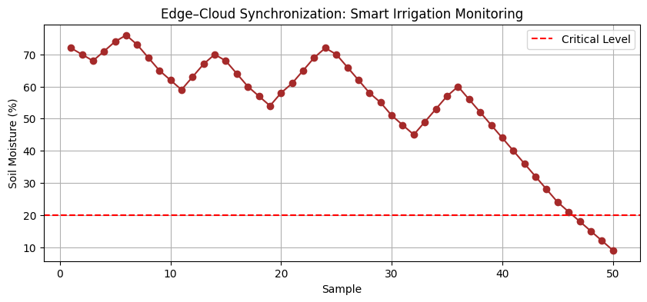
Experiment Completed Successfully
Result
The edge-cloud synchronization and data analytics process for the smart irrigation monitoring system was successfully simulated using Python in Google Colab. Soil moisture readings from the edge device were synchronized with the cloud in real time, and cloud-level analytics computed a mean moisture level of 53.92%, a final moving average of 15.0%, and a standard deviation of 17.56%. The system correctly identified the final soil moisture reading of 9%, which fell below the critical threshold of 20%, and flagged the status as "DRY SOIL - IRRIGATION NEEDED". The soil moisture trend was visualized using a line graph with the critical level clearly marked, enabling timely detection of dry soil conditions for efficient irrigation scheduling.

