EXPERIMENT 7
SMART STADIUM ENTRY GATE MANAGEMENT SYSTEM (SIMULATION):
DYNAMIC DENSITY-BASED GATE CONTROLLER USING PYTHON IN GOOGLE COLAB
Aim
To simulate a Smart Stadium Entry Gate Management System using Python in Google Colab, which dynamically monitors the number of fans waiting at each entry gate, identifies the busiest gate in real time, allocates extra staff to that gate, and visualizes the changing queue lengths across multiple monitoring cycles.
Software Requirements
- Google Colab
- Python 3
- Random Library
- Matplotlib Library
- IPython.display Library
Theory
A smart stadium entry gate management system uses real-time crowd data from multiple entry gates to balance fan inflow and reduce congestion. Sensors or counters at each gate continuously track the number of people waiting, and this data is analyzed to identify the gate with the highest queue density at any given moment. Based on this analysis, additional staff or resources can be dynamically redirected to the busiest gate, allowing it to process fans faster and preventing excessive crowding, long waiting times, and potential safety hazards at stadium entrances.
In this experiment, four entry gates (Gate A, Gate B, Gate C, and Gate D) are simulated with initial fan queues. Over 20 monitoring cycles, a random number of new fans arrive at each gate, and the queues are updated accordingly. During each cycle, the gate with the maximum number of fans waiting is identified as the busiest gate, and it is dynamically allocated extra staff, which is modeled by clearing a random number of fans (between 6 and 12) from that gate's queue. A bar chart is redrawn after every cycle, with the busiest gate highlighted in green and the remaining gates shown in red, along with the queue value on each bar and a caption describing the staffing action taken, giving a clear real-time picture of gate-wise congestion throughout the simulation.
Procedure
1. Import required Python libraries (random, matplotlib, IPython.display, time).
2. Define the four stadium entry gates (Gate A, Gate B, Gate C, Gate D) and initialize their starting fan queue lengths.
3. Set the number of monitoring cycles for the simulation.
4. In each monitoring cycle, generate a random number of newly arriving fans for every gate and add them to the respective queues.
5. Identify the busiest gate (the gate with the maximum queue length) as the active gate needing extra staff.
6. Process a random number of fans at the busiest gate and reduce its queue length accordingly.
7. Clear the previous graph output and plot an updated bar chart of the queue length at each gate, highlighting the busiest gate in green.
8. Display the number of fans waiting on top of each bar and the action taken (fans processed) below the chart.
9. Pause briefly before proceeding to the next monitoring cycle.
10. Repeat the monitoring cycle for all 20 cycles.
11. Print a completion message once the simulation ends.
Code

# ============================================
# Smart Stadium Entry Gate Management System
# Dynamic Density-Based Gate Controller
# Google Colab Version
# ============================================

import random
import matplotlib.pyplot as plt
from IPython.display import clear_output
import time

# Gate names
gates = ["Gate A", "Gate B", "Gate C", "Gate D"]

# Initial queue of fans
queues = [10, 6, 15, 8]

# Number of monitoring cycles
simulation_steps = 20

for step in range(1, simulation_steps + 1):

# Random new fans arrive
new_fans = [random.randint(0, 8) for _ in range(4)]
queues = [queues[i] + new_fans[i] for i in range(4)]

# Find busiest gate
active_gate = queues.index(max(queues))
active_gate_name = gates[active_gate]

# Fans processed
fans_cleared = min(queues[active_gate], random.randint(6, 12))
queues[active_gate] -= fans_cleared

# Clear previous graph
clear_output(wait=True)

# Colors
colors = ['red', 'red', 'red', 'red']
colors[active_gate] = 'green'

# Plot graph
plt.figure(figsize=(8,5))
plt.bar(gates, queues, color=colors)

plt.ylim(0,40)
plt.ylabel("Number of Fans Waiting")
plt.xlabel("Entry Gates")
plt.title(f"Monitoring Cycle {step}: Extra Staff -> {active_gate_name}")

# Display values on bars
for i, value in enumerate(queues):
plt.text(i, value+0.5, str(value),
ha='center', fontsize=12)

plt.figtext(
0.5,
0.01,
f"Action: Processed {fans_cleared} fans at {active_gate_name}",
ha='center',
fontsize=12,
bbox=dict(facecolor='white', edgecolor='black')
)

plt.show()

# Wait before next cycle
time.sleep(1.5)

print("Simulation Completed Successfully!")
Output
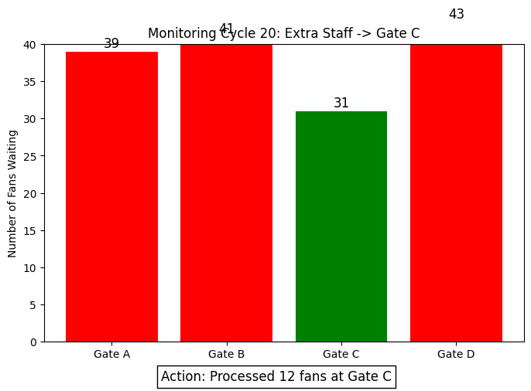
Simulation Completed Successfully!
Result
The Smart Stadium Entry Gate Management System was successfully simulated using Python in Google Colab. Over 20 monitoring cycles, fan queues at all four entry gates were dynamically updated as new fans arrived, and the busiest gate was identified and highlighted in each cycle for extra staff allocation. In the final monitoring cycle (Cycle 20), Gate C was identified as the busiest gate, and extra staff processed 12 fans there, reducing its queue to 31 while Gates A, B, and D held 39, 41, and 43 fans respectively. The bar chart visualizations across the cycles clearly demonstrated how the system continuously tracks gate-wise crowd density and dynamically redirects staffing resources to the most congested gate, helping manage stadium entry more efficiently.

