EXPERIMENT 10
IOT-BASED SMART WAREHOUSE FIRE AND GAS LEAK DETECTION SYSTEM (SIMULATION):
SMART WAREHOUSE SAFETY MONITORING USING PYTHON IN GOOGLE COLAB
Aim
To simulate an IoT-based smart warehouse fire and gas leak detection system using Python in Google Colab, and to monitor temperature, smoke density, gas concentration, and humidity, automatically trigger a fire/gas alarm based on defined safety thresholds, and visualize the sensor trends and alarm status over a 24-hour period.
Software Requirements
- Google Colab
- Python 3
- NumPy Library
- Pandas Library
- Matplotlib Library
Theory
An IoT-based fire and gas leak detection system continuously monitors environmental parameters such as temperature, smoke density, gas concentration, and humidity using a network of sensors installed within a warehouse. The sensor data is streamed at regular intervals to a monitoring unit, where automated decision logic compares each reading against predefined safety thresholds. When any parameter exceeds its threshold, the system immediately triggers a fire or gas alarm and can activate suppression mechanisms such as sprinklers, enabling rapid response and minimizing the risk of fire hazards or gas leaks in storage facilities.
In this experiment, hourly sensor readings for temperature, smoke density, gas concentration, and humidity are simulated over a 24-hour period using NumPy. An alarm/sprinkler trigger rule is applied: the alarm is set to ON if the temperature exceeds 45°C, smoke density exceeds 60 ppm, or gas concentration exceeds 600 ppm; otherwise, the status remains Normal. The complete dataset, along with the total number of alarm-triggered hours and the average gas concentration, is displayed and saved as a CSV file. Four visualizations are generated: the temperature trend with the fire threshold and alarm points, the smoke density and humidity trends, the gas concentration bar chart with the danger level marked, and the overall alarm system status timeline, together providing a complete picture of warehouse safety conditions throughout the day.
Procedure
1. Import required Python libraries (NumPy, Pandas, Matplotlib).
2. Simulate 24-hour IoT sensor readings for temperature, smoke density, gas level, and humidity in a smart warehouse.
3. Store the simulated hourly readings in a Pandas DataFrame.
4. Define automated alarm and sprinkler-trigger logic based on threshold conditions (temperature > 45°C, smoke > 60 ppm, or gas > 600 ppm).
5. Classify each hourly reading as Alarm Triggered (1) or Normal (0) using the defined logic.
6. Display the complete warehouse safety sensor dataset with alarm status.
7. Compute the total alarm-triggered hours and the average gas concentration over 24 hours.
8. Visualize the temperature trend with the fire threshold and alarm points highlighted.
9. Visualize the smoke density and humidity trends over 24 hours.
10. Visualize the gas concentration as a bar chart with the gas danger level marked.
11. Visualize the fire/gas alarm system status as an ON/OFF timeline.
12. Save the dataset as a CSV file.
13. End the program.
Code
# IoT-Based Smart Warehouse Fire and Gas Leak Detection System
# --------------------------------------------------------------
import numpy as np
import pandas as pd
import matplotlib.pyplot as plt

# Step 1: Simulate IoT Sensor Dataset (24-hour monitoring, hourly readings)
np.random.seed(7)
hours = np.arange(0, 24)

# Simulated sensor readings
temperature = np.clip(28 + 4*np.sin((hours-15)/5) + np.random.normal(0, 1.5, 24), 20, 65) # °C
smoke_density = np.clip(15 + 8*np.cos((hours-10)/6) + np.random.normal(0, 3, 24), 0, 100) # ppm
gas_level = np.clip(200 + 100*np.sin((hours-18)/4) + np.random.normal(0, 25, 24), 50, 900) # ppm (LPG/CO)
humidity = np.random.uniform(30, 70, 24) # %

# Step 2: Automated Alarm & Suppression Decision Logic
# Rule: Alarm ON if temperature > 45°C OR smoke > 60 ppm OR gas > 600 ppm
alarm_status = []
for temp, smoke, gas in zip(temperature, smoke_density, gas_level):
if temp > 45 or smoke > 60 or gas > 600:
alarm_status.append(1) # Alarm ON / Sprinkler Triggered
else:
alarm_status.append(0) # Normal

df = pd.DataFrame({
'Hour': hours,
'Temperature(C)': temperature.round(2),
'Smoke_Density(ppm)': smoke_density.round(2),
'Gas_Level(ppm)': gas_level.round(1),
'Humidity(%)': humidity.round(1),
'Alarm_Status': alarm_status
})

print("===== IoT Smart Warehouse Safety Sensor Dataset =====\n")
print(df.to_string(index=False))

alarm_hours = df['Alarm_Status'].sum()
avg_gas = df['Gas_Level(ppm)'].mean()
print(f"\nTotal hours Alarm/Sprinkler Triggered: {alarm_hours} hrs")
print(f"Average gas concentration over 24h : {avg_gas:.2f} ppm")

# Step 3: Visualization
fig, axs = plt.subplots(2, 2, figsize=(14, 10))

# (a) Temperature with threshold and alarm markers
axs[0, 0].plot(hours, temperature, marker='o', color='darkred', label='Temperature (°C)')
axs[0, 0].axhline(45, color='red', linestyle='--', label='Fire Threshold (45°C)')
alarm_hrs = df[df['Alarm_Status'] == 1]['Hour']
alarm_temp = df[df['Alarm_Status'] == 1]['Temperature(C)']
axs[0, 0].scatter(alarm_hrs, alarm_temp, color='orange', s=100, zorder=5, label='Alarm Triggered')
axs[0, 0].set_title('Temperature & Fire Alarm Trigger Points')
axs[0, 0].set_xlabel('Hour of Day')
axs[0, 0].set_ylabel('Temperature (°C)')
axs[0, 0].legend()
axs[0, 0].grid(True)

# (b) Smoke Density and Humidity trends
axs[0, 1].plot(hours, smoke_density, marker='s', color='gray', label='Smoke Density (ppm)')
axs[0, 1].plot(hours, humidity, marker='^', color='teal', label='Humidity (%)')
axs[0, 1].set_title('Smoke Density & Humidity over 24 Hours')
axs[0, 1].set_xlabel('Hour of Day')
axs[0, 1].set_ylabel('Value')
axs[0, 1].legend()
axs[0, 1].grid(True)

# (c) Gas level bar chart
axs[1, 0].bar(hours, gas_level, color=['red' if g > 600 else 'dodgerblue' for g in gas_level])
axs[1, 0].axhline(600, color='black', linestyle='--', label='Gas Danger Level')
axs[1, 0].set_title('Gas Concentration over 24 Hours')
axs[1, 0].set_xlabel('Hour of Day')
axs[1, 0].set_ylabel('Gas Level (ppm)')
axs[1, 0].legend()
axs[1, 0].grid(True, axis='y')

# (d) Alarm ON/OFF status timeline
axs[1, 1].step(hours, alarm_status, where='mid', color='red', linewidth=2)
axs[1, 1].fill_between(hours, alarm_status, step='mid', alpha=0.3, color='red')
axs[1, 1].set_title('Fire/Gas Alarm System Status')
axs[1, 1].set_xlabel('Hour of Day')
axs[1, 1].set_ylabel('Alarm Status')
axs[1, 1].set_yticks([0, 1])
axs[1, 1].set_yticklabels(['NORMAL', 'ALARM'])
axs[1, 1].grid(True)

plt.tight_layout()
plt.show()

# Step 4: Save dataset as CSV (optional download in Colab)
df.to_csv('smart_warehouse_safety_dataset.csv', index=False)
print("\nDataset saved as 'smart_warehouse_safety_dataset.csv'")
Output
===== IoT Smart Warehouse Safety Sensor Dataset =====

Hour Temperature(C) Smoke_Density(ppm) Gas_Level(ppm) Humidity(%) Alarm_Status
0 29.97 14.10 304.5 61.9 0
1 25.96 11.21 276.4 50.9 0
2 25.99 15.67 323.5 48.4 0
3 25.91 11.28 263.1 61.1 0
4 23.58 22.47 237.6 65.5 0
5 24.37 19.13 217.1 57.0 0
6 24.10 19.06 182.6 62.0 0
7 21.37 25.24 154.1 67.6 0
8 25.58 17.61 104.3 31.6 0
9 25.17 24.50 134.7 65.0 0
10 23.70 16.81 106.7 41.1 0
11 24.87 20.90 131.4 49.0 0
12 26.50 18.95 91.0 61.9 0
13 26.05 26.41 57.4 58.7 0
14 26.84 26.59 113.4 35.9 0
15 25.82 19.39 174.3 56.3 0
16 29.63 21.84 142.5 32.8 0
17 29.74 17.61 153.0 44.3 0
18 30.67 18.59 170.2 62.5 0
19 28.58 13.31 198.5 47.1 0
20 33.84 9.11 240.4 54.0 0
21 31.96 7.51 238.7 59.1 0
22 31.36 12.82 321.6 62.8 0
23 35.04 17.25 287.8 60.4 0

Total hours Alarm/Sprinkler Triggered: 0 hrs
Average gas concentration over 24h : 192.70 ppm

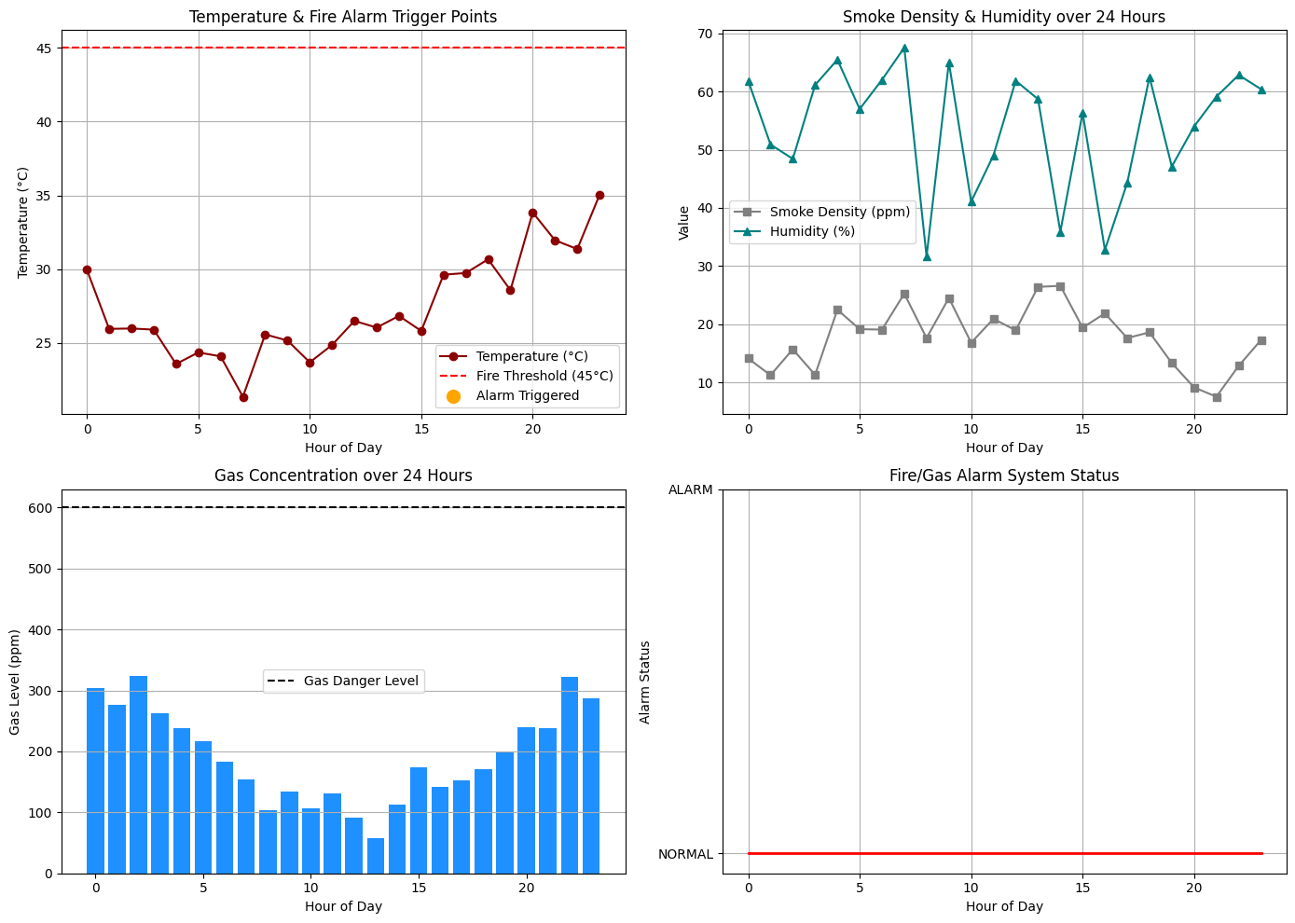
Dataset saved as 'smart_warehouse_safety_dataset.csv'
Result
The IoT-based smart warehouse fire and gas leak detection system was successfully simulated using Python in Google Colab. Hourly readings of temperature, smoke density, gas concentration, and humidity were generated for a 24-hour period, and the automated alarm logic classified every hour as Normal, with 0 hours of alarm/sprinkler triggering recorded, since none of the readings exceeded the fire (45°C), smoke (60 ppm), or gas (600 ppm) thresholds. The average gas concentration over the 24-hour period was found to be 192.70 ppm. The temperature, smoke density, humidity, and gas concentration trends were visualized along with the alarm system status timeline, clearly demonstrating how the system continuously monitors warehouse conditions and would raise a timely alarm if any safety threshold were breached.

