EXPERIMENT 3
DEVICE ONBOARDING AND DATA FLOW IN AWS IOT CORE (SIMULATION):
SMART WASTE BIN MONITORING SYSTEM USING PYTHON IN GOOGLE COLAB
Aim
To simulate the device onboarding process and end-to-end data flow of an IoT device in AWS IoT Core using Python in Google Colab, and to monitor the fill level of a smart waste bin, detect overflow conditions, and visualize the fill-level trend over time.
Software Requirements
- Google Colab
- Python 3
- Pandas Library
- Matplotlib Library
Theory
AWS IoT Core is a managed cloud platform that lets connected devices securely register, authenticate, and exchange data with cloud applications. The typical data flow begins with device registration, where a unique device identity is created, followed by device authentication, which verifies the device before it is allowed to publish data to the cloud. Once authenticated, the device streams sensor readings, which are processed and analysed by cloud analytics services to derive meaningful insights and trigger alerts when required.
In this experiment, the onboarding and data flow of a smart waste bin sensor in AWS IoT Core is simulated. The device, identified as “Waste_Bin_Sensor_007”, is first registered and authenticated. The sensor then generates fill-level readings (as a percentage of bin capacity) over ten time intervals. Cloud analytics computes the average fill level and classifies each reading as “Normal” or “Overflow Alert” based on a fixed threshold of 85%. The processed data is stored as a CSV file, representing persistent cloud storage, and the fill-level trend is visualized using a line graph, with overflow points highlighted and the threshold marked for quick identification.
Procedure
1. Import required Python libraries (pandas, matplotlib).
2. Register the IoT device and display the device ID.
3. Authenticate the device before allowing data transmission.
4. Generate time-series fill-level data for the waste bin sensor.
5. Store the time and fill-level readings in a Pandas DataFrame.
6. Perform cloud analytics to compute the average fill level.
7. Classify each reading as “Normal” or “Overflow Alert” based on the 85% threshold.
8. Display the waste bin dataset with status.
9. Save the dataset as a CSV file.
10. Plot the fill-level trend, highlighting overflow points and the threshold line.
11. End the program.
Code

# Experiment 3: Device Onboarding and Data Flow in AWS IoT Core (Simulation)
# Scenario: Smart Waste Bin Monitoring System

import pandas as pd
import matplotlib.pyplot as plt

# -----------------------------------
# Step 1: Device Registration
# -----------------------------------
device_id = "Waste_Bin_Sensor_007"
print("Device Registered Successfully")
print("Device ID:", device_id)

# -----------------------------------
# Step 2: Device Authentication
# -----------------------------------
print("\nAuthenticating Device...")

authenticated = True

if authenticated:
print("Authentication Successful\n")
else:
print("Authentication Failed")

# -----------------------------------
# Step 3: Generate Waste Bin Fill-Level Data
# -----------------------------------

time = [1, 2, 3, 4, 5, 6, 7, 8, 9, 10]

# Fill level in percentage (%)
fill_level = [10, 22, 35, 48, 60, 72, 85, 92, 78, 55]

bin_capacity = 100 # in percentage terms

# Create DataFrame
df = pd.DataFrame({
"Time": time,
"FillLevel": fill_level
})

# -----------------------------------
# Step 4: Cloud Analytics
# -----------------------------------

mean_fill = df["FillLevel"].mean()

print("Average Fill Level =", mean_fill, "%")

# Overflow Detection
df["Status"] = df["FillLevel"].apply(
lambda x: "Overflow Alert" if x >= 85 else "Normal"
)

print("\nWaste Bin Data")
print(df)

# -----------------------------------
# Step 5: Save CSV
# -----------------------------------

df.to_csv("waste_bin_data.csv", index=False)

print("\nCSV File Saved Successfully")

# -----------------------------------
# Step 6: Plot Graph
# -----------------------------------

plt.figure(figsize=(8, 5))

plt.plot(df["Time"],
df["FillLevel"],
marker='o',
linewidth=2,
color='green',
label="Fill Level (%)")

# Overflow Points
overflow = df[df["FillLevel"] >= 85]

plt.scatter(overflow["Time"],
overflow["FillLevel"],
color='red',
s=120,
label="Overflow Alert")

# Threshold
plt.axhline(y=85,
color='orange',
linestyle='--',
label="Overflow Threshold")

plt.title("Smart Waste Bin Fill-Level Monitoring")
plt.xlabel("Time")
plt.ylabel("Fill Level (%)")
plt.grid(True)
plt.legend()

plt.show()

print("\nExperiment Completed Successfully")

Output
Device Registered Successfully
Device ID: Waste_Bin_Sensor_007

Authenticating Device...
Authentication Successful

Average Fill Level = 55.7 %

Waste Bin Data
Time FillLevel Status
0 1 10 Normal
1 2 22 Normal
2 3 35 Normal
3 4 48 Normal
4 5 60 Normal
5 6 72 Normal
6 7 85 Overflow Alert
7 8 92 Overflow Alert
8 9 78 Normal
9 10 55 Normal

CSV File Saved Successfully
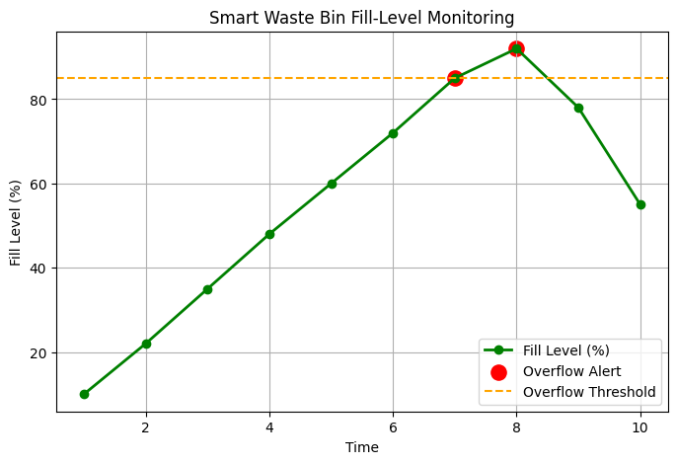
Experiment Completed Successfully
Result
The device onboarding and data flow process in AWS IoT Core was successfully simulated using Python in Google Colab. The smart waste bin sensor “Waste_Bin_Sensor_007” was registered and authenticated, and fill-level data was acquired and analysed, giving an average fill level of 55.7%. The system successfully identified overflow conditions at time intervals 7 and 8, where the fill level reached 85% and 92% respectively, exceeding the overflow threshold. The fill-level trend was visualized using a line graph with overflow points and the threshold clearly marked, enabling timely detection of bin overflow for efficient waste collection scheduling.

