ECA 6101 – COMPUTER NETWORKS AND CYBERSECURITY
192512041 S HARI PRASATH
EXP 9 Website IP Identification and DNS Response Time Analysis using Wireshark
Objectives
1. To capture and analyze DNS query and response packets using Wireshark and identify
the IPv4 (A Record) and IPv6 (AAAA Record) addresses of websites.
2. To measure and evaluate the DNS response time for selected websites and verify the
obtained IP addresses using the nslookup command.
OBJECTIVE 1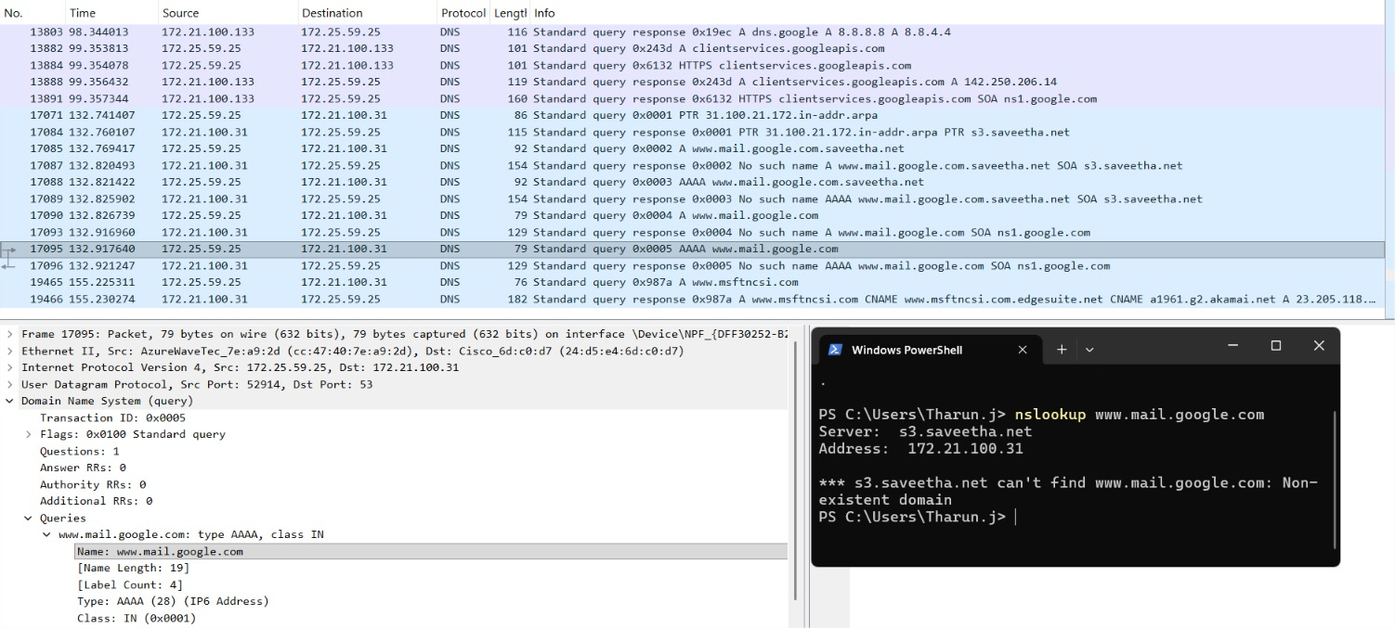

OBJECTIVE 2
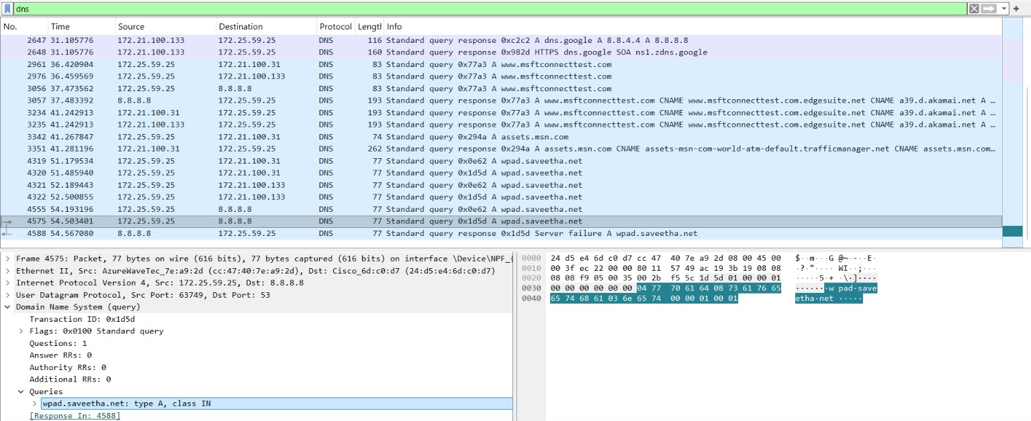

Results
Objective 1:
DNS query and response packets were successfully captured and analyzed using Wireshark. The
IPv4 (A) records and IPv6 (AAAA) records of the selected websites were identified from the
DNS response packets.
Objective 2:
The DNS response time for the selected websites was measured from the captured DNS packets
and the obtained IPv4/IPv6 addresses were successfully verified using the nslookup command.
The results confirmed the accuracy of the DNS resolution.

