NAME : GOKUL BARADWAJ C
REG NO. : 192512073
COURSE : DIGITAL SIGNAL PROCESSING

SIMULATION EXPERIMENT – 1
1.Design, Realization and Performance Analysis of Butterworth IIR Low-Pass and High-Pass Digital Filters Using MATLAB
Program code :
clear;
clc;
close all;

% Design Parameters
Fs = 8000; % Sampling frequency in Hz
Ap = 1; % Passband ripple in dB
As = 40; % Stopband attenuation in dB

% 1. Low-Pass Filter Design
fp_lp = 1000; % LPF Passband frequency (Hz)
fs_lp = 1500; % LPF Stopband frequency (Hz)
wp_lp = fp_lp / (Fs/2);
ws_lp = fs_lp / (Fs/2);

[N_lp, Wn_lp] = buttord(wp_lp, ws_lp, Ap, As);
[b_lp, a_lp] = butter(N_lp, Wn_lp, 'low');

% 2. High-Pass Filter Design
fp_hp = 2500; % HPF Passband frequency (Hz)
fs_hp = 1800; % HPF Stopband frequency (Hz)
wp_hp = fp_hp / (Fs/2);
ws_hp = fs_hp / (Fs/2);

[N_hp, Wn_hp] = buttord(wp_hp, ws_hp, Ap, As);
[b_hp, a_hp] = butter(N_hp, Wn_hp, 'high');

% ==========================================
% DISPLAY NUMERICAL OUTPUTS IN COMMAND WINDOW
% ==========================================
fprintf('=== EXPERIMENT 1: BUTTERWORTH IIR FILTERS ===\n\n');

fprintf('--- LOW-PASS FILTER ---\n');
fprintf('Calculated Filter Order (N_lp): %d\n', N_lp);
fprintf('3-dB Cutoff Frequency (Wn_lp): %.4f Hz\n', Wn_lp * (Fs/2));
fprintf('Numerator Coefficients (b_lp):\n');
disp(b_lp);
fprintf('Denominator Coefficients (a_lp):\n');
disp(a_lp);

fprintf('--- HIGH-PASS FILTER ---\n');
fprintf('Calculated Filter Order (N_hp): %d\n', N_hp);
fprintf('3-dB Cutoff Frequency (Wn_hp): %.4f Hz\n', Wn_hp * (Fs/2));
fprintf('Numerator Coefficients (b_hp):\n');
disp(b_hp);
fprintf('Denominator Coefficients (a_hp):\n');
disp(a_hp);

% Frequency Response Calculation
[H_lp, f] = freqz(b_lp, a_lp, 1024, Fs);
[H_hp, ~] = freqz(b_hp, a_hp, 1024, Fs);

% Plotting
figure('Name', 'Butterworth IIR LPF and HPF');
subplot(2,2,1);
plot(f, 20*log10(abs(H_lp)), 'b', 'LineWidth', 1.5); grid on;
title(['Butterworth LPF Magnitude (Order N = ', num2str(N_lp), ')']);
xlabel('Frequency (Hz)'); ylabel('Magnitude (dB)'); ylim([-80 5]);

subplot(2,2,2);
plot(f, angle(H_lp)*180/pi, 'r', 'LineWidth', 1.5); grid on;
title('Butterworth LPF Phase Response');
xlabel('Frequency (Hz)'); ylabel('Phase (degrees)');

subplot(2,2,3);
plot(f, 20*log10(abs(H_hp)), 'b', 'LineWidth', 1.5); grid on;
title(['Butterworth HPF Magnitude (Order N = ', num2str(N_hp), ')']);
xlabel('Frequency (Hz)'); ylabel('Magnitude (dB)'); ylim([-80 5]);

subplot(2,2,4);
plot(f, angle(H_hp)*180/pi, 'r', 'LineWidth', 1.5); grid on;
title('Butterworth HPF Phase Response');
xlabel('Frequency (Hz)'); ylabel('Phase (degrees)');

Output:

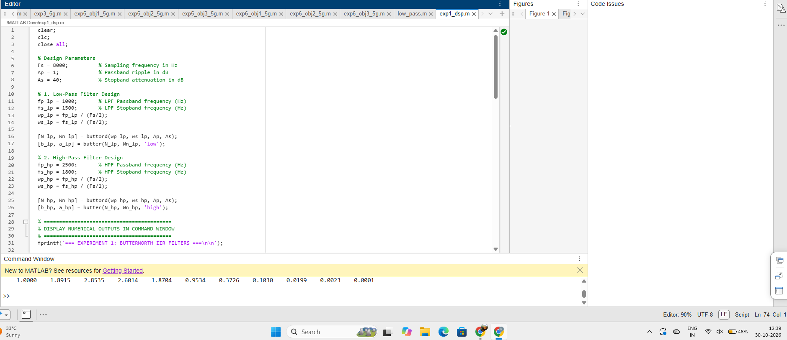

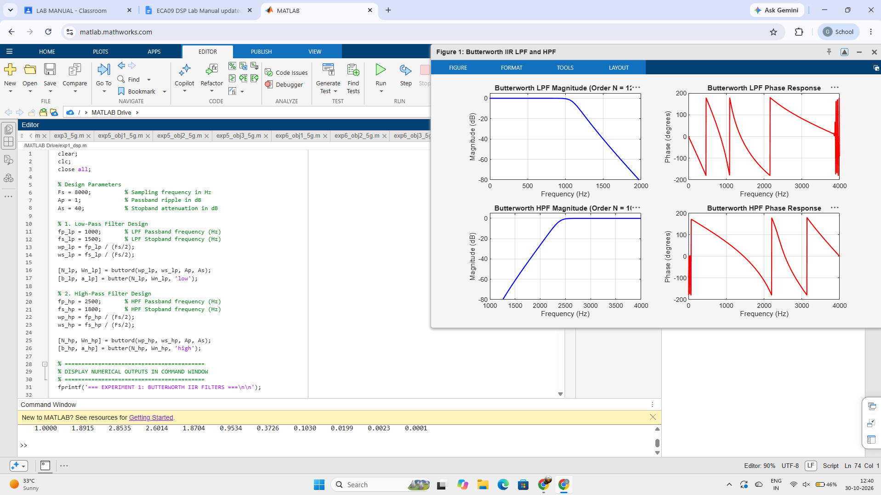

STUDENT RELECTION :
This experiment helped me connect theoretical IIR filter concepts with practical implementation in MATLAB. Using buttord and butter showed how frequency normalization and transition bandwidth directly determine the filter order ($N$). Analyzing the magnitude and phase plots confirmed the Butterworth filter's maximally flat passband, smooth roll-off, and non-linear phase response.

RESULT:
LOW-PASS FILTER ---
Calculated Filter Order (N_lp): 12
3-dB Cutoff Frequency (Wn_lp): 1087.8354 Hz
Numerator Coefficients (b_lp):
0.0000 0.0000 0.0002 0.0006 0.0013 0.0021 0.0024 0.0021 0.0013 0.0006 0.0002 0.0000 0.0000
Denominator Coefficients (a_lp):
1.0000 -5.4622 14.6771 -25.1616 30.3497 -26.9537 17.9862 -9.0534 3.4018 -0.9283 0.1743 -0.0202 0.0011
--- HIGH-PASS FILTER ---
Calculated Filter Order (N_hp): 10
3-dB Cutoff Frequency (Wn_hp): 2379.7556 Hz
Numerator Coefficients (b_hp):
0.0006 -0.0055 0.0248 -0.0662 0.1159 -0.1390 0.1159 -0.0662 0.0248 -0.0055 0.0006
Denominator Coefficients (a_hp):
1.0000 1.8915 2.8535 2.6014 1.8704 0.9534 0.3726 0.1030 0.0199 0.0023 0.0001

