NAME : GOKUL BARADWAJ C
REG NO. : 192512073
COURSE : DIGITAL SIGNAL PROCESSING

SIMULATION EXPERIMENT – 2
2. Design and Performance Analysis of Chebyshev Type-I IIR Low-Pass and High-Pass Filters Using MATLAB

Program Code:
clear; clc; close all;

% Design Parameters
Fs = 10000; % Sampling frequency in Hz
Ap = 0.5; % Passband ripple in dB
As = 30; % Stopband attenuation in dB

% 1. Low-Pass Filter Design
fp_lp = 1500; % Passband frequency (Hz)
fs_lp = 2000; % Stopband frequency (Hz)
wp_lp = fp_lp / (Fs/2);
ws_lp = fs_lp / (Fs/2);

[N_lp, Wn_lp] = cheb1ord(wp_lp, ws_lp, Ap, As);
[b_lp, a_lp] = cheby1(N_lp, Ap, Wn_lp, 'low');

% 2. High-Pass Filter Design
fp_hp = 2500; % Passband frequency (Hz)
fs_hp = 1800; % Stopband frequency (Hz)
wp_hp = fp_hp / (Fs/2);
ws_hp = fs_hp / (Fs/2);

[N_hp, Wn_hp] = cheb1ord(wp_hp, ws_hp, Ap, As);
[b_hp, a_hp] = cheby1(N_hp, Ap, Wn_hp, 'high');

% ==========================================
% DISPLAY NUMERICAL OUTPUTS IN COMMAND WINDOW
% ==========================================
fprintf('=== EXPERIMENT 2: CHEBYSHEV TYPE-I IIR FILTERS ===\n\n');

fprintf('--- CHEBYSHEV LOW-PASS FILTER ---\n');
fprintf('Calculated Filter Order (N_lp): %d\n', N_lp);
fprintf('Passband Edge Cutoff Frequency (Wn_lp): %.4f Hz\n', Wn_lp * (Fs/2));
fprintf('Numerator Coefficients (b_lp):\n');
disp(b_lp);
fprintf('Denominator Coefficients (a_lp):\n');
disp(a_lp);

fprintf('--- CHEBYSHEV HIGH-PASS FILTER ---\n');
fprintf('Calculated Filter Order (N_hp): %d\n', N_hp);
fprintf('Passband Edge Cutoff Frequency (Wn_hp): %.4f Hz\n', Wn_hp * (Fs/2));
fprintf('Numerator Coefficients (b_hp):\n');
disp(b_hp);
fprintf('Denominator Coefficients (a_hp):\n');
disp(a_hp);

% Frequency Response Calculation
[H_lp, f] = freqz(b_lp, a_lp, 1024, Fs);
[H_hp, ~] = freqz(b_hp, a_hp, 1024, Fs);

% Plotting
figure('Name', 'Chebyshev Type-I LPF and HPF Responses');
subplot(2,2,1);
plot(f, 20*log10(abs(H_lp)), 'b', 'LineWidth', 1.5); grid on;
title(['Chebyshev LPF Magnitude (Order N = ', num2str(N_lp), ')']);
xlabel('Frequency (Hz)'); ylabel('Magnitude (dB)'); ylim([-60 5]);

subplot(2,2,2);
plot(f, angle(H_lp)*180/pi, 'r', 'LineWidth', 1.5); grid on;
title('Chebyshev LPF Phase Response');
xlabel('Frequency (Hz)'); ylabel('Phase (degrees)');

subplot(2,2,3);
plot(f, 20*log10(abs(H_hp)), 'b', 'LineWidth', 1.5); grid on;
title(['Chebyshev HPF Magnitude (Order N = ', num2str(N_hp), ')']);
xlabel('Frequency (Hz)'); ylabel('Magnitude (dB)'); ylim([-60 5]);

subplot(2,2,4);
plot(f, angle(H_hp)*180/pi, 'r', 'LineWidth', 1.5); grid on;
title('Chebyshev HPF Phase Response');
xlabel('Frequency (Hz)'); ylabel('Phase (degrees)');

Output:
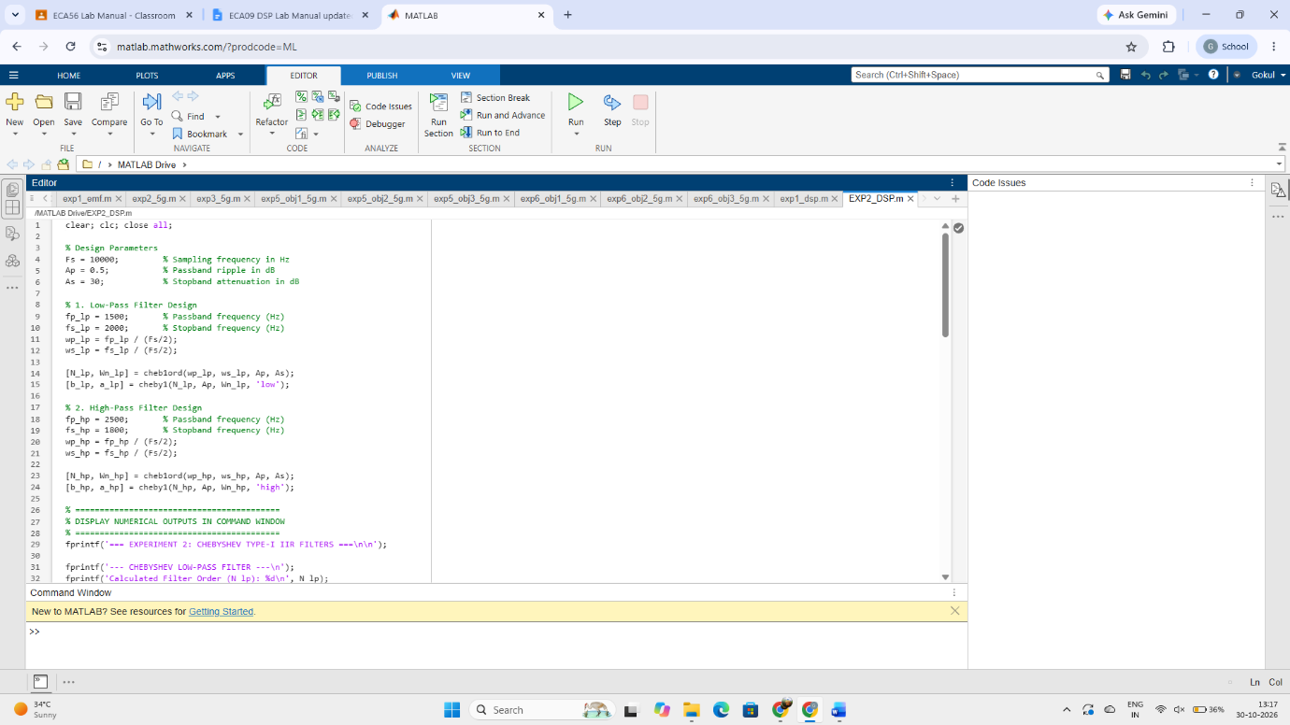

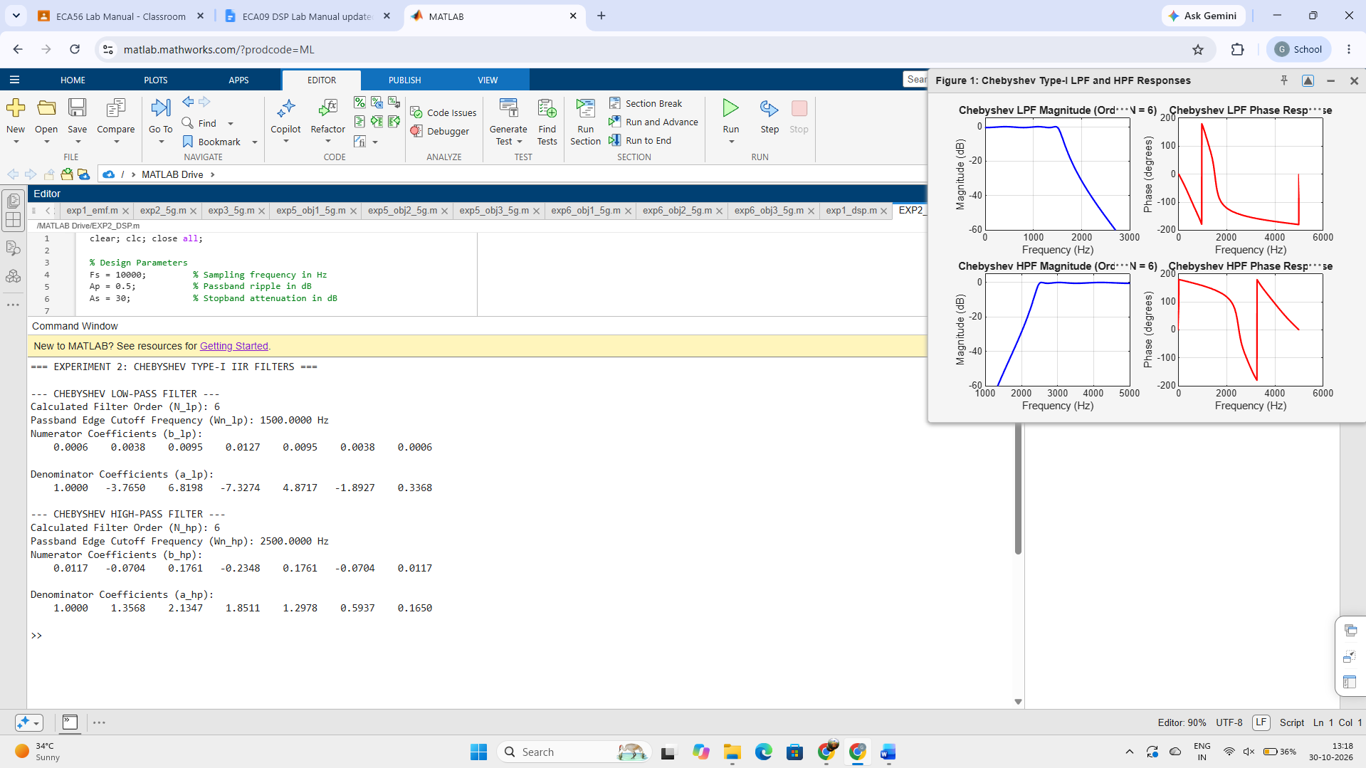

STUDENT RELECTION :
his experiment provided practical insight into designing Chebyshev Type-I IIR low-pass and high-pass filters in MATLAB using cheb1ord and cheby1. Analyzing the frequency response demonstrated the core trade-off of Chebyshev Type-I filters: accepting equiripple variations in the passband achieves a much steeper transition roll-off and requires a lower filter order ($N$) compared to a Butterworth filter with identical specifications.
RESULT :
--- CHEBYSHEV LOW-PASS FILTER ---
Calculated Filter Order (N_lp): 6
Passband Edge Cutoff Frequency (Wn_lp): 1500.0000 Hz
Numerator Coefficients (b_lp):
0.0006 0.0038 0.0095 0.0127 0.0095 0.0038 0.0006

Denominator Coefficients (a_lp):
1.0000 -3.7650 6.8198 -7.3274 4.8717 -1.8927 0.3368

--- CHEBYSHEV HIGH-PASS FILTER ---
Calculated Filter Order (N_hp): 6
Passband Edge Cutoff Frequency (Wn_hp): 2500.0000 Hz
Numerator Coefficients (b_hp):
0.0117 -0.0704 0.1761 -0.2348 0.1761 -0.0704 0.0117

Denominator Coefficients (a_hp):
1.0000 1.3568 2.1347 1.8511 1.2978 0.5937 0.1650

