ECA1411-EMBEDDED SYSTEM
LAB MANUAL
SAAMBAVI .U
192512099
Exp No: 1 FLASHING OF LED USING AT89C51 MICROCONTROLLER USING PROTEUS

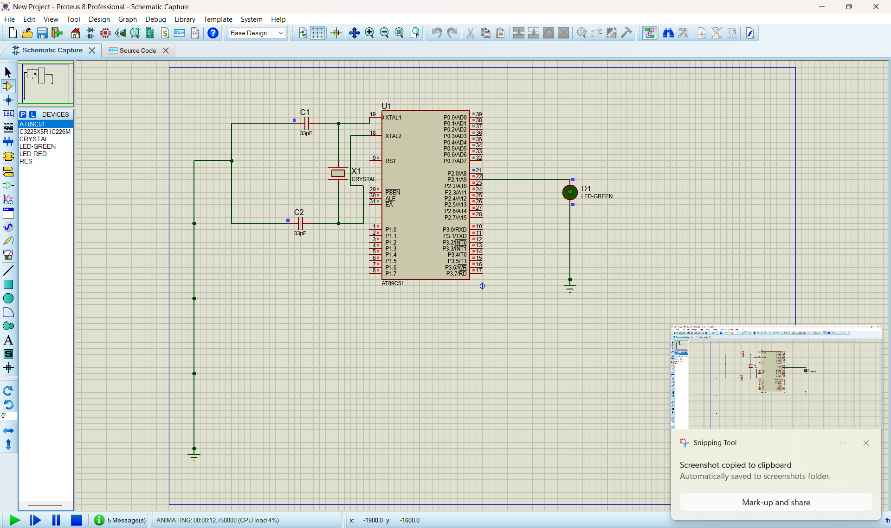

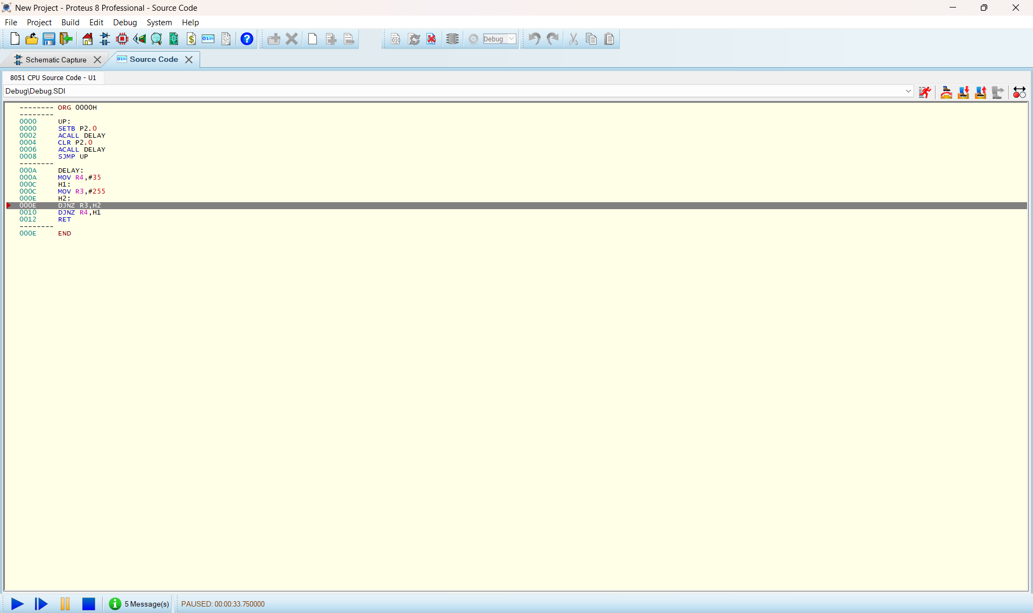
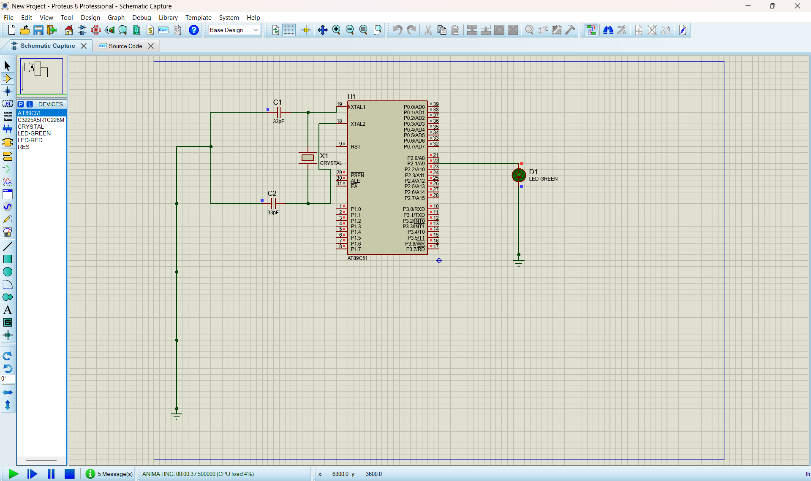

Exp No: 2 GENERATION OF SQUARE WAVE USING PROTEUS

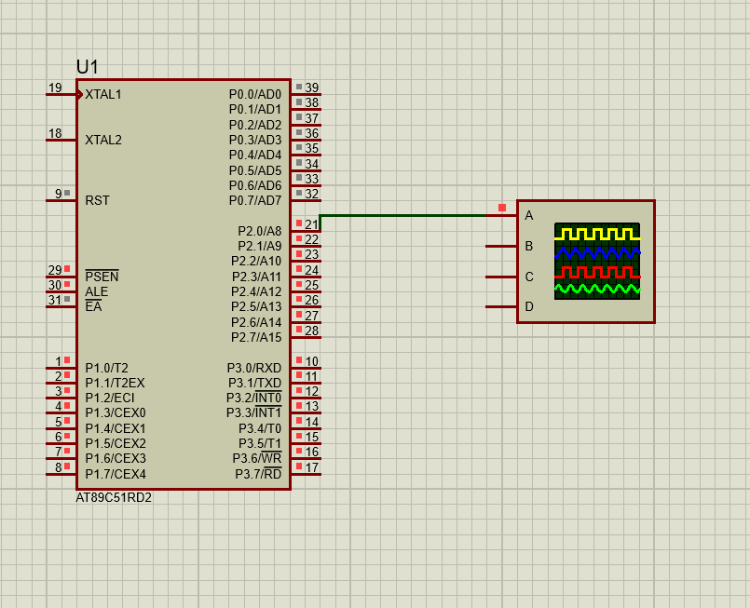

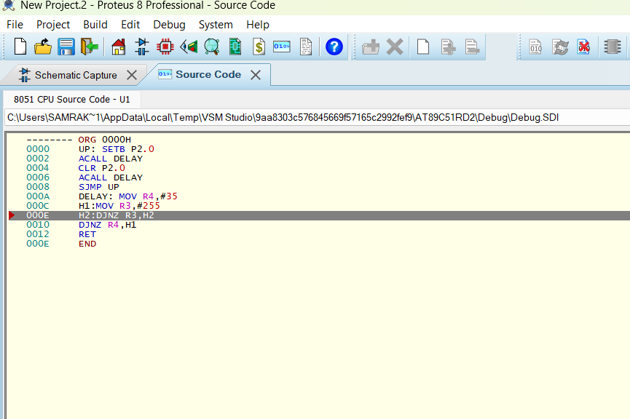

Exp No: 3 STEPPER MOTOR USING AT89C51 USING PROTEUS

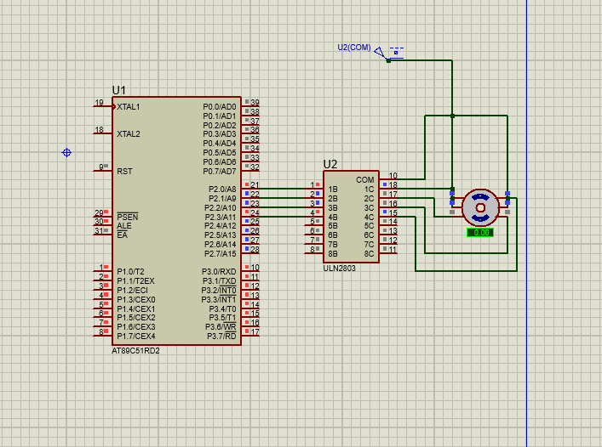

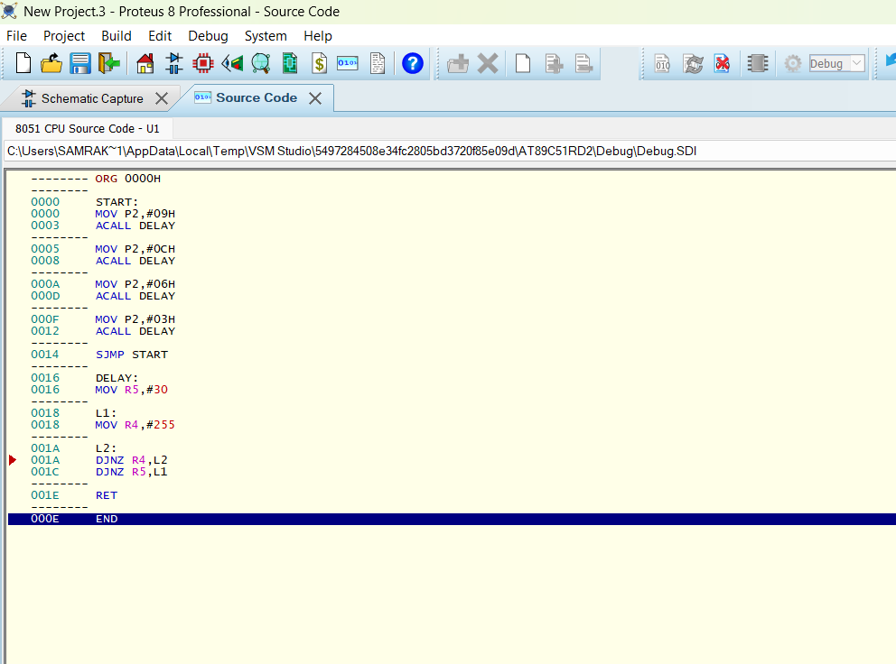
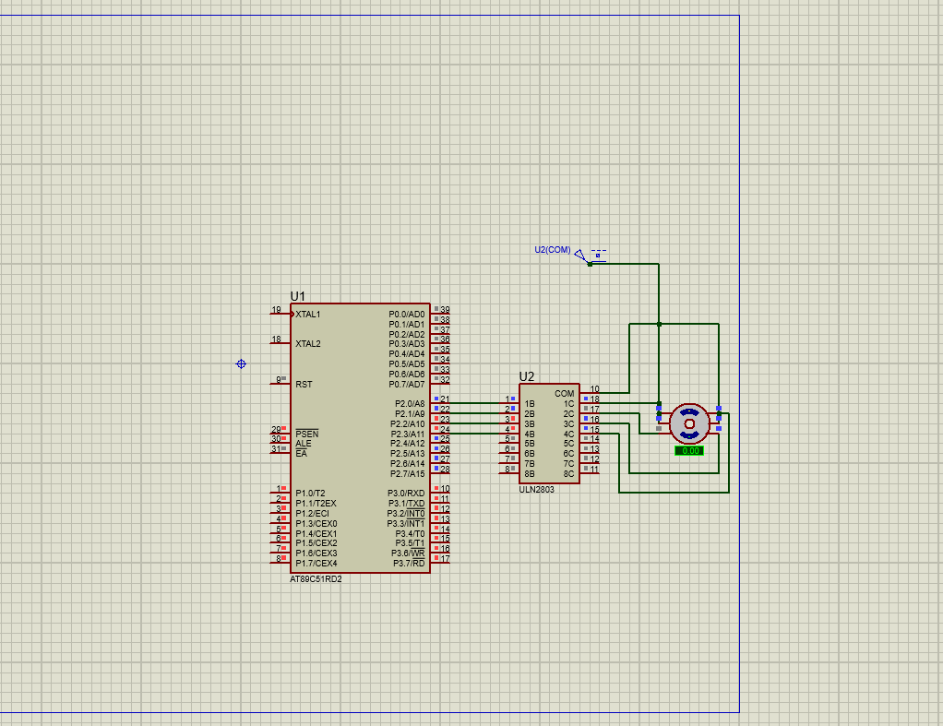

Exp No: 4 7 SEGMENT DISPLAY USING AT89C51 USING PROTEUS

