EXP5 MATLAB – Simulation and Throughput Analysis of LTE-Advanced Carrier Aggregation
Name:U.saambavi Reg.no: 192512099
Aim
To simulate an LTE-Advanced wireless link using carrier aggregation and analyze the effect of aggregating multiple component carriers on available transmission bandwidth and estimated throughput using MATLAB.

Objective – 1: Model One Component Carrier
Define a single LTE-Advanced component carrier and estimate its throughput for a selected bandwidth and spectral efficiency.

MATLAB Program
clc; clear; close all;
BW1 = 20; % Component carrier bandwidth (MHz)
SE = 4; % Spectral efficiency (bits/s/Hz)
Ncc = 1; % Number of component carriers
BWagg = BW1*Ncc;
Throughput = BWagg*SE; % Mbps for MHz × bits/s/Hz
disp('Single Component Carrier')
disp(['Bandwidth = ',num2str(BWagg),' MHz'])
disp(['Estimated Throughput = ',num2str(Throughput),' Mbps'])
figure
bar(Ncc,Throughput)
grid on
xlabel('Number of Component Carriers')
ylabel('Estimated Throughput (Mbps)')
title('LTE-Advanced Single Carrier Throughput')
Result:
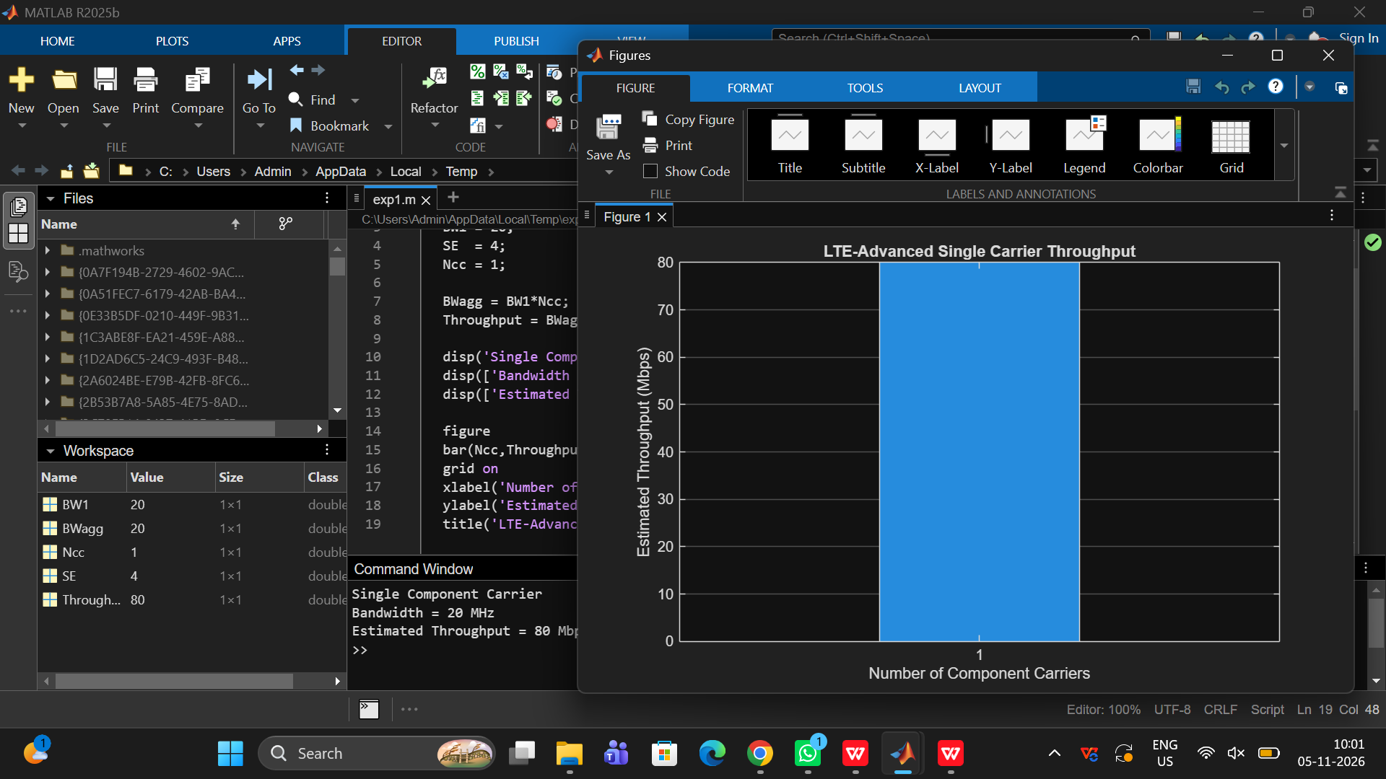

Objective – 2: Extend to Multiple Aggregated Component Carriers
Aggregate multiple component carriers and determine the resulting total bandwidth and estimated throughput.

MATLAB Program
clc; clear; close all;
BWcc = 20; % MHz per component carrier
SE = 4; % bits/s/Hz
CC = [1 2 3]; % Number of component carriers
AggBW = BWcc .* CC; % MHz
Throughput = AggBW .* SE; % Mbps
disp('CC Aggregated BW (MHz) Estimated Throughput (Mbps)')
disp([CC' AggBW' Throughput'])
figure
bar(CC,Throughput)
grid on
xlabel('Number of Aggregated Component Carriers')
ylabel('Estimated Throughput (Mbps)')
title('LTE-Advanced Carrier Aggregation Throughput')

Result:
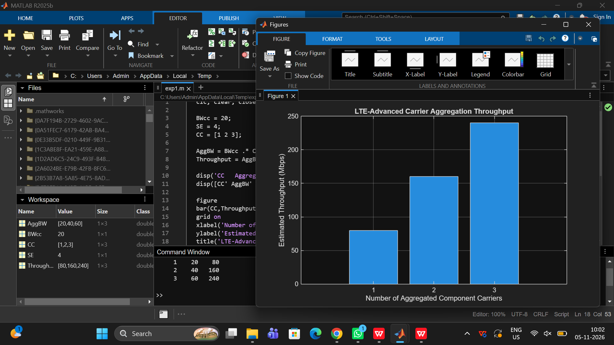

Objective – 3: Compare Estimated Throughput for Different Carrier Bandwidths
Procedure

MATLAB Program
clc; clear; close all;
BW = [5 10 15 20]; % Carrier bandwidths (MHz)
SE = 4; % bits/s/Hz
TP = BW .* SE; % Estimated throughput (Mbps)
disp('Bandwidth (MHz) Throughput (Mbps)')
disp([BW' TP'])
figure
plot(BW,TP,'o-','LineWidth',2)
grid on
xlabel('Carrier Bandwidth (MHz)')
ylabel('Estimated Throughput (Mbps)')
title('Throughput vs Component Carrier Bandwidth')

Result:



