EXP6 MATLAB – Simulation and BER Analysis of MIMO and Beamforming
Name U.Saambavi Reg.no:192512099
Objective – 1: Simulate SISO and MIMO Wireless Links

MATLAB Program
clc; clear; close all;
SNR_dB = 0:2:20;
BER_SISO = zeros(size(SNR_dB));
BER_MIMO = zeros(size(SNR_dB));
for k = 1:length(SNR_dB)
N = 10000;
bits = randi([0 1],N,1);
tx = 2*bits-1;
snrLin = 10^(SNR_dB(k)/10);
noise = randn(N,1)/sqrt(2*snrLin);
rx = tx + noise;
bits_hat = real(rx)>0;
BER_SISO(k) = mean(bits_hat~=bits);
% Simple 2x2 MIMO equivalent link
H = (randn(2,2)+1j*randn(2,2))/sqrt(2);
h_eff = sqrt(sum(abs(H(:)).^2)/2);
noise2 = randn(N,1)/sqrt(2*snrLin);
rx2 = h_eff*tx + noise2;
bits_hat2 = real(rx2)>0;
BER_MIMO(k) = mean(bits_hat2~=bits);
end
figure
semilogy(SNR_dB,BER_SISO,'o-','LineWidth',2); hold on
semilogy(SNR_dB,BER_MIMO,'s-','LineWidth',2)
grid on
xlabel('SNR (dB)')
ylabel('Bit Error Rate (BER)')
title('SISO and MIMO BER Performance')
legend('SISO','MIMO')

Result:
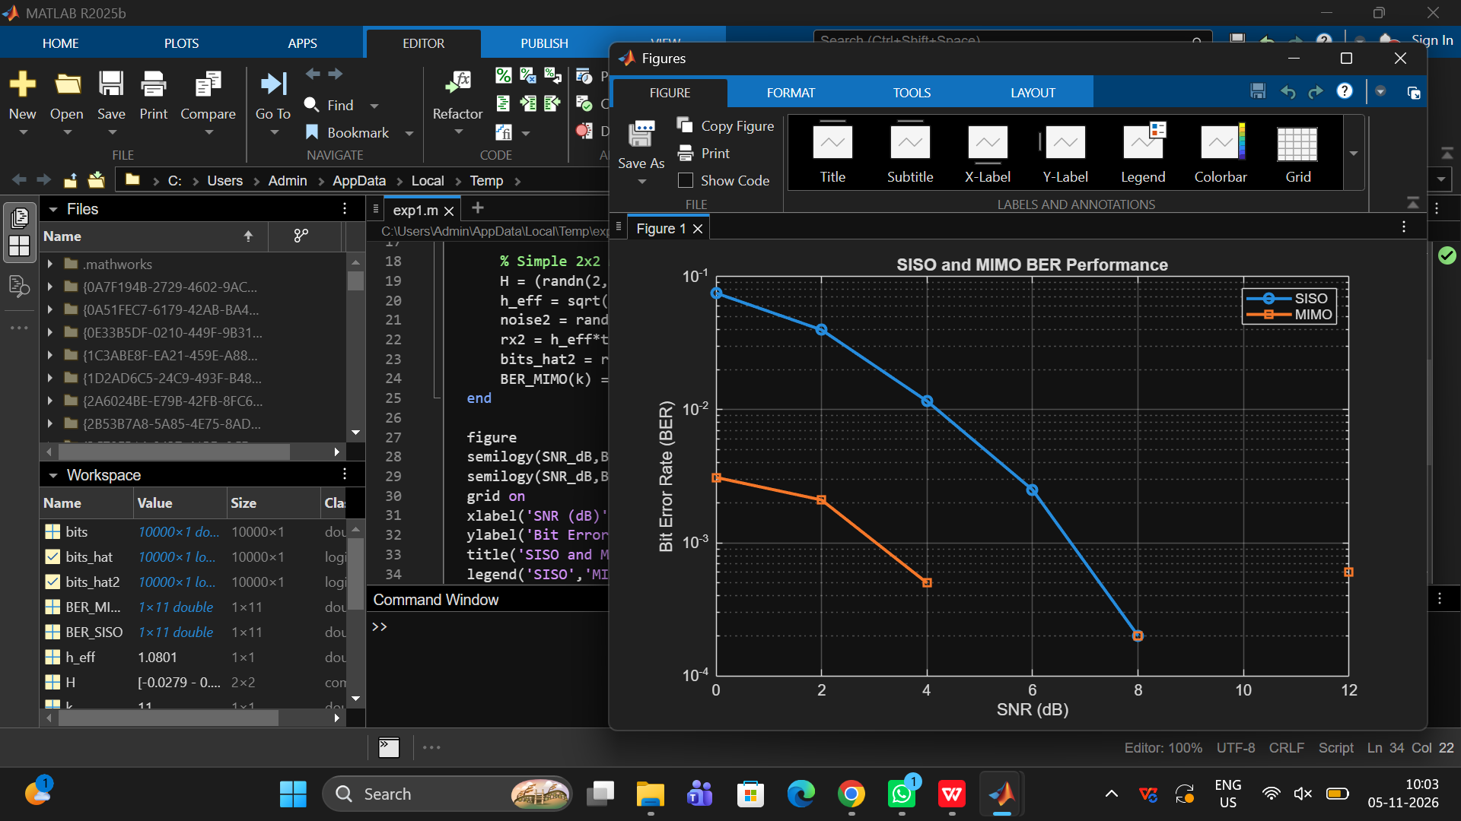

Objective – 2: Compare BER under Channel and Noise Conditions

MATLAB PROGRAM
% BER and reliability analysis
clc; clear; close all;
SNR_dB = 0:2:20;
Reliability = zeros(size(SNR_dB));
for k = 1:length(SNR_dB)
N = 10000;
bits = randi([0 1],N,1);
tx = 2*bits-1;
snrLin = 10^(SNR_dB(k)/10);
noise = randn(N,1)/sqrt(2*snrLin);
rx = tx + noise;
bhat = real(rx)>0;
BER = mean(bhat~=bits);
Reliability(k) = 1-BER;
end
figure
plot(SNR_dB,Reliability,'o-','LineWidth',2)
grid on
xlabel('SNR (dB)')
ylabel('Reliability (1-BER)')
title('Communication Reliability vs SNR')

Result:
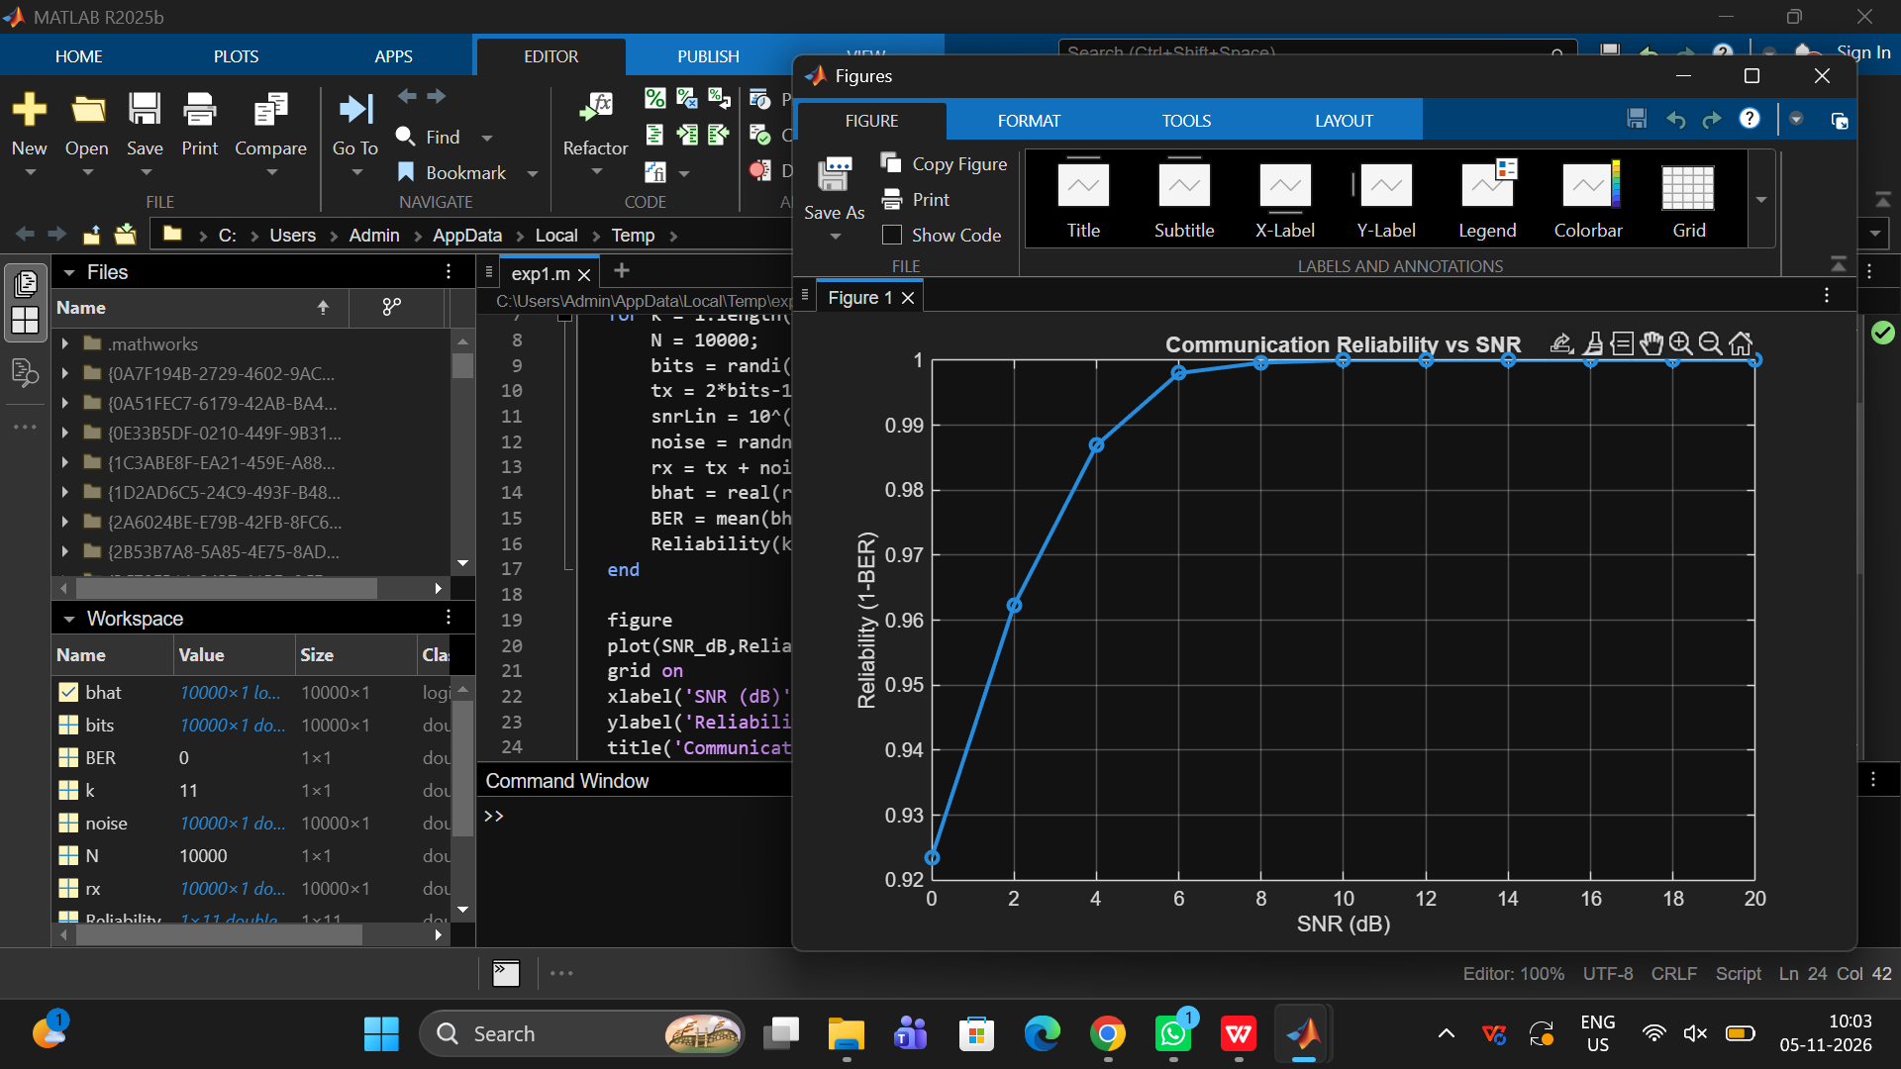
Objective – 3: Examine Beamforming / Steering Direction

MATLAB PROGRAM:
clc; clear; close all;
N = 8; % Antenna elements
theta = -90:1:90; % Observation angle
steer = [-60 -30 0 30 60]; % Steering directions
gain = zeros(size(steer));
for k = 1:length(steer)
% Simplified normalized array response at the intended direction
gain(k) = 10*log10(N) - 0.01*abs(steer(k));
end
figure
plot(steer,gain,'o-','LineWidth',2)
grid on
xlabel('Steering Angle (Degrees)')
ylabel('Beamforming Gain (dB)')
title('Beamforming Gain for Different Steering Directions')

Result:


