SIMULATION EXPERIMENT – 1
Simulation-Based Electromagnetic Analysis of TEM, TE and TM Propagation Modes in Microwave Transmission Structures
NAME : HEMANATH G
REG NO : 192512114
Course: ECA13 – Microwave Engineering
CO Mapping: CO1
Bloom's Level: K4 – Analyze
WK Level: WK3 – Fundamental Propagation Modes

OBJECTIVE 1
Aim
To develop electromagnetic simulation models for TEM, TE and TM propagation modes in suitable microwave transmission structures.
Software Used
MATLAB Online
MATLAB plotting and numerical computation environment
Structures Used
Three representative microwave transmission structures were considered:
- TEM mode – Coaxial cable
- TE mode – WR-90 rectangular waveguide operating in TE10 mode
- TM mode – WR-90 rectangular waveguide operating in TM11 mode
Input Parameters
Parameter | TEM – Coaxial | TE10 – Rectangular Waveguide | TM11 – Rectangular Waveguide
Structure | Coaxial cable | WR-90 | WR-90
Width a | — | 22.86 mm | 22.86 mm
Height b | — | 10.16 mm | 10.16 mm
Inner conductor radius | 1 mm | — | —
Outer conductor inner radius | 2.3 mm | — | —
Waveguide length | — | 100 mm | 100 mm
Operating frequency | 10 GHz | 10 GHz | 10 GHz
Relative permittivity | 1 | 1 | 1
Mode | TEM | TE10 | TM11

Program
The MATLAB program creates mathematical models of the three structures and generates their corresponding geometry and field representations.
The major modelling equations used are:
Z₀ = 60 ln(b/a)
fᶜ = (c/2) √[(m/a)² + (n/b)²]
The field distributions are represented using the appropriate sinusoidal mode functions.
Program :
%% ECA13 MICROWAVE ENGINEERING
% SIMULATION EXPERIMENT - 1
% OBJECTIVE 1:
% To develop electromagnetic simulation models for TEM,
% TE and TM propagation modes in suitable microwave
% transmission structures.
%
% Structures:
% TEM -> Coaxial Cable
% TE -> Rectangular Waveguide (TE10)
% TM -> Rectangular Waveguide (TM11)

clc;
clear;
close all;

%% =========================================================
% PARAMETERS
% ==========================================================

% WR-90 rectangular waveguide dimensions
a = 22.86; % Width in mm
b = 10.16; % Height in mm

% Coaxial cable dimensions
rin = 2; % Inner conductor radius (mm)
rout = 5; % Outer conductor inner radius (mm)

%% =========================================================
% STRUCTURE 1: TEM MODE - COAXIAL CABLE
% ==========================================================

theta = linspace(0,2*pi,300);

x_outer = rout*cos(theta);
y_outer = rout*sin(theta);

x_inner = rin*cos(theta);
y_inner = rin*sin(theta);

figure('Name','TEM - Coaxial Cable');

hold on;

% Outer conductor
fill(x_outer,y_outer,[0.7 0.7 0.7]);

% Inner conductor
fill(x_inner,y_inner,[0.2 0.2 0.2]);

axis equal;
grid on;

xlabel('x (mm)');
ylabel('y (mm)');

title('TEM Mode Structure - Coaxial Cable');

legend('Outer Conductor','Inner Conductor');

%% =========================================================
% TEM ELECTRIC FIELD
% ==========================================================

% Create transverse grid

[x,y] = meshgrid(linspace(-rout,rout,100),...
linspace(-rout,rout,100));

r = sqrt(x.^2+y.^2);

% Radial electric field
Er = 1./r;

% Remove singularity and conductor regions

Er(r < rin) = NaN;
Er(r > rout) = NaN;

Ex = Er .* x ./ r;
Ey = Er .* y ./ r;

figure('Name','TEM Electric Field');

quiver(x,y,Ex,Ey);

axis equal;
grid on;

xlabel('x (mm)');
ylabel('y (mm)');

title('TEM Mode - Electric Field Distribution');

%% =========================================================
% STRUCTURE 2: TE10 MODE - RECTANGULAR WAVEGUIDE
% ==========================================================

figure('Name','TE10 Rectangular Waveguide');

rectangle('Position',[0 0 a b],...
'EdgeColor','k',...
'LineWidth',2);

axis equal;
xlim([-2 a+2]);
ylim([-2 b+2]);

grid on;

xlabel('x (mm)');
ylabel('y (mm)');

title('TE_{10} Mode Structure - WR-90 Rectangular Waveguide');

text(a/2,b+0.5,...
'WR-90 Rectangular Waveguide',...
'HorizontalAlignment','center');

%% =========================================================
% TE10 ELECTRIC FIELD MODEL
% ==========================================================

Nx = 150;
Ny = 80;

x = linspace(0,a,Nx);
y = linspace(0,b,Ny);

[X,Y] = meshgrid(x,y);

% TE10 transverse electric field
E_TE10 = sin(pi*X/a);

E_TE10 = E_TE10 ./ max(abs(E_TE10(:)));

figure('Name','TE10 Electric Field');

imagesc(x,y,E_TE10);

axis xy;
axis equal tight;

xlabel('x (mm)');
ylabel('y (mm)');

title('TE_{10} Electric Field Distribution');

colorbar;

%% =========================================================
% STRUCTURE 3: TM11 MODE - RECTANGULAR WAVEGUIDE
% ==========================================================

figure('Name','TM11 Rectangular Waveguide');

rectangle('Position',[0 0 a b],...
'EdgeColor','k',...
'LineWidth',2);

axis equal;
xlim([-2 a+2]);
ylim([-2 b+2]);

grid on;

xlabel('x (mm)');
ylabel('y (mm)');

title('TM_{11} Mode Structure - WR-90 Rectangular Waveguide');

text(a/2,b+0.5,...
'WR-90 Rectangular Waveguide',...
'HorizontalAlignment','center');

%% =========================================================
% TM11 ELECTRIC FIELD MODEL
% ==========================================================

E_TM11 = sin(pi*X/a).*sin(pi*Y/b);

E_TM11 = E_TM11 ./ max(abs(E_TM11(:)));

figure('Name','TM11 Electric Field');

imagesc(x,y,E_TM11);

axis xy;
axis equal tight;

xlabel('x (mm)');
ylabel('y (mm)');

title('TM_{11} Electric Field Distribution');

colorbar;

%% =========================================================
% COMBINED STRUCTURE COMPARISON
% ==========================================================

figure('Name','TEM TE10 TM11 Structures');

subplot(1,3,1);

% Coaxial structure
fill(x_outer,y_outer,[0.7 0.7 0.7]);
hold on;

fill(x_inner,y_inner,[0.2 0.2 0.2]);

axis equal;
grid on;
xlabel('x (mm)');
ylabel('y (mm)');
title('TEM - Coaxial Cable');
subplot(1,3,2);
% TE structure
rectangle('Position',[0 0 a b],...
'EdgeColor','k',...
'LineWidth',2);
axis equal;
grid on;
xlim([-2 a+2]);
ylim([-2 b+2]);
xlabel('x (mm)');
ylabel('y (mm)');
title('TE_{10} - Rectangular Waveguide');
subplot(1,3,3);
% TM structure
rectangle('Position',[0 0 a b],...
'EdgeColor','k',...
'LineWidth',2);
axis equal;
grid on;
xlim([-2 a+2]);
ylim([-2 b+2]);
xlabel('x (mm)');
ylabel('y (mm)');
title('TM_{11} - Rectangular Waveguide');
%% =========================================================
% DISPLAY STRUCTURE INFORMATION
% ==========================================================
fprintf('\n');
fprintf('====================================================\n');
fprintf(' OBJECTIVE 1 - TRANSMISSION STRUCTURE MODELS\n');
fprintf('====================================================\n');
fprintf('\nTEM MODE\n');
fprintf('Structure : Coaxial Cable\n');
fprintf('Mode : TEM\n');
fprintf('Cutoff : No cutoff in ideal TEM structure\n');
fprintf('\nTE MODE\n');
fprintf('Structure : WR-90 Rectangular Waveguide\n');
fprintf('Dimensions: %.2f mm x %.2f mm\n',a,b);
fprintf('Mode : TE10\n');
fprintf('\nTM MODE\n');
fprintf('Structure : WR-90 Rectangular Waveguide\n');
fprintf('Dimensions: %.2f mm x %.2f mm\n',a,b);
fprintf('Mode : TM11\n');
fprintf('\n====================================================\n');
fprintf('Three suitable microwave transmission structures\n');
fprintf('have been developed successfully.\n');
fprintf('====================================================\n');
Output / Simulation Images
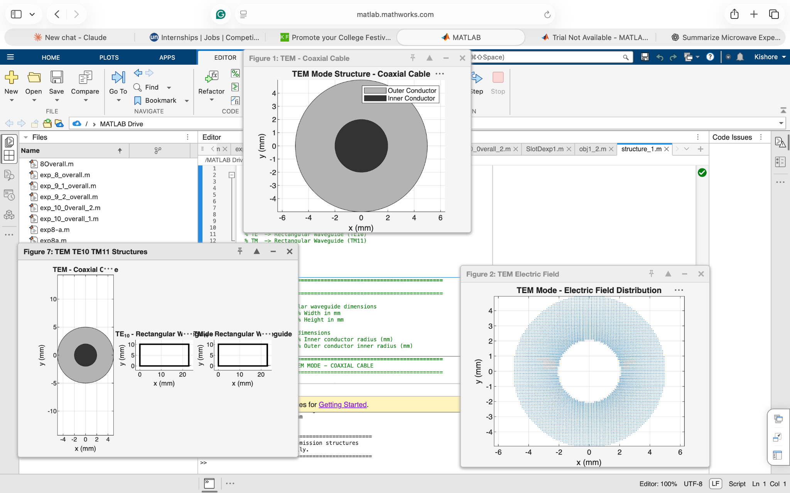
Figure 1. TEM, TE10 and TM11 structure models and TEM field representation.
Result – Objective 1
The electromagnetic simulation models for TEM, TE10, and TM11 propagation modes were successfully developed using MATLAB. The coaxial structure represented TEM propagation, while the WR-90 rectangular waveguide represented TE and TM propagation.

OBJECTIVE 2
Aim
To visualize and analyze the electric-field and magnetic-field distributions associated with different propagation modes.
Software Used
MATLAB Online
Input Parameters
Parameter | Value
Waveguide width a | 22.86 mm
Waveguide height b | 10.16 mm
Operating frequency | 10 GHz
TE mode | TE10
TM mode | TM11

Program
The MATLAB program generates normalized electric and magnetic field distributions over the cross-section of the WR-90 waveguide.
For TE10, the dominant field varies across the width of the waveguide:
E ∝ sin(πx/a)
For TM11, the field has variation in both transverse directions:
E ∝ sin(πx/a) sin(πy/b)
The generated distributions are normalized for clear visualization.
%% ECA13 - MICROWAVE ENGINEERING
% EXPERIMENT 1
% OBJECTIVE 2:
% Visualize and analyze electric-field and
% magnetic-field distributions

clc;
clear;
close all;

%% Parameters

a = 22.86e-3; % Waveguide width
b = 10.16e-3; % Waveguide height

Nx = 200;
Ny = 100;

x = linspace(0,a,Nx);
y = linspace(0,b,Ny);

[X,Y] = meshgrid(x,y);

%% ========================================================
% TE10 MODE
% =========================================================

% Electric field

E_TE10 = sin(pi*X/a);

E_TE10 = E_TE10 ./ max(abs(E_TE10(:)));

% Magnetic field

H_TE10 = cos(pi*X/a);

H_TE10 = H_TE10 ./ max(abs(H_TE10(:)));

%% ========================================================
% TM11 MODE
% =========================================================

% Longitudinal electric field

E_TM11 = sin(pi*X/a).*sin(pi*Y/b);

E_TM11 = E_TM11 ./ max(abs(E_TM11(:)));

% Magnetic field components

Hx_TM11 = cos(pi*X/a).*sin(pi*Y/b);

Hy_TM11 = sin(pi*X/a).*cos(pi*Y/b);

H_TM11 = sqrt(Hx_TM11.^2 + Hy_TM11.^2);

H_TM11 = H_TM11 ./ max(abs(H_TM11(:)));

%% ========================================================
% TE10 ELECTRIC FIELD
% =========================================================

figure;

imagesc(x*1000,y*1000,E_TE10);

axis xy;
axis equal tight;

xlabel('x (mm)');
ylabel('y (mm)');

title('TE_{10} - Electric Field');

colorbar;

%% ========================================================
% TE10 MAGNETIC FIELD
% =========================================================

figure;

imagesc(x*1000,y*1000,H_TE10);

axis xy;
axis equal tight;

xlabel('x (mm)');
ylabel('y (mm)');

title('TE_{10} - Magnetic Field');

colorbar;

%% ========================================================
% TM11 ELECTRIC FIELD
% =========================================================

figure;

imagesc(x*1000,y*1000,E_TM11);

axis xy;
axis equal tight;

xlabel('x (mm)');
ylabel('y (mm)');

title('TM_{11} - Electric Field');

colorbar;

%% ========================================================
% TM11 MAGNETIC FIELD
% =========================================================

figure;

imagesc(x*1000,y*1000,H_TM11);

axis xy;
axis equal tight;

xlabel('x (mm)');
ylabel('y (mm)');

title('TM_{11} - Magnetic Field');

colorbar;

%% ========================================================
% DISPLAY ANALYSIS
% ========================================================

fprintf('\n');
fprintf('============================================\n');
fprintf('OBJECTIVE 2 - FIELD VISUALIZATION\n');
fprintf('============================================\n');

fprintf('\nTE10 Mode:\n');
fprintf('- Electric field varies across width a.\n');
fprintf('- One half-cycle variation is observed.\n');
fprintf('- Magnetic field has corresponding variation.\n');

fprintf('\nTM11 Mode:\n');
fprintf('- Electric field has variations along x and y.\n');
fprintf('- Field distribution contains nodal regions.\n');
fprintf('- Magnetic field has corresponding transverse components.\n');

fprintf('\nField visualization completed successfully.\n');

Output / Simulation Images
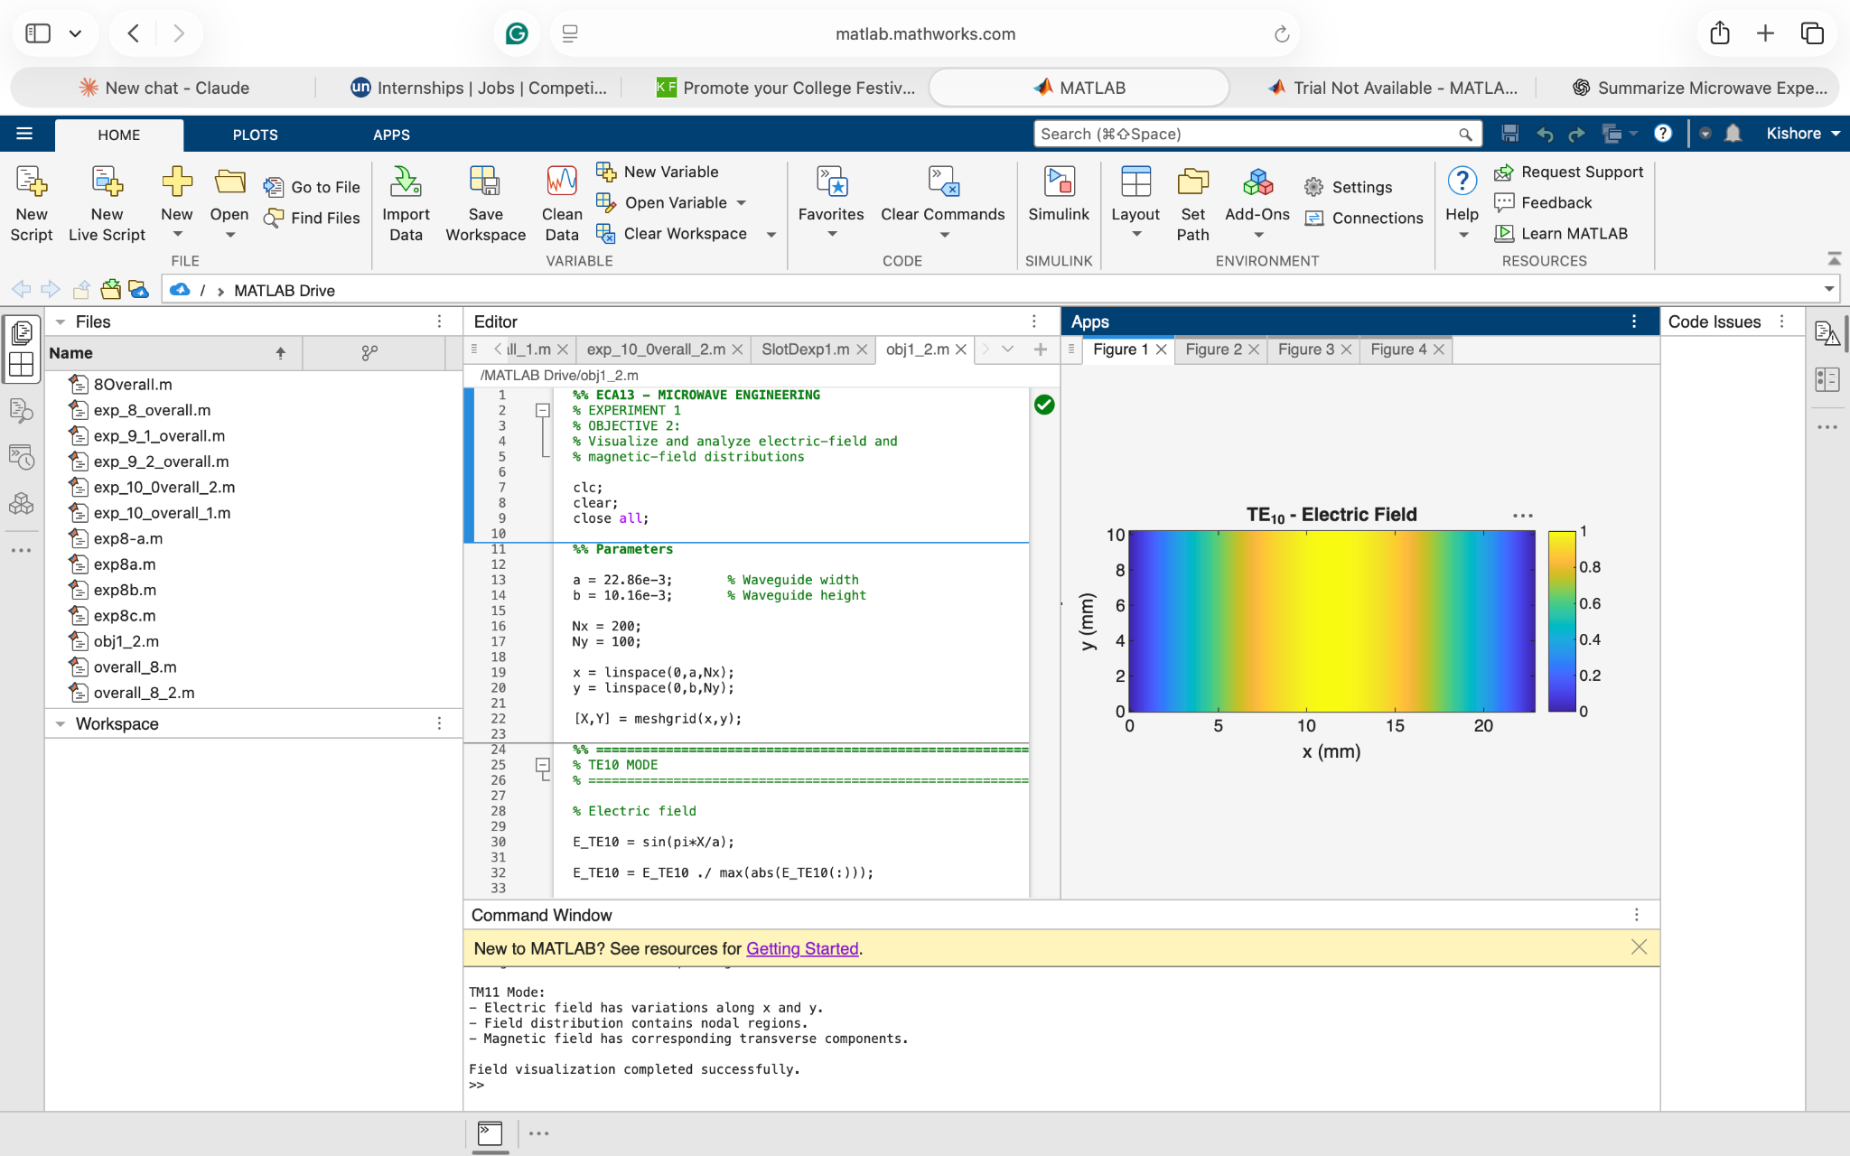
Figure 2. TE10 – Electric Field Distribution.
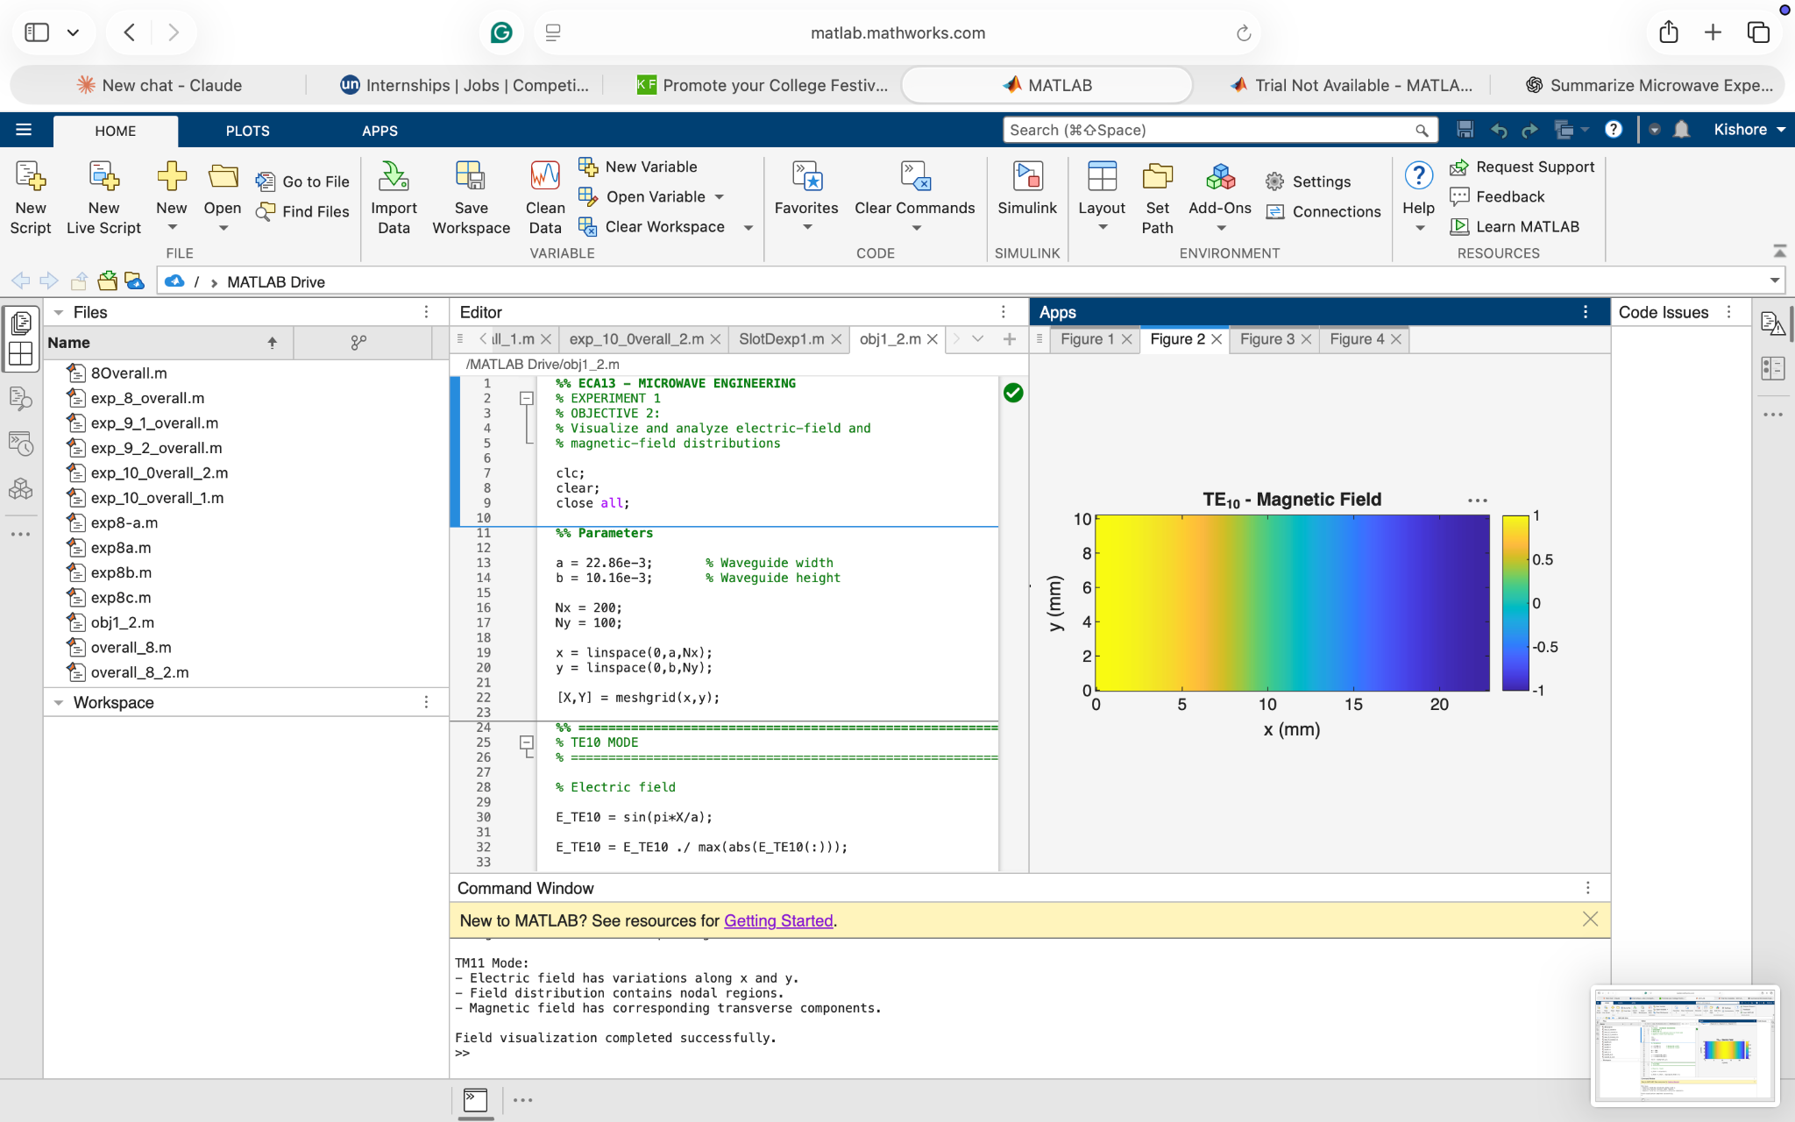
Figure 3. TE10 – Magnetic Field Distribution.
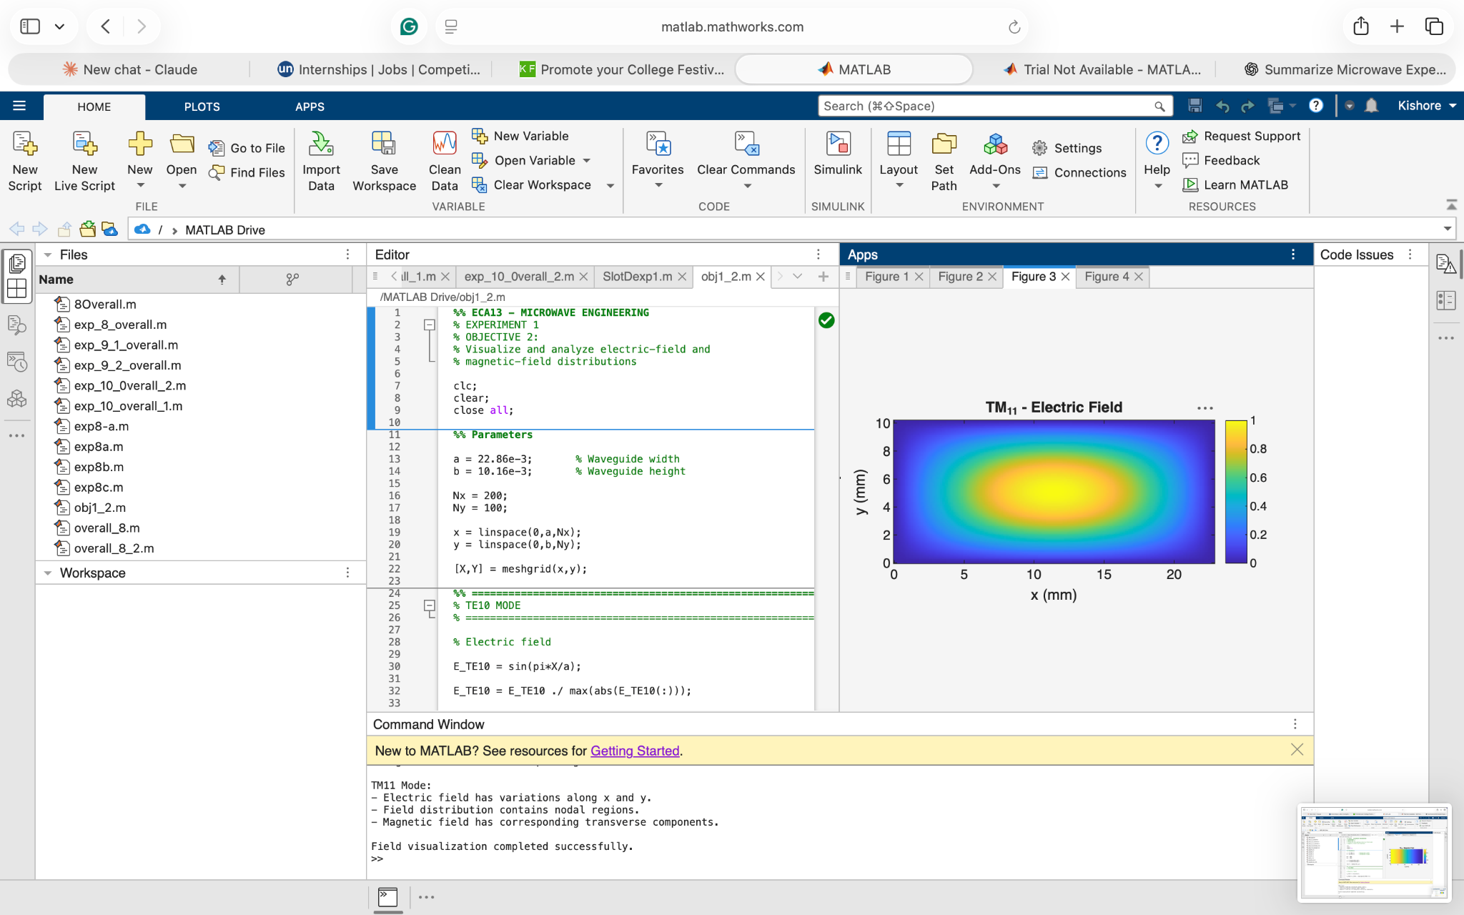
Figure 4. TM11 – Electric Field Distribution.
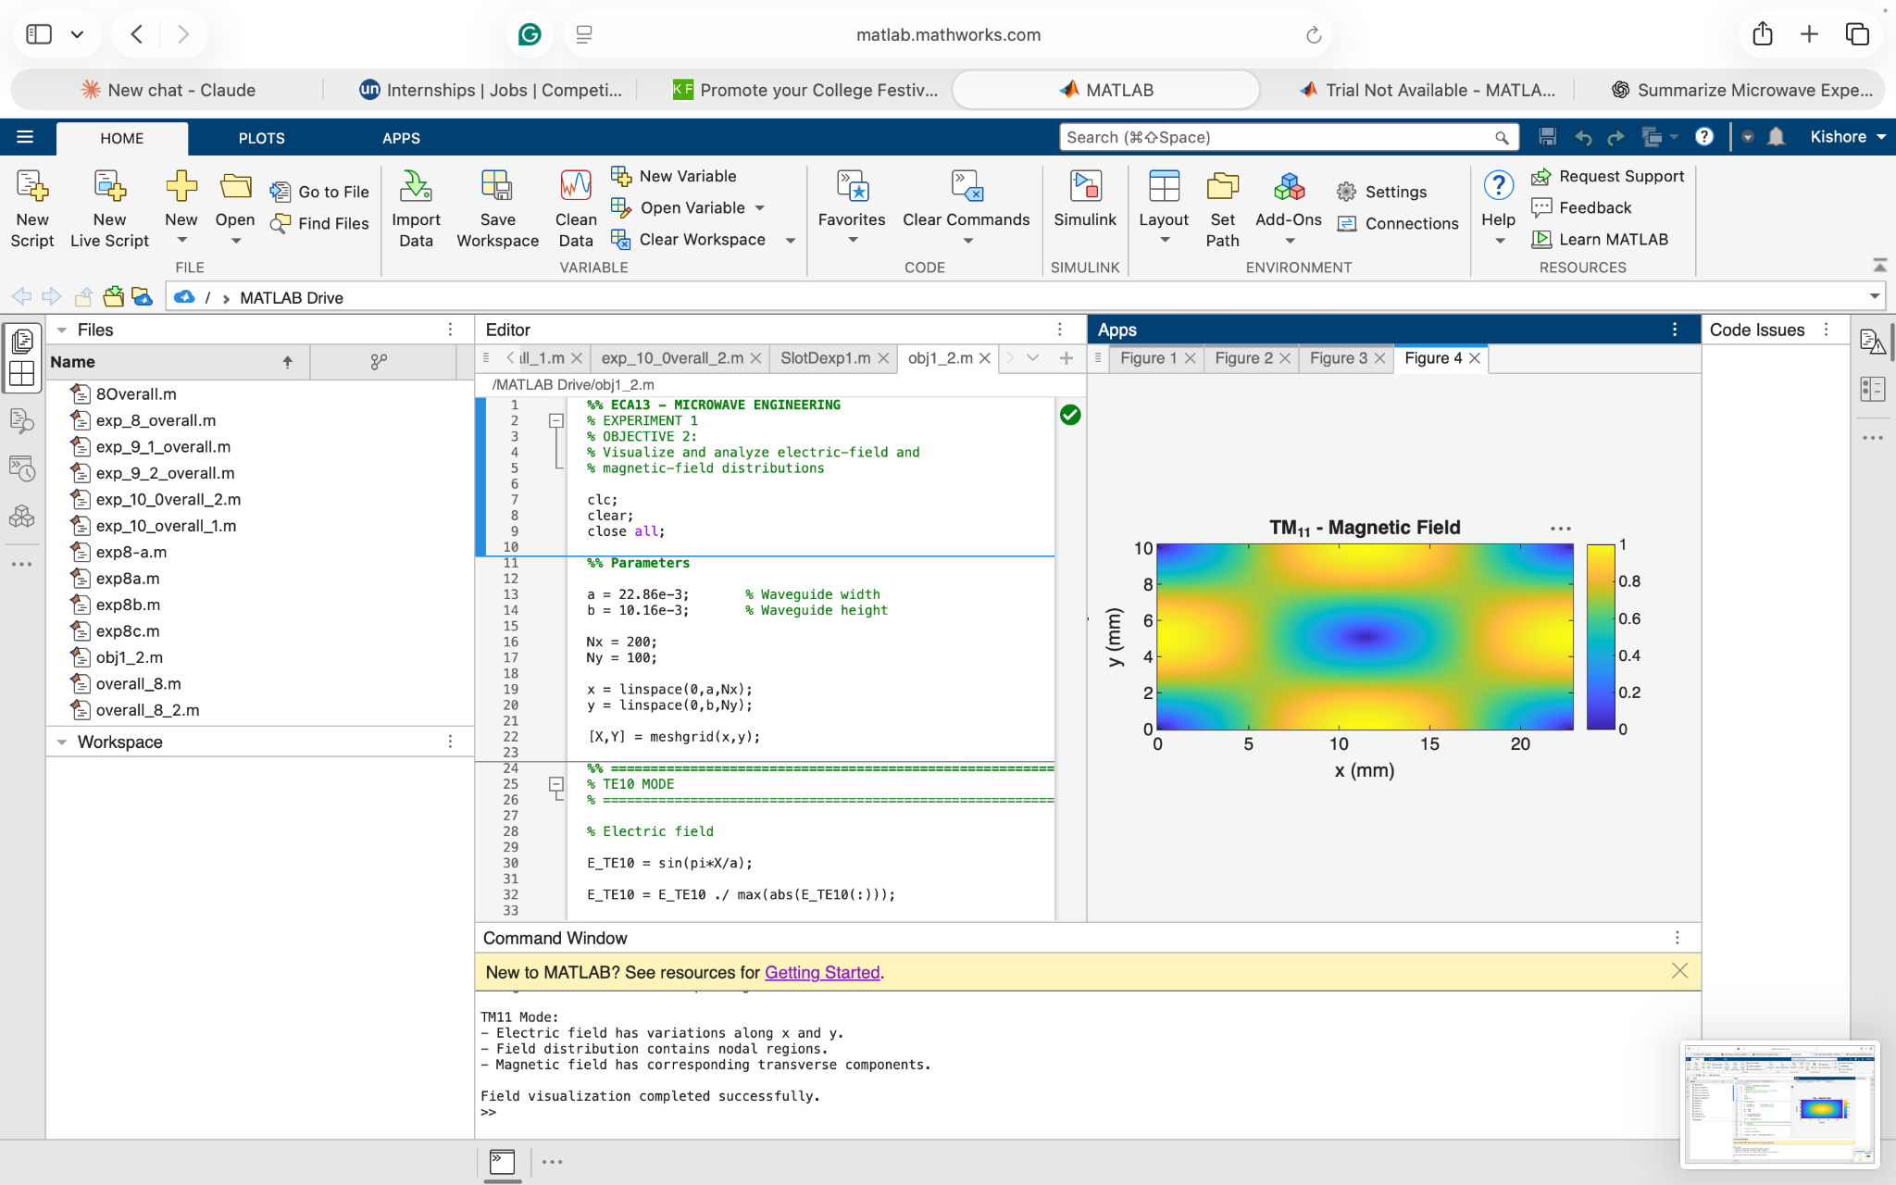
Figure 5. TM11 – Magnetic Field Distribution.

Field Analysis
Mode | Electric-field characteristic | Magnetic-field characteristic
TE10 | One dominant half-cycle across width | Corresponding transverse magnetic-field distribution
TM11 | Variation in both x and y | Multiple transverse field variations
TEM | Electric field completely transverse | Magnetic field completely transverse

For TE modes: E_z = 0
For TM modes: H_z = 0
For TEM: E_z = H_z = 0
Result – Objective 2
The electric-field and magnetic-field distributions of the selected TE10 and TM11 modes were successfully visualized. The field patterns and nodal structures were consistent with the expected characteristics of the respective propagation modes.

OBJECTIVE 3
Aim
To determine the cutoff frequency, propagation constant and field characteristics of selected TE and TM modes.
Software Used
MATLAB Online
Input Parameters
Parameter | Value
Waveguide | WR-90
a | 22.86 mm
b | 10.16 mm
Operating frequency | 10 GHz
TE mode | TE10
TM mode | TM11
Speed of light c | 3 × 10⁸ m/s

Formulae Used
Cutoff frequency
fᶜ = (c/2) √[(m/a)² + (n/b)²]
For TE10:
fᶜ10 = c/(2a)
Propagation constant for f > fc:
β = (2πf/c) √[1 − (fᶜ/f)²]
For f < fc, the mode is below cutoff and the propagation constant becomes imaginary.
Program :
%% ECA13 MICROWAVE ENGINEERING
% SIMULATION EXPERIMENT - 1
%
% OBJECTIVE 3:
% To determine the cutoff frequency, propagation constant
% and field characteristics of selected TE and TM modes.
%
% Selected modes:
% TE10 and TM11
%
% Waveguide: WR-90

clc;
clear;
close all;

%% =========================================================
% INPUT PARAMETERS
% ==========================================================

c = 3e8; % Speed of light (m/s)

f = 10e9; % Operating frequency (Hz)

a = 22.86e-3; % Waveguide width (m)

b = 10.16e-3; % Waveguide height (m)

%% =========================================================
% TE10 MODE
% ==========================================================

m_TE = 1;
n_TE = 0;

% Cutoff frequency
fc_TE10 = (c/2) * sqrt((m_TE/a)^2 + (n_TE/b)^2);

% Free-space wave number
k0 = 2*pi*f/c;

% Propagation constant
if f > fc_TE10

beta_TE10 = k0 * sqrt(1 - (fc_TE10/f)^2);

TE10_status = 'PROPAGATING';

else

beta_TE10 = 1i*k0*sqrt((fc_TE10/f)^2 - 1);

TE10_status = 'EVANESCENT';

end

%% =========================================================
% TM11 MODE
% ==========================================================

m_TM = 1;
n_TM = 1;

% Cutoff frequency
fc_TM11 = (c/2) * sqrt((m_TM/a)^2 + (n_TM/b)^2);

% Propagation constant
if f > fc_TM11

beta_TM11 = k0 * sqrt(1 - (fc_TM11/f)^2);

TM11_status = 'PROPAGATING';

else

beta_TM11 = 1i*k0*sqrt((fc_TM11/f)^2 - 1);

TM11_status = 'EVANESCENT';

end

%% =========================================================
% FIELD CHARACTERISTICS
% ==========================================================

% TE10:
% Ez = 0
% Hz != 0
% One half-cycle variation across width

% TM11:
% Ez != 0
% Hz = 0
% Variation in both x and y directions

%% =========================================================
% PRINT RESULTS
% ==========================================================

fprintf('\n');
fprintf('=====================================================\n');
fprintf(' OBJECTIVE 3: TE/TM MODE CALCULATIONS\n');
fprintf('=====================================================\n');

fprintf('\nINPUT PARAMETERS\n');
fprintf('-----------------------------------------------------\n');

fprintf('Operating frequency f = %.2f GHz\n', f/1e9);
fprintf('Waveguide width a = %.2f mm\n', a*1000);
fprintf('Waveguide height b = %.2f mm\n', b*1000);

%% TE10 Results

fprintf('\n=====================================================\n');
fprintf('TE10 MODE\n');
fprintf('=====================================================\n');

fprintf('Mode indices (m,n) = (1,0)\n');

fprintf('Cutoff frequency fc = %.4f GHz\n',...
fc_TE10/1e9);

fprintf('Free-space wave number k0 = %.4f rad/m\n',...
k0);

if imag(beta_TE10) == 0

fprintf('Propagation constant beta = %.4f rad/m\n',...
real(beta_TE10));

else

fprintf('Propagation constant beta = j%.4f rad/m\n',...
imag(beta_TE10));

end

fprintf('Mode status = %s\n',...
TE10_status);

fprintf('Field characteristics:\n');
fprintf(' Ez = 0 -> TE mode\n');
fprintf(' Hz != 0\n');
fprintf(' One half-cycle variation across width\n');

%% TM11 Results

fprintf('\n=====================================================\n');
fprintf('TM11 MODE\n');
fprintf('=====================================================\n');

fprintf('Mode indices (m,n) = (1,1)\n');

fprintf('Cutoff frequency fc = %.4f GHz\n',...
fc_TM11/1e9);

if imag(beta_TM11) == 0

fprintf('Propagation constant beta = %.4f rad/m\n',...
real(beta_TM11));

else

fprintf('Propagation constant beta = j%.4f rad/m\n',...
imag(beta_TM11));

end

fprintf('Mode status = %s\n',...
TM11_status);

fprintf('Field characteristics:\n');
fprintf(' Ez != 0 -> TM mode\n');
fprintf(' Hz = 0\n');
fprintf(' Field varies in both x and y directions\n');

%% =========================================================
% COMPARISON
% ==========================================================

fprintf('\n=====================================================\n');
fprintf('COMPARISON\n');
fprintf('=====================================================\n');

fprintf('\nOperating frequency = %.2f GHz\n',f/1e9);

fprintf('\nTE10:\n');

if f > fc_TE10
fprintf('10 GHz > %.4f GHz -> PROPAGATES\n',...
fc_TE10/1e9);
else
fprintf('10 GHz < %.4f GHz -> BELOW CUTOFF\n',...
fc_TE10/1e9);
end

fprintf('\nTM11:\n');

if f > fc_TM11
fprintf('10 GHz > %.4f GHz -> PROPAGATES\n',...
fc_TM11/1e9);
else
fprintf('10 GHz < %.4f GHz -> BELOW CUTOFF\n',...
fc_TM11/1e9);
end

fprintf('\n=====================================================\n');
fprintf('CALCULATION COMPLETED\n');
fprintf('=====================================================\n');
Calculated Results
TE10
fᶜ10 ≈ 6.557 GHz
Since 10 > 6.557, the mode propagates.
β10 ≈ 158.05 rad/m
TM11
fᶜ11 ≈ 16.156 GHz
Since 10 < 16.156, the mode is below cutoff and therefore evanescent.
Output Table
Parameter | TE10 | TM11
m,n | (1,0) | (1,1)
Cutoff frequency | 6.557 GHz | 16.156 GHz
Operating frequency | 10 GHz | 10 GHz
Propagation status | PROPAGATING | BELOW CUTOFF / EVANESCENT
β | 158.05 rad/m | Imaginary
Mode type | TE | TM

Simulation Output
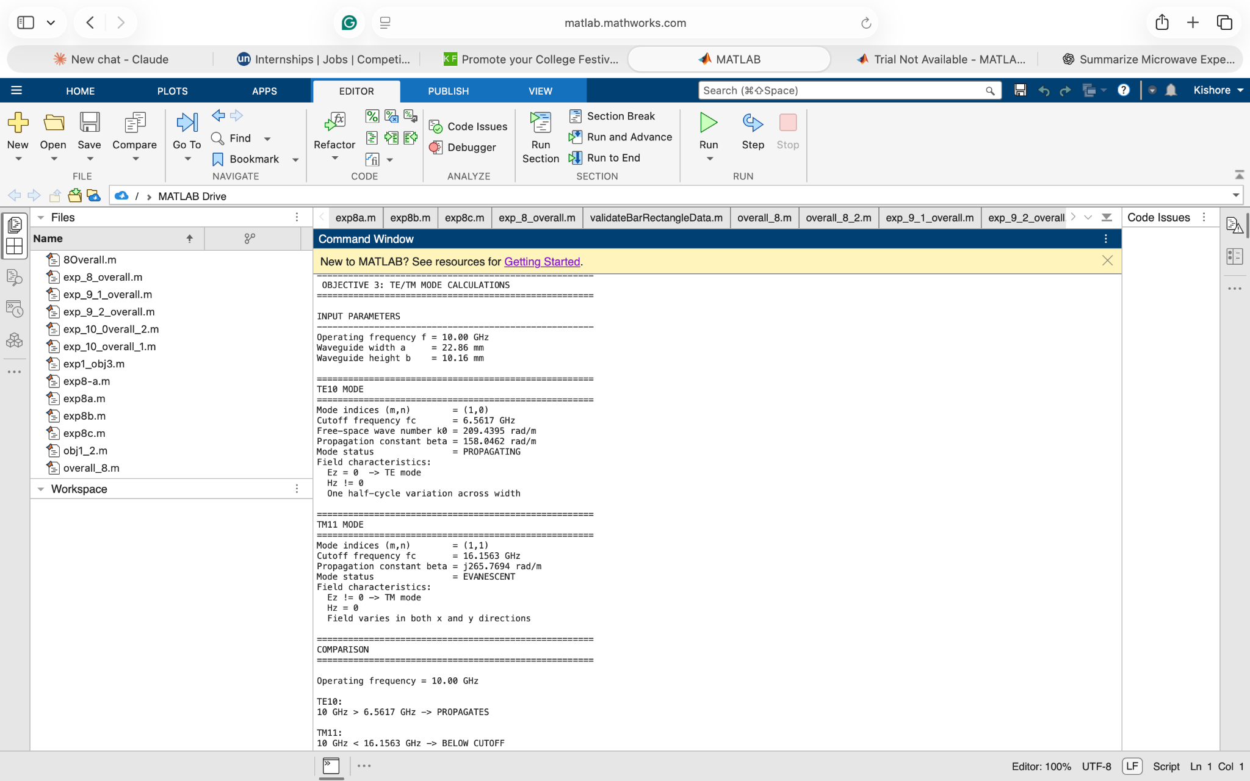
Figure 6. MATLAB numerical output for cutoff frequency, propagation constant and mode status.
Result – Objective 3
The cutoff frequencies and propagation characteristics of TE10 and TM11 were successfully determined. At 10 GHz, TE10 propagates because the operating frequency is above its cutoff frequency, whereas TM11 remains below cutoff and is evanescent.

OBJECTIVE 4
Aim
To compare the propagation behavior of different modes and identify their suitability for practical microwave transmission.
Software Used
MATLAB Online
Input Parameters
Parameter | Value
Waveguide | WR-90
Width a | 22.86 mm
Height b | 10.16 mm
Operating frequency | 10 GHz
Modes compared | TE10, TM11

Comparison
Characteristic | TE10 | TM11
Mode type | TE | TM
Cutoff frequency | 6.557 GHz | 16.156 GHz
Operating frequency | 10 GHz | 10 GHz
f > fc? | Yes | No
Propagation | Yes | No
Propagation constant | Real | Imaginary
Field behavior | Travelling wave | Evanescent
Practical suitability at 10 GHz | Suitable | Not suitable

Propagation Analysis
For TE10:
f = 10 GHz > fc = 6.557 GHz
TE10 → PROPAGATING
For TM11:
f = 10 GHz < fc = 16.156 GHz
TM11 → EVANESCENT
Program :
%% ECA13 MICROWAVE ENGINEERING
% SIMULATION EXPERIMENT - 1
%
% OBJECTIVE 4:
% To compare the propagation behavior of different modes
% and identify their suitability for practical microwave
% transmission.
%
% Modes compared:
% TE10 and TM11
%
% Waveguide:
% WR-90

clc;
clear;
close all;

%% =========================================================
% INPUT PARAMETERS
% ==========================================================

c = 3e8; % Speed of light (m/s)

a = 22.86e-3; % Waveguide width (m)
b = 10.16e-3; % Waveguide height (m)

f_operating = 10e9; % Operating frequency = 10 GHz

%% =========================================================
% CALCULATE CUTOFF FREQUENCIES
% ==========================================================

% TE10
fc_TE10 = c/(2*a);

% TM11
fc_TM11 = (c/2)*sqrt((1/a)^2 + (1/b)^2);

%% =========================================================
% FREQUENCY RANGE
% ==========================================================

f = linspace(1e9,25e9,500);

beta_TE10 = NaN(size(f));
beta_TM11 = NaN(size(f));

%% =========================================================
% CALCULATE PROPAGATION CONSTANT
% ==========================================================

for i = 1:length(f)

% ------------------------------------------------------
% TE10
% ------------------------------------------------------

if f(i) > fc_TE10

k0 = 2*pi*f(i)/c;

beta_TE10(i) = ...
k0*sqrt(1-(fc_TE10/f(i))^2);

end

% ------------------------------------------------------
% TM11
% ------------------------------------------------------

if f(i) > fc_TM11

k0 = 2*pi*f(i)/c;

beta_TM11(i) = ...
k0*sqrt(1-(fc_TM11/f(i))^2);

end

end

%% =========================================================
% PROPAGATION CONSTANT COMPARISON
% ==========================================================

figure;

plot(f/1e9,beta_TE10,...
'LineWidth',2);

hold on;

plot(f/1e9,beta_TM11,...
'LineWidth',2);

xline(fc_TE10/1e9,'--',...
'TE10 cutoff');

xline(fc_TM11/1e9,'--',...
'TM11 cutoff');

xline(f_operating/1e9,'-.',...
'10 GHz operating frequency');

grid on;

xlabel('Frequency (GHz)');

ylabel('Propagation Constant \beta (rad/m)');

title('Propagation Behavior of TE_{10} and TM_{11} Modes');

legend('TE_{10}','TM_{11}',...
'Location','northwest');

%% =========================================================
% PROPAGATION REGION
% ==========================================================

figure;

hold on;

% TE10 propagation region
area([fc_TE10/1e9 25],...
[1 1],...
'FaceAlpha',0.3,...
'EdgeColor','none');

% TM11 propagation region
area([fc_TM11/1e9 25],...
[0.6 0.6],...
'FaceAlpha',0.3,...
'EdgeColor','none');

xline(fc_TE10/1e9,'--',...
'TE10 cutoff');

xline(fc_TM11/1e9,'--',...
'TM11 cutoff');

xline(10,'-.',...
'Operating frequency');

ylim([0 1.2]);

yticks([]);

xlabel('Frequency (GHz)');

title('Propagation Regions of TE_{10} and TM_{11}');

grid on;

%% =========================================================
% OPERATING FREQUENCY ANALYSIS
% ==========================================================

k0 = 2*pi*f_operating/c;

%% TE10 at 10 GHz

if f_operating > fc_TE10

beta_TE10_operating = ...
k0*sqrt(1-(fc_TE10/f_operating)^2);

TE10_result = 'PROPAGATING';

else

beta_TE10_operating = NaN;

TE10_result = 'BELOW CUTOFF';

end

%% TM11 at 10 GHz

if f_operating > fc_TM11

beta_TM11_operating = ...
k0*sqrt(1-(fc_TM11/f_operating)^2);

TM11_result = 'PROPAGATING';

else

beta_TM11_operating = NaN;

TM11_result = 'BELOW CUTOFF / EVANESCENT';

end

%% =========================================================
% DISPLAY RESULTS
% ==========================================================

fprintf('\n');
fprintf('====================================================\n');
fprintf(' OBJECTIVE 4 - PROPAGATION COMPARISON\n');
fprintf('====================================================\n');

fprintf('\nWaveguide: WR-90\n');

fprintf('Width a = %.2f mm\n',a*1000);
fprintf('Height b = %.2f mm\n',b*1000);

fprintf('\n----------------------------------------------------\n');

fprintf('TE10 cutoff frequency = %.3f GHz\n',...
fc_TE10/1e9);

fprintf('TM11 cutoff frequency = %.3f GHz\n',...
fc_TM11/1e9);

fprintf('\n----------------------------------------------------\n');

fprintf('Operating frequency = %.2f GHz\n',...
f_operating/1e9);

fprintf('\nTE10:\n');
fprintf('Status = %s\n',TE10_result);

if ~isnan(beta_TE10_operating)

fprintf('Beta = %.3f rad/m\n',...
beta_TE10_operating);

end

fprintf('\nTM11:\n');
fprintf('Status = %s\n',TM11_result);

if ~isnan(beta_TM11_operating)

fprintf('Beta = %.3f rad/m\n',...
beta_TM11_operating);

end

%% =========================================================
% PRACTICAL SUITABILITY
% ==========================================================

fprintf('\n====================================================\n');
fprintf(' PRACTICAL MICROWAVE TRANSMISSION SUITABILITY\n');
fprintf('====================================================\n');

fprintf('\nTE10:\n');
fprintf(' - Lowest-order mode in rectangular waveguide.\n');
fprintf(' - Lowest cutoff frequency.\n');
fprintf(' - Propagates at 10 GHz.\n');
fprintf(' - Suitable for practical microwave transmission.\n');

fprintf('\nTM11:\n');
fprintf(' - Higher-order mode.\n');
fprintf(' - Higher cutoff frequency.\n');
fprintf(' - Does not propagate at 10 GHz.\n');
fprintf(' - Not suitable at the selected 10 GHz operating frequency.\n');

fprintf('\n====================================================\n');
fprintf('CONCLUSION:\n');
fprintf('TE10 is the preferred mode for practical transmission\n');
fprintf('at 10 GHz in the WR-90 waveguide.\n');
fprintf('====================================================\n');

Practical Interpretation
TE10 is the preferred mode for the selected WR-90 waveguide because it has the lowest cutoff frequency among the supported modes and therefore can propagate at 10 GHz.
TM11 is unsuitable at 10 GHz because its cutoff frequency is significantly higher than the operating frequency.
Output Image
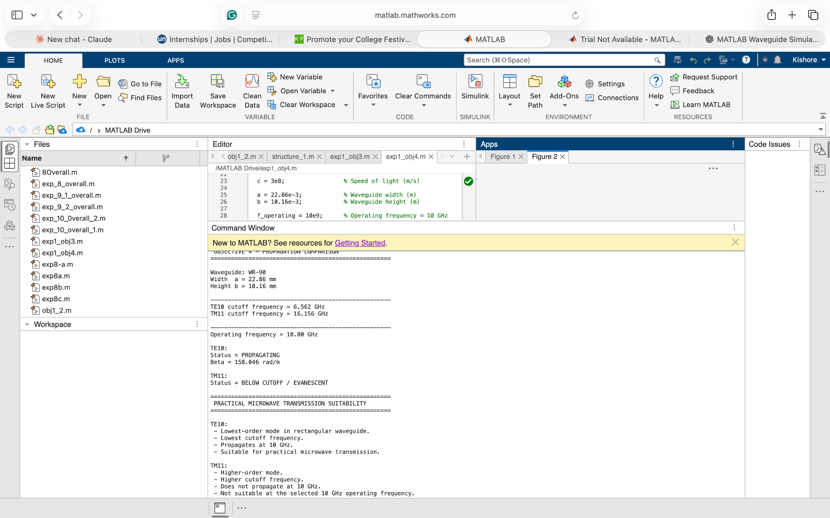
Figure 7. MATLAB comparison and practical microwave transmission suitability analysis.
Result – Objective 4
The propagation characteristics of TE10 and TM11 were compared successfully. TE10 was identified as suitable for practical microwave transmission at 10 GHz, while TM11 was found to be below cutoff and therefore unsuitable at the selected operating frequency.

OVERALL RESULT
The simulation-based electromagnetic analysis of TEM, TE and TM propagation modes was successfully performed using MATLAB.
The coaxial structure was used to represent TEM propagation, while the WR-90 rectangular waveguide was used to analyze TE10 and TM11 modes. The corresponding electric-field and magnetic-field distributions were obtained and analyzed.
fᶜ,TE10 = 6.557 GHz
βTE10 ≈ 158.05 rad/m
fᶜ,TM11 ≈ 16.156 GHz
Since the operating frequency is above the TE10 cutoff frequency, TE10 propagates. Since the operating frequency is below the TM11 cutoff frequency, TM11 becomes evanescent.
Hence, the simulation confirms that TE10 is the suitable practical propagation mode for the WR-90 waveguide at 10 GHz, while TM11 does not propagate at this frequency.
Final Conclusion
Thus, the electromagnetic models for TEM, TE and TM modes were developed, their field distributions were visualized, cutoff frequencies and propagation constants were determined, and the propagation behavior of the selected modes was successfully compared using MATLAB.

