EXP 09: ANALYSIS OF PHOTODETECTOR NOISE AND SNR USING MATLAB/SCILAB
OBJECTIVES :
1. Analyze the key noise sources in an optical photodetector, namely shot noise, dark current noise and thermal (receiver) noise.
2. Compute the individual and total noise current variances (σ²) across a range of input optical powers.
3. Evaluate the Signal-to-Noise Ratio (SNR) and observe its scaling in the thermalnoise-limited and shot-noise-limited regimes.
4. Calculate the Minimum Detectable Optical Power (Pmin) at SNR = 1 (0 dB). 5. Simulate and visualize photodetector noise and SNR curves using MATLAB.
SOFTWARE USED : MATLAB
MATLAB PROGRAM:
% Photodetector Noise and SNR Analysis
clc; clear;
close all;
%% 1. Constants and input parameters q = 1.602e-19; kB = 1.381e-23; h = 6.626e-34; c = 2.998e8;
lambda = 1550e-9; | % wavelength (m)
eta = 0.85; | % quantum efficiency
Id = 5e-9; | % dark current (A)
T = 300; | % temperature (K)
RL = 50; | % load resistance (ohm)
Fn = 2; | % noise figure (3 dB = 2 linear)
B = 1e9; | % bandwidth (Hz)
Pdbm = -60:0.1:0; | % input power sweep (dBm)
P = 10.^((Pdbm-30)/10); % input power (W)
%% 2. Responsivity and signal current
R = eta*q*lambda/(h*c);
Ip = R*P;
%% 3. Noise variances and SNR var_shot = 2*q*Ip*B; var_dark = 2*q*Id*B; var_th = 4*kB*T*B*Fn/RL; var_tot = var_shot + var_dark + var_th;
SNR_dB = 10*log10(Ip.^2 ./ var_tot);

%% 4. Minimum detectable power (SNR = 1)
a = R^2; b = -2*q*B*R; cc = -(var_dark + var_th);
Pmin = (-b + sqrt(b^2 - 4*a*cc))/(2*a);
PmindBm = 10*log10(Pmin) + 30;
%% 5. Display results
[~,k] = min(abs(Pdbm+30)); % index of -30 dBm fprintf('Responsivity R = %.4f A/W\n', R); fprintf('Thermal variance = %.3e A^2\n', var_th); fprintf('Dark variance = %.3e A^2\n', var_dark); fprintf('Shot variance(-30) = %.3e A^2\n', var_shot(k)); fprintf('SNR at -30 dBm = %.2f dB\n', SNR_dB(k));
fprintf('Pmin (SNR = 1) = %.2f dBm (%.1f nW)\n', PmindBm, Pmin*1e9);
%% 6.Plots subplot(2,1,1);
loglog(P, var_th*ones(size(P)), P, var_dark*ones(size(P)), P, var_shot, P, var_tot); grid on; xlabel('P_{in} (W)'); ylabel('Noise variance (A^2)'); legend('Thermal','Dark','Shot','Total','Location','best'); subplot(2,1,2);
plot(Pdbm, SNR_dB); hold on; plot([-60 0],[0 0],'r--'); plot([PmindBm PmindBm],[-60
70],'k:'); grid on; xlabel('P_{in} (dBm)'); ylabel('SNR (dB)'); Expected Outputs:
Command Window Output
Responsivity R = 1.0625 A/W
Thermal variance = 6.629e-13 A^2
Dark variance = 1.602e-18 A^2
Shot variance(-30) = 3.404e-16 A^2
SNR at -30 dBm = 2.31 dB
Pmin (SNR = 1) = -31.16 dBm (766.4 nW)

RESULTS:
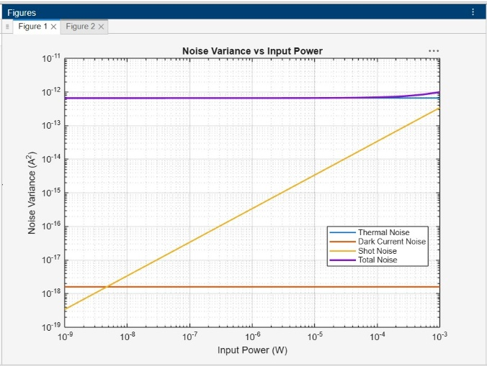 | 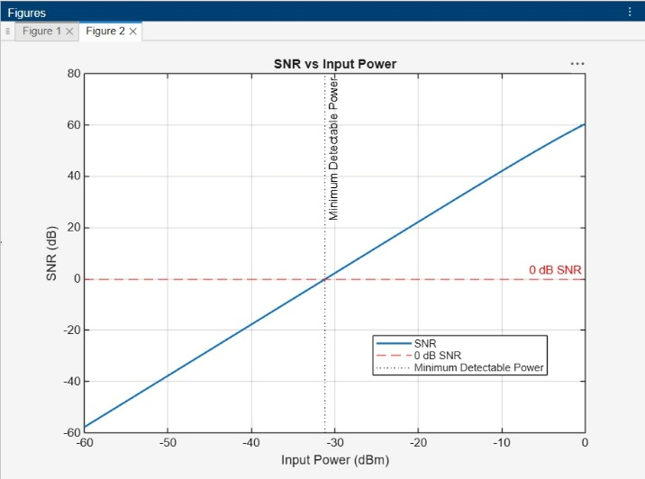

RUBRICS :

Objective | Assessment Criterion | Excellent – 4 | Good – 3 | Satisfactory – 2 | Needs  Improvement – 1 | Weightage
Develop the  MATLAB program with correct constants and system parameters. | Program  Setup and  Parameter  Definition | Defines all constants and parameters correctly with proper units and a clean script structure, independently. | Defines parameters correctly with minor unit or syntax errors and limited assistance. | Defines most parameters but needs considerable assistance or has unit errors (e.g., dBm/W, linear Fn). | Unable to set up the script or define the parameters. | 25
Compute  R, signal current, noise variances and SNR  across the power sweep. | Simulation  Execution and  Data  Acquisition | Computes R,  Ip, all noise variances and SNR correctly  over −60 to 0 dBm and  records the values. | Computes all quantities with minor errors or omissions. | Computes some quantities with noticeable errors or inconsistencies. | Unable to run the simulation or record the values. | 25
Obtain the noise and SNR plots and determine  P_{min}. | Graph  PloBing and  Pmin  Determination | Plots accurate log–log and semi-log curves with labels and reference lines; Pmin within 5% of the reference. | Plots the curves with minor errors; Pmin identified with small deviation. | Plots partial or poorly scaled curves; Pmin approximate. | Unable to plot the curves or determine  P_{min}. | 25
Interpret noise regimes, SNR slopes and receiver sensitivity. | Analysis and  Engineering  Interpretation | Correctly identifies thermal- and shot-limited regimes, explains the SNR slopes and links results to receiver design. | Identifies the regimes with minor errors and reasonable interpretation. | Performs basic interpretation with noticeable errors or limited justification. | Unable to interpret the results. | 25

REFLECTION :
I learned to analyze shot, dark-current, and thermal noise in a photodetector using MATLAB and calculate reposivity, SNR, and minimum detectable optical power. I observed how noiseaffects receiver sensitivity and verified that SNR increases with input optical power.
RESULT :
The study shows how input optical power affects noise and SNR in a PIN photodetector receiver. Performance depends on the power level:
• Low power: thermal noise dominates, giving negative SNR and no reliable detection (below Pmin ≈ −31.16 dBm).
• Moderate power: the signal rises above the thermal noise and the SNR increases at 20 dB/decade.
• High power: SNR becomes large and shot noise grows linearly, approaching the thermal level near +2.9 dBm.
These results help in estimating the receiver sensitivity and in designing low-noise optical receivers.

