EXP 10 : PHOTODIODE RESPONSE AND SENSITIVITY ANALYSIS USING OPTISYSTEM
OBJECTIVES
1. Design and simulate an optical receiver using PIN and APD photodetectors in OptiSystem.
2. Observe the photocurrent generated for a given received optical power and determine the responsivity of the detectors.
3. Determine the receiver sensitivity (minimum received power), bandwidth and the variation of SNR and BER with received power.
4. Compare the PIN and APD receivers and evaluate photodetector performance.
SOFTWARE USED : Optisytem software
CIRCUIT DIAGRAM:
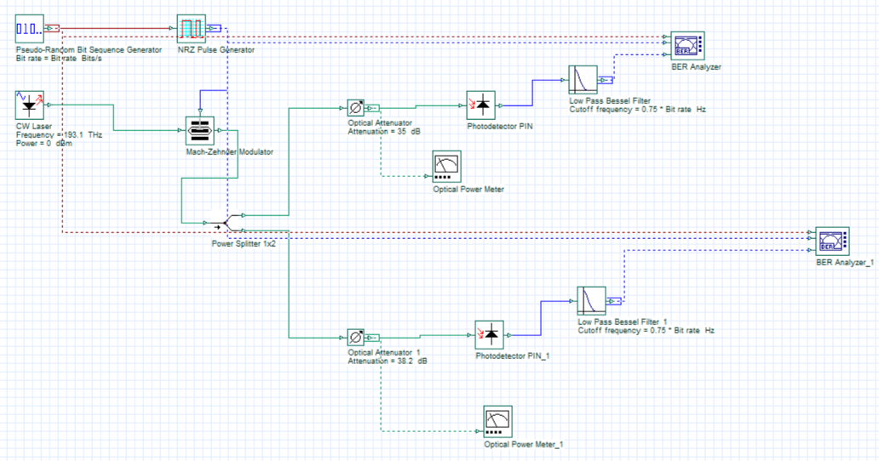
RESULTS:
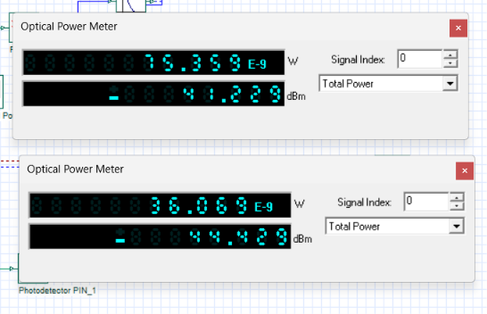

REFLECTION:
I learned to design and simulate PIN and APD optical receivers in Optisystem and analyze responsivity, sensitivity, bandwidth, SNR and BER. I observed that the APD provides higher photocurrent due to avalanche gain and can operate at lower received optical power that the PIN receiver.
RUBRICS:
Objective | Assessment Criterion | Excellent – 4 | Good – 3 | Satisfactory – 2 | Needs  Improvement – 1 | Weightage
Design the  OptiSystem PIN/APD  receiver circuit with correct components and parameters. | Circuit Setup and Parameter  Definition | Builds the complete circuit (laser, modulator,  Fork 1×2, aDenuators, PIN/APD, filters, power meters, BER analyzers) with all parameters correct (193.1  THz, 0 dBm,  35/38.2 dB, 0.75 × bit rate), independently. | Builds the circuit with minor connection or parameter errors and limited assistance. | Builds only part  of the circuit or needs considerable assistance; has unit/parameter errors (e.g., dB vs dBm). | Unable to build the circuit or set the parameters. | 25
Run the simulation and record received power, Q factor and BER for both receivers. | Simulation  Execution and  Data  Acquisition | Runs the simulation and records received power (W and dBm), eye  diagram, Q factor, BER and the aDenuation sweep correctly for PIN and APD. | Records all quantities with minor errors or omissions. | Records some quantities with noticeable errors or inconsistencies. | Unable to run the simulation or record the values. | 25
Obtain eye diagrams and BER/SNR  plots; determine responsivity, sensitivity and bandwidth. | Graph  PloDing and  Sensitivity  Determination | Plots accurate eye diagrams and  BER (semi-log) / SNR curves with labelled axes and a BER = 10⁻⁹ line; sensitivity within  ±1 dB, responsivity and bandwidth within  10% of the reference. | Plots the curves with minor errors; sensitivity, responsivity and bandwidth identified with small deviation. | Plots partial or poorly scaled curves; sensitivity, responsivity or bandwidth approximate. | Unable to plot the curves or determine the parameters. | 25
Interpret photocurrent– power  relation,  SNR/BER  variation and PIN vs APD performance. | Analysis and  Engineering  Interpretation | Correctly explains linear photocurrent, noise-limited regions, SNR/BER trend and the APD gain advantage, and links results to detector selection. | Explains the trends with minor errors and reasonable interpretation. | Performs basic interpretation with noticeable errors or limited justification. | Unable to interpret the results. | 25

RESULT:
The experiment shows how the photodetector converts received optical power into photocurrent and how this determines receiver performance. The following observations were made:
• PIN receiver: with −38.2 dBm at the detector the eye is open; photocurrent is proportional to optical power with responsivity of about 1 A/W.
• APD receiver: with 3.2 dB less power (−41.4 dBm) the eye is still open and its amplitude is larger, since avalanche gain (≈ 3) increases the effective responsivity and sensitivity. • Power dependence: below the sensitivity level SNR falls and BER approaches 0.5; above it the SNR and Q factor rise rapidly and the link is error-free.
• Bandwidth: the photodiode bandwidth is much larger than the bit rate, so the receiver bandwidth is set by the low pass filter at 0.75 × bit rate.
The APD gives be er sensitivity at the cost of added avalanche noise and higher bias, whereas the PIN photodiode is simpler and less noisy at high power. These results help in selecting the detector for a given power budget.

