COURSE CODE & NAME: ECE1408- EMEBEDDED SYSTEM
NAME: CH.AKHIL
ROLL NO: 192512151
EX NO: 1
ARDUINO UNO-BASED SMART HOME SAFETY AND OCCUPANCY MONITORING SYSTEM USING GAS, PIR AND ULTRASONIC SENSORS
Aim
To design and simulate a smart home safety and occupancy monitoring system using Arduino UNO and suitable sensors to detect hazardous conditions and human presence.
2. Software and Hardware Requirements
Software:
- Arduino IDE
- Proteus Design Suite
Hardware / Simulation Components:
- Arduino UNO
- Gas sensor
- PIR motion sensor
- Ultrasonic sensor
- LED indicators
- Buzzer
- Virtual Terminal
- Connecting wires

Program code:

const int MQ2_PIN = A0;

const int PIR_PIN = 2;

const int TRIG_PIN = 8;

const int ECHO_PIN = 7;

const int LED_PIN = 10;

const int BUZZER_PIN = 9;

const float DISTANCE_LIMIT = 10.0; // cm

void setup() {

Serial.begin(9600);

pinMode(MQ2_PIN, INPUT);

pinMode(PIR_PIN, INPUT);

pinMode(TRIG_PIN, OUTPUT);

pinMode(ECHO_PIN, INPUT);

pinMode(LED_PIN, OUTPUT);

pinMode(BUZZER_PIN, OUTPUT);

digitalWrite(TRIG_PIN, LOW);

Serial.println("GAS, MOTION AND DISTANCE MONITOR");

Serial.println("System Started");

Serial.println("-------------------------------");

}

float getDistance() {

digitalWrite(TRIG_PIN, LOW);

delayMicroseconds(2);

digitalWrite(TRIG_PIN, HIGH);

delayMicroseconds(10);

digitalWrite(TRIG_PIN, LOW);

unsigned long duration = pulseIn(ECHO_PIN, HIGH, 30000UL);

if (duration == 0) {

return -1.0;

}

return duration * 0.0343 / 2.0;

}

void loop() {

// This Proteus MQ-2 model gives HIGH when gas is simulated

int gasState = digitalRead(MQ2_PIN);

int motionState = digitalRead(PIR_PIN);

float distance = getDistance();

bool gasDetected = (gasState == HIGH);

bool motionDetected = (motionState == HIGH);

bool nearbyObject =

(distance >= 0 && distance <= DISTANCE_LIMIT);

bool alarm = gasDetected || motionDetected || nearbyObject;

Serial.print("Gas: ");

Serial.println(gasDetected ? "DETECTED" : "SAFE");

Serial.print("Motion: ");

Serial.println(motionDetected ? "DETECTED" : "NOT DETECTED");

Serial.print("Distance: ");

if (distance < 0) {

Serial.println("No echo");

} else {

Serial.print(distance, 1);

Serial.println(" cm");

}

if (gasDetected) {

Serial.println("WARNING: GAS DETECTED!");

}

if (motionDetected) {

Serial.println("WARNING: MOTION DETECTED!");

}

if (nearbyObject) {

Serial.println("WARNING: OBJECT TOO CLOSE!");

}

if (alarm) {

digitalWrite(LED_PIN, HIGH);

digitalWrite(BUZZER_PIN, HIGH);

Serial.println("SYSTEM ALERT");

} else {

digitalWrite(LED_PIN, LOW);

digitalWrite(BUZZER_PIN, LOW);

Serial.println("SYSTEM SAFE");

}

Serial.println("-------------------------------");

delay(1000);

}

OUTPUT:
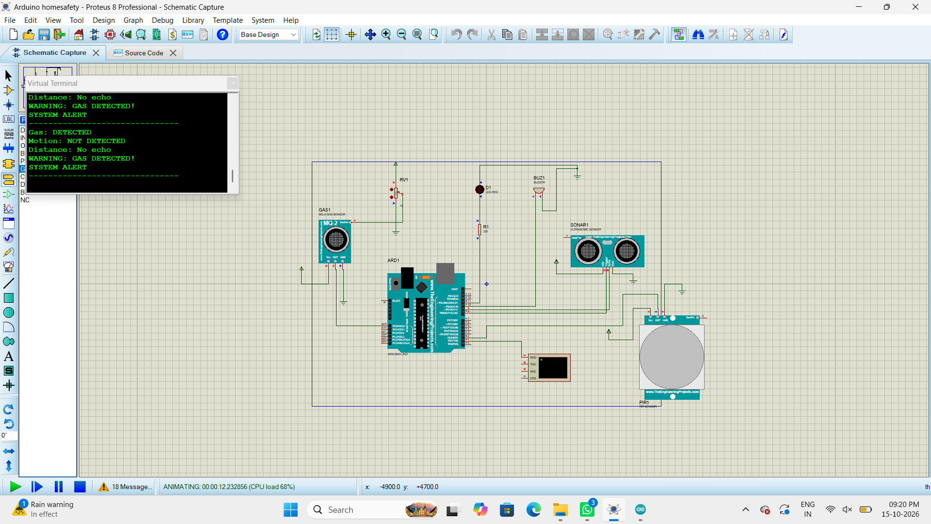
Result
Thus, the Smart Home Safety and Occupancy Monitoring System was designed and simulated using Arduino UNO and suitable sensors. The system monitors gas conditions, human movement, and nearby object distance, and provides alerts according to the programmed conditions

