COURSE CODE & NAME: ECE1408- EMEBEDDED SYSTEM
NAME: CH.AKHIL
ROLL NO: 192512151

EX NO: 2
FORMAL DESIGN OF EMBEDDED CONTROLLER USING FSM – TRAFFIC LIGHT CONTROLLER
1. Aim
To design and simulate a traffic light controller using a Finite State Machine (FSM) to control traffic signals in a systematic sequence.
2. Software and Hardware Requirements
Software:
- Arduino IDE
- Proteus Design Suite
Hardware / Simulation Components:
- Arduino UNO
- Red LED indicators
- Yellow LED indicators
- Green LED indicators
- Resistors
- Virtual Terminal (if required)
- Connecting wires
3. Program code:
// ----------------------------------------------------
// Formal Design of Embedded Controller Using FSM
// Traffic Light Controller
// Arduino UNO + Proteus
// ----------------------------------------------------
enum TrafficState
{
STATE_NS_GREEN,
STATE_NS_YELLOW,
STATE_EW_GREEN,
STATE_EW_YELLOW
};
TrafficState currentState = STATE_NS_GREEN;
// North-South traffic signal
const int NS_RED_PIN = 2;
const int NS_YELLOW_PIN = 3;
const int NS_GREEN_PIN = 4;
// East-West traffic signal
const int EW_RED_PIN = 5;
const int EW_YELLOW_PIN = 6;
const int EW_GREEN_PIN = 7;
void setup()
{
pinMode(NS_RED_PIN, OUTPUT);
pinMode(NS_YELLOW_PIN, OUTPUT);
pinMode(NS_GREEN_PIN, OUTPUT);
pinMode(EW_RED_PIN, OUTPUT);
pinMode(EW_YELLOW_PIN, OUTPUT);
pinMode(EW_GREEN_PIN, OUTPUT)
Serial.begin(9600);
}
void allOff()
{
digitalWrite(NS_RED_PIN, LOW);
digitalWrite(NS_YELLOW_PIN, LOW);
digitalWrite(NS_GREEN_PIN, LOW);
digitalWrite(EW_RED_PIN, LOW);
digitalWrite(EW_YELLOW_PIN, LOW);
digitalWrite(EW_GREEN_PIN, LOW);
}
void enterState(TrafficState state)
{
allOff();
switch (state)
{
case STATE_NS_GREEN:
digitalWrite(NS_GREEN_PIN, HIGH);
digitalWrite(EW_RED_PIN, HIGH);
Serial.println("STATE S0: NS GREEN - EW RED");
break;
case STATE_NS_YELLOW:
digitalWrite(NS_YELLOW_PIN, HIGH);
digitalWrite(EW_RED_PIN, HIGH);
Serial.println("STATE S1: NS YELLOW - EW RED");
break;
case STATE_EW_GREEN:
digitalWrite(NS_RED_PIN, HIGH);
digitalWrite(EW_GREEN_PIN, HIGH);
Serial.println("STATE S2: NS RED - EW GREEN");
break;
case STATE_EW_YELLOW:

digitalWrite(NS_RED_PIN, HIGH);
digitalWrite(EW_YELLOW_PIN, HIGH);
Serial.println("STATE S3: NS RED - EW YELLOW");
break;
}
}
void loop()
{
switch (currentState)
{
case STATE_NS_GREEN:
enterState(STATE_NS_GREEN);
delay(10000);
currentState = STATE_NS_YELLOW;
break;
case STATE_NS_YELLOW:
enterState(STATE_NS_YELLOW);
delay(3000);
currentState = STATE_EW_GREEN;
break;
case STATE_EW_GREEN:
enterState(STATE_EW_GREEN);
delay(10000);
currentState = STATE_EW_YELLOW;
break;
case STATE_EW_YELLOW:
enterState(STATE_EW_YELLOW);
delay(3000);
currentState = STATE_NS_GREEN;
break;
}
}
4.OUTPUT:
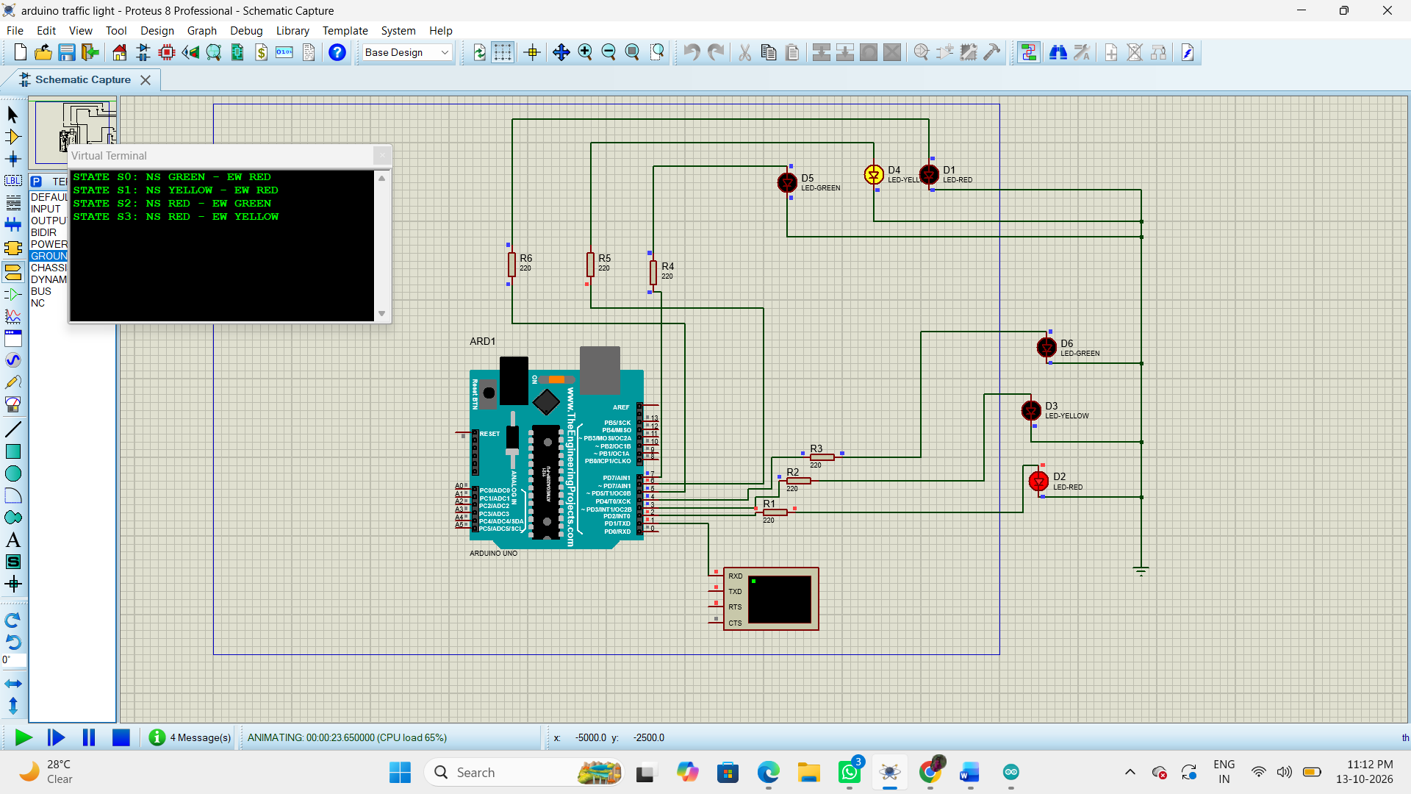
5. Result
Thus, the traffic light controller was designed and simulated using the Finite State Machine (FSM) concept. The controller operates the red, yellow, and green traffic signals in a predefined sequence to support systematic traffic management.

